



Contents

Introduction **3**

Software Requirements and Technology Stacks **3**

Required Software 3

Technology Stacks 3

Application Setup **3**

Download GITHUB Code 3

Folder Structure 4

Run the Application **4**

# Introduction

This document describes the setup of the “**Project Manager**” application in local machine for development and debugging purposes.

# Software Requirements and Technology Stacks

## Required Software

These are the list of the software installed in the system to develop and run the application:

1. Visual Studio 2017
2. Visual Studio Code
3. SQL Server Management Studio 2017
4. Google Chrome
5. Node JS v 8.12.0
6. GIT BASH (to commit code to the GITHUB repository)

## Technology Stacks

These are the list of the technologies used to develop the application:

1. Angular (UI)
2. HTML (UI)
3. CSS3 and BOOTSTRAP (UI)
4. .NET Framework
5. Web API 2.0 (C#)
6. Entity Framework
7. SQL

# Application Setup

## Download GITHUB Code

1. Visit the URL <https://github.com/prantick-ghosh/project-manager> where the code is checked in.
2. Click on the ‘**Clone or download**’ button.

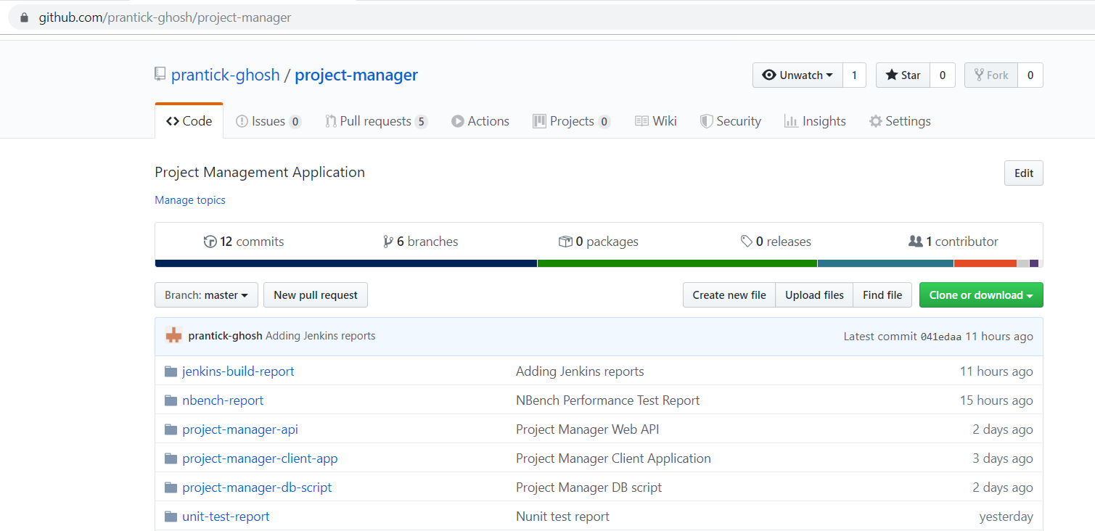

1. Click on the “**Download ZIP**” button.
2. Extract the downloaded zip file to a folder on the system.

## Folder Structure

In the main folder there are sub folders:

1. **project-manager-client-app:** This folder contains the Project Manager UI application that is developed using Angular.
2. **project-manager-api**: This folder contains the Project Manager Web API that is developed using C# Programming language.

**project-manager-client-app**

1. Go to the path **project-manager-client-app** where you can see the file ***angular.json***
2. Open command prompt
3. Copy the path from Step No. 1
4. Traverse to the path of Step 1 in the command prompt
5. Once you are in this path, run this command **“npm install –g -f @angular/cli**”
6. After this installation is done, run this command **“npm install -f”**
7. Let all the npm packages install in the project
8. Once the installation is done you will be able to see a folder “*node_modules*” in your system
9. Don’t close the command window

**project-manager-api**

1. Open the folder **project-manager-api**/**ProjectManager**
2. Open the file “**ProjectManager.sln**” in Visual Studio 2017
3. Build the application
4. Don’t close the Visual Studio 2017

**project-manager-db-script**

1. Open the SQL Server Management Studio
2. Run the script “**Database_Creation_Script.sql**”
3. Run the script “**ParentTask_Table_Script.sql**”
4. Run the script **“Project_Table_Script.sql”**
5. Run the script **“Task_Table_Script.sql”**
6. Run the script **“User_Table_Script.sql”**

# Run the Application

Once the build is succeeded:

1. Open the command prompt and run the command “**npm start**”
2. Open the visual studio 2017 and select the “**ProjectManager**” project as startup project and press “**Start**” to run the application
3. Once the node modules are built after the step 1, open Google Chrome and enter the URL “**localhost:4200**”