

Document Title
Online Radio
Submitted to
Hasan Murad
Hasan Murad
Lecturer
University of Asia Pacific
Department of Computer Science & Engineering

Title of the Course
Software Development
Course Code
CSE 410

Submitted by
Armanur Rahman Pranto

Id:17101090
Abdur Rob
Id:17101082
MAksuda Islam Rumu
Id;17101089
Section: b2/c1
University of Asia Pacific

Department of Computer Science and Engineering
Introduction: Internet radio has now become a great source of entertainment. With the coming of radio on internet, the traditional radio has lost its importance to some extent. With the increasing number of internet users, the people who listen to internet radio have also increased.
Broadcasting has been defined as the transmission of information through radio waves from a radio or television station to the audience in far and near places, through their receivers, which help in decoding such information.
Streaming stands for the real-time transport of live or stored media (e.g. video, audio and any associated data) over the Internet, between the client and server computers.

Scope: This project is limited to development of online radio station which would be developed using global standard such that other radio stations and media outlet can take a lead from it.

Significance:
- This would help in transmitting Audio content over the internet audio content which includes News and Updates, Music, Lectures, Roundtable discussions, Advertisement, talk shows, Sports Updates, Islamic Programs etc
- Students would help in promoting the publicity of the university to the whole world.
- Students can access the radio station on their smart phones and computers.
- The university community and the host communities could enjoy the services of the radio station.
- The radio station could transmit 24 hours 7 days.

Design Methodology:
The methodology adopted for this project is the component based software Engineering (CBSE). CBSE emerged in the late 1990s as an approach to software systems development based on reusing software components. Components are higher-level abstractions than objects and are defined by their interfaces. They are usually larger than individual objects and all implementation details are hidden from other components.

Components Needed For Implementation:
This is open source software for streaming music files and encoding it to shout cast servers.
The mobile application for the system is developed using the ibuilapp cloud IDE. Java language used in this project.

How Radio Works?
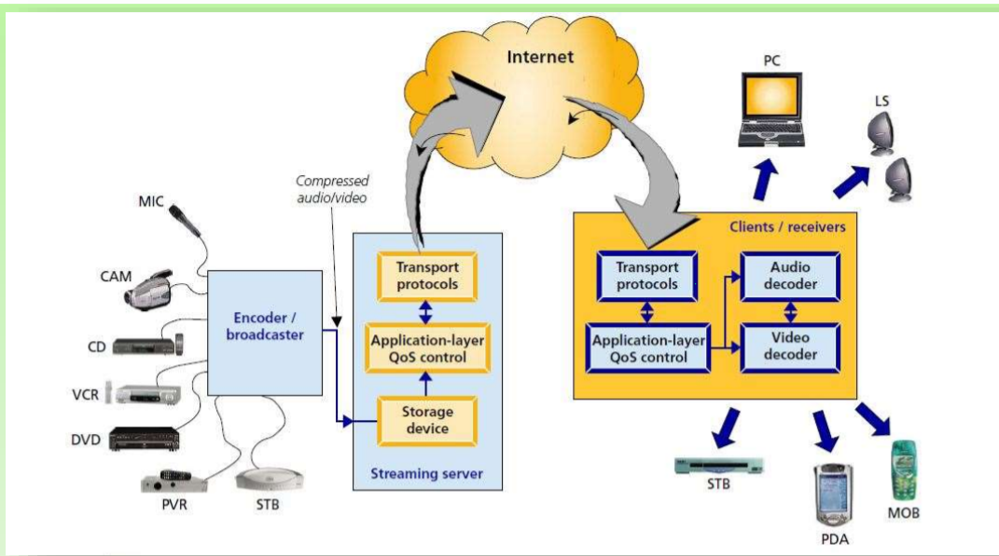

System architecture diagram:
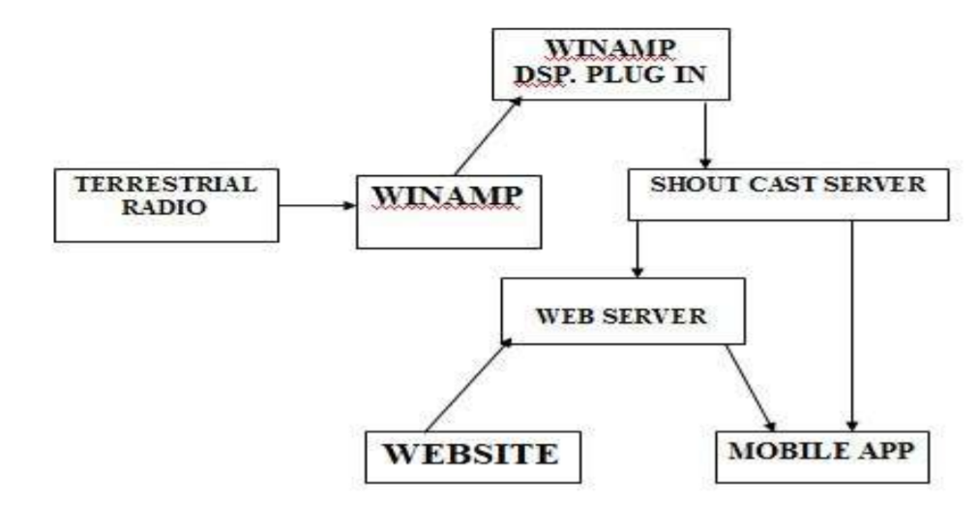

Privacy policy:
Information Collection and Use
For a better experience, while using our Service, we may require you to provide us with certain personally identifiable information. The information that we request is will be retained by us and used as described in this privacy policy.
Log Data
We want to inform you that whenever you use our Service, in a case of an error in the app we collect data and information on your phone called Log Data. This Log Data may include information such as your device Internet Protocol (“IP”) address, device name, operating system version, the configuration of the app when utilizing our Service, the time and date of your use of the Service, and other statistics.
Service Providers
We may companies and individuals due to the following reasons:
- To facilitate our Service;
- To provide the Service on our behalf;
- To perform Service-related services; or
- To assist us in analyzing how our Service is used.
We want to inform users of this Service that these third parties have access to your Personal Information. The reason is to perform the tasks assigned to them on our behalf. However, they are obligated not to disclose or use the information for any other purpose.
Security
We value your trust in providing us your Personal Information, thus we are striving to use commercially acceptable means of protecting it. But remember that no method of transmission over the internet, or method of electronic storage is 100% secure and reliable, and we cannot guarantee its absolute security.

Radio station requirements:
- Android studio.
- Dsp plugin.
- Android mobile.
- Web Browser (Mozilla Firefox, Opera, Internet Explorer e.t.c)
- Firewall Software for security enhancement.
- The server system require a minimum work stations with the following.

Client System Requirement:
- An android 2.3 ginger bread and above for android mobile phones.
- Tune In Mobile App.

Screenshot Online Radio


Conclusion:
With the increase in the number of internet users and accessibility to the internet via mobile networks, wifi, and wired networks, it is very important to radio system this would aid in the transfer of information across the online version as well as the world as whole.

Recommendation:
- A web master should be appointed to maintain and manage whatever content that is to be published on the platform.
- For easier transmission of data i.e streaming, dedicated bandwidths should be allocated for the fountain university radio system.
- A sub-Domain should be given to the radio website on the university website.
To ensure fountain university radio system is listed in Tune-In radio directory, there has to be continu.

