HOSPITAL MANAGEMENT SYSTEM

Sabbir Ahmed Akkhar
Department of computer science and Engineering
Daffodil International University
Dhaka, Bangladesh
Sakkhar.7534@gmail.com
Mohammad Fahim Jamali
Department of computer science and Engineering
Daffodil International University
Dhaka, Bangladesh
fahim.7545@gmail.com
PRANTO SHARMA
Department of computer science and Engineering
Daffodil International University
Dhaka, Bangladesh
Pranto7539@gmail.com

Abstract :This paper is to computerize the Front Office Management of Hospital to develop software which is user
friendly simple, fast, and cost – effective. It deals with the collection of patient’s information, diagnosis details, etc.
Traditionally, it was done manually. The main function of the system is register and store patient details and doctor
details and retrieves these details as and when required, and also to manipulate these details meaningfully. System input
contains patient details, diagnosis details, while system output is to get these details on to the screen. The Hospital
Management System can be entered using a username and password. It is accessible either by an administrator or
receptionist. Only they can add data into the database. The data can be retrieved easily. The data are well protected for
personal use and makes the data processing very fast.
Keywords— hospitality, trigger, administrators, receptions.
Introduction
Human Body is a very complex and sophisticated structure
and comprises of millions of functions. All these
complicated functions have been understood by man him,
part-by-part their research and experiments. As science and
technology progressed, medicine became an integral part of
the research. Gradually, medical science became an entirely
new branch of science. As of today, the Health Sector
comprises of Medical institutions i.e. Hospitals,
HOSPITALs etc. research and development institutions and
Medical colleges. Thus the Health sector aims at providing
the best medical facilities to the common man. Still being a
developing nation India has seen a tremendous growth of
the Health sector in the field of research as well as in the
field of development of numerous large and small scale
Hospital institutions still lacking in inter-structure facilities.
Government of Bangladesh has still aimed at providing medical
facilities by establishing hospital. The basic working of
various hospitals in Bangladesh is still on paper as compared to hospitals in European countries where computers have been
put in to assist the hospital personals their work. The concept of automation of the administration and
management of hospital is now being implemented in Bangladesh also, with large hospitals like APPOLO and BARDEM in Dhaka, Popular in Rajshahi , having automated their existing system.

System functional

The Functionality of the online patient management system Includes 2 parts
1) The complete website that includes all the functions required
2) The customized application for every doctor as per their specialty on their respective tablets.

1) Online registration of the patient
Anybody can register online filling all the details required and the system will generate a Patient Id. This patient ID should be maintained by the person and the system. This patient ID will be used for patient records management and all further actions. This will eliminate the need for form filling procedures at last moment in many emergency cases.

2) Record storage
All the records of each and every patient is maintained in the System data base. This includes the patient’s personal details, cases history, diseases, tests results, MRI scans, CT scans, X-rays, visit number , patient is admitted or not , details of doctor allocated, prescriptions, further actions and treatments this will eliminate the need of maintaining the records on papers and scans on films also all the record will be accessible by knowing the patient’s ID .

3) Patient status
The current status of each patient can be maintained. The flow of the patient status is shown below in fig 1.
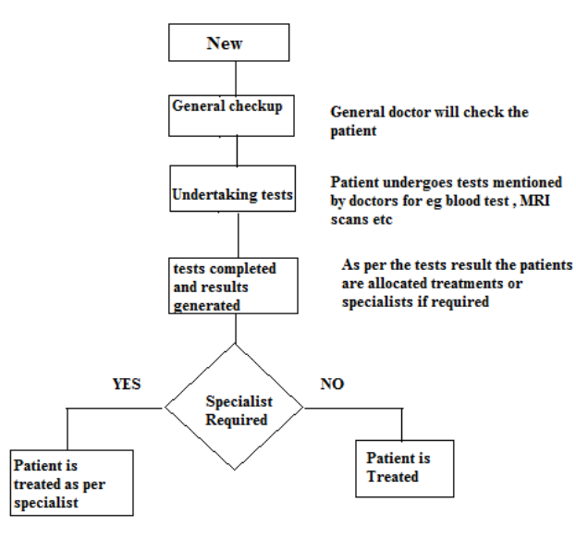
FIG 1 PATIENT STATUS FLOW

4) Customized application for each doctor as per their specialty on their tablets
Every doctor can have a tablet with a customized application based on their specialty. Each doctor can check the patient list assigned to him/her . can get every details about any patient on click . notifications on patients reports , test results can will be generated on the application. When the results are generated the lab technician updates the result in the system and the notification is generated at the assigned doctors end and result, reports are also sent at doctors end. Doctor can check the details on tablet and maintain his/her schedule , prioritizing the patients, doctors can update the treatments for patients , doctors can check if any operating rooms available currrently and book accordingly and can release the OR after his work is done.doctors can also update prescribtion to the patient in system which is then notified to the pharmacist through the system.Doctors can also send videos, pictures to other doctors for second opinion etc.

5) Online appointments
The person who is registered can also schedule his/her appointment online . he can check the availability of the doctors .

6) Research
Every doctors can publish their research online , several medical journals can be published. Articles and details on unique cases can be maintained online. Videos of surgeries, differenct techniques , can be shared . latest breakthroughs , researches , can be maintained. This will give everyone a very good platform for research and studying different cases making the doctors aware of new techniques used to cure any disease as well publishing the same. Doctors can use this for investigation on cases and it can help them in decision making process decreasing the time in diagnosis and treatment.

Hardware and technical requirements To implement this application we will require computers in each functional room of hospital for e.g. All the wards of hospital should have a computer to update the details about patient in those wards, all the departments like MRI, CT scan, X-ray rooms should have computers to store the reports on the system database and all these computers should be in network and it should have an updated browsers and internet connection. Every patient should be registered and have a patient ID, and every person who handles the patients in some or the other way should have a login access to the system so that person can update about the patient relatively. All the doctors should have a tablet with internet connection and connected with the other hospital computers, these tablets should contain the customized application of the system.

Other tools and languages that can be used This web based application can be developed by using object oriented programming languages for java , which will provide the latest technology in developing quite user friendly user interface so there is very less difficulty for all the users to learn the system. The Database or backend can be created on relational database management system like My SQL SERVER 2016 . these tools will help to design and develop very efficient database which we will require to store and manage a very huge amount of data on patients and doctors and their treatments etc.

CONCLUSION
Since the Hospital Management System is essential for
maintaining detail about the Doctor, Patient, Hospital staff
etc. we understand that by using of Hospital Management
System project the work became very easy and we save lot
of time. Hospital administrators would be able to
significantly improve the operational control and thus
streamline operations. This would enable to improve the
response time to the demands of patient care because it
automates the process of collecting, collating and retrieving
patient information. Accounting sometimes becomes
awfully pathetic and complex. This product will eliminate
any such complexity.

REFERENCES
[1] Herbert Scheldt, Java Complete Reference, Fifth Edition,
Tata McGraw Hill Edition.
[2] Phil Hanna, JSP 2.0: The Complete Reference, Tata McGraw
Hill Edition, 2003.
[3] Elmarsi and Navathe, Fundamentals of Database System
(Third Edition), Addision Wesley.
[4] Ian Somerville, Software Engineering, Third Edition, Pearson
Education.
[5] Ali Bahrami, Object-Oriented System Development, Third
Edition, Tata McGraw Hill Edition.
[6] Ivan Bayross, SQL, PL/SQL programming language of
Oracle, Second Edition, BPB Publication[2] Phil Hanna, JSP 2.0: The Complete Reference, Tata McGraw
Hill Edition, 2003.
[3] Elmarsi and Navathe, Fundamentals of Database System
(Third Edition), Addision Wesley.
[4] Ian Somerville, Software Engineering, Third Edition, Pearson
Education.
[5] Ali Bahrami, Object-Oriented System Development, Third
Edition, Tata McGraw Hill Edition.
[6] Ivan Bayross, SQL, PL/SQL programming language of
- Oracle, Second Edition, BPB Publication

