**REPORT**

**GESTURE CONTROLLED BOT**

**MICROPROCESSOR AND MICROCONTROLLER (CS221)**

|  |  |
| --- | --- |
| **INTRODUCTION:**  Implementation of a system through which the user can give commands to a wireless bot using gestures. Through this method, the user can control or navigate the bot by using gestures of his/her palm, thereby interacting with the robotic system. The command signals are generated from these gestures using image processing. These signals are then passed to the bot to navigate it in the specified directions via Bluetooth module. | **18052577_1392821747444788_1577096570_n (1).jpg** |

**EQUIPMENTS:**

**HARDWARE:**

1. Arduino Nano
2. Printed Circuit Board
3. Bluetooth
4. 12V AC Motors - 2
5. Chessis and wheels
6. Caster Wheel
7. Female to Female connectors – 4
8. Nuts and Screws
9. 12V Adapter
10. USB A to B

**SOFTWARES:**

1. Matlab
2. Arduino

**COMPONENT DESCRIPTION:**

**Arduino Nano:**

|  |  |
| --- | --- |
| Microcontroller                        Atmel ATmega328 Operating Voltage (logic level)  5 V  Digital I/O Pins                        14 (of which 6 provide PWM output) Analog Input Pins                    8 DC Current per I/O Pin            40 mA Flash Memory                          32 KB (of which 2KB used by bootloader)  Clock Speed                           16 MHz Dimensions                            0.70” x 1.70” | arduino.jpg |

**Bluetooth:**

Used for receiving data from Matlab and transmits streamline data to Arduino.

|  |  |
| --- | --- |
| * Power Supply: +3.3VDC 50mA * Frequency: 2.4GHz ISM band * Bluetooth Protocol: Bluetooth specification v2.0+EDR * Wireless module * Bluetooth transceiver PCB * Range: 30 feet | Bluetooth.jpg |

**12V Motor:**

|  |  |
| --- | --- |
| * Working voltage: 3V to 9V * 30gm weight * Ability to operate with minimum or no lubrication, due to inherent lubricity. * 1.9 Kgf.cm torque * No-load current = 60 mA, Stall current = 700 mA * 300rpm | **C:\Users\pranitha\AppData\Local\Microsoft\Windows\INetCache\Content.Word\IMG_20171122_013357.jpg** |

**Printed Circuit Board (PCB):**

**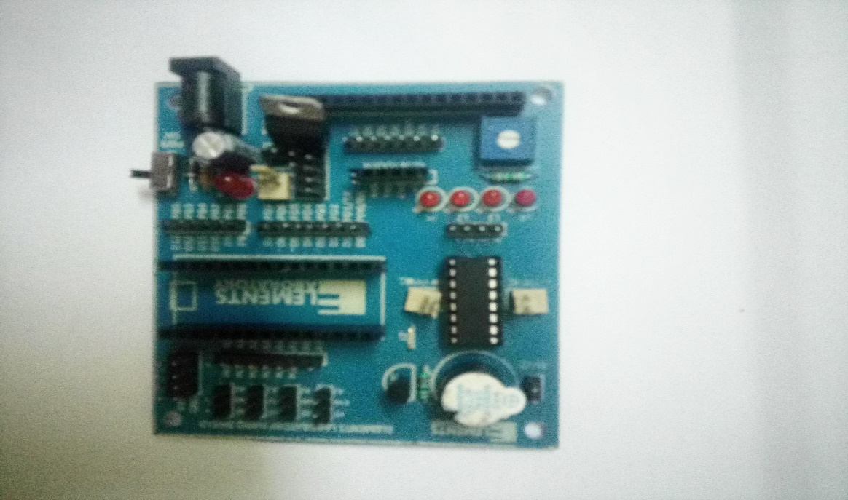**

**SCHEMATIC DIAGRAM :**

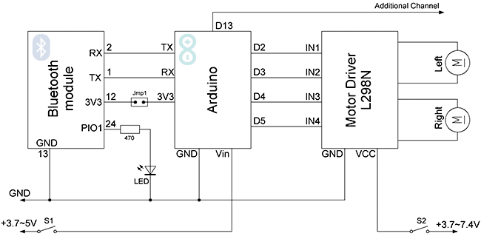

**Data Transmission Flowchart:**

Matlab

(Bluetooth)

Arduino

Bluetooth

TX

TX

TX

RX

RX

RX

**PROCEDURE:**

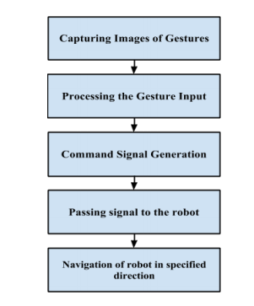

**Capturing images of simple gestures:**

The video device captures the image and processes the image. The end result of gesture recognition system is to generate a command and that is given to the bot. There are mainly four possible gesture commands that can be given to the bot (Forward, Backward, Right and Left).

**Processing the gesture input:**

Video Device takes the gestured input and the input is processed:

* Convert image into grayscale
* Extract green component of RGB
* Remove small objects from binary image
* Remove Noise
* Smoothen the edges
* Identify number of objects of specified color

If number of objects is 1 – Forward is written in command window of Matlab

|  |  |
| --- | --- |
|  |  |

If number of objects is 2 – Left is written in command window of Matlab

|  |  |
| --- | --- |
| C:\Users\pranitha\AppData\Local\Microsoft\Windows\INetCache\Content.Word\IMG_20171122_001409.jpg | C:\Users\pranitha\AppData\Local\Microsoft\Windows\INetCache\Content.Word\Screenshot (6).png |

If number of objects is 3 – Right is written in command window of Matlab

|  |  |
| --- | --- |
| C:\Users\pranitha\AppData\Local\Microsoft\Windows\INetCache\Content.Word\IMG_20171122_001331.jpg | C:\Users\pranitha\AppData\Local\Microsoft\Windows\INetCache\Content.Word\Screenshot (7).png |

If number of objects is 4 – Backward is written in command window of Matlab

|  |  |
| --- | --- |
| C:\Users\pranitha\AppData\Local\Microsoft\Windows\INetCache\Content.Word\IMG_20171122_001347.jpg | C:\Users\pranitha\AppData\Local\Microsoft\Windows\INetCache\Content.Word\Screenshot (8).png |

**Passing signal to bot:**

After number of objects are identified, digital signals are passed to bot.

For forward movement:

* -ve terminal of right motor is set to HIGH
* -ve terminal of right motor is set to LOW
* +ve terminal of right motor is set to HIGH
* +ve terminal of right motor is set to LOW

For left movement:

* -ve terminal of right motor is set to LOW
* -ve terminal of right motor is set to LOW
* +ve terminal of right motor is set to HIGH
* +ve terminal of right motor is set to LOW

For right movement:

* -ve terminal of right motor is set to HIGH
* -ve terminal of right motor is set to LOW
* +ve terminal of right motor is set to LOW
* +ve terminal of right motor is set to LOW

For backward movement:

* -ve terminal of right motor is set to LOW
* -ve terminal of right motor is set to HIGH
* +ve terminal of right motor is set to LOW
* +ve terminal of right motor is set to HIGH

**Navigation of the bot in specified direction:**

If number of objects is 1, the bot moves forward.

If number of objects is 2, the bot moves left.

If number of objects is 2, the bot moves right.

If number of objects is 4, the bot moves backward.

If no object is shown, the bot stops moving.

**Power Supply:**

DC Motors are powered by 12V adapter, connected to bot, of which the Arduino Nano takes 5V regulated external power supply (pin 27). The power source is automatically selected to the highest voltage source.

**APPLICATION:**

Gesture Controlled autonomous moving bot which moves according to the gestures useful for physically challenged people.

**LIMITATIONS:**

* Detects only a specified color.

**CONCLUSION:**

The Gesture Controlled Bot System gives an alternative way of controlling robots. Gesture control being a more natural way of controlling devices makes control of bots more efficient and easy. We have provided two techniques for giving gesture input, finger count based gesture control and direction of hand palm based gesture control. In which each finger count specifies the command for the bot to navigate in specific direction in the environment and direction based technique directly gives the direction in which bot is to be moved.