# Implement Programs for Time Series Data Analysis

## AIM:

To implement programs for time series data loading, visualization, and analysis techniques.

## PROCEDURE:

1. **Import the necessary libraries:**  
     
   import pandas as pd  
   import matplotlib.pyplot as plt  
   import seaborn as sns
2. **Load the dataset:**

url = "/content/airline-passengers.csv"  
data = pd.read_csv(url, parse_dates=['Month'], index_col='Month')

1. **Check the first few rows of the dataset:**

print(data.head())

1. **Plot the time series data:**

plt.figure(figsize=(12, 6))  
plt.plot(data.index, data['Passengers'], marker='o', linestyle='-')  
plt.title('Monthly Air Passengers (1949-1960)', fontsize=16)  
plt.xlabel('Date', fontsize=12)  
plt.ylabel('Number of Passengers (in thousands)', fontsize=12)  
plt.grid()  
plt.show()

1. **Analyze trends and seasonality using rolling mean:**

data['Passengers_MA'] = data['Passengers'].rolling(window=12).mean()  
  
plt.figure(figsize=(12, 6))  
plt.plot(data.index, data['Passengers'], label='Original Data', color='blue')  
plt.plot(data.index, data['Passengers_MA'], label='12-Month Rolling Mean', color='orange', linewidth=2)  
plt.legend()  
plt.show()

## OUTPUT:

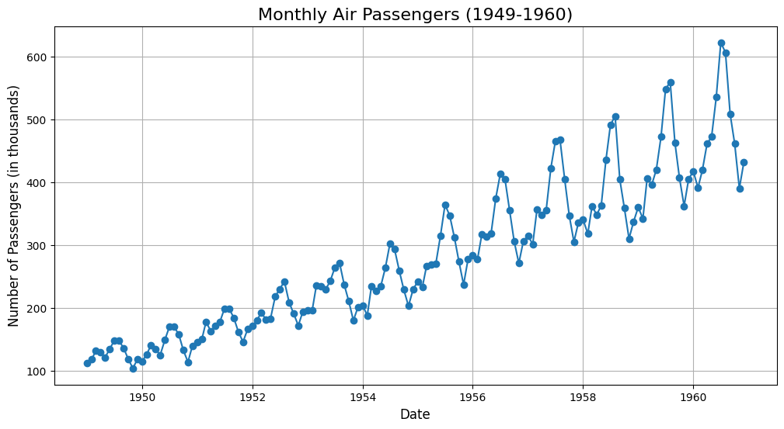

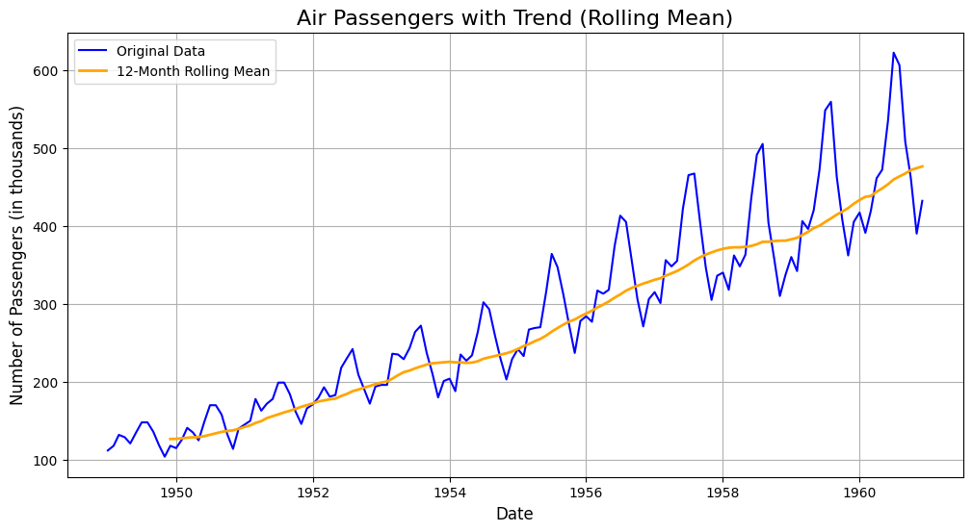

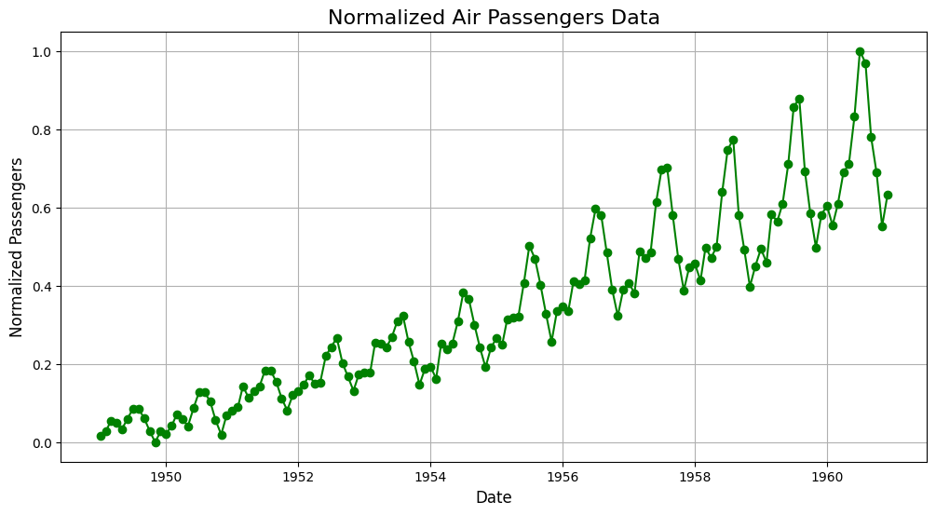

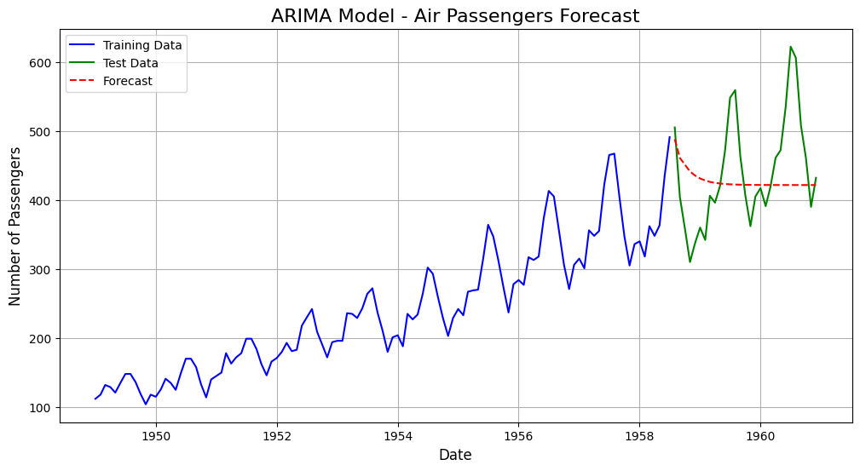

## RESULT:

The programs for time series data loading, visualization, and analysis techniques on the airline passengers dataset have been implemented successfully.