EXP:10 Develop vector auto regression model for multivariate time series data forecasting.
Aim: To Develop vector auto regression model for multivariate time series data forecasting using autism screening dataset
Procedure:
1.Import the necessary libraries:
import pandas as pd
import numpy as np
import matplotlib.pyplot as plt
from statsmodels.tsa.api import VAR
from statsmodels.tsa.stattools import adfuller
2. Load the dataset
df = pd.read_csv("autism_screening.csv")
3. Visualize the data
monthly_positive.plot(title="Monthly Positive Autism Screenings")
plt.xlabel("Month")
plt.ylabel("Number of Positive Screenings")
plt.show()
4. Check for stationarity (ADF test)
from statsmodels.tsa.stattools import adfuller
result = adfuller(monthly_positive.dropna())
print(f"ADF Statistic: {result[0]}")
print(f"p-value: {result[1]}")

5. Train-Test Split (80% training, 20% test)
train_size = int(len(df_subset_diff) * 0.8)
train, test = df_subset_diff[:train_size], df_subset_diff[train_size:]
6. Fit the VAR Model
model = VAR(train)
model_fitted = model.fit(maxlags=15, ic='aic') # Use AIC to select the optimal lag length
print(model_fitted.summary())
7. Visualize the Actual vs Forecasted values
plt.figure(figsize=(12, 6))
plt.plot(df_subset.index, df_subset['A1_Score'], label="Actual A1_Score")
plt.plot(df_subset.index, df_subset['A2_Score'], label="Actual A2_Score")
plt.plot(forecast_df.index, forecast_df['A1_Score'], label="Forecasted A1_Score", linestyle='--')
plt.plot(forecast_df.index, forecast_df['A2_Score'], label="Forecasted A2_Score", linestyle='--')
plt.title("Actual vs Forecasted Scores for A1_Score and A2_Score")
plt.xlabel("Date")
plt.ylabel("Scores")
plt.legend()
plt.show()

OUTPUT:
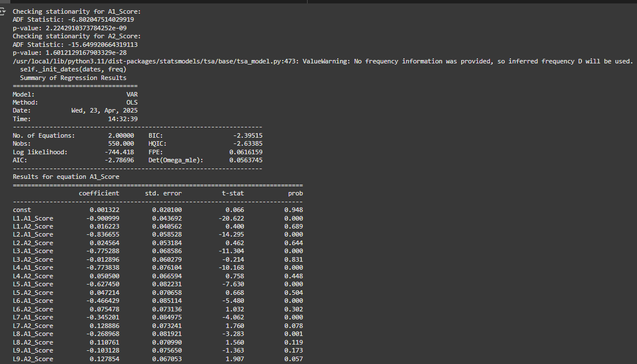
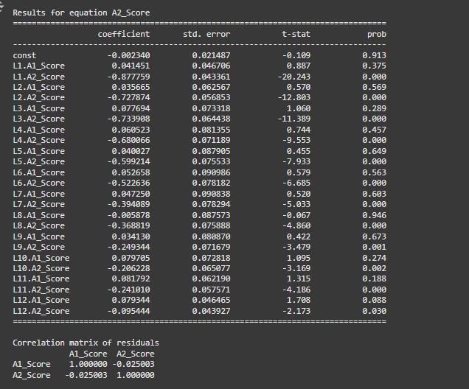

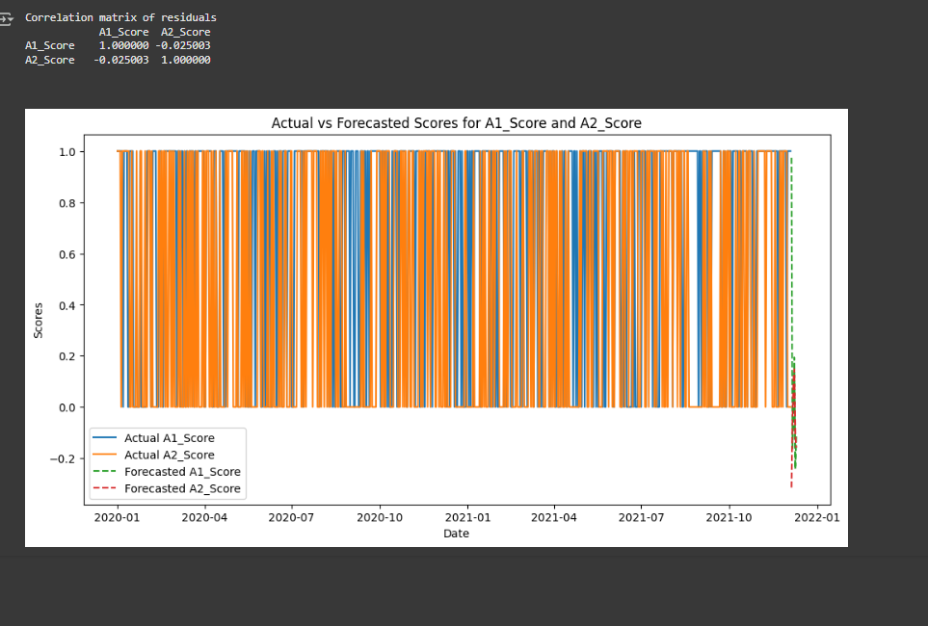

Result: This program t To Develop vector auto regression model for multivariate time series data forecasting using autism screening dataset was implemented and executed successfully
