# TO FIND CORRELATION BETWEEN ATTRITION AND OTHER ATTRIBUTES:

In [15]:

## import pandas as pd

In [16]:

dataset=pd.read_csv("general_data.csv")

In [17]:

dataset

Out[17]:

**Age Attrition BusinessTravel Department DistanceFromHome Education EducationField EmployeeCount Employ**

**0** 51 No Travel_Rarely Sales 6 2 Life Scienc1

**1** 31 Yes Travel_Frequently Research &

Development

10 1 Life Sciences 1

**3** 38 No Non-Travel Research &

Development

2 5 Life Sciences 1

**...** ... ... ... ... ... ... ... ...

**4405** 42 No Travel_Rarely Research &

Development

**4406** 29 No Travel_Rarely Research &

Development

5 4 Medical 1

2 4 Medical 1

**4408** 42 No Travel_Rarely Sales 18 2 Medical 1

**4409** 40 No Travel_Rarely Research &

Development

28 3 Medical 1

4410 rows × 24 columns

In [18]:

**from scipy.stats import** pearsonr

In [19]:

## import matplotlib.pyplot as plt

In [20]:

dataset['Attrition'].replace(to_replace=("No","Yes"),value=(0,1),inplace=**True**)

# 

Correlation between Attrition and Age

In [21]:

stats,p = pearsonr(dataset.Attrition,dataset.Age) print("Correlation: ",stats,"**\n** P-value: ",p) **if** stats == 0 :

print("**\n**No Correlation") **elif** stats > 0 :

print("**\n**Positive correlation") **else**:

print("**\n**Negative correlation") **if** p<0.05:

print("Reject null hypothesis") **else**:

print("Accept null hypothesis") plt.scatter(dataset.Attrition,dataset.Age)

Correlation: -0.15920500686577949 P-value: 1.996801615887198e-26

Negative correlation Reject null hypothesis

Out[41]:

<matplotlib.collections.PathCollection at 0x7fa453a1fa58>

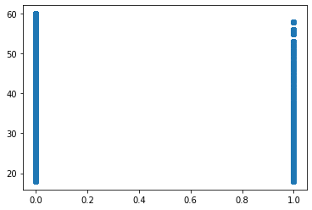

Correlation between Attrition and Monthly Income

In [18]:



stats1,p1 = pearsonr(dataset.Attrition,dataset.MonthlyIncome) print("Correlation: ",stats1,"**\n** P-value: ",p1)

**if** stats1 == 0 :

print("**\n**No Correlation")

**elif** stats1 > 0 :

print("**\n**Positive correlation")

**else**:

print("**\n**Negative correlation") **if** p1<0.05:

print("Reject null hypothesis") **else**:

print("Accept null hypothesis") plt.scatter(dataset.Attrition,dataset.MonthlyIncome)

Correlation: -0.03117628169811501

P-value: 0.03842748490600132

Negative correlation Reject null hypothesis

Out[18]:

<matplotlib.collections.PathCollection at 0x7fa453982588>

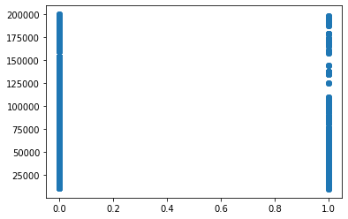

Correlation between Attrition and DistanceFromHome

In [19]:



stats2,p2 = pearsonr(dataset.Attrition,dataset.DistanceFromHome) print("Correlation: ",stats2,"**\n** P-value: ",p2)

**if** stats2 == 0 :

print("**\n**No Correlation")

**elif** stats2 > 0 :

print("**\n**Positive correlation")

**else**:

print("**\n**Negative correlation") **if** p2<0.05:

print("Reject null hypothesis") **else**:

print("Accept null hypothesis") plt.scatter(dataset.Attrition,dataset.DistanceFromHome)

Correlation: -0.009730141010179692 P-value:

Negative correlation Accept null hypothesis

Out[19]:

<matplotlib.collections.PathCollection at 0x7fa45396a240>

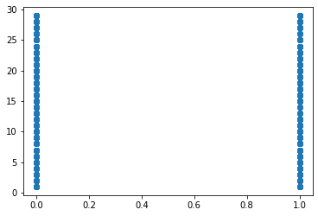

Correlation between Attrition and Job level

In [20]:



stats3,p3 = pearsonr(dataset.Attrition,dataset.JobLevel) print("Correlation: ",stats3,"**\n** P-value: ",p3)

**if** stats3 == 0 :

print("**\n**No Correlation")

**elif** stats3 > 0 :

print("**\n**Positive correlation")

**else**:

print("**\n**Negative correlation") **if** p3<0.05:

print("Reject null hypothesis") **else**:

print("Accept null hypothesis") plt.scatter(dataset.Attrition,dataset.JobLevel)

Correlation: -0.010289713287494923

P-value: 0.4945171727183978

Negative correlation Accept null hypothesis

Out[20]:

<matplotlib.collections.PathCollection at 0x7fa4538cc470>

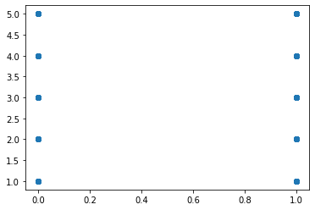

Correlation between Attrition and BusinessTravel

In [5]:



dataset['BusinessTravel'].unique().tolist()

Out[38]:

['Travel_Rarely', 'Travel_Frequently', 'Non-Travel'] In [40]:



dataset["BusinessTravel"].replace(to_replace=("Travel_Rarely" ,"Travel_Frequently", "Non-Tra vel"),value=(0,1,2),inplace=**True**)

In [18]:



stats4,p4 = pearsonr(dataset.Attrition,dataset.BusinessTravel) print("Correlation: ",stats4,"**\n** P-value: ",p4)

**if** stats4 == 0 :

print("**\n**No Correlation")

**elif** stats4 > 0 :

print("**\n**Positive correlation")

**else**:

print("**\n**Negative correlation") **if** p4<0.05:

print("Reject null hypothesis") **else**:

print("Accept null hypothesis") plt.scatter(dataset.Attrition,dataset.BusinessTravel)

Correlation: 7.377694602216824e05

P-value: 0.9960919945440154

Negative correlation Accept null hypothesis

Out[18]:

<matplotlib.collections.PathCollection at 0x7fa4538b3160>

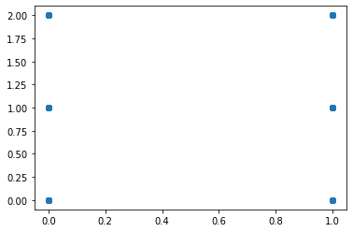

Correlation between Attrition and PercentSalaryHike

In [12]:

stats5,p5 = pearsonr(dataset.Attrition,dataset.PercentSalaryHike) print("Correlation: ",stats5,"**\n** P-value: ",p5)

**if** stats5 == 0 :

print("**\n**No Correlation")

**elif** stats5 > 0 :

print("**\n**Positive correlation")

**else**:

print("**\n**Negative correlation") **if** p5<0.05:

print("Reject null hypothesis") **else**:

print("Accept null hypothesis") plt.scatter(dataset.Attrition,dataset.PercentSalaryHike)

Correlation: 0.0325325948910535

P-value: 0.030743386433355353

Positive correlation Reject null hypothesis

Out[12]:

<matplotlib.collections.PathCollection at 0x7fa45380edd8>

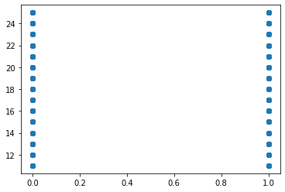

Correlation between Attrition and StockOptionLevel

In [11]:

stats6,p6 = pearsonr(dataset.Attrition,dataset.StockOptionLevel) print("Correlation: ",stats6,"**\n** P-value: ",p6)

**if** stats6 == 0 :

print("**\n**No Correlation")

**elif** stats6 > 0 :

print("**\n**Positive correlation")

**else**:

print("**\n**Negative correlation") **if** p6<0.05:

print("Reject null hypothesis") **else**:

print("Accept null hypothesis")

plt.scatter(dataset.Attrition,dataset.StockOptionLevel)

Correlation: -0.006838852403261526

P-value: 0.6498072937475723

Negative correlation Accept null hypothesis

Out[11]:

<matplotlib.collections.PathCollection at 0x7fa45377f0b8>

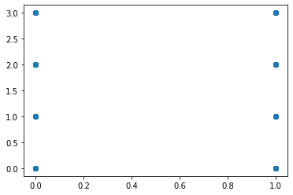

Correlation between Attrition and TrainingTimesLastYear

stats7,p7 = pearsonr(dataset.Attrition,dataset.TrainingTimesLastYear) print("Correlation: ",stats7,"**\n** P-value: ",p7)

**if** stats7 == 0 :

print("**\n**No Correlation")

**elif** stats7 > 0 :

print("**\n**Positive correlation")

**else**:

print("**\n**Negative correlation") **if** p7<0.05:

print("Reject null hypothesis") **else**:

print("Accept null hypothesis") plt.scatter(dataset.Attrition,dataset.TrainingTimesLastYear)

Correlation: -0.049430576244254974

P-value: 0.0010247061915365072

Negative correlation Reject null hypothesis

Out[19]:

<matplotlib.collections.PathCollection at 0x7fa45375b320>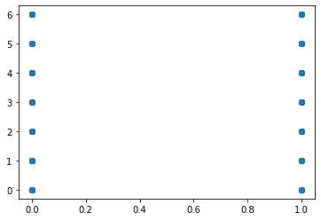

Correlation between Attrition and YearsSinceLastPromotion

In [31]:

stats8,p8 = pearsonr(dataset.Attrition,dataset.YearsSinceLastPromotion) print("Correlation: ",stats8,"**\n** P-value: ",p8)

**if** stats8 == 0 :

print("**\n**No Correlation")

**elif** stats8 > 0 :

print("**\n**Positive correlation")

**else**:

print("**\n**Negative correlation") **if** p8<0.05:

print("Reject null hypothesis") **else**:

print("Accept null hypothesis") plt.scatter(dataset.Attrition,dataset.YearsSinceLastPromotion)

Correlation: -0.03301877514258437

P-value: 0.028330336189396753

Negative correlation Reject null hypothesis

Out[31]:

<matplotlib.collections.PathCollection at 0x7fa454236438>

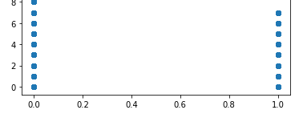

Correlation between Attrition and YearsWithCurrManager

In [6]:

stats9,p9 = pearsonr(data.Attrition,data.YearsWithCurrManager) print("Correlation: ",stats9,"**\n** P-value: ",p9)

**if** stats9 == 0 :

print("**\n**No Correlation")

**elif** stats9 > 0 :

print("**\n**Positive correlation")

## else:

print("**\n**Negative correlation") **if** p9<0.05:

print("Reject null hypothesis") **else**:

print("Accept null hypothesis") plt.scatter(data.Attrition,data.YearsWithCurrManager)

Correlation: -0.15619931590162806 P-value: 1.7339322652900218e-25

Negative correlation Reject null hypothesis

Out[6]:

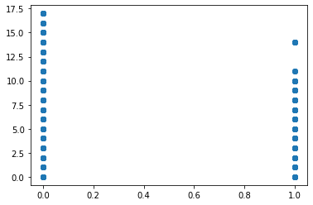<matplotlib.collections.PathCollection at 0x7fa4543d9208>