Introduction to Physical Design: OpenLane Colab Notebook
In this section, you will follow along with the Physical Design flow to generate physical IC layouts from RTL using OpenLane.
OpenLane is an open-source toolchain for physical design. At SiliconJackets, we use the Cadence suite, not OpenLane. However, following along with this flow is a good way to get an idea of what the Physical Design team does.
1. Follow this link to create a copy of the OpenLane Colab Notebook.
For in-depth information about the OpenLane flow, refer to the OpenLane reference manual.
2. Run all the steps in the OpenLane Colab Notebook. Make sure to read each part thoroughly so you understand what the Notebook is actually doing.
3. Take screenshots of your Notebook after completing each of the following steps and paste them into the answer box below.
- Floorplan
- PDN Generation
- GDS Streamout
4. Describe in your own words what the following flow steps do.
a. Floorplanning

b. Clock Tree Synthesis

c. Global Route

d. Signoff Static Timing Analysis (Post-PnR STA)

Clocking a Sequential Circuit
In this section, you’ll get an introduction to critical paths, setup times, and identifying viable clock frequencies.
Performing timing analysis on an IC with millions of transistors requires many of the same essential skills as performing timing analysis on a breadboard circuit diagram — just on a much different scale.
This section requires knowledge of some Static Timing Analysis concepts you may not be familiar with.
To learn about Setup and Hold times, see this resource.
To learn about Static Timing Analysis, see this resource or this more comprehensive resource.
1. For this question, consider the following Sequential Circuit.
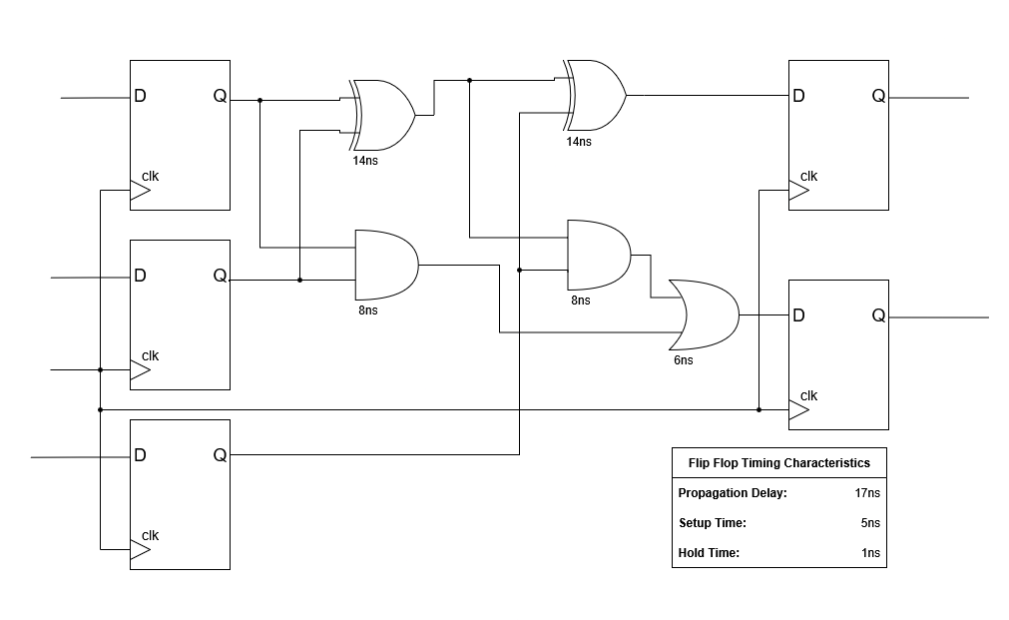

How long does it take for a signal to propagate along the circuit’s critical path?

What is the maximum viable clock frequency?

2. Explain the concepts of setup slack and hold time. Why is a negative slack value problematic?

3. Assume a timing path has a data arrival time of 5ns and a required time of 4.5ns. Is this path meeting timing? Calculate the setup slack. What if the required arrival time was 5.5ns?

Python Timing Report Analysis
In this section, you’ll get an introduction to the analysis of timing reports generated by our EDA tools using Python.
We’ve provided a sample timing report (full_paths.max.rpt) for you to analyze.
The report is too large to analyze by hand, so you’ll have to write a Python script to help parse the file data. You can use the provided template.py if you’d like.
This guide on File I/O and this guide on String processing might be good places to start if you don’t have any Python experience.
1. How many paths violated timing constraints (i.e., have negative slack)?

2. What is the average depth (or number of gates) of paths with the smallest positive slack?
Hint: In this context, “smallest positive slack” refers to paths that are passing timing, but just barely.
Answering this question might involve creating a script that extracts tuples containing each path’s slack and gate depth, then sorting the tuples by slack.

3. What is this design's operating frequency? From a timing perspective, is there potential to achieve higher performance?
Advanced Questions - please try to answer as much as you know without the use of the internet
4. This timing report comes from the signoff stage of design (after routing). What is the first issue you notice in this report?
5. How would you address the issue identified in question 4? Additionally, reconsider your answer to question 3 based on this observation.

TCL Procedures
This section focuses on the Tool Command Language (TCL), which we use to write scripts that automate aspects of running the flow.
You need to run the flow to completion before answering some problems in this section. See the RTL2GDS README in the repo for instructions on running the flow.
1. Navigate to the design/scripts directory. Choose a .tcl script in this directory and explain what it does.

2. We want to highlight an SRAM block in our design.
a. Consult the Cadence Support website to identify the Innovus commands to dim the background and highlight an object.
Use these commands in the Innovus shell to highlight an SRAM block and paste a screenshot in the box below.

b. Let's automate that process. Create a TCL proc (procedure) that takes an SRAM’s name as an input and invokes these two commands to highlight it in Innovus.
Paste or screenshot your TCL proc code here, as well as the file being sourced in the Innovus shell.

2. We can also use TCL to highlight paths in our design. This is especially useful for highlighting paths that fail timing to help us decide how to optimize our layout to improve timing.
Find and use Innovus commands that read a timing debug report and highlight the paths in the GUI. Paste a screenshot of the GUI showing failed paths in the box below.

3. Let’s automate this too. Write a TCL proc that takes in a path number as an input and highlights in the GUI.
Paste or screenshot your TCL proc code here, as well as the file being sourced in the Innovus shell.

Static Timing Analysis on our 32-bit Adder
The questions in this section involve analyzing the timing reports generated by running the flowtool in Github repository on the 32-bit adder design.
You should have already run the flow once, and you will have to run it a few more times. In case you haven’t run it yet, see the RTL2GDS README in the repo for instructions on running the flow.

4. Identify the Worst Negative Slack (WNS) from the timing summary for both setup and hold in the current design.
Hint: There are multiple ways to find this information. The file qor.html may be a good place to start.

5. Using the WNS and the clock frequency (set in the file pipeline_src/base.sdc), calculate the max frequency that the current design can theoretically run at.
Hint: Frequency is the reciprocal of period.

6. Modify the current design SDC file and rerun the flow to make the WNS at least +0.01ns. Include the screenshot of the flow summary or qor.html showing your positive WNS.

Placing Macros in Innovus
At this point, our design is meeting timing!
Does that mean our chip is ready for tape-out? No, unfortunately not.
This section will familiarize you with Design Rule Checking (DRC), another challenge we have to consider in the Physical Design process.
In this section, you will be implementing and understanding the importance of macros in VLSI design. Within your Verilog design, you instantiate SRAMs to use as memory blocks. These cannot be implemented with RTL; instead, we have to instantiate them as design macros.
For help using Innovus, see the Using Innovus guide in the docs/ directory.
1. If you haven’t already, do a complete run-through of your flow and open the final (postroute) database in Innovus.
The white markers in the design are what are known as DRC violations. DRC stands for Design Rule Checking.
Foundries supply chip designers with design rules that specify requirements the design must meet for it to be taped out. Design libraries often have hundreds of rules. Some examples are minimum spacing between elements, layer overlap, and area limitations.
These are rules the foundry supplies us with allowing us to know whether a chip can actually be manufactured. Your goal as a PD engineer should be to create a manufacturable design, and in doing so you have to correct the DRC violations you've found. Describe what you see and make some inferences about what has caused them. Additionally, provide an image of the design.
Provide a screenshot of your design’s DRC violations in Innovus, describe what they look like, and make some inferences about what has caused them.
The DRC violations can be fixed through modifications to our TCL code.
In the previous section, you learned some examples of TCL and what it can be used for. For the rest of this section, you will be trying to modify TCL code to fix some of the errors you encountered.
2. Using the Cadence Support website, look for a command to be able to manually place these SRAM instances in the design.
In the box below, provide these commands and give a brief description of why you think we are placing these macros manually instead of letting the tool decide.

3. This is one of the three distinct commands necessary to fix the DRC errors you have encountered thus far.
As you saw in the OpenLane tutorial, during the physical design flow, the tool places cells throughout the design and routes physical connections between cells in your design.
However, when your design utilizes macros, this can sometimes cause problems, as it attempts to place and route too close to the macro.
You will need two more commands to block the cells and metal layers from causing DRCs. Use Cadence Support to find the commands you are going to use and describe how they will prevent errors in your design.

4. Now that you’ve found the commands necessary to fix the DRC violations, it's time to fix them. To do this you will be taking the commands that you found and implementing them in the TCL code.
In floorplan.tcl there are two commented lines labeled with “REQUIRED”. Under each of those, add your implementations for placing your SRAMs and preventing DRC violations. Here is some helpful information for your implementation:
- Each SRAM block is 683nm x 416nm in size
- You must keep in mind that the metal 5 layer will be used to provide power to the SRAM blocks
Once you have your implementation set in the scripts, run the flow again. You can run from the floorplan step as nothing before that step has been modified.
Attach a picture of your final design without any DRC violations!

