**VISVESVARAYA TECHNOLOGICAL UNIVERSITY, BELAGAVI**



**REPORT ON DBMS MINI PROJECT(21CSL55)**

**“Project Title”**

Submitted in partial fulfillment for the award of Degree of,

**BACHELOR OF ENGINEERING**

**IN**

**COMPUTER SCIENCE &ENGINEERING**

**By**

|  |  |
| --- | --- |
| **Student Name 1** | **USN** |
| **Student Name 2** | **USN** |
|  |  |
|  |  |

**Under the Guidance of**

**Mr/Mrs/Prof./Dr. _____________________**

**Designation**



**DEPARTMENT OF COMPUTER SCIENCE & ENGINEERING**

**Accredited by NBA**

**S.S EDUCATION TRUST**

**S. G. BALEKUNDRI INSTITUTE OF TECHNOLOGY**



**2023– 2024**

**S. G. BALEKUNDRI INSTITUTE OF TECHNOLOGY**

**Shivabasavanagar, Belagavi-10, Karnataka.**



**DEPARTMENT OF COMPUTER SCIENCE & ENGINEERING**

**Accredited by NBA**

**CERTIFICATE**

This is to certify that the DBMS mini project entitled **“_________________________”** has been successfully completed by

|  |  |
| --- | --- |
| **STUDENT NAME 1** | **USN** |
| **STUDENT NAME 2** | **USN** |
|  |  |
|  |  |

the bonafide students of **DEPARTMENT OF COMPUTER SCIENCE & ENGINEERING,S. G. BALEKUNDRI INSTITUTE OF TECHNOLOGY** of the **VISVESVARAYA TECHNOLOGICAL UNIVERSITY,BELAGAVI** during the year 2023–2024. It is certified that all corrections/suggestions indicated for Internal Assessment have been incorporated in the report deposited in the departmental library. The Project Work (21CSL55) has been approved as it satisfies the academic requirements in respect of DBMS mini Project work prescribed for the Bachelor of Engineering Degree.

**Mr./Mrs./Prof./Dr. ______ Dr. B. S. HalakarnimathDr.B. R. Patagundi**

**Project Guide Head of the Department Principal**

**TABLE OF CONTENTS**

**ACKNOWLEDGEMENT**

The satisfaction and euphoria that accompany a successful completion of any task would be incomplete without the mention of people who made it possible, success is the epitome of hard work and perseverance, but steadfast of all is encouraging guidance.

So, with gratitude we acknowledge all those whose guidance and encouragement served as beacon of light and crowned the effort with success.

We thank our project guide **Dr.S F Rodd** ,Professor in Department of Computer Science & Engineering, who has been our source of inspiration. He has been especially enthusiastic in giving his valuable guidance and critical reviews.

The selection of this project work as well as the timely completion is mainly due to the interest and persuasion of my project coordinator **Mrs. Sheetal Kokatanoor,** Assistant Professor, Department of Computer Science & Engineering. We will remember her contribution for ever.

We sincerely thank, **Dr. B. S. Halakarnimath**, Professor and Head, Department of Computer Science & Engineering who has been the constant driving force behind the completion of the project.

We thank Principal **Dr. B. R. Patagundi,** for his constant help and support throughout.

We are also indebted to **Management of S. G. Balekundri Institute of Technology, Belagavi** for providing an environment which helped us in completing the project.

Also, we thank all the teaching and non-teaching staff of Department of Computer Science & Engineering for the help rendered.

Finally, we would like to thank my parents and friends whose encouragement and support was invaluable.

|  |  |
| --- | --- |
| STUDENT NAME 1 | USN |
| STUDENT NAME 2 | USN |
|  |  |
|  |  |

**ABSTRACT**

The "Student Library Management System" is a comprehensive software solution designed to streamline and automate the management of library resources in educational institutions. This project aims to provide an efficient platform for librarians and students to manage library operations effectively. The system encompasses various modules to handle tasks such as book management, student registration, book issuance, returns, and administrative functions.

Key features of the system include:

Student Registration: Enables the registration of students into the library system, capturing essential details such as student ID, full name, contact information, and login credentials.

Book Management: Facilitates the management of books available in the library, including adding new books, updating existing book information, and categorizing books based on genres or subjects.

Book Search and Availability: Provides a search interface for students to find books based on title, author, category, or ISBN number. The system also displays real-time availability status to inform students about the availability of desired books.

Book Issuance and Returns: Allows students to borrow books from the library by scanning their student ID or entering their credentials. The system records issuance details such as book ID, student ID, issuance date, and expected return date. Additionally, it manages the return process and calculates fines for overdue books.

Admin Dashboard: Offers an administrative dashboard for librarians and administrators to monitor library activities, view statistics, generate reports, and perform configuration tasks.

Notifications and Reminders: Sends automated notifications and reminders to students regarding upcoming due dates, overdue books, and other relevant announcements.

Security and Access Control: Implements robust security measures to safeguard sensitive data and restrict unauthorized access to the system functionalities.

The "Student Library Management System" enhances the efficiency of library operations, improves access to educational resources for students, and provides valuable insights for administrators to optimize resource allocation and decision-making. This project report explores the system architecture, design methodologies, implementation details, user documentation, and future enhancements to support continuous improvement and scalability of the system.

**CHAPTER 1**

**INTRODUCTION**

* 1. **PROBLEM STATEMENT**

In the physical library management system, manual processes, outdated technology, and disjointed systems lead to inefficiencies and errors. Our project aims to develop a modern library management system to automate processes, integrate systems, and enhance user experience. By automating cataloging and record-keeping, integrating systems, and implementing online access, we streamline operations, ensure data consistency, and improve accessibility. Real-time reporting and analytics capabilities empower administrators with insights for informed decision-making. Through this project, we address these challenges, transforming the library management system into a modern, efficient, and user-friendly platform.

**1.2 OBJECTIVES:**

* **Automate processes**: Develop automated cataloging and record-keeping systems to reduce manual errors and administrative workload.
* **Integrate systems**: Consolidate disparate systems into a unified platform to ensure data consistency and streamline administrative tasks.
* **Enhance user experience**: Implement online access and self-service functionalities to improve accessibility and convenience for users.
* **Enable real-time reporting**: Introduce reporting and analytics capabilities to provide administrators with insights for informed decision-making.
* **Modernize library management**: Transform the physical library management system into a modern, efficient, and user-centric platform to meet the evolving needs of librarians and users.
* **Ensure scalability and adaptability**: Design the system to be scalable and adaptable to accommodate future growth, technological advancements, and evolving user needs, ensuring its long-term effectiveness and relevance in the ever-changing library landscape.

**CHAPTER 2**

**METHODOLOGY**

**2.1 ABOUT BACKEND CONNECTION:**

**Database Layer:** This layer consists of the database management system (DBMS) where all data related to the library management system is stored. In this project, the DBMS used is MySQL, indicated by the SQL commands and structure defined for tables such as `tblbooks`, `tblstudents`, etc.

**Application Layer:** The application layer contains the business logic and application code responsible for processing user requests, interacting with the database, and generating responses. This layer can be implemented using various programming languages and frameworks. We have used PHP for server-side scripting.

**Connection Setup:**

The connection setup involves configuring the backend to establish a connection with the database management system. This typically includes:

* Database Configuration**:** Setting up the database server, creating the necessary databases and tables, and configuring user permissions and access rights.
* Backend Configuration**:** Configuring the backend application to connect to the database. This involves specifying the database host, port, username, password, and other connection parameters. In PHP applications, this is often done using functions like `mysqli_connect()` or PDO (PHP Data Objects) to establish a connection to the MySQL database.

**2.2 INTRODUCTION TO SERVER:**

To host a library management system, you need a server configured with the following components:

* Operating System: Choose a stable and secure operating system like Linux (e.g., Ubuntu, CentOS) or Windows Server.
* Web Server: Install and configure a web server such as Apache or Nginx to handle HTTP requests.
* Database Server: Set up a database management system (e.g., MySQL, PostgreSQL) to store and manage library data.
* Server-Side Scripting: Use a server-side scripting language like PHP, Python, or Node.js to build the backend logic of the system.
* Backup and Monitoring: Set up regular backups of data and monitor server performance to ensure reliability and availability.

**2.2 SQL**

**CHAPTER 3**

**SYSTEM REQUIREMENTS AND SPECIFICATIONS**

**3.1 SOFTWARE REQUIREMENTS:**

.

**3.1 HARDWARE REQUIREMENTS:**

**Server Hardware (for Deployment):**

Processor: Dual-core or higher for handling server operations efficiently.

RAM: At least 4GB, though 8GB or more would be beneficial for smoother performance.

Storage: 512 SSD storage for faster read/write operations.

Network: Stable internet connection for serving requests to client devices.

**CHAPTER 3**

**SYSTEM DESIGN**

**3.1 ER DIAGRAM**

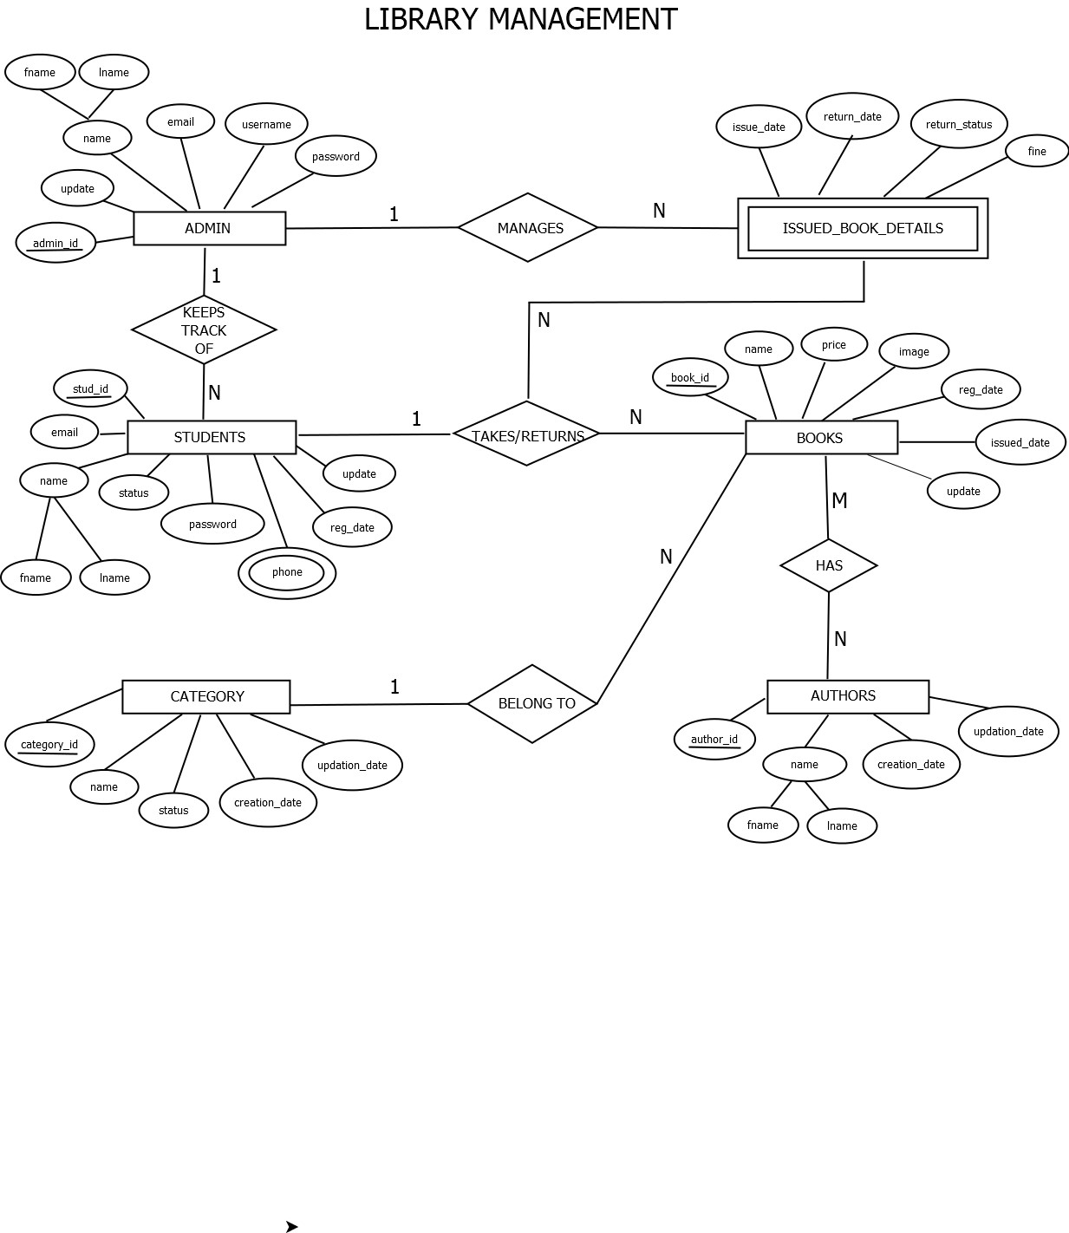

**3.2 SCHEMA DIAGRAM:**

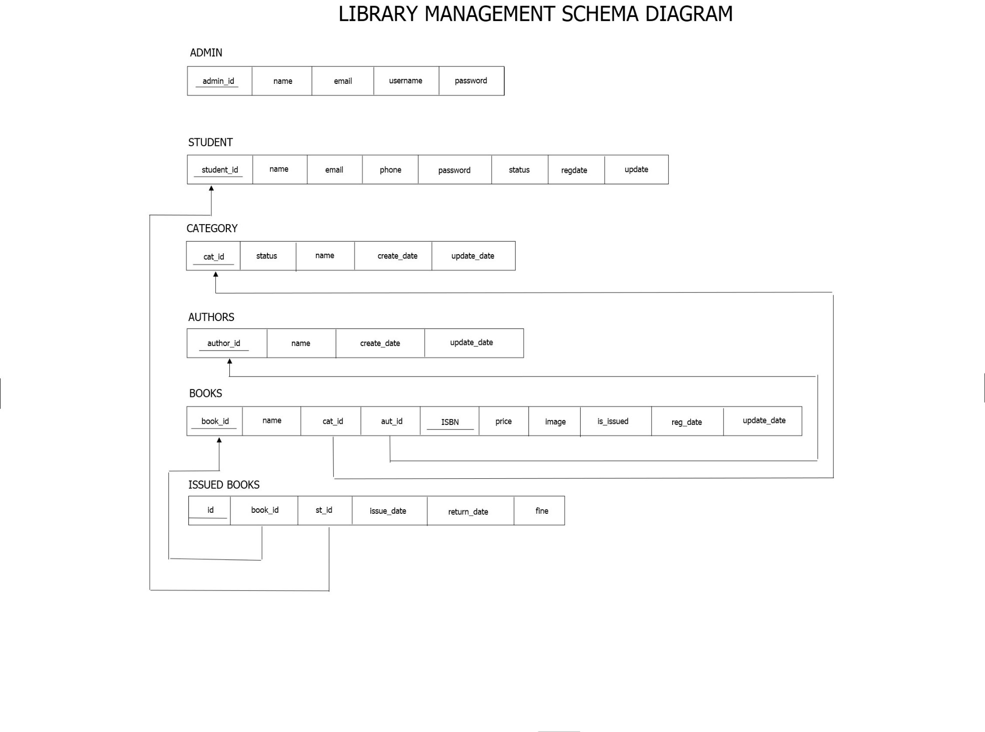

* **Admin:-** Primary Key: id
* **Books:-** Primary Key: id

Foreign Key: Admin_id (refers to Admin's id)

Foreign Key: Category_id (refers to Category's id)

* **IssuedBookDetails:-** Primary Key: id

Foreign Key: BookId (refers to Books' id)

Foreign Key: StudentID (refers to Students' id)

* **Students:-** Primary Key: id
* **Category:-** Primary Key: id
* **Authors:-** Primary Key: id

**CHAPTER 4**

**IMPLEMENTATION**