GITVerse

GITVerse System Design

STATUS  Draft |  | OWNER  Project maintainer |  | LAST UPDATED  November 10, 2026

Authors | GITVerse
Reviewers | Not assigned
Related docs | RELEASING.md and source contracts
Scope | Desktop architecture and Git workflows.

1. Abstract
GITVerse is a desktop Git client built with Electron, React, TypeScript, Vite, and Zustand. The renderer shows history and working changes; preload exposes named APIs to the main process, where Git runs through the system CLI. Preferences and remembered tabs stay local.
The app supports local repositories, paginated history, working changes, and cancellable scans. Repository-size targets and production SLOs are not defined; lazy loading reduces some UI work but does not establish supported scale.

2. Goals and Non-Goals
Goals | Non-goals
Keep Git and filesystem work behind the Electron main-process boundary. | Implement a hosted Git server or remote repository mirror.
Make history and working-tree state reviewable without loading all history by default. | Guarantee a maximum supported repository size; no such limit is measured.
Validate stale snapshots and explicit leases before risky Git mutations. | Run arbitrary shell commands through the Copilot SDK integration.
Package the app for the configured Windows, macOS, and Linux targets. | Silently replace application binaries or block use for an optional update.

3. Background and Problem Statement
GITVerse is a single-user desktop app. Its key constraint is coordinating Git history and working-tree state while keeping filesystem and process access out of renderer code. Supported repository size and latency targets are not measured.
Renderer requests pass through preload to main-process services. Git state stays in the selected repository; preferences and remembered tabs use app-local JSON. Network paths are Git remotes, user-invoked AI, and packaged release checks. Keep mutations in main and recheck snapshots before destructive writes.

4. Proposed Architecture

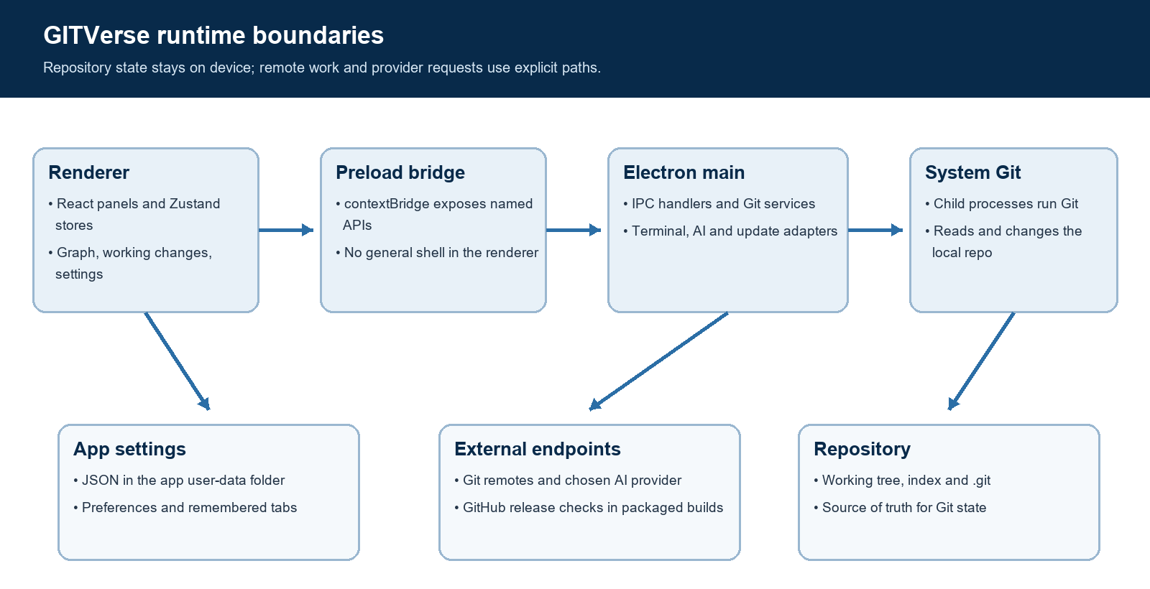
Figure 1. Data and process boundaries in the current application.

Core components

Component | Responsibility | Primary storage | Failure behavior
Renderer and stores | React panels and Zustand coordinate repositories, graph, changes, settings, and AI state. | In-memory UI; settings bridge. | Bridge failure blocks startup with recovery; request errors return to UI.
Preload bridge | contextBridge exposes named Git, repository, terminal, AI, update, and state methods. | No repository datastore; forwards IPC. | Rejected calls surface to the UI; renderer has no direct Node access.
Git services | Main-process services run history, refs, status, merge, stash, and file operations. | System Git, worktree, index, and .git directory. | Errors reach the user; destructive actions recheck status and diff snapshots.
Local state and scans | Persists preferences and remembered tabs; scans folders iteratively with progress and cancellation. | gitverse-state.json; active scan sessions in memory. | Corrupt/missing settings fall back to defaults; root scan errors surface and child errors are counted.
AI, terminal, updates | Routes provider requests, integrated terminal processes, and release checks. | Encrypted user-data secrets, process handles, provider and release endpoints. | Errors are feature-level; scans can cancel; release checks are packaged-app only.

5. Request Lifecycle
- A user opens a local repository, clones from a supplied Git URL, or selects a repository and Git action. Each request carries the active repository path and any operation-specific inputs.
- Renderer calls named preload methods; main receives the IPC request. Helpers validate branch names, paths, operation state, and destructive snapshots as needed. The bridge is not a general shell.
- Services read current refs/status, Git config, preferences, credentials, or release metadata only when needed. Repository history and status come from local Git.
- Main-process Git services run the system CLI; Zustand coordinates history, selection, conflicts, working state, and feedback.
- Git writes repository state through Git. App settings use a JSON file in user data, written through a temporary file and rename.
- Clone and scans report progress; scans can cancel. Errors are operation-specific, with no shared retry or request-budget policy.
- Results update the renderer and activity feedback. Visible-window polling compares status, refs, and operation state, reloading history only when needed. No centralized telemetry or production SLOs are defined.

6. API and Data Contracts

Primary data contract

Field | Type | Required | Description
repoPath | Absolute path | Yes | Selects the local repository scope for a Git operation.
FileStatus | path, index, worktree, oldPath? | Yes | Porcelain status record; index and worktree codes remain independent.
area | staged | unstaged | untracked | For file diff | Identifies which current Git view the diff request addresses.
expectedDiff | UTF-8 diff text | For discard | Must match a freshly read diff; stale snapshots are rejected before mutation.
expectedRemoteHash | 40- or 64-digit hex | For force push | Lease value for the selected remote branch; required for a forced update.
ScanProgress | scanned, repositories, skipped, folder | During scan | Progress event scoped to the requesting renderer's scan session.
AppUpdateCheck | development | current | optional | error | Yes | Typed update state; only packaged apps query releases.

Contract guarantees

- Before a discard, the main process rechecks operation state and the current file diff against the displayed snapshot. A mismatch fails before a write; tracked discard restores the worktree and keeps the index.
- Git object IDs identify commits and stash snapshots. Repository paths scope Git operations. Force push uses an explicit expected remote hash with --force-with-lease for the selected branch.
- Discard captures the file path, working-change area, and diff snapshot. Force push captures the target ref and expected remote hash. The app does not provide a general event-replay system.
- The working tree and .git database are authoritative for repository state. The app JSON file stores UI preferences and remembered repositories, not a second copy of commit history or files.
Shared IPC contracts are maintained in
src/shared/types.ts, src/shared/updates.ts, and src/shared/repositoryScan.ts; keep them aligned with preload and main-process handlers.

7. Consistency, Idempotency, and Replay

The app treats Git as the authority and uses fresh status or diff snapshots before risky writes. Repository actions are not globally transactional: after a successful push, for example, a later fetch can fail while the local history still refreshes. Async responses are guarded against repository changes in key flows; there is no cross-machine event replay.
Scenario | Expected behavior | Reasoning
Displayed file changed before discard | Fresh status and diff mismatch stops the write and asks for refresh. | Prevents stale UI from discarding a different version of a file.
Repository or operation state is invalid | Git helper returns an error; caller reports it and does not show success. | Avoids treating an invalid or conflicted operation as complete.
Push succeeds but follow-up fetch fails | Keep the local history refresh and show a separate fetch warning. | The remote push may already be complete; retrying the whole operation could repeat a side effect.
Repository changes during async work | Key store flows ignore results when the active repository no longer matches. | Prevents late responses from updating the wrong repository view; not a global transaction guarantee.

8. Security and Privacy Considerations

- Electron enables context isolation and exposes the Git API through preload. Git services and credentials stay in the main process. Repository data remains local except for Git remote operations and user-invoked AI requests.
- Git remotes can be fetched in the background (one minute by default, configurable or disabled). Push and pull contact the configured remote. AI requests send user-selected context to the chosen provider when invoked; update checks run only in packaged builds. The source documents no central telemetry backend.
- Secrets use Electron safeStorage encryption in the app user-data file. If OS-backed encryption is unavailable, the app refuses to save a secret and directs the user to an environment variable. Plain preferences are stored separately in the same local JSON store.
- Destructive file actions validate current state and displayed diffs; force push requires an expected remote hash. Update URLs are restricted to the configured release repository. The Copilot integration is described in Settings as a technical preview limited to Git tools.
- The source documents local settings persistence and encrypted credential storage but no retention schedule, telemetry export, or deletion policy for provider-side data. Review the selected provider's data terms before sending repository context.

9. Operational Readiness
Signal | SLO or alert | Owner | Launch gate
Git operation result | No production rate or latency SLO is defined in the repository. | Not assigned in source. | Set measurable targets before public rollout.
History and scan latency | Lazy history loading and scan progress/cancel exist; numeric targets are not defined. | Not assigned in source. | Benchmark representative repositories.
Provider, network, and Git errors | Operation-specific errors are shown; no shared error-rate threshold is defined. | Not assigned in source. | Verify the failure UI in each packaged provider flow.
Update and package integrity | Release URLs are validated against the configured repository; signing is not configured in this build. | Project maintainer. | Confirm platform signing and release provenance.
State recovery | App state writes use temp file plus rename; no backup/restore contract is documented. | Project maintainer. | Test corruption and recovery behavior before wider release.
Rollout constraint: validate with disposable repos, CI, packaged smoke, and the agreed platform matrix before broader release.

10. Alternatives Considered

Alternative | Why it was considered | Why it was not selected
Run Git in renderer | Fewer process boundaries and direct call sites. | Would place privileged Git and filesystem work in renderer code; current design keeps it in main.
Embed a Git implementation | Could standardize the Git version across installations. | Current product uses configured system Git and its user environment; embedding adds another runtime to package and support.
Load complete history by default | Simpler graph query and no page transitions. | Can make large repositories expensive; current settings use lazy history by default.
Automatic binary replacement | Could reduce manual upgrade steps. | Current release flow offers optional release access and platform-specific download behavior, with no auto-replacement or minimum-version block.

11. Open Questions
- Which repository sizes and history-loading latency should define the supported workload?
- What user-facing data-retention guidance should accompany AI requests that include repository context?
- Which Windows, macOS, and Linux versions and native-module combinations are supported release targets?
- Who owns code signing, third-party license exceptions, release monitoring, and recovery guidance?

12. Decision and Next Steps
Recommendation: retain the local repository as the source of truth and keep Git mutations behind the main-process API. Complete the stale-state recovery and accessibility work, validate it in disposable repositories, then run CI and packaged smoke checks. The repository does not identify a production audience, rollout date, owner, or SLO; agree those before treating a build as a broader release.
Milestone | Deliverable | Exit criteria
M1 | Stale-state recovery and keyboard navigation | Lint, format, unit tests, and targeted UI states pass.
M2 | Packaged workflow validation on disposable repositories | Folder open, branch safety, diffs, and working changes pass without touching user data.
M3 | Release candidate and license review | Supported targets, notices, signing plan, and recoverable update path are documented.
M4 | Broader distribution decision | Maintainer sets audience, platform matrix, support route, and measurable operational goals.

The working tree and .git database are authoritative for repository state; the app JSON stores preferences and remembered tabs.

