**PRIME COLLEGE**



**LAB REPORT**

**ON**

**Software Project Management**

**Submitted By: Submitted To:**

Praphul Raj Vaidya Sravan Ghimire

BIM 8rd Sem

Symbol No. : 10154/19

Microsoft Project Professional

Microsoft Project Professional 2016 is a professional business tool that helps create business projects in collaboration with others. It comprises all Project Standard features, and also resource management, collaboration tools, time-sheets, SharePoint task sync, etc. Microsoft Project is one of the Microsoft’s most successful products, and different versions of the software have helped project professionals and teams across businesses and industries. Microsoft Project is one of the Microsoft’s most successful products, and different versions of the software have helped project professionals and teams across businesses and industries.

Features of Microsoft Project Professional 2016

* Create Resource Engagement

This function allows project managers to secure the necessary resources efficiently, or people, a project needs to be completed and have an up-to-date status of all their requests at any time. By creating a resource engagement, a project manager can request resources and lock them down once approval has been given to prevent a resource from being used simultaneously by another project manager. This simplified workflow allows those in charge of resource allocation to approve or reject the request without extra steps.

* Refined Resource Manager Experience

The resource manager also gets a new and improved interface from which to allocate resources as necessary, allowing for an overview of capacity utilization so he or she can make an informed decision about whether to approve a resource for use or not. A new feature for Project Online lets resource managers view proposed resource allocations easily for approval or rejection.

* Improved Timelines

The overhauled Project 2016 timeline feature now allows managers to add multiple timelines with separate start and end times as well as different task milestone to be completed. With this new system in place, a manager can have a realistic view of how and when different parts of a project will be completed. Other new features include drag-and-drop functionality and saving to PowerPoint with editable objects.

Lab 1 Question

Construct a Gantt chart and network diagram for a project whose activities, duration and their predecessor relationship are given in the table below. Also find the critical path.

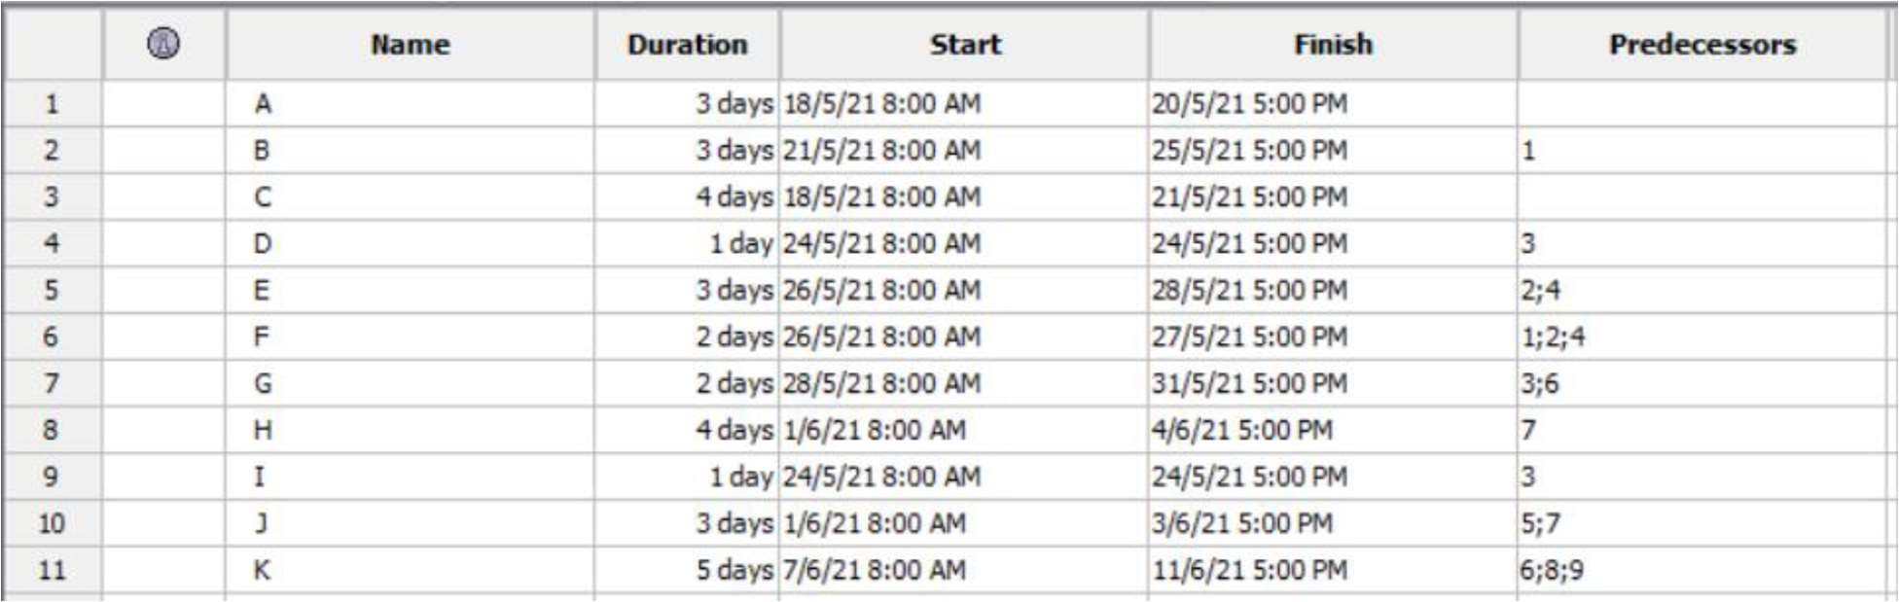

**Gantt Chart**

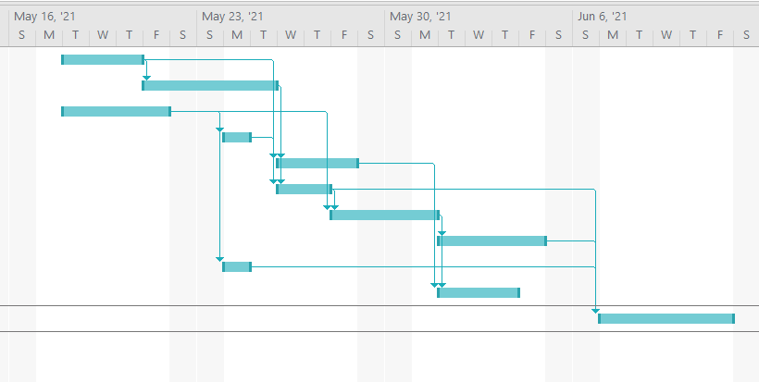A Gantt chart is a project management tool that illustrates work completed over a period of time in relation to the time planned for the work. It typically includes two sections: the left side outlines a list of tasks, while the right side has a timeline with schedule bars that visualize work. The Gantt chart can also include the start and end dates of tasks, milestones, dependencies between tasks, and assignees.

**Network diagram**

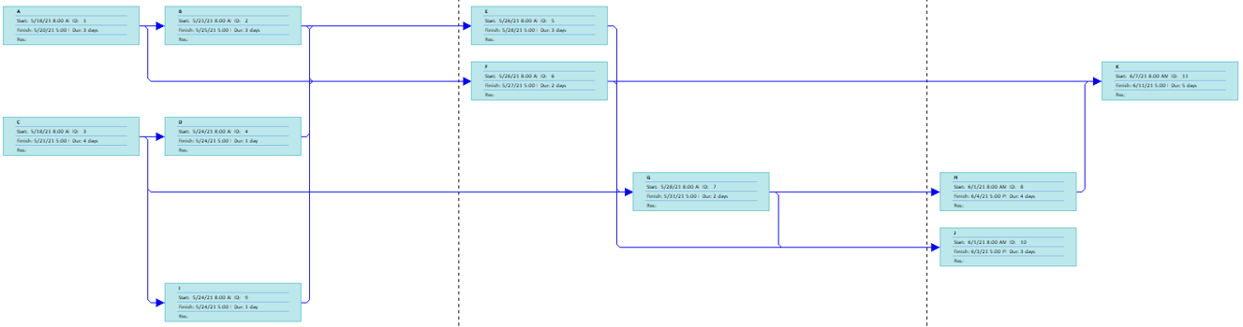A network diagram is a schematic that shows all the tasks in a project, who is responsible for them and the flow of work that is necessary to complete them. In other words, they help visualize the project schedule. Like the PERT chart, it’s also made up of arrows and nodes that show the course of tasks through the life cycle of a project. It can be used to track progress and scope once a project has been executed. Network diagrams can be used to visualize the order in which task sequences and workflows should be completed. But the main difference between them is that network diagrams lack the information that’s needed for project planning or project scheduling such as task due dates or duration.

**Critical path**

In project management, the critical path is the longest sequence of tasks that must be completed to execute a project. The tasks on the critical path are called critical activities because if they’re delayed, the whole project completion will be delayed. To find the critical path, project managers use the critical path method (CPM). The critical path method is a project management technique that’s used by project managers to create an accurate project schedule.

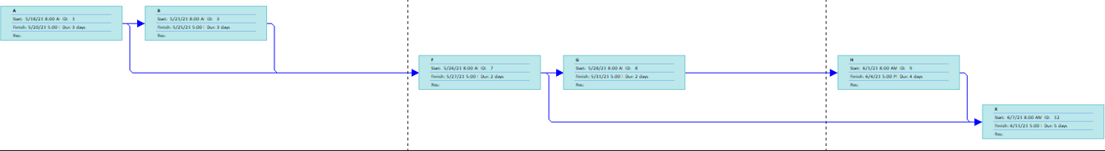

Lab 2 Question

Construct a Gantt chart and network diagram for a project whose activities, duration and their predecessor relationship are given in the table below. Also find the critical path.

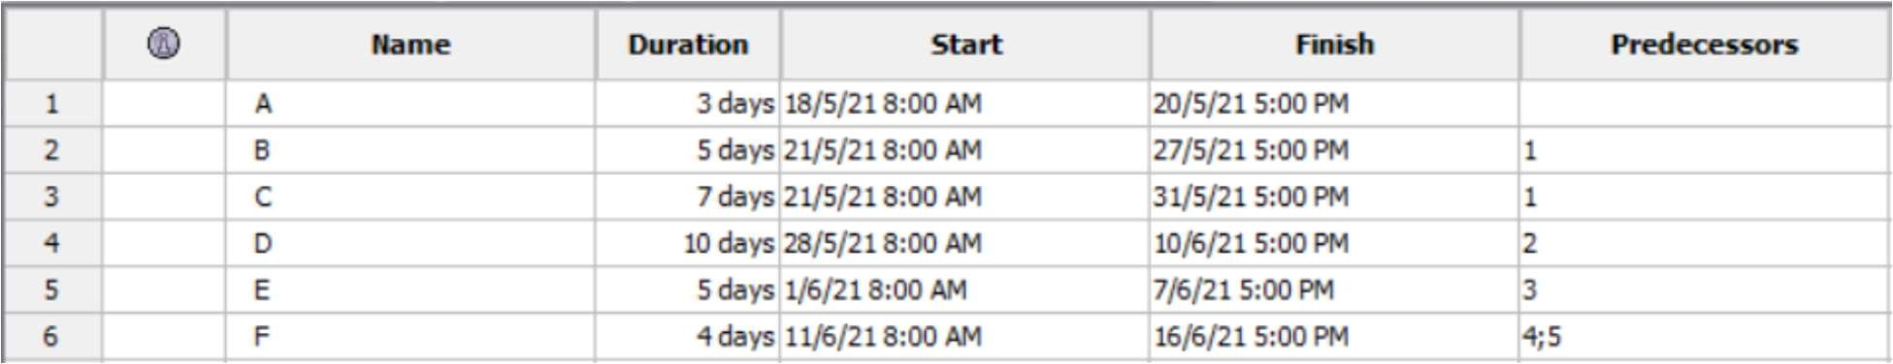

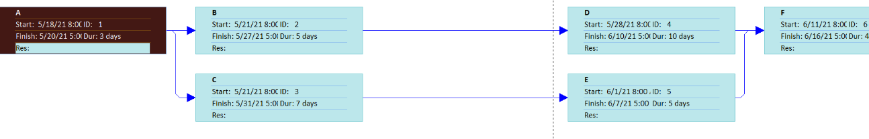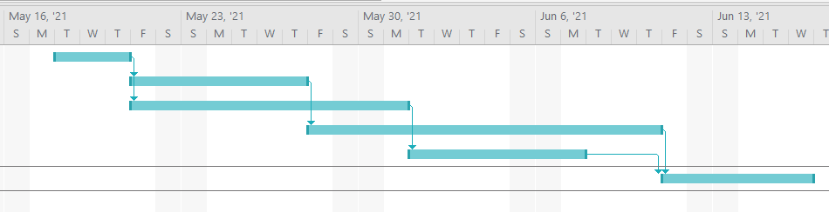**Gantt Chart**

**Network diagram**

 **Critical path**

Lab 3 Question

From the data given in the table below, construct the Gantt chart, Network diagram and find the critical path.

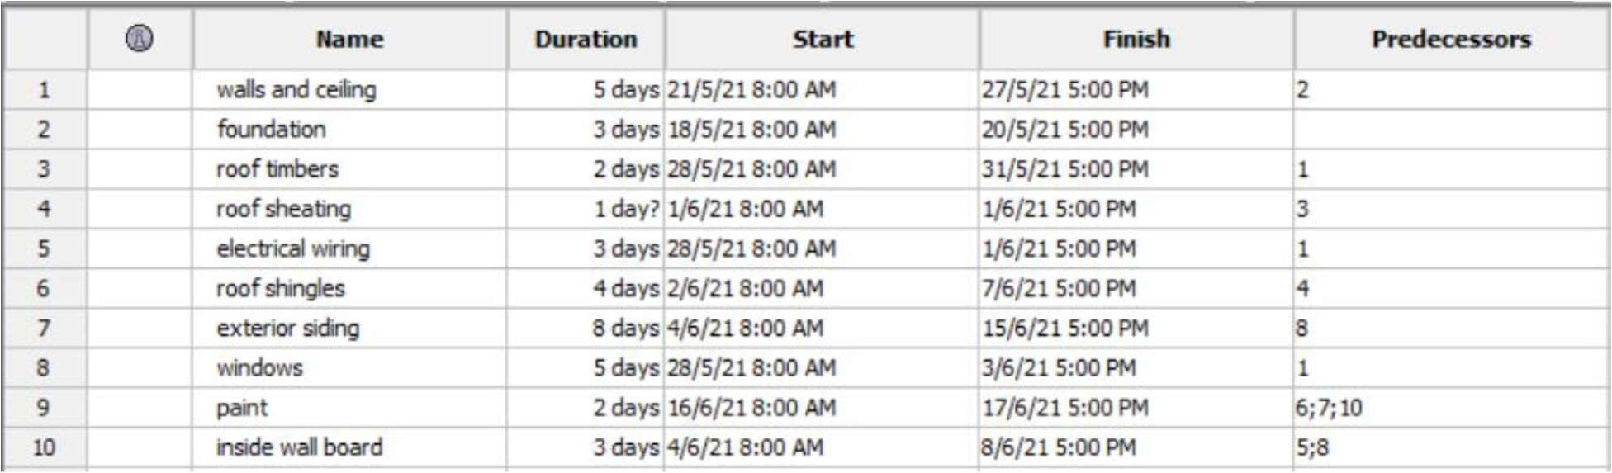

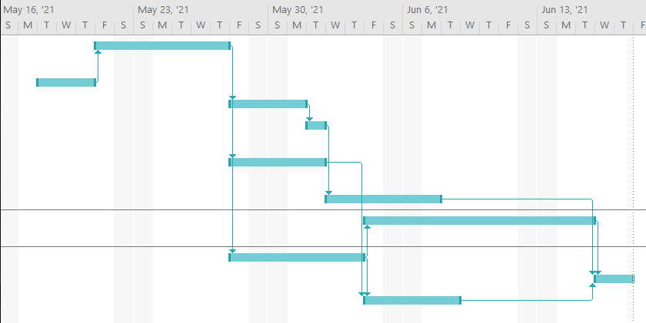**Gantt Chart**

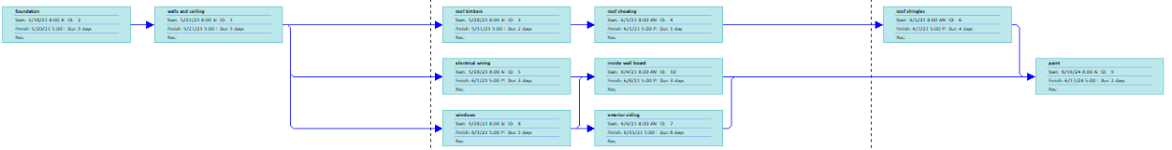**Network diagram**

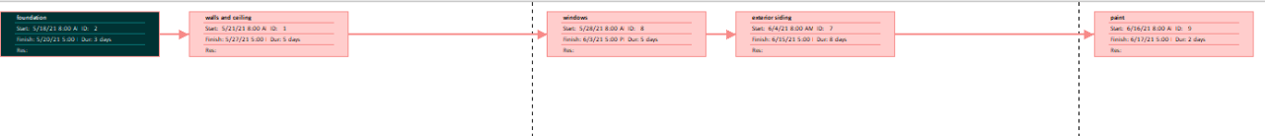**Critical Path**

Lab 4 Question

From the data given in the table below, construct the Gantt chart, Network diagram and find the critical path.

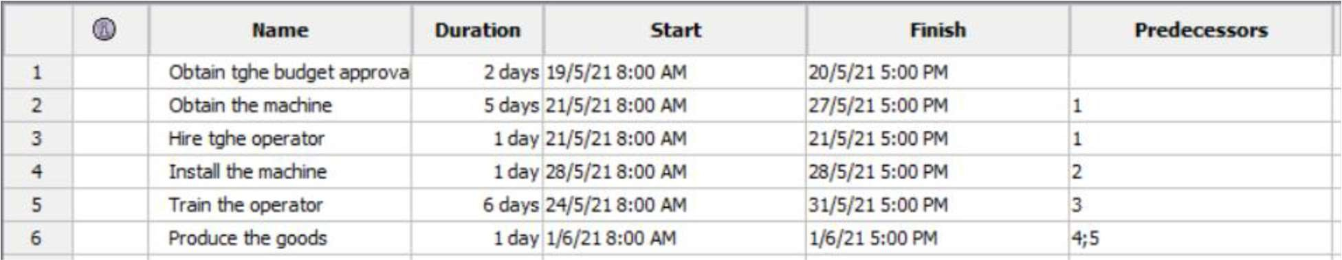

**Gantt Chart**

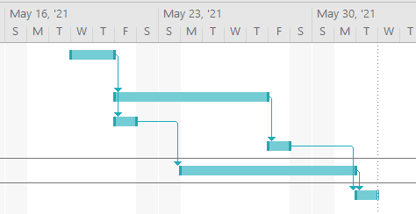

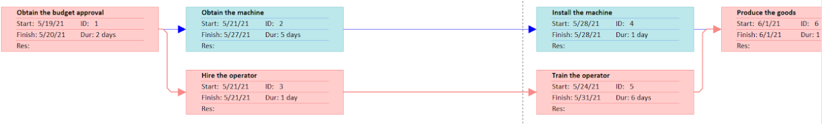 **Network diagram**

**Critical Path**

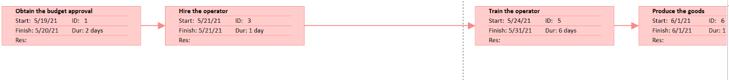

Lab 5 Question

Construct a Gantt chart and network diagram for a project whose activities, duration and their predecessor relationship are given in the table below. Also find the critical path.

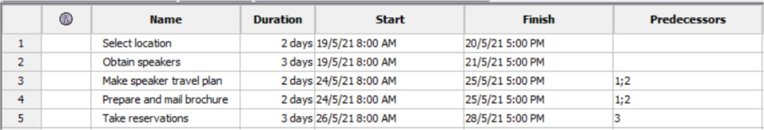

**Gantt Chart**

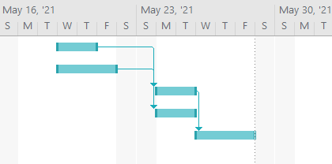

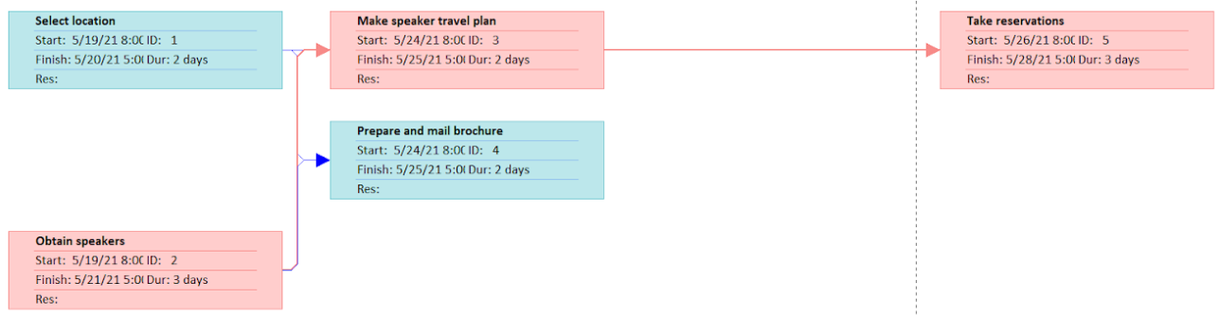**Network diagram**

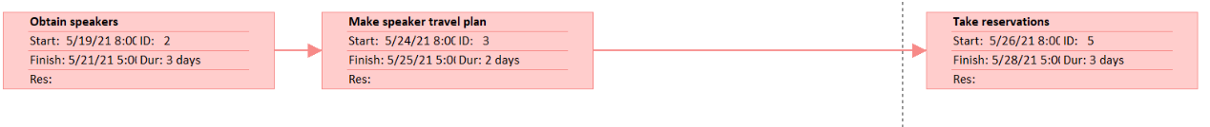**Critical Path**

Lab 6 Question

Create a git repo, clone any project from any repo then push your 1st project on that repo again create a new project and pull from that repo also create a branch.  
Git command o/p   
Push command o/p

**Github**

GitHub is an online software development platform. It's used for storing, tracking, and collaborating on software projects. It makes it easy for developers to share code files and collaborate with fellow developers on open-source projects. GitHub also serves as a social networking site where developers can openly network, collaborate, and pitch their work. Since its founding in 2008, GitHub has acquired millions of users and established itself as a go-to platform for collaborative software projects.

