**How to add external tables using csv and txt file:**

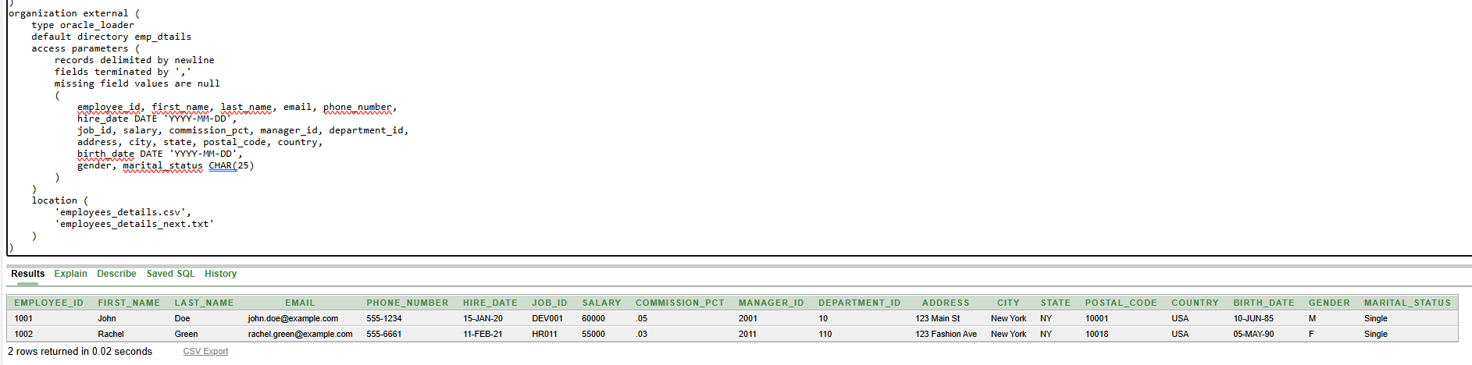

**Selecting all directories:**

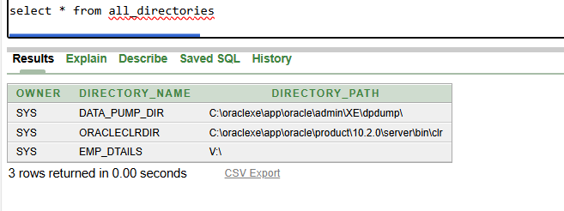

**When working on external tables the most commonly used format is CSV**

**Droping directories is possible only,when we have DROP ANY DIRECTORY privilege access:**

**drop directory directory_name;**

**still,** **this command only removes the reference in Oracle, not the actual folder on the filesystem.**

**If you want to move data from external to permanent table:**

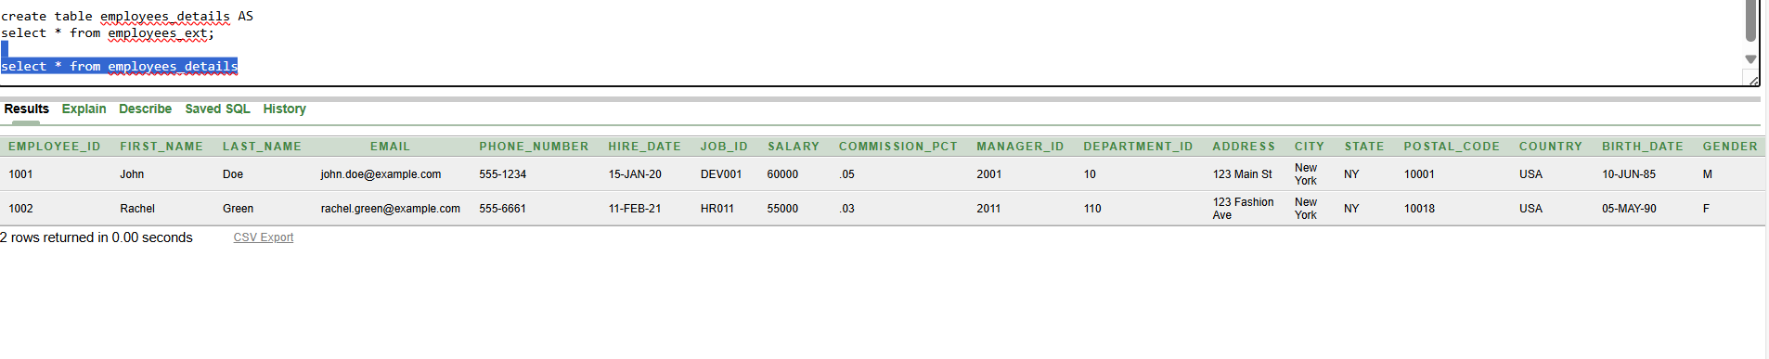

**Now employees_details is a normal Oracle table.**

**To check current users privileges:**

