**1.find the 2nd highest salary using subquery and display all details?**

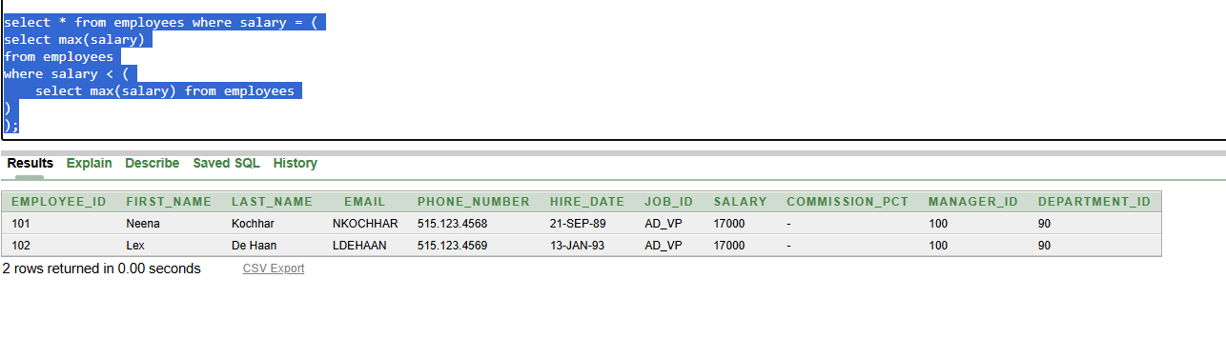

**2.** **who are all get highest salary from department wise using multi column subquery?**

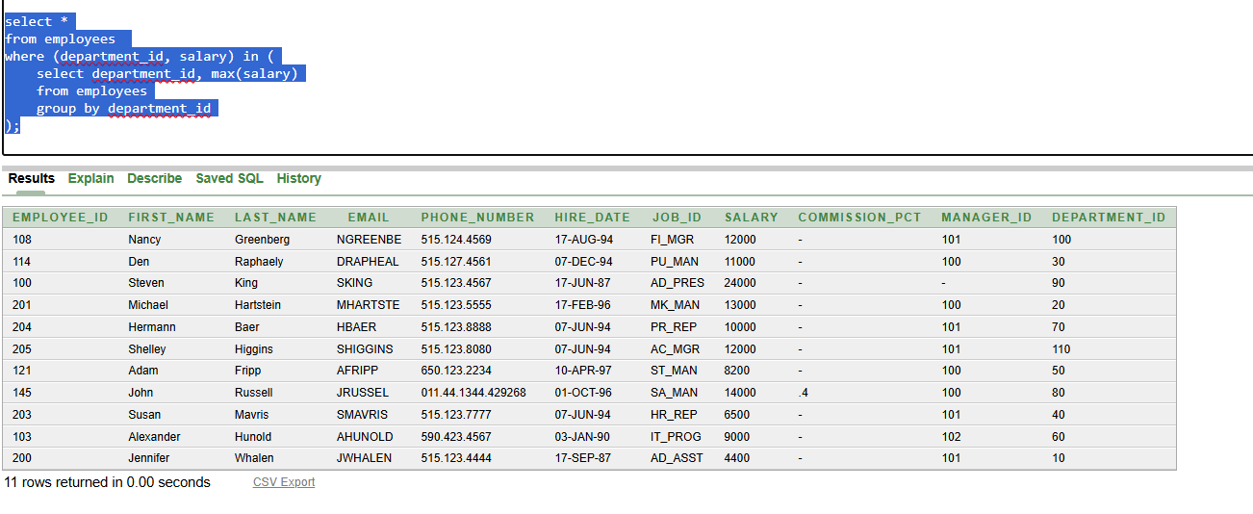

**3.** **current salary of employees, max_salary and min_salary of employees and display first_name,salary,max_salary,min_salary?**

