**1.need to print *** in before and after string using lpad &rpad**

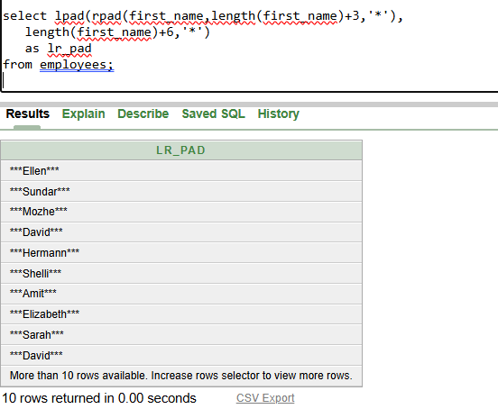

**lpad,rpad(string, total_length,pad_string)**

**Explaination: for ellen**

**Inner fn execute first rpad(ellen,5+3=8,’*’) ans = ellen\*\*\***

**Then in lpad(ellen*** as a string, 5+6=11,’*’)=***ellen\*\*\***

**here updated rpad string length became 8 so we adding +6 in actual string to tally rpad additional +3**

**output:**

**\*\*\*ellen\*\*\***

**2.** **create table in the name of emp add a column in name of**

**NAME insert 3values print words in between 2 and 3 (A)?**

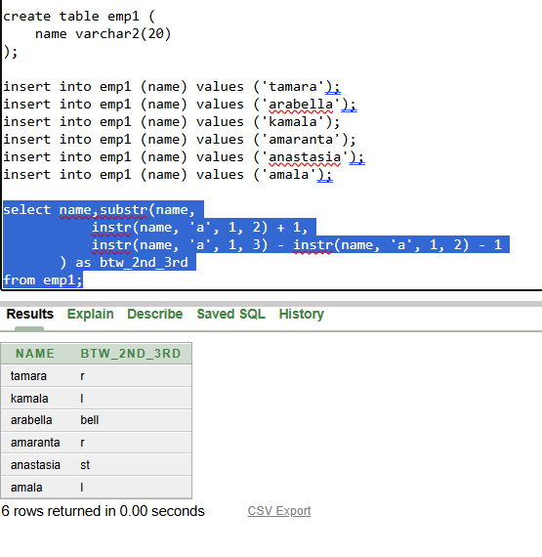

**Explaination:**

**For tamara first we execute inside substr to find first position and length of the string so,**

**Syntax of substr:**

**Substr(string, first_position, length)s**

**Finding First_position:**

**we use instr,syntax**

**Instr(string, substring, start_pos, occurance):**

**Instr(tamara, ‘a’, 1 , 2) 🡺pos = 4 but we need next value of a so +1**

**First_position = Instr(tamara, ‘a’, 1 , 2) +1 = 4+1 = 5**

**Length:**

**Logic: (3rd pos - 2ndpos - 1) 🡺to find length of the string in between**

**instr(tamara, ‘a’, 1, 3) - instr(tamara, ‘a’, 1, 2) - 1 = 1**

**6 - 4 - 1 = 1**

**So finally we got substr(tamara, 5,1)**

**Output:**

**r**