1. **Try to print others by using case statement:**

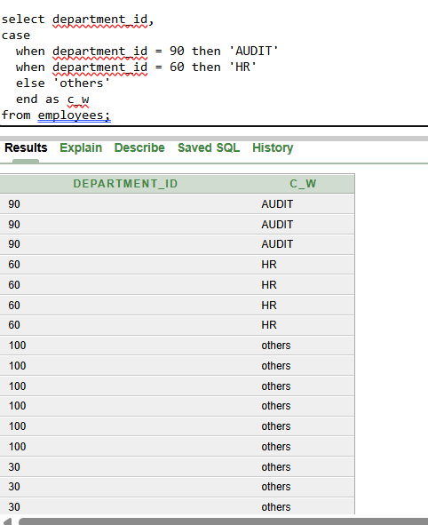

1. **print the first_date of the month**

