**1.create table and change table name ,update,commit,delete,rollback concepts?**

**After created and alter inserted in table:**

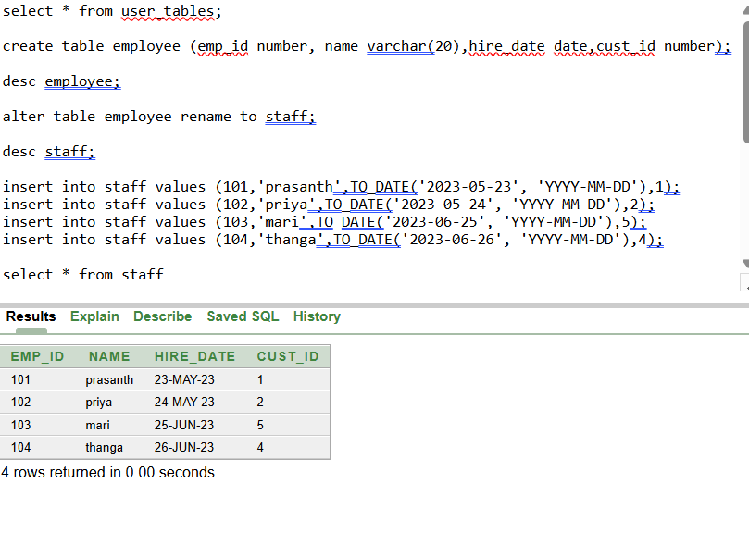

INSERTED VALUES IN TABLE

**Updated cust_id=3 value in staff table:**

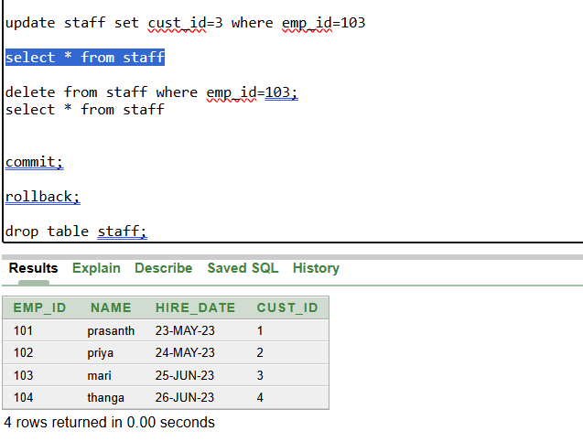

UPDATED VALUES

**Commit the table after updating:**

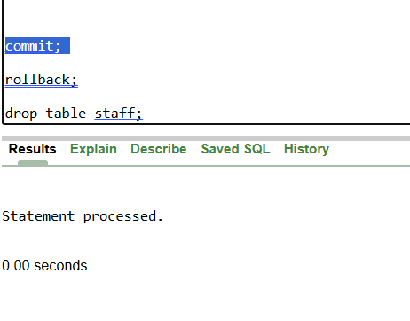

**Delete the emp_id =103 in table:**

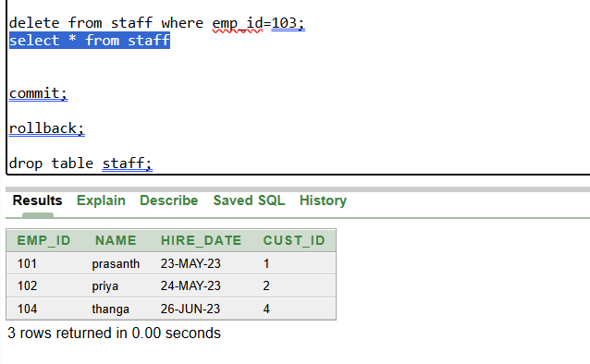

DELETED 103 ROW

**Rollback is to retrieve deleted data from table but before there shouldn’t be commited otherwise rollback wont comes in play…**

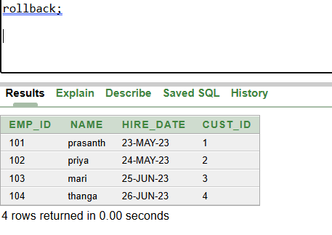

RESTORED EMP_ID=103;

**2.create table and checking how its works:**

**create table student(id number,name varchar(20),subject varchar(20),marks number); (table created comes under DDL so AUTOCOMMIT )**

**insert into student(id, name,subject,marks) values (1001,'jyo','maths',80)(table insert comes under DML so no autocommit)**

**insert into student(id, name,subject,marks) values (1002,'pras','maths',85) (table insert comes under DML so no autocommit)**

**insert into student(id, name,subject,marks) values (1003,'master','maths',90) (table insert comes under DML so no autocommit)**

**select * from student;**

**create table student1(id number,name varchar(20),subject varchar(20),marks number); (table created comes under DDL so AUTOCOMMIT )**

**insert into student1(id, name,subject,marks) values (1001,'jyo','maths',80) (table insert comes under DML so no autocommit)**

**insert into student1(id, name,subject,marks) values (1002,'pras','maths',85) (table insert comes under DML so no autocommit)**

**truncate table student1;(TRUNCATED ONLY MENTIONED TABLE STUDENT1)**

**select * from student1;**

**rollback;(HERE TABLE1 INSERTION IS NOT COMMIT SO IT WILL ROLLBACK TO EMPTY FOR STUDENT TABLE AND ANOTHER TABLE ALREADY TRUNCATED….)**

**create table student2(id number,name varchar(20),subject varchar(20),marks number); (table created comes under DDL so AUTOCOMMIT )**

**insert into student2(id, name,subject,marks) values (1001,'jyo','maths',80) (table insert comes under DML so no autocommit)**

**insert into student2(id, name,subject,marks) values (1002,'pras','maths',85) (table insert comes under DML so no autocommit)**

**commit; (HERE STUDENT2 TABLE IS COMMIT)**

**select * from student2;**

**SO, FINALLY**

**STUDENT TABLE ROLLBACK**

**STUDENT1 TABLE TRUNCATED**

**STUDENT2 TABLE COMMIT**