**1.check wheather we can use multiple constraints in single column?**

**Yes, you can apply multiple constraints to a single column**

**Ex;**

**CREATE TABLE employees (**

**emp_id INT PRIMARY KEY,**

**email VARCHAR(100) NOT NULL UNIQUE,**

**salary DECIMAL(10, 2) NOT NULL CHECK (salary > 0)**

**);**

**Here Common column-level constraints you can combine:**

**Not null**

**Unique**

**Default**

**Check**

**But here,primary key should be in for one field only and that should associate with reference foreign key if needed**

**So, we cant use multiple primary key in single column,, remaining keys we can use multiple times**

**Composite Primary Key: we have this key to use one or more column to identify unique values….**

**PRIMARY KEY (student_id, course_id)**

**Here, student_id cant able to find unique value so we associate with another course_id to filter perfect unique value**

**2.create two table using constraints associated?**

**Create order table and insert value:**

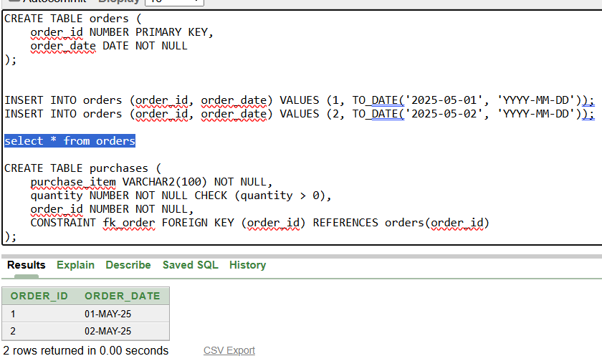

**Create purchase table and insert values:**

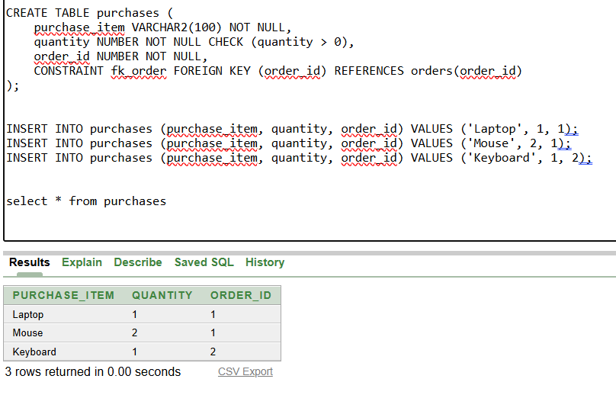

**Check whether primary and foreign key associated correctly**

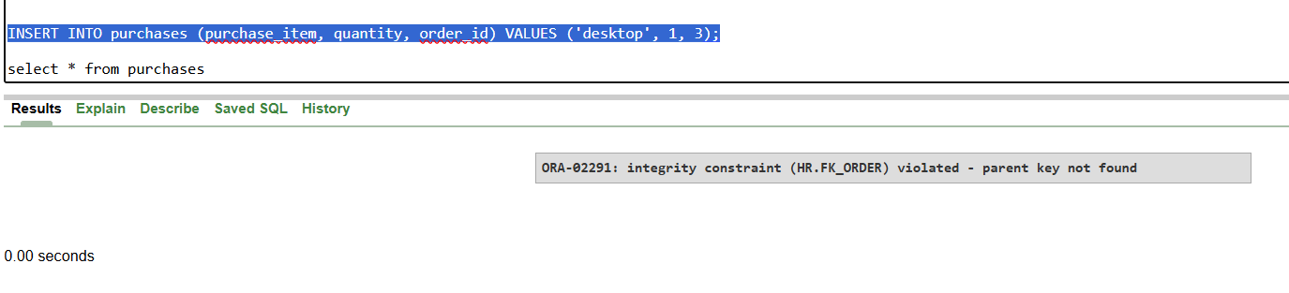

**Here, I change purchase order_id to 3 which is not in primary key orders table errors:parent key not found**

**So,here confirmed foreign key is reference to primary key order table and if we want to use that means their should be common id with unique value association is must**