**1.create user access from hr to user, user to user1 and access hr tables from user1?**

**Create hr to user(prasanth):**

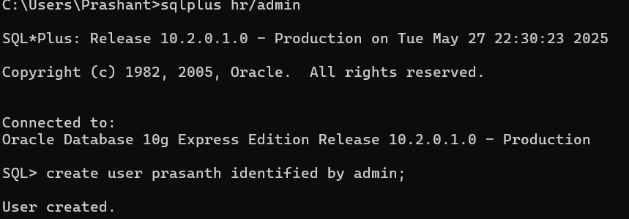

**Grand access:**

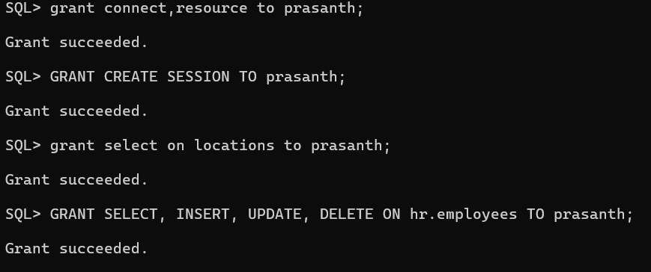

**create user1(mari) from user(prasanth)**

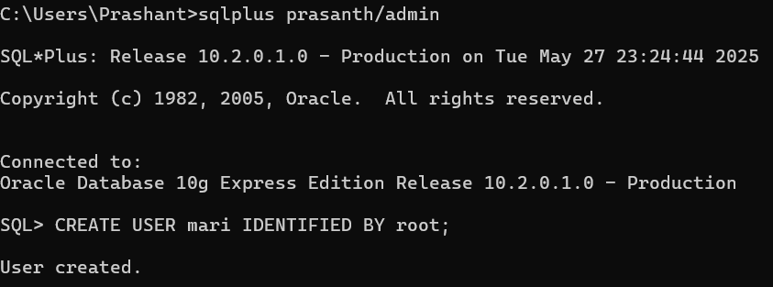

**But to start session for user1(mari) I used PRIVILEGE option to user(prasanth):**

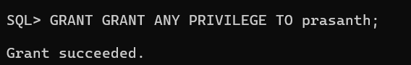

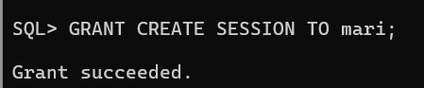

**Now from user(prasanth) to user1(mari) successfully connected:**

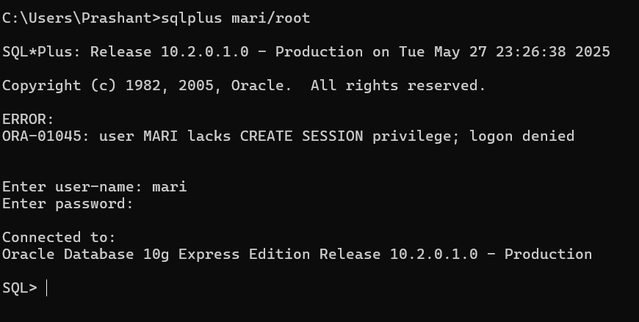

**Now task is to access hr table to user1(mari):**

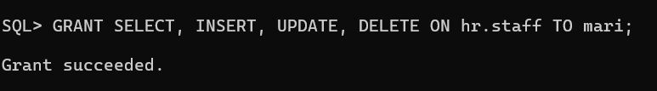

**Here I deleted and rollback data of hr.staff table in user1(mari):**

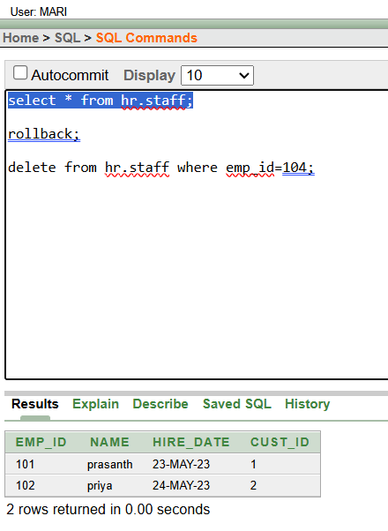

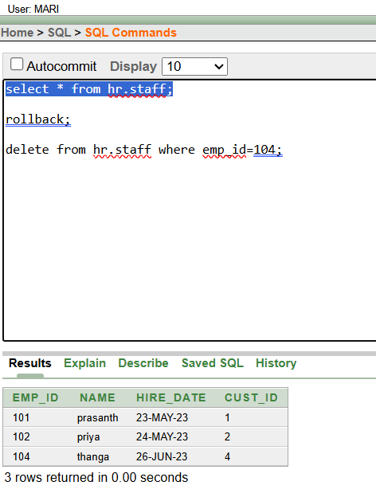

**So,successfully accessed hr table using user1(mari)**

**2.how to drop or delete user in database?**

**Here 3 users I have :**

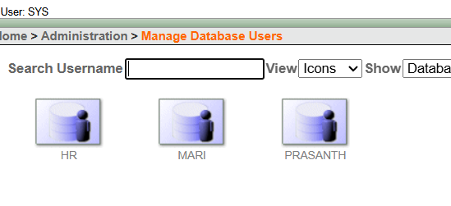

**After disconnecting user(prasanth):**

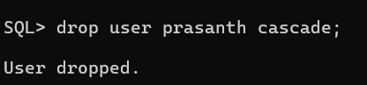

**After droping user(prasanth) in manage users we have only:**

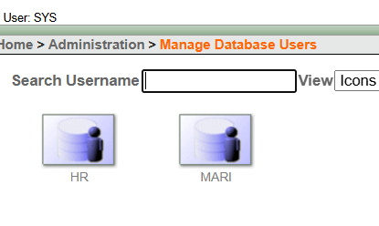

**So,successfully droped user(prasanth)…**