**1.load 3 datas in table and again load 3 datas in same table?**

**Loading csv(comma separate value file) using ctl(control file) thru command line:**

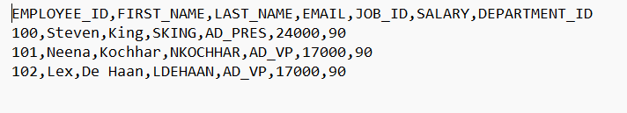

**CSV FILE**

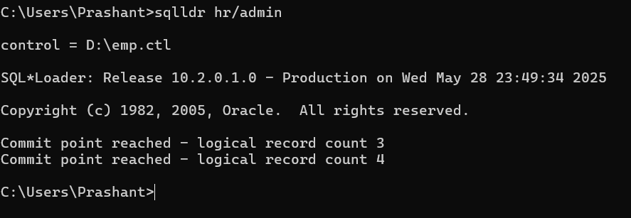

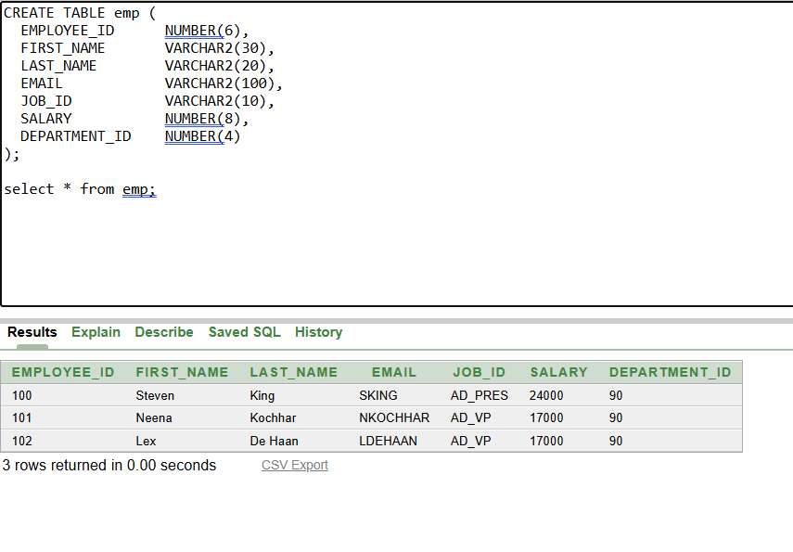

**Again adding using append command:**

