**1.do joins for 3 tables only matching tables to view:**

**Here employees,departments and job_history has common department_id to join:**

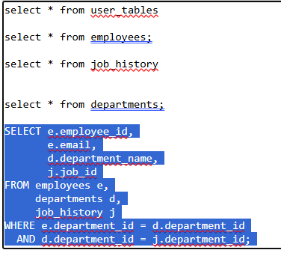

**OUTPUT:**

