1. **find metadata for sequence to know what are the sequence available in current user?**

**View all sequences accessible to the current user: SELECT * FROM ALL_SEQUENCES;**

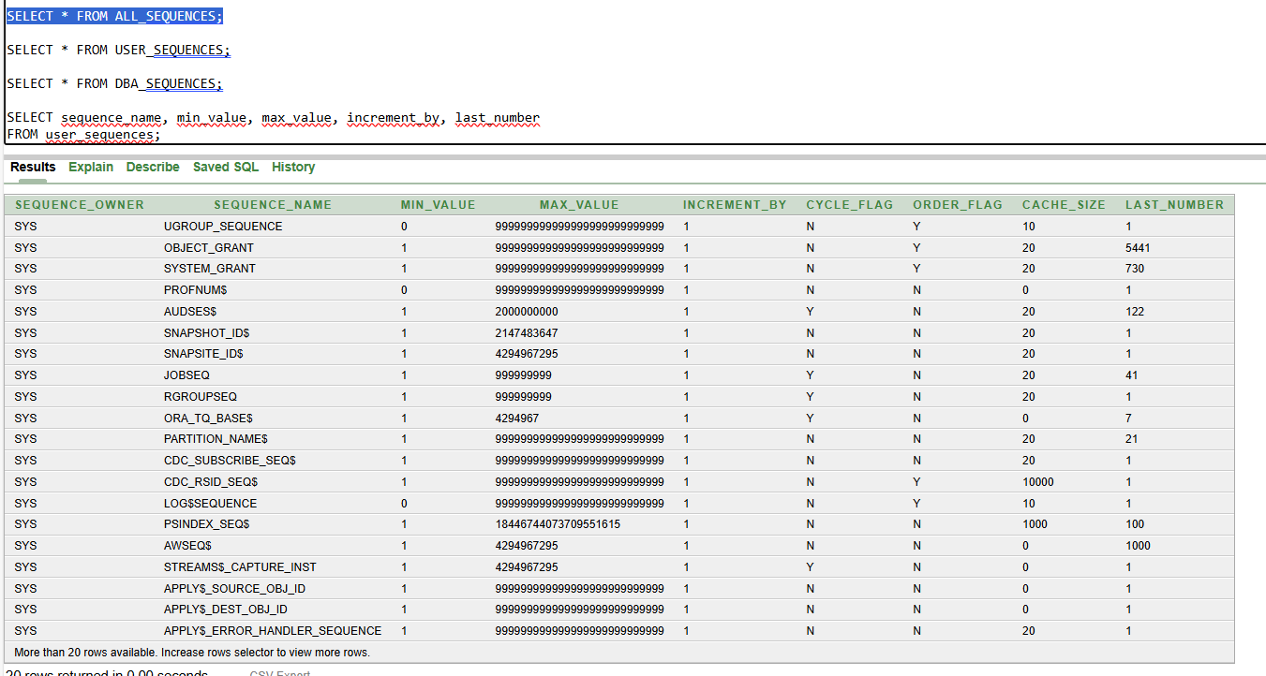

**This view includes all sequences that the current user has access to, including those owned by other users**

**View only the sequences owned by the current user:** **SELECT * FROM USER_SEQUENCES;**

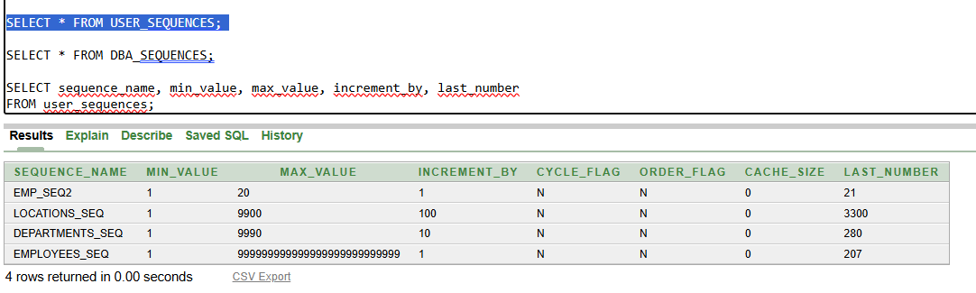

**This view is filtered to only show sequences owned by the current user.**

**View all sequences in the database same as all sequences:** **SELECT * FROM DBA_SEQUENCES;**

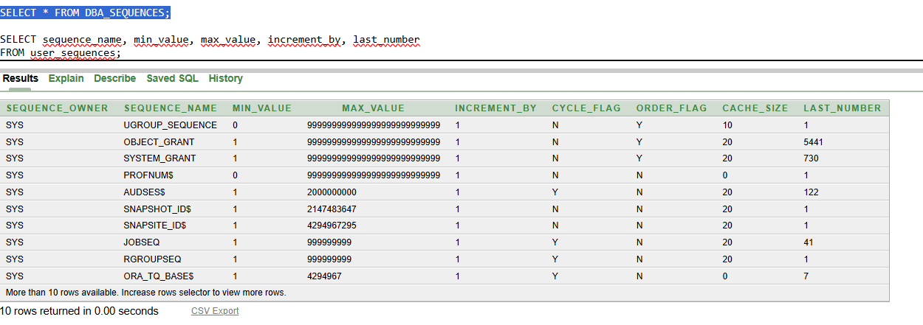

**SEQUENCE_NAME: Name of the sequence.**

**MIN_VALUE: Minimum value of the sequence.**

**MAX_VALUE: Maximum value.**

**INCREMENT_BY: The increment step.**

**CYCLE_FLAG (Y/N):**

* **'Y' means the sequence restarts from the MINVALUE after reaching MAXVALUE.**
* **'N' means it will throw an error once it exceeds MAXVALUE.**

**ORDER_FLAG (Y/N):**

* **'Y' guarantees that sequence numbers are generated in order, important in RAC (Real Application Clusters) environments.**
* **'N' does not guarantee strict ordering (but is faster).**

**CACHE_SIZE:**

* **Number of sequence numbers kept in memory for faster access. Higher cache reduces disk access but risks value loss in crash.**

**LAST_NUMBER:**

* **Indicates the next number to be generated after the cached values are exhausted. It may not reflect the most recently generated number if caching is in use.**

1. **create a table and insert value by using sequence?**

