**GROUP BY**

1. **HOW MANY EMPLOYEE WORKING DEPARTMENT WISE?**

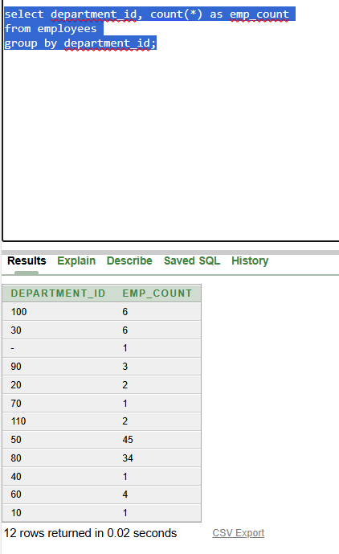

**based on country_id in location table:**

