**To find what are the views available in schema, what are the metadata table we using:**

**To find all views available in a schema in Oracle Database,**

**you can query the data dictionary views (metadata**

**tables). Here are the main ones used:**

**1. USER_VIEWS:**

**Lists all views owned by the current user.**

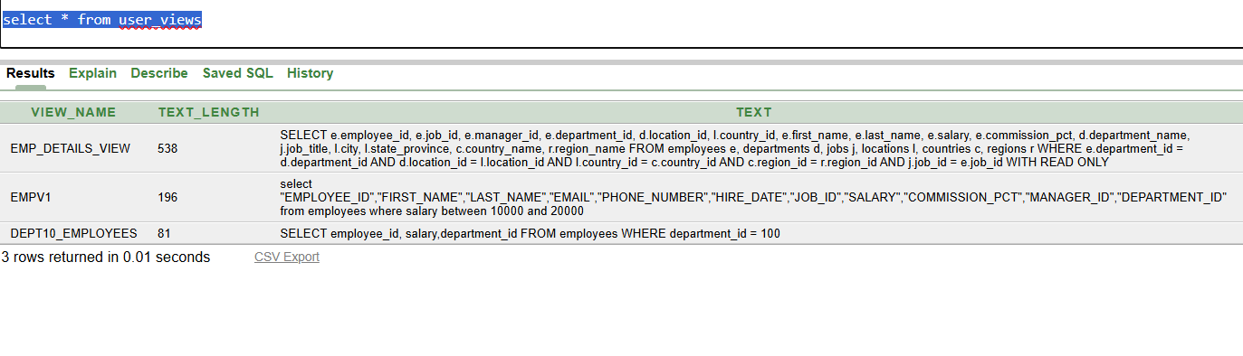

**2. ALL_VIEWS:**

**Lists all views accessible to the current user (including views owned by others if you have privileges).**

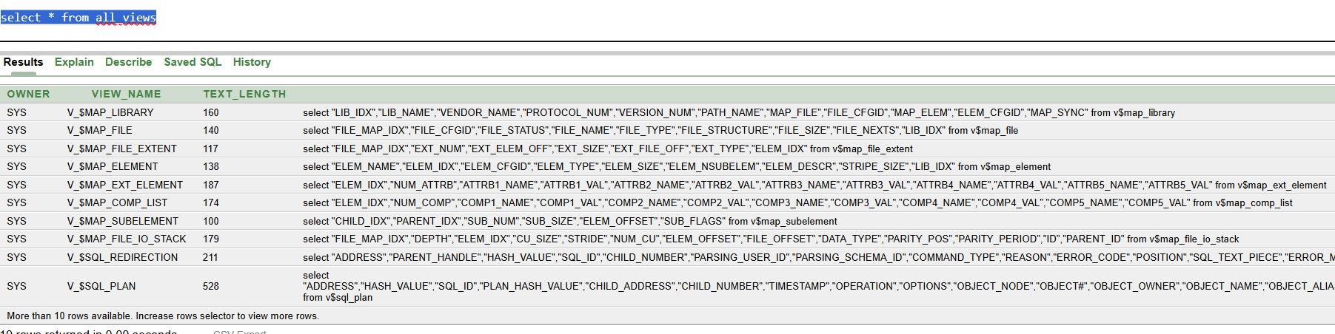

**3. DBA_VIEWS:**

**Lists all views in the entire database, across all**

**schemas. *(requires DBA privileges)***

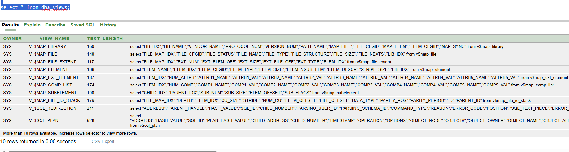

| **Column Name** | **Description** |
| --- | --- |
| **VIEW_NAME** | **Name of the view** |
| **TEXT** | **SQL query text that defines the view** |
| **OWNER** | **Owner of the view (only in ALL_ / DBA_)** |

**Example: Show All Views and Their SQL Definition:**

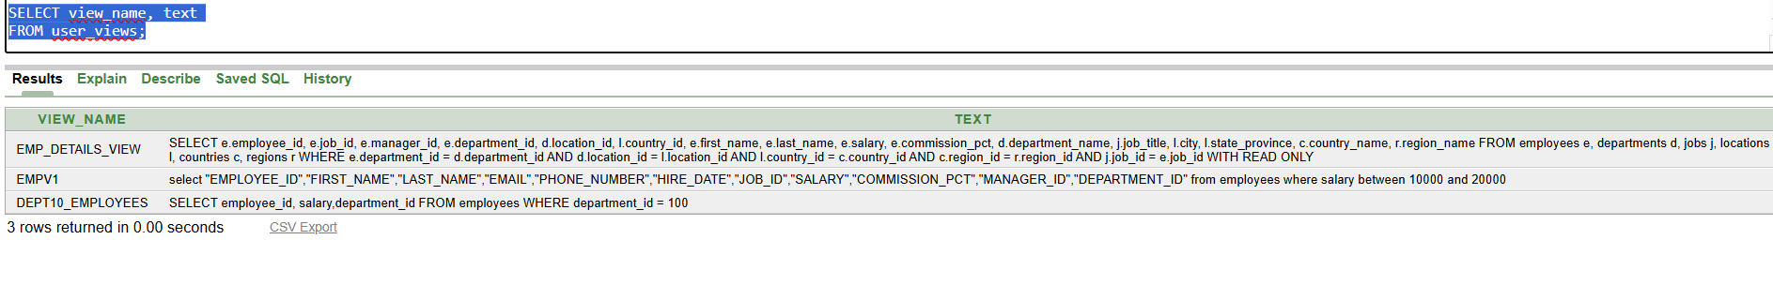

**To see the SQL query behind a view in a formatted way, use:**

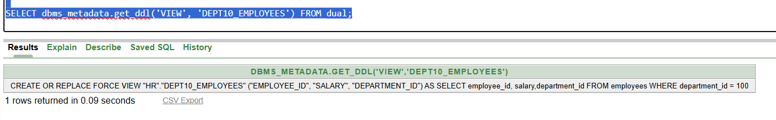

**4. Get the Columns of a View**

**Use the USER_TAB_COLUMNS, ALL_TAB_COLUMNS, or**

**DBA_TAB_COLUMNS metadata views:**

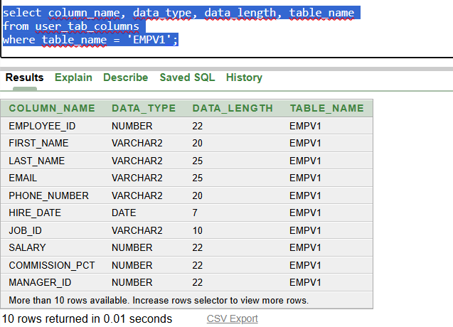

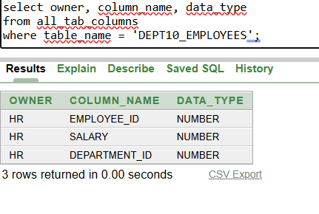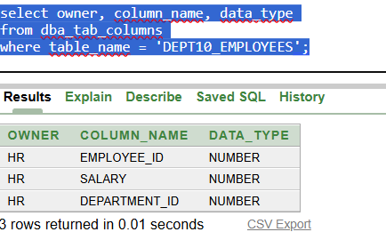

**View names are stored in uppercase by default in Oracle.**

**5.** **Find Views That Use a Specific Table:**

**Example: Find views that use the EMPLOYEES table:**

**DBMS_METADATA.GET_DDL works for all version to search specific table VIEWS**

**Here I used for EMPLOYEE_ID and EMAIL:**

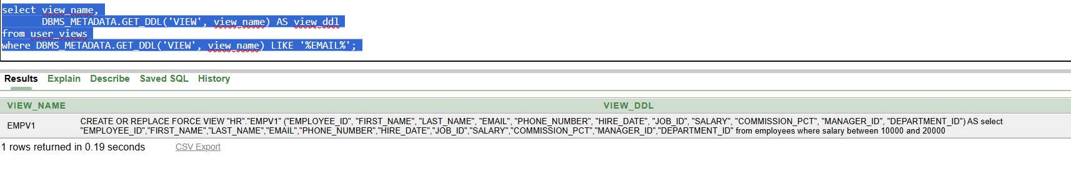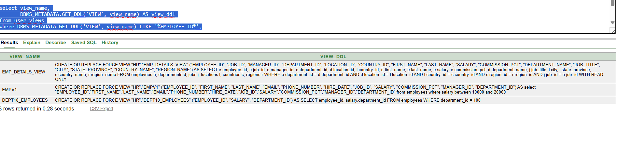

**Summary of Metadata Tables Used for Views**

| **Purpose** | **Metadata View** |
| --- | --- |
| **List views in current schema** | **USER_VIEWS** |
| **List all views accessible to user** | **ALL_VIEWS** |
| **List all views in the database** | **DBA_VIEWS** |
| **Find view definitions (SQL)** | **TEXT column or DBMS_METADATA.GET_DDL** |
| **List columns in a view** | **USER_TAB_COLUMNS** |
| **List view columns across all users** | **ALL_TAB_COLUMNS / DBA_TAB_COLUMNS** |