

Department of Computer Science and Engineering

**National Institute of Technology,Warangal**

*DBMS Project*

Topic: - HOTEL MANAGEMENT SYSTEM

Submission Date: - 26January2020

Submission To: - T. Ramakrishnudu

Submitted By : -

Prapti Maheshwari (187245)

ACKNOWLEDGEMENT

I would like to thank Dr.T.Ramakrishnudu for giving me the opportunity to do the project as a part of the Database Management System course. Through this project I have gained deeper insight in Database Design,Relational Model,ER Model and Normalization.

OVERVIEW

The main aim of this project is to manage the data of the hotel, finding out information about the availability of the rooms in the hotel, customer and staff details. Moreover the project tells about the recreational activities like gym, swimming etc. provided by the hotel.

ER DIAGRAM

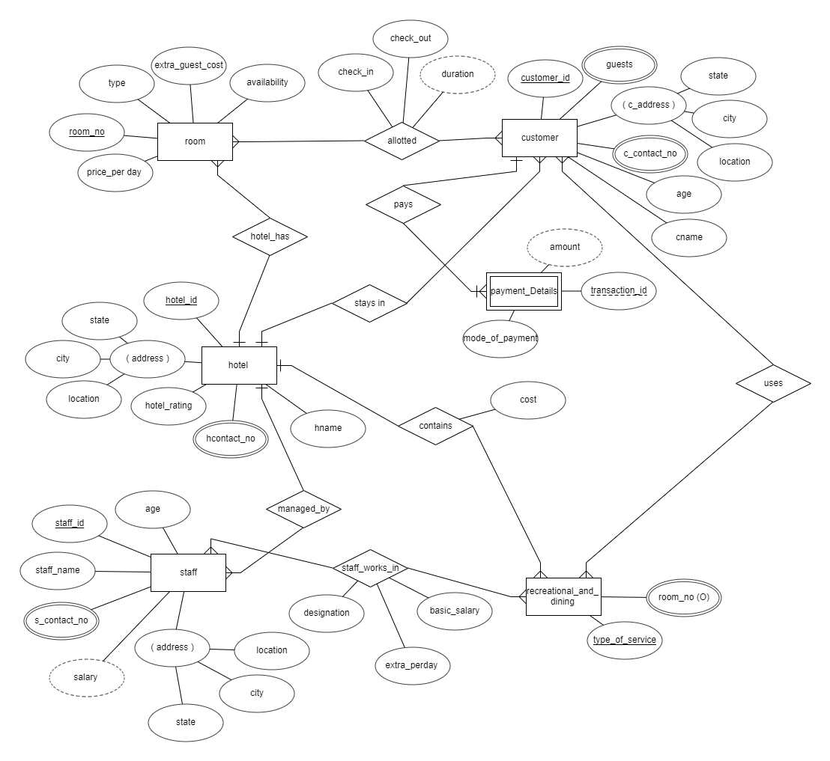

ASSUMPTIONS

* No two hotels have the same room number, customer id or staff id. Hence the relationships between hotel and room, customer, staff are one to many relations
* One hotel can have many recreational activities and dining facilities and the same facilities can be present in many hotels. Hence the relationship between hotel and recreational_and_dining table is many to many.
* One customer can stay in only one room and one room can have many customers living in it. Hence the relationship is many to many.
* Every member living in the same room has the same customer id.
* The recreational activities and dining of the hotel can be used only by the customers of the hotel.
* One customer can use as many recreational activities that he wants to and every recreational activity has facility to accommodate many customers. Hence the relation between customer and recreational_and_dining table is many to many.
* One staff member can work for many recreational activities and one recreational activity can have many staff members. Hence the relation between staff table and recreational_and_dining table is a many to many relationship.
* The entity payment detail is weak because there can be no payment without a customer booking the room. Hence there is a total participation from the payment_detail table.

FUNCTIONAL DEPENDENCIES

*ROOM*

ROOM_NO->TYPE

TYPE->EXTRA_GUEST_COST

ROOM_NO->AVAILABILITY

TYPE->PRICE_PER_DAY

CANDIDATE KEY :ROOM_NO

*CUSTOMER*

CUSTOMER_ID->GUEST

CUSTOMER_ID->STATE

CUSTOMER_ID->CITY

CITY->STATE

CUSTOMER_ID->LOCATION

CUSTOMER_ID->AGE

CUSTOMER_ID->CNAME

CANDIDATE KEY: CUSTOMER_ID

*ALLOTtED*

{ROOM_NO,CUSTOMER_ID}->CHECK_IN

{ROOM_NO,CUSTOMER_ID}->CHECK_OUT

CANDIDATE KEY: {ROOM_NO,CUSTOMER_ID}

*PAYMENTDETAILS*

{CUSTOMER_ID,TRANSACTION_ID}->MODE_OF_PAYMENT

CANDIDATE KEY: {CUSTOMER_ID,TRANSACTION_ID}

*HOTEL*

HOTEL_ID->HNAME

HOTEL_ID->STATE

HOTEL_ID->CITY

CITY->STATE

HOTEL_ID->LOCATION

HOTEL_ID->HOTEL_RATING

CANDIDATE KEY: HOTEL_ID

*STAFF*

STAFF_ID->STAFF_NAME

STAFF_ID->AGE

STAFF_ID->CITY

CITY->STATE

STAFF_ID->STATE

STAFF_ID->LOCATION

STAFF_ID->HOTEL_ID

CANDIDATE KEY: STAFF_ID

*RECREATION_AND_DINING*

CANDIDATE KEY: TYPE_OF_SERVICE,ROOM_NO

*STAFF_WORKS_IN*

{STAFF_ID,TYPE_OF_SERVICE}->DESIGNATION

{TYPE_OF_SERVICE,DESIGNATION}->BASIC_SALARY

{TYPE_OF_SERVICE,DESIGNATION}->EXTRA_PERDAY

CANDIDATE KEY: {STAFF_ID,TYPE_OF_SERVICE}

*USES*

NO FUNCTIONAL DEPENDENCIES

CANDIDATE KEY: CUSTOMER_ID,TYPE_OF_SERVICE

*SCHEMA OF DECOMPOSED TABLES (IN 3NF AND BCNF )*

**PLACE**(CITY, STATE)

**HOTEL**(HOTEL_ID, HNAME ,CITY(FK), LOC ,RATING)

**HOTEL_CONTACT**(HOTEL_ID (FK),H_CONTACT_NO)

**CUSTOMER**( CITY(FK), C_ID ,CNAME,LOCATION, AGE, HOTEL_ID (FK))

**C_CONTACT**(CONTACT_NO, C_ID(FK), )

**GUESTS**(GUEST_NAME ,C_ID(FK))

**PAYMENT_DETAILS**(C_ID(FK),T_ID ,PAY_MODE)

**STAFF**(STAFF_ID ,SNAME ,AGE,CITY(FK) ,LOC ,HOTEL_ID(FK) )

**STAFF_CONTACT**(STAFF_ID(FK),CONTACT_NO )

**STAFF_WORK**(STAFF_ID,SERVICE_TYPE(FK) , DESG(FK))

**DESIGNATION_SALARY** (DESG ,B_SALARY, EXTRA_PERDAY ,SERVICE_TYPE(FK) )

**CONTAINS** (HOTEL_ID (FK), SERVICE_TYPE (FK), COST )

**RECREATIONAl**(SERVICE_TYPE (FK),REC_ROOM(FK) )

**USES**( C_ID (FK) ,SERVICE_TYPE(FK) )

**ROOM**_**TYPE**(R_TYPE ,PRICE_PERDAY EXTRA_GUEST_COST)

**ROOM(**ROOM_NO, R_TYPE(FK) ,HOTEL_ID(FK), AVAIL)

**ALLOTED** ( ROOM_NO(FK) C_ID(FK),CHECK_IN, CHECK_OUT,))