TOPIC: RESTAURANT MANAGEMENT SYSTEM

Q-1-: Create 12 tables or entities and 5 attributes:

- Restaurant Table:
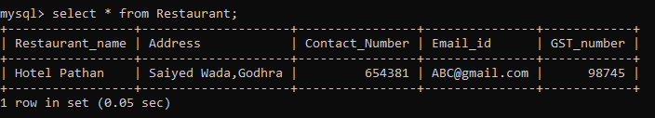

- Owner Table:
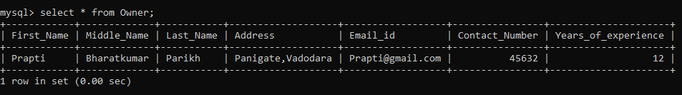

- Manager Table:
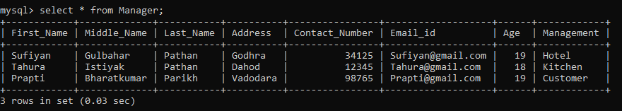

- Waiter Table:
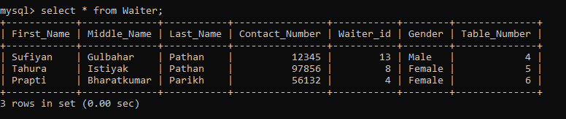

- Chef Table:
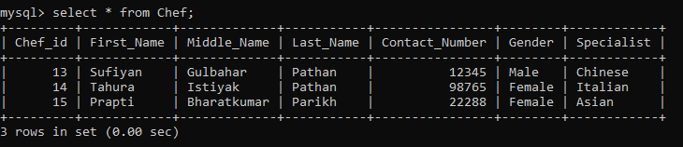

- Ordered table:
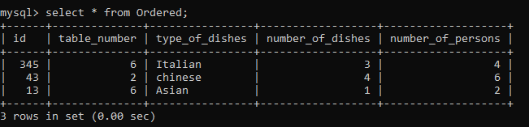

- Starter Table:

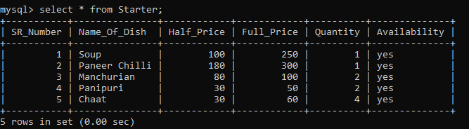

- Main_Course Table:

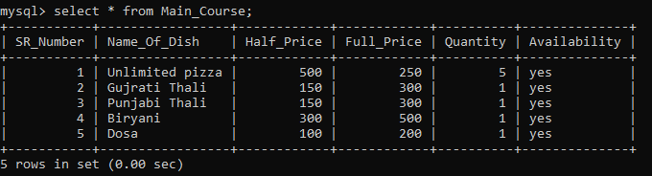

- Dessert table:

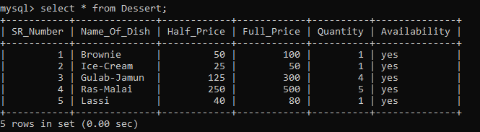

- Bill Table:
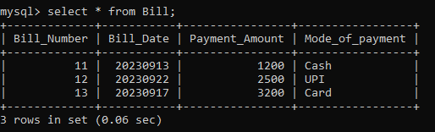

- Customer Table:
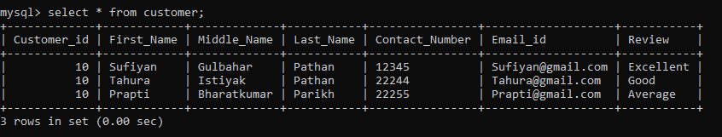

- Cashier Table:
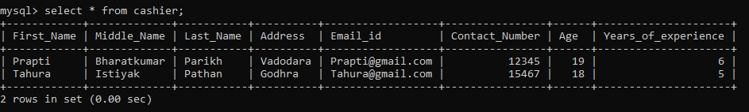

- Cleaners Table:
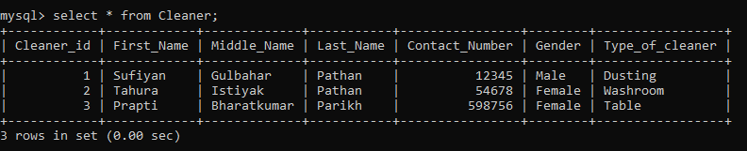

- Guards Table:
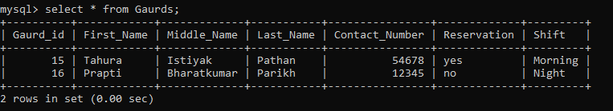

Q-1: JOIN Queries:
- INNER JOIN:
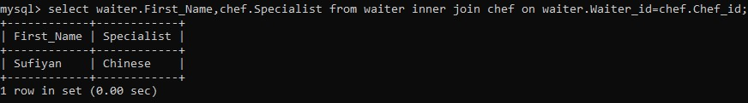

- LEFT OUTER JOIN:
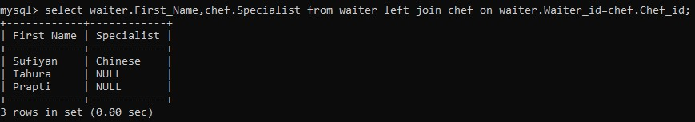

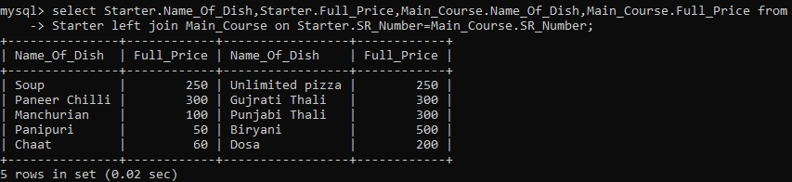

- RIGHT OUTER JOIN:
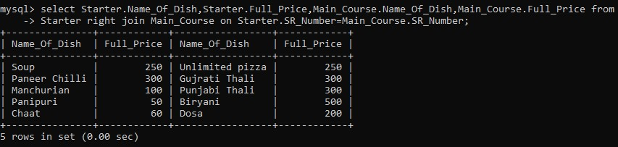

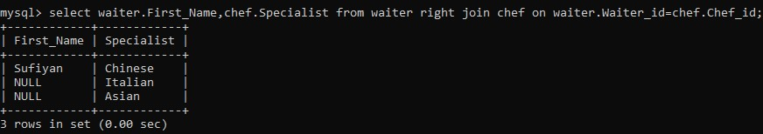

Q-2: Aggregation Functions Queries:
- SUM():
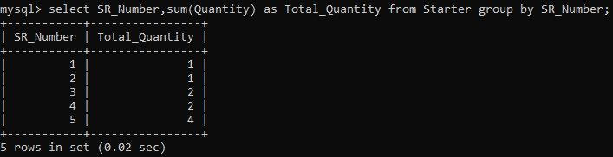

- COUNT():
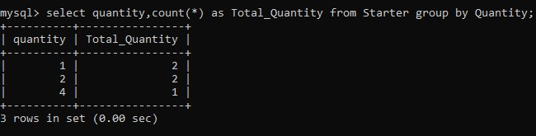

- MIN():
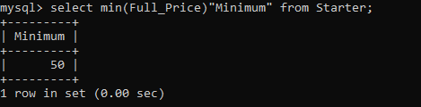
- MAX():
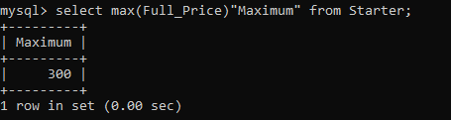

- AVG():
