LAB-5
Assignment-6

Name: V. Prapul Kumar

Roll no:2503A52377
Task Description-1 (Classes – Data Validation)
PROMPT:
- Prompt AI to generate a Student class with attributes: name, roll_no, and marks. Add a method is_ pass() that returns whether the student has passed (marks ≥ 40).
Input:
class Student:
def __init__(self, name, roll_no, marks):
self.name = name
self.roll_no = roll_no
self.marks = marks

def is_pass(self):
return self.marks >= 40

name = input("Enter student name: ")
roll_no = input("Enter roll number: ")
marks = int(input("Enter marks: "))

student = Student(name, roll_no, marks)

if student.is_pass():
print("Pass")
else:
print("Fail")
Output:
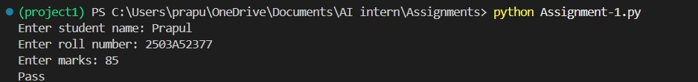
Task Description-2 (Loops – Pattern Generation)
PROMPT:
- Ask AI to generate a function that prints a right-angled triangle star pattern using a for loop. Then regenerate the same pattern using a while loop.
Input:
def triangle_for(n):
print("Using for loop:")
for i in range(1, n + 1):
print("*" * i)

def triangle_while(n):
print("\nUsing while loop:")
i = 1
while i <= n:
print("*" * i)
i += 1

n = int(input("Enter number of rows: "))

triangle_for(n)
triangle_while(n)

Output:
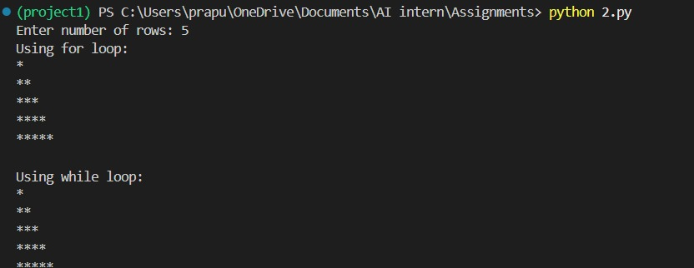
Task Description-3 (Conditional Statements – Number Analysis)
Prompt:
- Ask AI to write a function that checks whether a given number is positive, negative, or zero using if-elif-else. Test the function with multiple inputs.
Input:
def check_number(number):
if number > 0:
return "Positive"
elif number < 0:
return "Negative"
else:
return "Zero"

# Test with multiple inputs
numbers = [10, -5, 0, 25, -12]

for number in numbers:
print(number, "is", check_number(number))

Output:
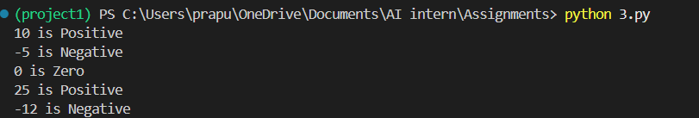
Task Description-4 (Nested Conditionals)
Prompt:
- Generate a function check_discount(age, is_member) that determines discount eligibility:
- Age ≥ 60 → Senior discount
Member → Additional discount
Use nested if statements.
Input:
def check_discount(age, is_member):
if age >= 60:
print("Senior discount eligible")

if is_member:
print("Additional member discount")
else:
print("No additional member discount")

else:
print("Not eligible for senior discount")

if is_member:
print("Member discount eligible")
else:
print("No discount")

check_discount(65, True)

print()

check_discount(65, False)

print()

check_discount(30, True)

print()

check_discount(30, False)
Output:
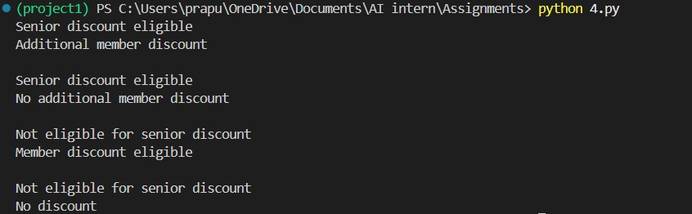
Task Description-5 (Class – Mathematical Opera)
Prompt:
- Ask AI to create a Circle class with methods to calculate area () and circumference () given the radius.
Input:
import math

class Circle:
def __init__(self, radius):
self.radius = radius

def area(self):
return math.pi * self.radius ** 2

def circumference(self):
return 2 * math.pi * self.radius

r = float(input("Enter the radius: "))

circle = Circle(r)

print("Area:", circle.area())
print("Circumference:", circle.circumference())
Output:
