**NewsNOW**

Team 4 – Jyothi H R, Manasi Sadanand Pai, Prarthana Hemanth

PROJECT OVERVIEW:

NewsNow is an Android News App. The app can be used to view latest news, search for news, share on social media, view news by categories etc. The UI for the app is simple and users can navigate smoothly through the app. An authentication mechanism is also in place where the users can register themselves and login using those credentials. All in all, NewsNOW is a very user-friendly and useful app helping users get latest news on their fingertips.

IMPLEMENTED FEATURES:

The main features of the app are as follows:

* Registration and Login: The app has an authentication mechanism. Where a user can register and use those credentials to login to the app.
* Fetching the News: The latest news is fetched from the News API and displayed, the user can select any news item to open the entire article.
* Search Functionality: The user has an option to search for news on any subject by entering a keyword.
* News Categories: The fetched news has been divided based on categories, such as Business, Sports etc. A user can click on a specific category to view the news items related to the selected category.
* Share News: User has the option to share any news article on social media, email, message etc… installed on the phone.
* Browser View: User has the option to open any article in any web browser installed on the phone and view it there.

TASK DISTRIBUTION:

* JYOTHI H R: Worked on the user registration and login, as well as categorizing news into different categories.
* MANASI SADANAND PAI: Worked on the feature of sharing news to social media and on the feature that allows users to open news articles in web browser.
* PRARTHANA HEMANTH: Worked on fetching the news from the News API and the search functionality.

TECHNICAL DETAILS:

* The app is an Android app built using the JAVA Programming language.
* The API that we are hitting to fetch the news is: <https://newsapi.org/>

Endpoints:

* <https://newsapi.org/v2/top-headlines?country=us&apiKey=yourapikey>
* <https://newsapi.org/v2/everything?q=q&apiKey=yourapikey>
* We are using the Retrofit library for retrieving the data from the news API

APP SCREENSHOTS:

Registration Screen:

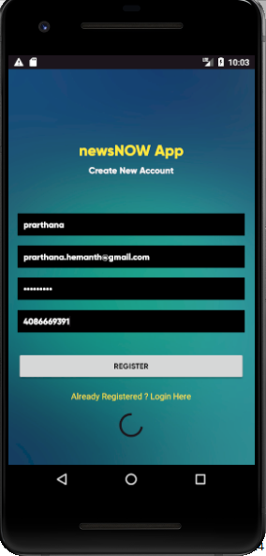

Login Screen:

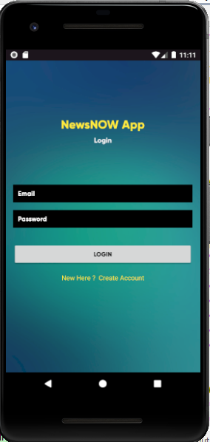

Main News Screen:

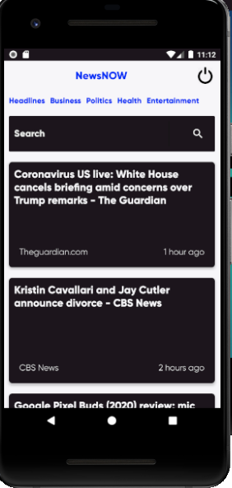

News Detail Screen when an article is opened:



Search by a certain keyword:

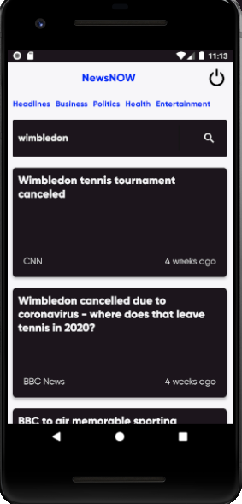

Clicking on a particular Category : Entertainment:



Share to social media:

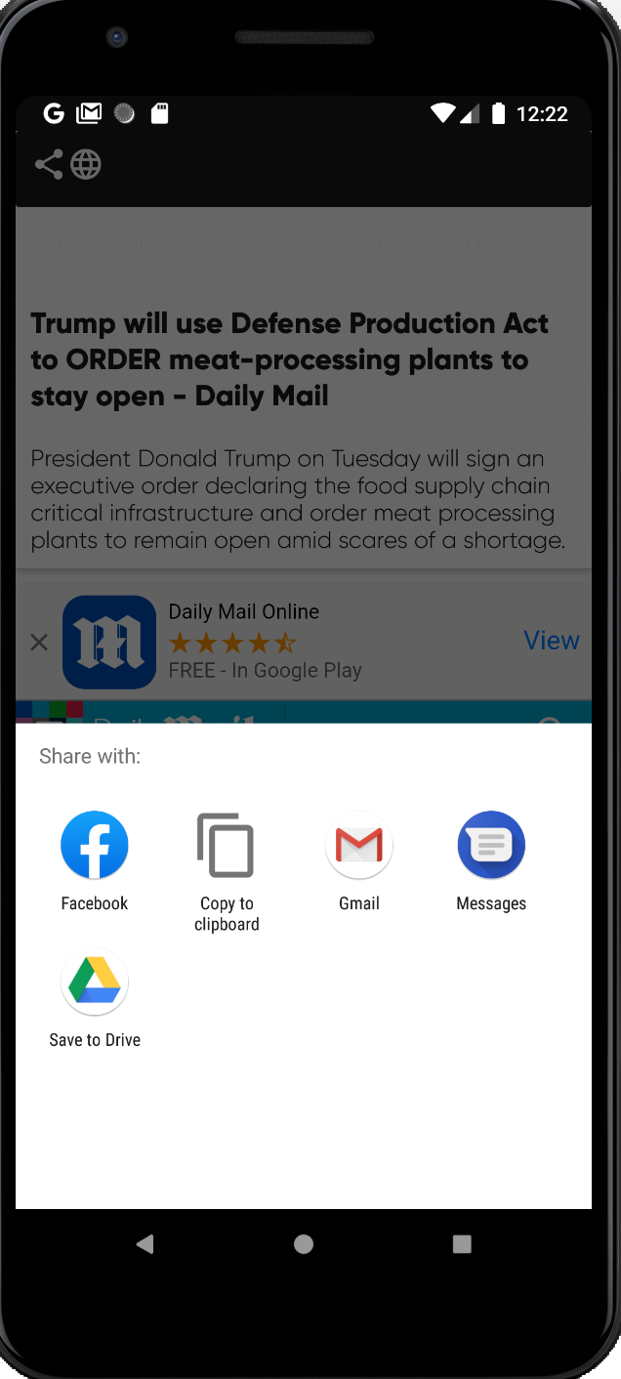

Open article in browser:

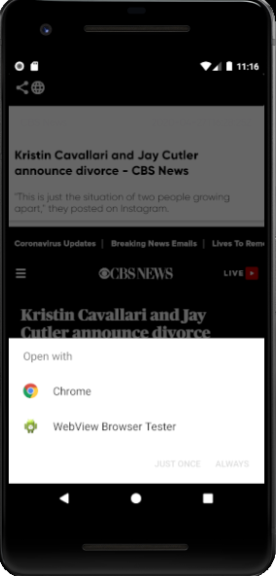

REFERENCES: