**CLEVELAND STATE UNIVERSITY**

**CIS 524 – COMPARATIVE PROGRAMMING LANGUAGES**

**FINAL PROJECT**

**Submitted To**

Weidong Xong

**Submitted By**

Prudhvi Reddy Araga

**Introduction to cloud’s concept:**

Cloud computing can be defined as web processing with enormous amount of assets. The client of the cloud can acquire the administration thought organization (in both web and intranet). As such, clients are utilizing or computing services from others. The asset of the cloud can be anything IT related. By and large, cloud gives application, calculation power, stockpiling, transfer speed, database and a few innovations like MapReduce. As the asset pool is enormous, client can expand the application on cloud to any scale. It is completely under the control of users.

The cloud empowers clients to get access to similar records and applications from practically any gadget, on the grounds that the registering and capacity happens on servers in a data center, rather than locally on the client gadget. This is the reason a client can sign into their Instagram account on another telephone after their old telephone breaks and still locate their old record set up, with all their photographs, recordings, and discussion history. It works a similar path with cloud email suppliers like Gmail or Microsoft Office 365, and with distributed storage suppliers like Dropbox or Google Drive.

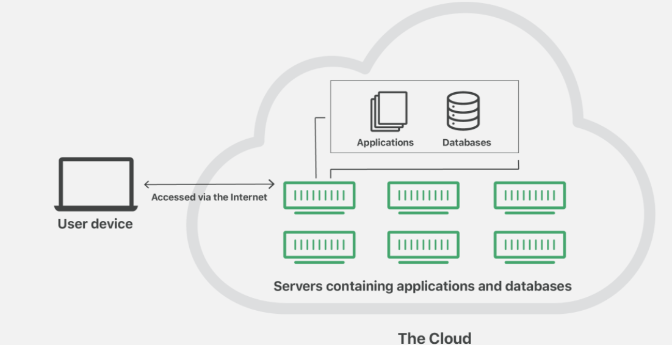

**Why cloud is so powerful:**

1. **Resource pool is enormous:** Public cloud gives clients shock with its flexible property and large resource pool with a hundreds of many machines. With a couple of line of orders, client can utilize these machines to do anything they needed to do.
2. **Easy to oversee:** Private cloud gives clients shock with its ease of overseeing asset and better utilization of asset. Private cloud clients can send demand like the public cloud clients. Aside from that, they can nearly get what they need right away. Every one of these activities are dealt with by cloud framework and overseers need not to set up any new machines.
3. **Collaboration productivity:** Collaboration in cloud environment enables your business to convey and share more effectively outside of the customary techniques. On the off chance that you are dealing with an undertaking across various areas, you could utilize cloud computing to give workers, temporary workers and outsiders admittance to similar records. You could likewise pick a cloud computing model that makes it simple for you to impart your records to your consultants.

The big cloud computing services in the corporate computing sphere include:

* Google Cloud
* Amazon Web Services (AWS)
* Microsoft Azure
* IBM Cloud
* Alibaba Cloud

The Free Cloud platform that I’ve used for this project is **IBM Cloud** because IBM offers both platform as a service (PaaS) and infrastructure as a service (IaaS).

**About IBM** **Cloud:**

The combination of PaaS with IaaS is used to provide the integrated experience. The IBM cloud platform combines platform as a service (PaaS) with infrastructure as a service (IaaS) to provide an integrated experience.

The IBM Cloud platform is made out of different parts that cooperate to give a predictable and reliable cloud insight.

* A vigorous support that fills in as the front end for making, seeing, dealing with your cloud assets
* An identity and access the executive’s segment that safely validates clients for both stage administrations and controls admittance to assets reliably across IBM Cloud
* An index that comprises of many upheld items
* A search and labeling instrument for sifting and distinguishing your assets
* A record and charging the executives framework that gives accurate utilization to evaluating plans and secure Visa extortion assurance

The components of IBM Cloud are shown below:

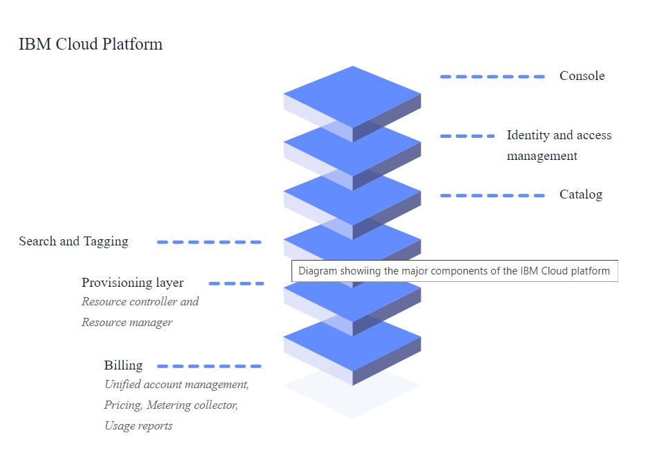

**Steps to deploy my project on the IBM Cloud:**

Here’s the plan to deploy my project to the cloud using nothing but HTML and javascript. First of all, I created an account on IBM cloud. Then,

**Step 1. Create a toolchain for new app:**

1. Log in to IBM Cloud.
2. Navigate to the DevOps dashboard.
3. Click Create a toolchain.
4. Select the Develop a Cloud Foundry app toolchain.
5. On the toolchain page, enter a name for toolchain.
6. For the Git Repos and Issue Tracking tool integration, select the Repository type of New, and enter a name for new repo.

**Toolchains**

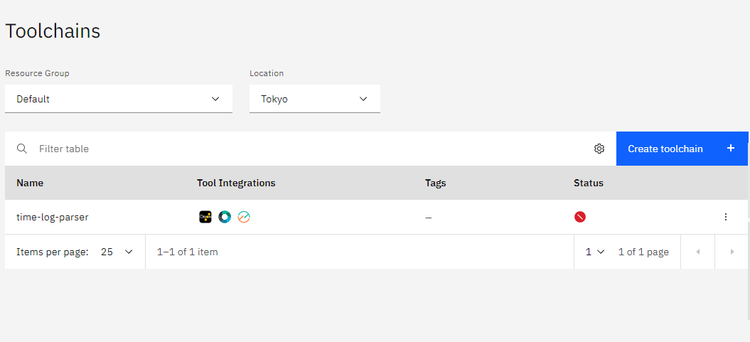

**Build and Deploy Templates**

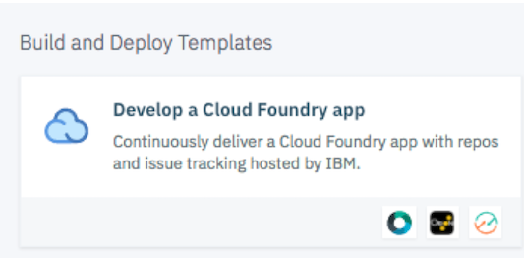

**Develop a Cloud Foundry App**

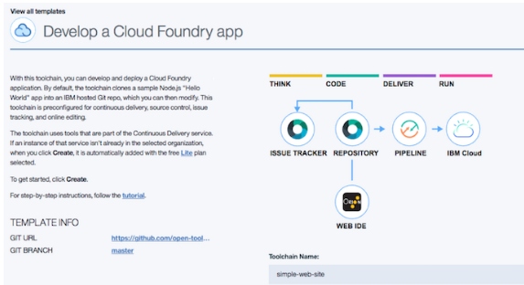

**Tool Integrations**

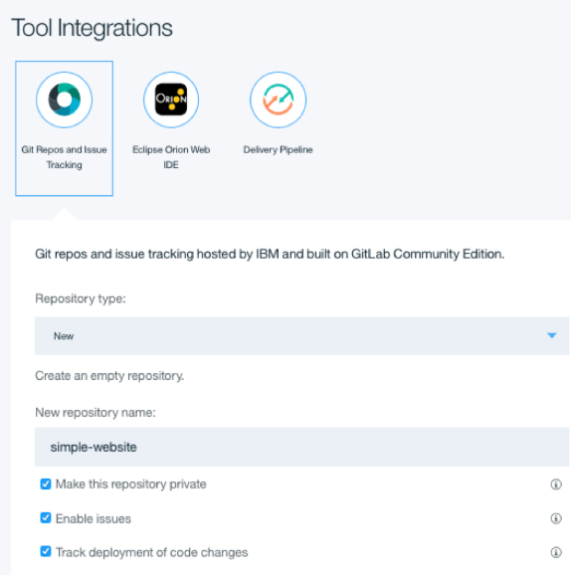

**Step 2. Create a cloud web page**

1. On the toolchain’s overview page, click the Eclipse Orion Web IDE. The Web IDE will open. A few files like .cfignore and .gifignore will be created for you automatically.
2. In the Web IDE, select File > New > File.
3. The file is highlighted so that you can name it. Enter index.html.
4. In the editor area on the right, write the code:

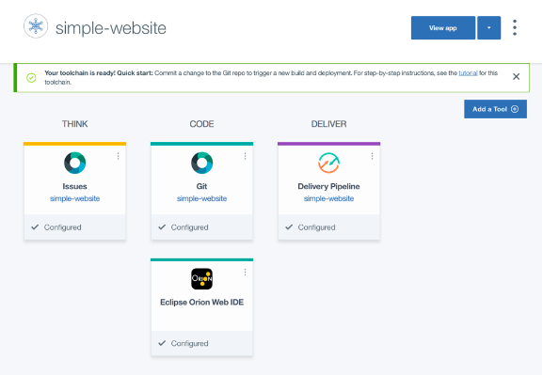

**Step 3. Create a manifest**

1. In the web IDE, select File > New > File
2. The file is highlighted so that you can name it. Enter manifest.yml
3. In the editor area on the right, paste the following:
4. ---
5. applications:
6. - buildpack: https://github.com/cloudfoundry/staticfile-buildpack.git
7. host: simple-website-${random}
8. name: simple-website-${random}
9. memory: 64M
10. stack: cflinuxfs2

NOTE:  The host and app name must be unique across all of IBM Cloud, so replace ${random} with a unique string.

**Step 4. Deploy and open the app**

1. In the web IDE, click the Deploy button
2. When app is deployed, open it in a web browser by clicking the Open the application URL button
3. The running website opens in a new window

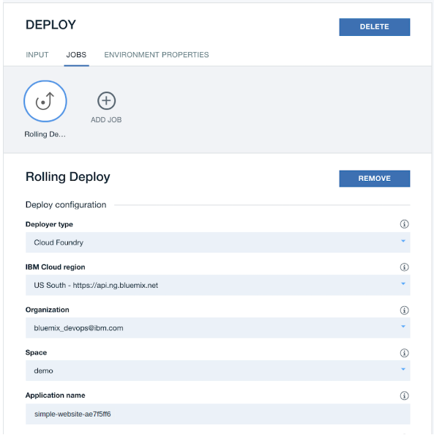

**Step 5. Commit your changes to the repo**

1. Click on the Git icon
2. On the commit page, enter a commit comment and click Commit
3. Click Sync to push all changes to the repo.

**URL for the application access:**

<https://simple-website-smallparser.mybluemix.net/>

Sample Output:

# Works Cited

*Namasudra, S. (2010, Jan 6). Cloud Computing: Fundamentals and Research Issues . Retrieved from Cloud Computing: Fundamentals and Research Issues : https://ieeexplore.ieee.org/document/8057500*

*Odun-Ayo, I. (2011, Aug 10). An Overview of Data Storage in Cloud Computing . Retrieved from An Overview of Data Storage in Cloud Computing : https://ieeexplore.ieee.org/document/8520306*

*Cloud Computing: Concepts, Technology & Architecture (The Pearson Service Technology Series from Thomas Erl) by Erl Thomas, Puttini Ricardo, Mahmood Zaigham*