Case Study 3
Results and Discussion
BCSE308L Computer Networks
Cooperative Multi-UAV Angle-of-Arrival Fusion for Misbehaviour and Sybil Attack Detection in Vehicular Networks: Evaluation on the VeReMi Extension Dataset
Prakash R (Reg. No. 24BCE0469)
Joshua Daniel D (Reg. No. 24BCE0436)
Saryu M (Reg. No. 24BCE2524)
BCSE308L Computer Networks, [Department], [Institution Name], [City, Country]
1. Overview and Reading Guide
This document reports and discusses the experimental results of the project “Cooperative multi-UAV angle-of-arrival fusion for misbehaviour and Sybil attack detection in vehicular networks”. The project builds a detection pipeline on the VeReMi Extension dataset [1], [2]: a sender-history baseline, a virtual multi-UAV observer layer with cooperative angle-of-arrival (AoA) fusion, window-level features, a spatiotemporal graph with node2vec embeddings [7], and an XGBoost classifier [6].
Measured versus simulated. The dataset contains only the positions that vehicles claim, not where they truly were. Cooperative bearings therefore cannot be measured on it directly. Results that use only the dataset are marked Measured. Results that use the fusion features rely on a documented simulation in which attackers transmit from a hidden position offset by 30 to 300 m from the claimed one, and are marked SIMULATED in every table and figure (shaded rows, dashed lines, hatched bars). Simulated figures are upper bounds, not measured performance on real attackers.
2. Experimental Setup
All experiments use a 20% sample of senders (whole senders, so message sequences stay intact), giving 59,108 vehicle-window rows of which 30.2% are attacker windows. The train/test split is by vehicle: 17,888 windows (5,439 of them attacks) are held out and never seen in training. Four variants are compared with identical test rows: features only, features with node2vec embeddings, features with simulated fusion features, and all three. Variants that use fusion features are marked SIMULATED in every table and figure, because the dataset has only claimed positions and the fusion inputs come from the spoofing simulation of the project methodology [1], [2].
2.1 Evaluation metrics
Attack windows are the positive class. Accuracy is the share of correct decisions. Precision is the share of flagged windows that are real attacks, recall the share of real attacks that are flagged, and F1 their harmonic mean. ROC-AUC measures how well the model ranks attack windows above genuine ones (0.5 is chance, 1 is perfect), PR-AUC does the same under class imbalance, and the false-positive rate (FPR) is the share of genuine windows wrongly flagged. A decision threshold of 0.5 is used for the threshold-based metrics. Per-class results score one attack class against all genuine windows.
2.2 Model variants
- Features only: window-mean baseline features plus speed variance, heading-change rate and position variance (measured).
- Graph: the same features plus 32-dimensional node2vec embeddings (measured).
- Fusion (SIMULATED): the features plus claimed-versus-fused distance, residual score and coverage features from the simulation.
- Graph + fusion (SIMULATED): all of the above.
3. Results
3.1 Overall comparison
Table 1 reports the held-out results. Without any simulated input, the kinematic and trust features reach an F1 score of 0.969 and a ROC-AUC of 0.979. Adding node2vec embeddings changes F1 by +0.001 and ROC-AUC by -0.001, so the graph adds no accuracy gain, although the false-positive rate falls from 0.0034 to 0.0018.
Adding the simulated fusion features lifts F1 to 0.988 and ROC-AUC to 0.9985; combining all three gives 0.987 and 0.9983. The gain comes mainly from recall, which rises from 0.947 to 0.981, while precision stays near 0.995. The ROC curves in Figure 2 show the same ordering: the two non-fusion curves almost coincide, as do the two fusion curves.
Table 1. Held-out results on the same test windows (shaded rows = SIMULATED fusion features).
Model | F1 | ROC-AUC | FPR | Evidence
features only | 0.969 | 0.9794 | 0.0034 | Measured
graph | 0.970 | 0.9780 | 0.0018 | Measured
fusion | 0.988 | 0.9985 | 0.0022 | Simulated
graph + fusion | 0.987 | 0.9983 | 0.0020 | Simulated

Table 2. Further metrics for the same four variants.
Model | Accuracy | Precision | Recall | PR-AUC | ROC-AUC
features only | 0.9817 | 0.9919 | 0.9474 | 0.9786 | 0.9794
graph | 0.9824 | 0.9956 | 0.9465 | 0.9775 | 0.9780
fusion (SIMULATED) | 0.9927 | 0.9948 | 0.9811 | 0.9974 | 0.9985
graph + fusion (SIMULATED) | 0.9922 | 0.9953 | 0.9790 | 0.9972 | 0.9983

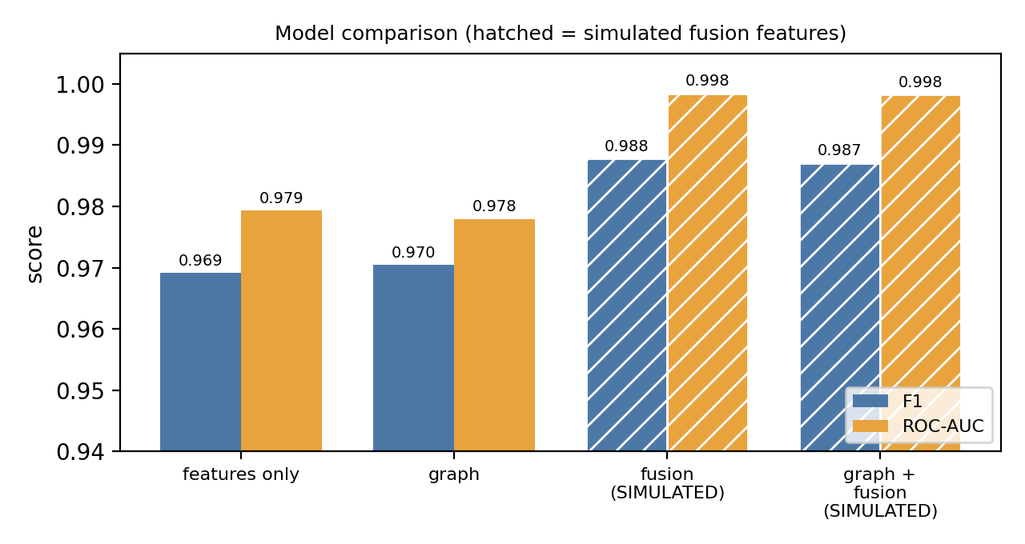
Figure 1. F1 and ROC-AUC of the four variants (hatched = simulated fusion features).
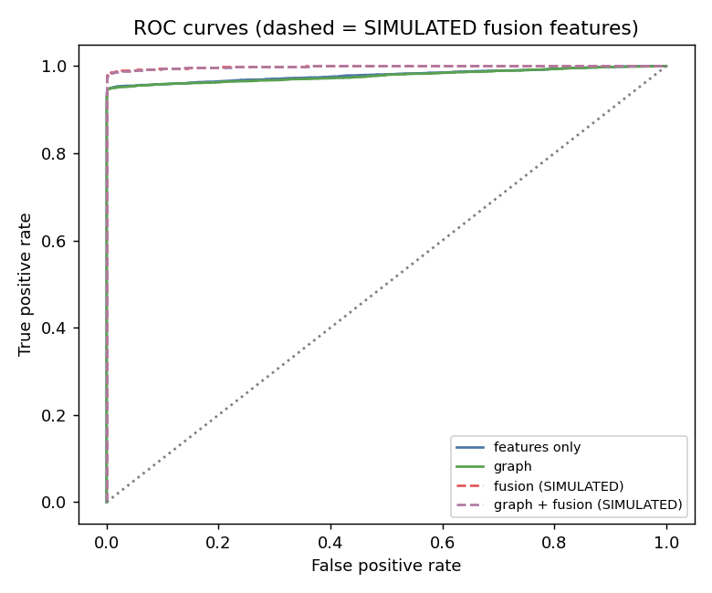
Figure 2. ROC curves of the four variants (dashed = simulated fusion features).
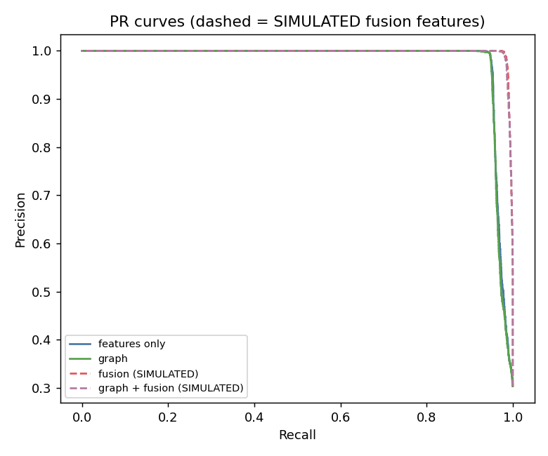
Figure 3. Precision-recall curves of the four variants.
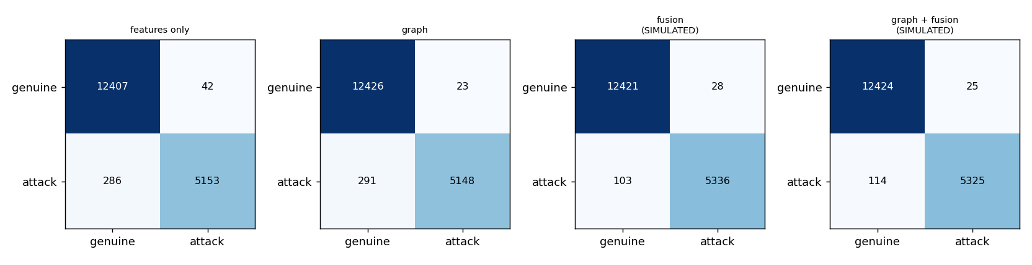
Figure 4. Confusion matrices at threshold 0.5 (simulated variants are tagged in their titles).
3.2 Ablation of the fusion features
Table 1I reports the ablation over five random vehicle-level splits. Removing the claimed-versus-fused distance lowers F1 from 0.9850 to 0.9588 (-0.0261), which equals the model with no fusion features at all (0.9589). That single feature therefore carries the whole gain. Removing the residual score changes F1 by 0.0002, well inside the split-to-split standard deviation of about 0.001 to 0.002. Dropping both leaves only coverage counts and gives 0.9588, which confirms that coverage no longer leaks the label. The same pattern holds with graph embeddings (full 0.9841, without the distance 0.9579).
Table 3. Ablation without graph embeddings, mean ± standard deviation over five vehicle-level splits (all rows except the last are SIMULATED).
Variant | F1 (mean ± sd) | Δ F1 | Evidence
Full (all fusion features) | 0.9850 ± 0.0009 | — | Simulated
Drop claimed-vs-fused distance | 0.9588 ± 0.0028 | -0.0261 | Simulated
Drop residual score | 0.9852 ± 0.0015 | +0.0002 | Simulated
Drop both (coverage counts left) | 0.9588 ± 0.0033 | -0.0261 | Simulated
No fusion features | 0.9589 ± 0.0030 | -0.0261 | Measured

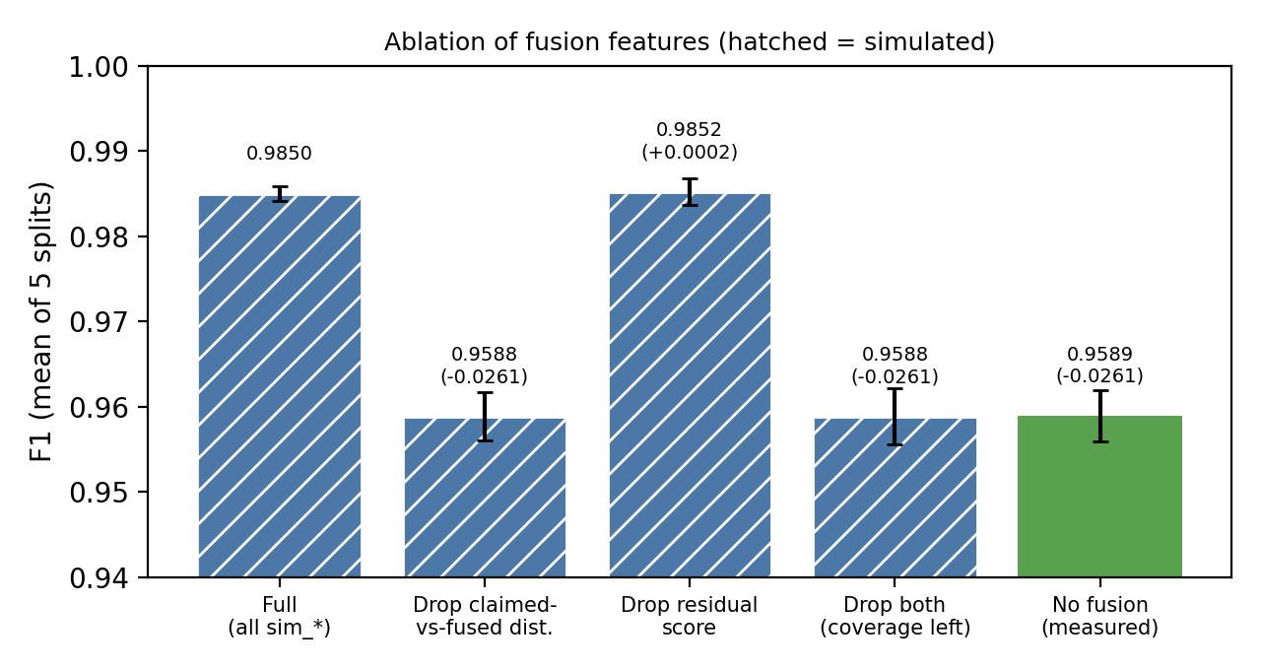
Figure 5. Ablation of the fusion features (hatched = simulated; error bars = one standard deviation).
3.3 Spoof detection by the fusion features alone
Used on its own, the claimed-versus-fused distance separates spoofed from genuine windows with ROC-AUC 0.962 for offsets of 30 to 300 m and 0.874 for 10 to 50 m (Table 4). The residual score reaches 0.395 and 0.455, both below the 0.5 expected from a random guess.
Table 4. ROC-AUC of single features for spoofed versus genuine vehicle-windows (SIMULATED).
Offset | Feature | ROC-AUC
30-300 m | Claimed-vs-fused distance | 0.962
30-300 m | Angular-consistency residual | 0.395
10-50 m | Claimed-vs-fused distance | 0.874
10-50 m | Angular-consistency residual | 0.455

3.4 Per-attack-class results
Figure 6 and Table 5 shows F1 per attack class, each class scored against all genuine windows. Without fusion, 17 of the 19 classes reach F1 between 0.869 and 0.952. Class 2 is the exception: F1 is 0.000 and its ROC-AUC is near chance, so kinematic features cannot separate it from genuine traffic. Class 9 is also weak (0.739). With the simulated fusion features they rise to 0.792 and 0.872, but only because the simulation treats every class as position spoofing.
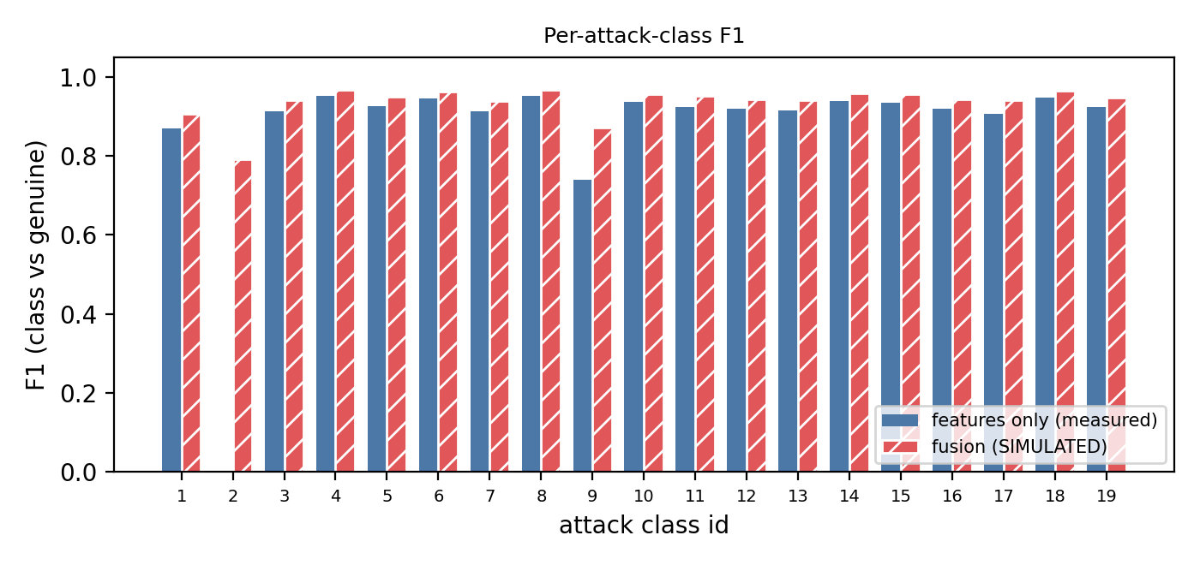
Figure 6. F1 per attack class, class versus genuine (hatched = simulated fusion features).
Table 5. F1 per attack class and number of test windows (the last two columns use SIMULATED fusion features).
Class | Windows | Features only | Graph | Fusion (sim.) | Graph + fusion (sim.)
1 | 152 | 0.869 | 0.916 | 0.906 | 0.911
2 | 146 | 0.000 | 0.000 | 0.792 | 0.774
3 | 241 | 0.914 | 0.950 | 0.941 | 0.947
4 | 427 | 0.951 | 0.971 | 0.966 | 0.969
5 | 261 | 0.926 | 0.958 | 0.949 | 0.954
6 | 365 | 0.946 | 0.969 | 0.963 | 0.967
7 | 217 | 0.912 | 0.950 | 0.939 | 0.946
8 | 424 | 0.952 | 0.972 | 0.968 | 0.970
9 | 315 | 0.739 | 0.750 | 0.872 | 0.863
10 | 325 | 0.936 | 0.963 | 0.957 | 0.961
11 | 297 | 0.924 | 0.953 | 0.952 | 0.956
12 | 285 | 0.919 | 0.952 | 0.943 | 0.954
13 | 230 | 0.914 | 0.948 | 0.940 | 0.946
14 | 320 | 0.938 | 0.965 | 0.958 | 0.962
15 | 301 | 0.935 | 0.963 | 0.956 | 0.960
16 | 237 | 0.919 | 0.954 | 0.944 | 0.950
17 | 258 | 0.907 | 0.940 | 0.941 | 0.946
18 | 387 | 0.949 | 0.971 | 0.965 | 0.969
19 | 251 | 0.923 | 0.956 | 0.947 | 0.953

4. Discussion
Strong kinematic baseline. Checks of claimed speed against actual movement, heading changes and message timing already separate most attackers (F1 0.969). This is in line with earlier work on VeReMi in which plausibility-style features feed classical learners [3]. The result is measured, not simulated.
Graph context adds little. Embeddings from the spatiotemporal graph leave F1 unchanged and only halve the false-positive rate. A plausible reason is that VeReMi attackers act independently, so neighbouring vehicles carry little evidence beyond what each vehicle’s own history shows.
Why the residual fails and the distance works. All UAVs measure the same physical transmitter, so their bearings agree with each other whatever position the message claims; the residual measures only bearing noise. A lie about position shows up instead as a gap between the claimed position and the position implied by the bearings, which is what the claimed-versus-fused distance captures. The residual would help only when bearings disagree, for example when several physical sources are involved, which the simulation does not model.
Relation to related work. Directional-antenna position checks have been proposed on the vehicle side [4]; here the direction measurement comes from elevated UAV observers and is fused cooperatively in the spirit of [5]. Whether this works on real traffic cannot be answered from the present data.
5. Limitations and Threats to Validity
- The fusion results are simulated. Every attack class is treated as position spoofing by 30 to 300 m; real VeReMi attacks include speed and denial-of-service types that do not falsify position, so the simulated gain is an upper bound.
- Coverage is decided from the claimed position, which is not how radio propagation behaves. UAV positioning error, antenna error beyond 2° Gaussian noise and GPS error beyond the dataset’s noise columns are not modelled.
- The task is attack versus genuine over 19 numeric classes; the classes are not mapped to attack names, and the study is not Sybil-only.
- The baseline uses each sender’s history because the table has no receiver-side data, so it is stronger than a strict single-observer detector and the margin for fusion is smaller.
- Only 20% of senders are used, the main tables use one fixed split (five splits only for the ablation), and no hyperparameters were tuned.
6. Conclusion
On real data, kinematic and trust features already detect attackers with an F1 score of 0.969, and graph embeddings add no accuracy. Under the stated simulation, cooperative multi-UAV fusion raises F1 to 0.988; the ablation attributes the whole gain to the claimed-versus-fused distance, while the angular-consistency residual contributes nothing. These cooperative results are simulated upper bounds and should be validated on data that includes true transmitter positions.
References
[1] J. Kamel, M. Wolf, R. W. van der Heijden, A. Kaiser, P. Urien, and F. Kargl, “VeReMi Extension: A dataset for comparable evaluation of misbehavior detection in VANETs,” in Proc. IEEE Int. Conf. Commun. (ICC), 2020.
[2] O. Slama, B. Alaya, and S. Zidi, “Towards misbehavior intelligent detection using guided machine learning in vehicular ad-hoc networks (VANET),” Inteligencia Artificial, vol. 25, no. 70, pp. 138–154, 2022, doi: 10.4114/intartif.vol25iss70pp138-154.
[3] S. So, P. Sharma, and J. Petit, “Integrating plausibility checks and machine learning for misbehavior detection in VANET,” in Proc. 17th IEEE Int. Conf. Mach. Learn. Appl. (ICMLA), 2018, pp. 564–571.
[4] M. Thomas, A. Borah, and A. Paranjothi, “Trust-aware Sybil attack detection for resilient vehicular communication,” Internet Technology Letters, 2024, arXiv:2411.07520.
[5] B. Ananthasubramaniam and U. Madhow, “Cooperative localization using angle of arrival measurements: Sequential algorithms and non-line-of-sight suppression,” arXiv:1206.3988, 2012.
[6] T. Chen and C. Guestrin, “XGBoost: A scalable tree boosting system,” in Proc. 22nd ACM SIGKDD Int. Conf. Knowl. Discov. Data Min., 2016, pp. 785–794.
[7] A. Grover and J. Leskovec, “node2vec: Scalable feature learning for networks,” in Proc. 22nd ACM SIGKDD Int. Conf. Knowl. Discov. Data Min., 2016, pp. 855–864.
[8] L. Breiman, “Random forests,” Mach. Learn., vol. 45, no. 1, pp. 5–32, 2001.

