Cooperative Multi-UAV Angle-of-Arrival Fusion for Misbehaviour and Sybil Attack Detection in Vehicular Networks: Evaluation on the VeReMi Extension Dataset
Prakash R (Reg. No. 24BCE0469)
Joshua Daniel D (Reg. No. 24BCE0436)
Saryu M (Reg. No. 24BCE2524)
BCSE308L Computer Networks, [Department], [Institution Name], [City, Country]
Abstract—Vehicles in a vehicular ad hoc network (VANET) broadcast basic safety messages that carry self-reported position, speed and heading, so a malicious node can lie, or pose as several vehicles at once in a Sybil attack, without any receiver being able to check the claim directly. This paper studies whether direction measurements from several unmanned aerial vehicles (UAVs) can expose such lies. We build an end-to-end pipeline on the public VeReMi Extension dataset (3.19 million messages, 19 attack classes): a sender-history baseline classifier, a virtual multi-UAV observer layer, cooperative angle-of-arrival (AoA) fusion by sequential linearised LMMSE estimation, window-level features, a spatiotemporal graph with node2vec embeddings, and an XGBoost classifier. Because the dataset contains only claimed positions, the fusion layer is evaluated under an explicit simulation in which attackers transmit from a hidden position offset by 30 to 300 m from the claim. On real data the kinematic and trust features alone reach an F1 score of 0.969, and graph embeddings add no meaningful gain (F1 0.970). Under the simulation, fusion raises F1 to 0.988, and an ablation shows that the gain comes entirely from the distance between the claimed and the fused position (about +0.026 F1), while the angular-consistency residual carries no signal. The simulated results are upper bounds that still need validation on data with true transmitter positions.
Keywords—Vehicular networks, Sybil attack, Misbehaviour detection, Angle of arrival, UAV, Cooperative localization
I. INTRODUCTION
Vehicular ad hoc networks let cars, trucks and roadside equipment exchange short broadcast messages, typically once or ten times per second, so that drivers and automated systems can anticipate hazards beyond line of sight. Each basic safety message (BSM) states where the sender is, how fast it travels and which way it heads. Safety applications trust those statements, which makes the network only as reliable as the least honest sender [2], [4].
A dishonest sender can falsify its own data, replay stale messages, flood the channel, or launch a Sybil attack, in which one physical device presents many identities to look like a crowd [1]. Fake identities can paint a phantom traffic jam, steer vehicles away from a clear road, or drown out genuine reports. Preventing identity forgery outright needs a trusted authority [1], and deploying one everywhere is costly, so a large body of work instead tries to detect misbehaviour after the fact. Existing detectors check whether claims are plausible and consistent [10], compare radio signal strength over time [3], [9], rely on roadside infrastructure [5], [6], or learn patterns from labelled traces [10], [16].
Most of these detectors share a limitation: the evidence they use is either the claim itself or a weak physical proxy for it. A receiver that hears one signal cannot tell whether the transmitter is really where it says it is. Direction-of-arrival measurements are a stronger physical witness, because the angle at which a signal reaches an antenna array does not depend on what the message says. A single observer gives only a bearing, but several observers at different places can intersect their bearings and estimate the true transmitter position [20]. Unmanned aerial vehicles (UAVs) flying above a road are natural observers because they have an elevated, largely unobstructed view of the traffic below.
This paper builds and evaluates that idea on a public benchmark. A difficulty shapes the whole study: the VeReMi Extension dataset [14], [16] records only the positions that vehicles claim, not where they truly were, so the benefit of cooperative bearings cannot be measured on it directly. We therefore keep two kinds of evidence strictly apart. Results that use only the dataset are measured. Results that use the fusion features rest on an explicit, documented simulation of position spoofing and are labelled simulated throughout.
The main contributions of this work are:
- An end-to-end, reproducible pipeline from raw VeReMi Extension records to attack-versus-genuine classification, with a sender-history baseline that works without receiver-side data.
- A virtual multi-UAV observer layer and a sequential linearised LMMSE fusion engine that turns bearings from several UAVs into a position estimate and a claimed-versus-fused distance.
- A transparent spoofing simulation, a graph-based classifier, and an ablation study that identifies which cooperative feature actually carries information.
- A negative result: the angular-consistency residual, a natural choice for a fusion consistency check, has no discriminative power in this setting, whereas the claimed-versus-fused distance does.
The remainder of the paper is organised as follows. Section II surveys related work. Section III describes the architecture. Section IV presents the methodology. Section V reports and discusses results. Section VI concludes.
II. LITERATURE SURVEY
Twenty studies were reviewed, ordered by year. Each is summarised below in paragraph form and compared in Table I. They cover the origin of the Sybil attack, infrastructure-based and signal-based detection, learning-based misbehaviour detection, benchmark datasets and cooperative localisation.
A. Paragraph review
Douceur (2002) introduced the Sybil attack, in which one faulty entity presents many identities to a peer-to-peer system and thereby controls a disproportionate share of it. His analysis concludes that, without a logically centralised authority vouching for identities, such attacks are essentially always possible unless unrealistic assumptions about resource parity and coordination hold. The paper named the attack and framed the problem that all later detection work addresses [1].
Hubaux, Čapkun and Luo (2004) argue that road safety, traffic management and driver convenience increasingly depend on information technology, and that the security and privacy consequences of this shift had been overlooked by researchers. Their article highlighted vehicular security as a research topic and set out concerns that later architectures had to answer [2].
Xiao, Yu and Gao (2006) propose a lightweight, distributed scheme in which vehicles test the positions claimed by neighbours against signal-strength statistics gathered over time. Traffic patterns and roadside base stations are used so that Sybil nodes cannot vouch for one another. Their statistical algorithms markedly reduce the error rate of position verification [3].
Raya and Hubaux (2007) analyse threats to vehicular networks, propose a security architecture and a set of protocols, and show that the protocols protect privacy while analysing their robustness and efficiency. The work remains a standard reference for the design of vehicular security systems [4].
Park et al. (2009) let roadside units issue timestamps and observe that two vehicles rarely pass several units at the same moment, so identical timestamp series reveal several identities sent from one vehicle. The method needs no dedicated vehicular public-key infrastructure and targets the early deployment stage, when roadside units exist but few vehicles are network-capable [5].
Zhou et al. (2011) present P2DAP, a lightweight and scalable protocol in which fixed road-side boxes passively overhear traffic so that a user posing as several vehicles can be detected in a distributed manner without vehicles revealing their identities [6].
Ruj et al. (2011) let each node check an alert message by comparing it with recent messages, with reported and estimated vehicle positions, and with the sender’s later behaviour. They argue that nodes can thereby identify false information and misbehaving senders without voting, which gives resilience to Sybil attacks, and that imposing fines instead of revoking credentials lowers computation and communication cost [7].
Yu, Xu and Xiao (2013) study whether signal-strength distributions can expose Sybil nodes. They first propose a cooperative position-verification method that uses a RANSAC-based algorithm to resist fabricated data, and then build a statistical Presence Evidence System. Simulations on realistic United States maps and traffic models show the scheme works without special positioning hardware [8].
Yao et al. (2017) detect Sybil attacks by comparing the similarity of received-signal-strength time series, treating each sender’s pattern as a distinctive voiceprint. The approach avoids position estimates that depend on a fixed radio propagation model and needs no central infrastructure. Simulations and real-world experiments show it to be effective, low-cost and more accurate in varying environments [9].
So, Sharma and Petit (2018) feed plausibility-check results as features to K-nearest-neighbour and support-vector-machine classifiers on the VeReMi dataset, targeting location-spoofing misbehaviour. They report raising detection precision by more than 20% while keeping recall within 5%, and show that detected misbehaviour can be sorted into known attack types to help choose countermeasures [10].
van der Heijden, Lukaseder and Kargl (2018) released VeReMi, a public dataset created so that misbehaviour detectors can be evaluated and compared on the same data, which was difficult before because researchers used private traces. Later learning-based detectors, for example [10], have used it as a benchmark [11].
Hamdan, Hudaib and Awajan (2019) combine the footprint and P2DAP schemes into a hybrid algorithm that relies on encryption, authentication and vehicle trajectory data, implemented in ns-2 with SUMO and MOVE traffic. Their comparison finds P2DAP performs better as the number of vehicles grows, while footprint performs better as vehicle speed grows [12].
Baza et al. (2019) have roadside units issue signed, timestamped location proofs that a vehicle can obtain only after solving a proof-of-work puzzle. Proofs from consecutive units form a trajectory that serves as an anonymous identity, and an event manager flags Sybil identities whose trajectories overlap, since they must come from one vehicle. They report high detection rates, low false negatives and acceptable overhead [13].
Kamel et al. (2020a) extend VeReMi with a realistic sensor error model, a new set of attacks and more data points, and supply benchmark detection metrics obtained with local detectors and a simple misbehaviour detection mechanism. The extension is the data source on which this study builds [14].
Kamel et al. (2020b) present F2MD, an open-source simulation framework that lets researchers build, test and compare misbehaviour detection algorithms in cooperative intelligent transport systems, and demonstrate it with example scenarios [15].
Slama, Alaya and Zidi (2022) propose a misbehaviour detection method that combines feature selection with machine learning to classify misbehaviours in vehicular environments. The same group released the labelled VeReMi_Extension table used in the present work [16].
Kakulla and Malladi (2022) propose SDTC, which builds mobility matrices from vehicle data collected by base stations, reduces them to eigenvalue features and applies an Extreme Learning Machine to identify Sybil nodes. In SUMO simulations of a Manhattan grid with 800 vehicles, accuracy increases and loss falls as training proceeds [17].
Thomas, Borah and Paranjothi (2024) propose TASER, which scores each vehicle’s trust from the integrity of data it shares inside local clusters, examines low-scoring vehicles statistically, and verifies claimed GPS positions with directional antennas. In OMNeT++, SUMO and Veins simulations it cut detection time by up to 66% in urban settings and kept accuracy within 3% with up to 30% Sybil nodes, without roadside infrastructure [18].
Khan, Utsho and Jahan (2026) build more distinct vehicle trajectories from GPS data and apply DBSCAN clustering to flag fake identities, without roadside units, dense traffic or manual parameter tuning. They report about 72% fewer false positives in both dense and sparse areas, 52% fewer false negatives and a 99% detection rate in sparse areas, and shorter detection times [19].
Ananthasubramaniam and Madhow (2012) show how several nodes can localise a source from angle-of-arrival measurements with sequential algorithms, and how to suppress outliers caused by multipath reflections in non-line-of-sight conditions. Exhaustive testing of all measurement subsets would be needed for maximum-likelihood estimation, so they offer a randomised alternative whose cost is linear in the number of measurements. Our fusion engine follows this sequential idea [20].
TABLE I. COMPARATIVE SUMMARY OF THE SURVEYED PAPERS
S.No | Title of the paper, authors, year | Methodology | Key findings | Advantages and limitations
1 | The Sybil attack. J. R. Douceur, 2002 [1] | Theoretical analysis of identity forgery in distributed systems. | Without a trusted identity authority Sybil attacks cannot be ruled out in general. | Adv: foundational, domain-independent. Lim: no detector; not specific to vehicles.
2 | The security and privacy of smart vehicles. J.-P. Hubaux, S. Čapkun, J. Luo, 2004 [2] | Overview and threat discussion for connected vehicles. | Security and privacy are open problems for smart vehicles. | Adv: early, clear framing. Lim: no detection mechanism or evaluation.
3 | Detection and localization of Sybil nodes in VANETs. B. Xiao, B. Yu, C. Gao, 2006 [3] | Position verification from signal-strength statistics. | Statistical tests sharply lower position-verification errors. | Adv: distributed and lightweight. Lim: uses roadside base stations; signal strength is an indirect position cue.
4 | Securing vehicular ad hoc networks. M. Raya, J.-P. Hubaux, 2007 [4] | Threat analysis, architecture and protocol design. | A security architecture can protect vehicular networks while preserving privacy. | Adv: comprehensive treatment. Lim: centred on cryptographic security design rather than behavioural detection.
5 | Defense against Sybil attack in vehicular ad hoc network based on roadside unit support. S. Park, B. Aslam, D. Turgut, C. C. Zou, 2009 [5] | Timestamp series issued by roadside units. | Matching timestamp series expose multiple identities of one vehicle. | Adv: no dedicated vehicular PKI. Lim: requires roadside units along the route.
6 | P2DAP: Sybil attacks detection in vehicular ad hoc networks. T. Zhou, R. R. Choudhury, P. Ning, K. Chakrabarty, 2011 [6] | Passive overhearing by fixed road-side boxes. | Distributed detection of multi-identity users without identity disclosure. | Adv: privacy-preserving, scalable. Lim: depends on deployed road-side boxes.
7 | Data-centric misbehavior detection in VANETs. S. Ruj, M. A. Cavenaghi, Z. Huang, A. Nayak, I. Stojmenovic, 2011 [7] | Data-centric checks of alerts against context and later behaviour. | False information and misbehaving senders can be found without voting. | Adv: no voting round. Lim: preprint; relies on claimed data, so a consistent lie is harder to catch.
8 | Detecting Sybil attacks in VANETs. B. Yu, C.-Z. Xu, B. Xiao, 2013 [8] | RANSAC-based cooperative position verification plus a statistical evidence system. | Sybil nodes are exposed without extra positioning hardware. | Adv: robust to fabricated data. Lim: evaluated in simulation; relies on signal-strength statistics.
9 | Voiceprint: A novel Sybil attack detection method based on RSSI for VANETs. Y. Yao, B. Xiao, G. Wu, X. Liu, Z. Yu, K. Zhang, X. Zhou, 2017 [9] | Similarity of RSSI time series between senders. | Effective, low-cost detection across varying environments. | Adv: no propagation model or infrastructure. Lim: signal strength is only an indirect fingerprint.
10 | Integrating plausibility checks and machine learning for misbehavior detection in VANET. S. So, P. Sharma, J. Petit, 2018 [10] | Plausibility checks as features for KNN and SVM on VeReMi. | Precision rises by over 20% with recall within 5%; attack types can be classified. | Adv: simple, interpretable features. Lim: depends on claimed data only.
11 | VeReMi: A dataset for comparable evaluation of misbehavior detection in VANETs. R. W. van der Heijden, T. Lukaseder, F. Kargl, 2018 [11] | Simulated traffic with injected attacks and labelled logs. | A shared dataset makes detector results reproducible and comparable. | Adv: public and widely used. Lim: simulated traffic; limited attack variety in the original release.
12 | Detecting Sybil attacks in vehicular ad hoc networks. S. Hamdan, A. Hudaib, A. Awajan, 2019 [12] | Hybrid of footprint and P2DAP using trajectories and authentication. | Each base scheme wins in a different traffic regime; no numeric figures are given in the abstract. | Adv: combines complementary schemes. Lim: simulation only; preprint.
13 | Detecting Sybil attacks using proofs of work and location in VANETs. M. Baza, M. Nabil, N. Bewermeier, K. Fidan, M. Mahmoud, M. Abdallah, 2019 [13] | Proof-of-work location proofs forming trajectory identities. | High Sybil detection with low false negatives and acceptable overhead. | Adv: anonymous and cheap to verify. Lim: needs roadside units and a central event manager.
14 | VeReMi Extension: A dataset for comparable evaluation of misbehavior detection in VANETs. J. Kamel, M. Wolf, R. W. van der Heijden, A. Kaiser, P. Urien, F. Kargl, 2020 [14] | Extended dataset with sensor error model and new attacks. | A richer benchmark with baseline metrics for local detectors. | Adv: more attacks and realistic noise. Lim: claimed positions only; no true transmitter positions.
15 | Simulation framework for misbehavior detection in vehicular networks. J. Kamel, M. R. Ansari, J. Petit, A. Kaiser, I. Ben Jemaa, P. Urien, 2020 [15] | Open-source simulator covering the full detection chain. | A common tool for developing and comparing detectors. | Adv: reproducible and extensible. Lim: simulation fidelity bounds conclusions.
16 | Towards misbehavior intelligent detection using guided machine learning in vehicular ad-hoc networks (VANET). O. Slama, B. Alaya, S. Zidi, 2022 [16] | Feature selection guiding machine-learning classifiers. | Guided feature selection supports classification of misbehaviours. | Adv: supplies a ready labelled table. Lim: uses claimed message data only.
17 | Sybil attack detection in VANET using machine learning approach. S. Kakulla, S. Malladi, 2022 [17] | Mobility-matrix eigenvalue features with an Extreme Learning Machine. | Accuracy rises and loss falls over training epochs in simulation. | Adv: learning-based and automatic. Lim: depends on base-station data; results shown graphically only.
18 | Trust-aware Sybil attack detection for resilient vehicular communication. M. Thomas, A. Borah, A. Paranjothi, 2024 [18] | Cluster-level trust scores plus directional-antenna position checks. | Up to 66% shorter detection time; accuracy within 3% up to 30% Sybil nodes. | Adv: infrastructure-free. Lim: simulation only; relies on directional antennas on vehicles.
19 | A robust framework for Sybil attack detection in vehicular ad hoc networks. M. S. T. Khan, M. S. A. Utsho, M. Jahan, 2026 [19] | GPS trajectory construction with DBSCAN clustering. | About 72% fewer false positives; 99% detection rate in sparse areas. | Adv: no infrastructure or tuning. Lim: preprint; trajectory similarity can misfire for vehicles on the same route.
20 | Cooperative localization using angle of arrival measurements: Sequential algorithms and non-line-of-sight suppression. B. Ananthasubramaniam, U. Madhow, 2012 [20] | Sequential AoA localisation with randomised outlier suppression. | Accurate cooperative localisation despite NLOS outliers at linear cost. | Adv: efficient, robust. Lim: general localisation; no misbehaviour-detection application.
B. Research gap
Taken together, the surveyed detectors fall into three groups. Infrastructure-based schemes [3], [5], [6], [8], [13] need roadside equipment. Signal-strength schemes [3], [8], [9] use an indirect fingerprint of position. Learning-based schemes [10], [16], [17] work from the claims themselves. None of them combines an elevated mobile observer with a direct bearing measurement and cooperative estimation of the true transmitter position, although the localisation methods needed for it exist [20]. This study fills that gap at the level of an evaluated design, while being explicit about what the available data allows.
III. ARCHITECTURE
Fig. 1 shows the architecture. Real data flows through the unshaded blocks; the shaded block marks the one simulated assumption on which the cooperative path depends.
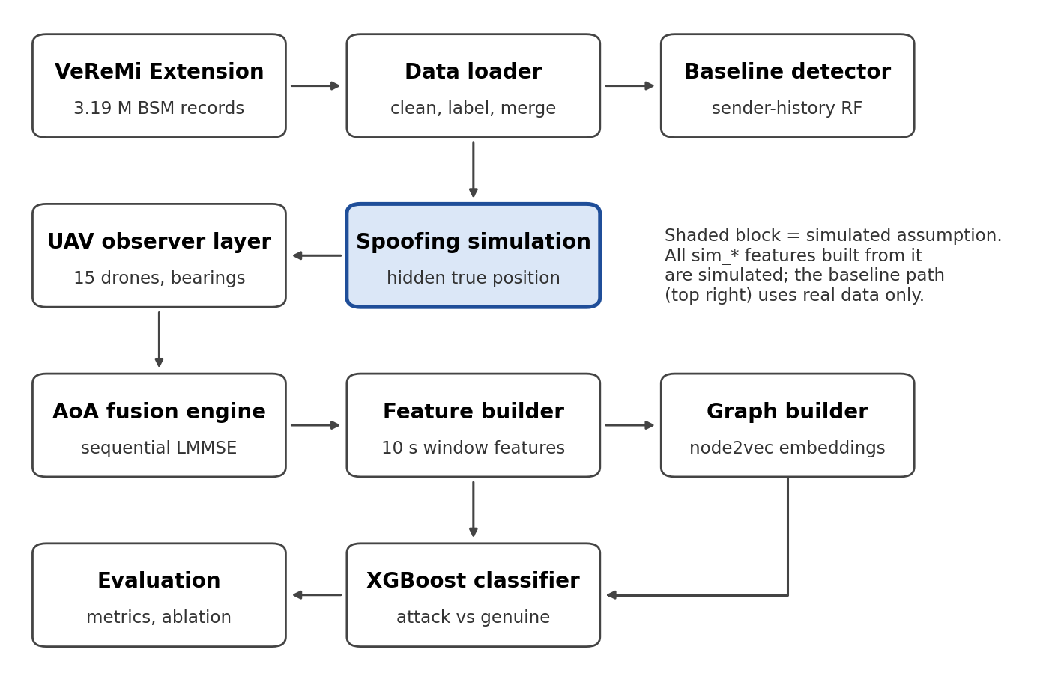
Fig. 1. Architecture of the proposed pipeline. The shaded block is a simulated assumption.
A. VeReMi Extension data. The source of all messages: 3,194,808 BSM records from 24,663 senders, each with claimed position, speed, acceleration, heading, noise columns and a class label (0 genuine, 1 to 19 attack types) [14], [16].
B. Data loader. Reads the raw table, standardises columns, derives speed and heading magnitudes, attaches a binary attacker label and writes a merged Parquet file that every later stage consumes.
C. Baseline detector. A Random Forest [23] that scores each message from the sender’s own history: gap between claimed and implied speed, heading change, message-interval deviation, reported noise and a trust value blending the sender’s recent plausibility with that of its pseudonym. It uses real data only and sets the reference accuracy.
D. UAV observer layer. Places 15 virtual drones at 100 m altitude (cluster centres of traffic density) and computes, for every message heard within 250 m, the azimuth and elevation at which the signal arrives. Overlap between drones is what makes cooperation possible: in the experimental sample 67% of messages are heard by two or more drones.
E. Spoofing simulation (simulated). Because true positions are absent, attackers are given a hidden true position equal to the claimed position minus a random 30 to 300 m offset. The drones measure bearings to that hidden position. Which drones hear a message is decided from the claimed position so that coverage cannot reveal the label.
F. AoA fusion engine. Combines the bearings of two or more drones into one position estimate by sequential linearised LMMSE updates, and outputs the fused position, a per-observer residual and the distance between claimed and fused position.
G. Feature builder. Aggregates per vehicle and 10 s window: baseline features, speed variance, heading-change rate, position variance and the fusion features, which carry a sim_ prefix to keep them identifiable as simulated.
H. Graph builder. Creates one node per (vehicle, window), links consecutive windows of a vehicle and each vehicle to its five nearest neighbours within 150 m, and learns 32-dimensional node2vec embeddings [22] without using labels.
I. XGBoost classifier. Takes features, optionally with embeddings, and predicts attacker versus genuine [21]. Training and test sets are split by vehicle.
J. Evaluation. Computes accuracy, precision, recall, F1, ROC-AUC, PR-AUC and false-positive rate overall and per attack class, draws curves, and runs the ablation study.
IV. PROPOSED METHODOLOGY
A. Data and sampling
The VeReMi Extension table [14], [16] contains 3,194,808 messages, of which 40.5% belong to attack classes 1 to 19. To keep experiments tractable on a CPU, whole senders (never individual messages) are sampled: 20% of senders, about 625,000 messages, which aggregate to 59,108 vehicle-window rows with 30.2% attacker windows. Sampling by sender keeps each vehicle’s message sequence intact, which the history-based features need.
B. Baseline features
For every message the baseline computes causal features from the sender’s earlier messages only. With claimed positions (x_{k}, y_{k}) at times t_{k}, the implied speed is
v_{impl}(k) = √[(x_{k} − x_{k−1})² + (y_{k} − y_{k−1})²] / (t_{k} − t_{k−1}) (1)
and the speed gap is |v_{impl}(k) − v_{claim}(k)|. Further features are the change of claimed heading, the angle between the implied direction of motion and the claimed heading, the deviation of the inter-message gap from the nominal 1 s, the reported position and speed noise, and a trust value T = 0.7 T_{direct} + 0.3 T_{indirect}, where T_{direct} is the share of the sender’s last five messages whose speed gap is below 5 m/s and T_{indirect} is the same measure accumulated over the sender’s pseudonym. The weights and threshold are design choices of this study.
C. UAV observation model
Each UAV i at position o_{i} = (x_{i}, y_{i}, z_{i}) hears a message when the horizontal range to the sender is below 250 m. The azimuth and elevation of the arrival direction are
θ_{i} = atan2(y − y_{i}, x − x_{i}), φ_{i} = atan2(z_{i}, r_{i}) (2)
where (x, y) is the transmitter position, r_{i} the horizontal range and z_{i} the UAV altitude (senders are at ground level). Bearings carry independent Gaussian error of 2° standard deviation, an assumed value rather than a measured one.
D. Cooperative AoA fusion
For a message heard by m ≥ 2 UAVs the transmitter position p = (x, y) is estimated by processing the bearings one after another, starting from the intersection of the first two bearings and a wide prior (200 m standard deviation). Each bearing updates the estimate and its covariance P through
K = P Hᵀ (H P Hᵀ + σ²)⁻¹ (3)
p ← p + K · wrap(θ_{i} − h_{i}(p)) (4)
P ← P − K H P (5)
where h_{i}(p) = atan2(y − y_{i}, x − x_{i}), H = [−Δy/r², Δx/r²] is its Jacobian, σ is the bearing standard deviation and wrap(·) maps an angle to (−π, π]. The pass is repeated once, re-linearising at the previous estimate. This sequential structure follows the cooperative localisation approach of [20]. Two outputs feed the classifier: the claimed-versus-fused distance d = ‖p_{fused} − p_{claimed}‖ and, when three or more UAVs hear a message, the residual score, the root-mean-square of wrap(θ_i − h_{i}(p_{fused})). With only two bearings the residual is zero by construction, so it is undefined there.
E. Spoofing simulation (simulated)
The dataset has no true transmitter positions, so a simulation supplies them. A genuine message has true position equal to its claimed position. An attacker message has true position equal to the claimed position minus an offset with uniformly random direction and a magnitude drawn uniformly from 30 to 300 m. The UAVs measure bearings to the true position. Coverage is decided from the claimed position, because deciding it from the true position lets the number of hearing UAVs reveal the label, a leak we found and removed during the ablation study. Two simplifications limit what the simulation can claim: every attack class is treated as position spoofing, although some VeReMi attacks (for example speed or denial-of-service types) do not falsify position, and the coupling of coverage to the claimed position is not how radio propagation works.
F. Window features
For each vehicle and 10 s window the feature vector contains the window means of the baseline features, the window maximum speed gap, speed variance, heading-change rate and position variance, and the aggregated fusion features: median and maximum claimed-versus-fused distance (clipped at 500 m because nearly parallel bearings give unstable fixes), mean number of hearing UAVs, mean residual score, share of single-observer sub-windows and the number of fused sub-windows. Windows without any fused sub-window keep missing values, which tree models handle natively.
G. Graph and embeddings
A graph with one node per (vehicle, window) links a vehicle’s consecutive windows and connects each vehicle to up to five nearest neighbours within 150 m in the same window. node2vec [22] (dimension 32, walk length 20, 10 walks per node) produces embeddings without labels, so they can be computed before the train/test split without leaking labels.
H. Classification and evaluation
XGBoost [21] (300 trees, depth 6, learning rate 0.1, subsample 0.8, column sampling 0.8) classifies windows. The 70/30 train/test split is by vehicle, so no vehicle appears in both sets. Four variants are compared: features only, features with graph embeddings, features with simulated fusion features, and all three. We report accuracy, precision, recall, F1, ROC-AUC, PR-AUC and false-positive rate (FPR), overall and per attack class, and an ablation over five random splits.
V. RESULTS AND DISCUSSION
A. Experimental setup
All experiments use a 20% sample of senders (whole senders, so message sequences stay intact), giving 59,108 vehicle-window rows of which 30.2% are attacker windows. The train/test split is by vehicle: 17,888 windows (5,439 of them attacks) are held out and never seen in training. Four variants are compared with identical test rows: features only, features with node2vec embeddings, features with simulated fusion features, and all three. Variants that use fusion features are marked SIMULATED in every table and figure, because the dataset has only claimed positions and the fusion inputs come from the spoofing simulation of Section IV [14], [16].
B. Overall comparison
Table II reports the held-out results. Without any simulated input, the kinematic and trust features reach an F1 score of 0.969 and a ROC-AUC of 0.979. Adding node2vec embeddings changes F1 by +0.001 and ROC-AUC by -0.001, so the graph adds no accuracy gain, although the false-positive rate falls from 0.0034 to 0.0018.
Adding the simulated fusion features lifts F1 to 0.988 and ROC-AUC to 0.9985; combining all three gives 0.987 and 0.9983. The gain comes mainly from recall, which rises from 0.947 to 0.981, while precision stays near 0.995. The ROC curves in Fig. 3 show the same ordering: the two non-fusion curves almost coincide, as do the two fusion curves.
TABLE II. HELD-OUT RESULTS (SHADED = SIMULATED FUSION FEATURES)
Model | F1 | ROC-AUC | FPR | Evidence
features only | 0.969 | 0.9794 | 0.0034 | Measured
graph | 0.970 | 0.9780 | 0.0018 | Measured
fusion | 0.988 | 0.9985 | 0.0022 | Simulated
graph + fusion | 0.987 | 0.9983 | 0.0020 | Simulated
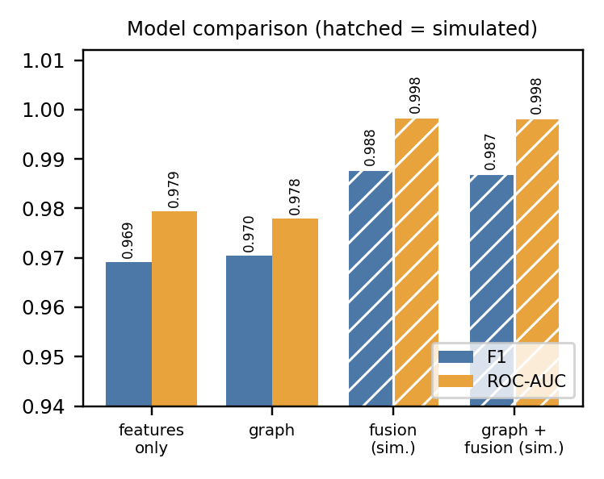
Fig. 2. F1 and ROC-AUC of the four variants (hatched = simulated).
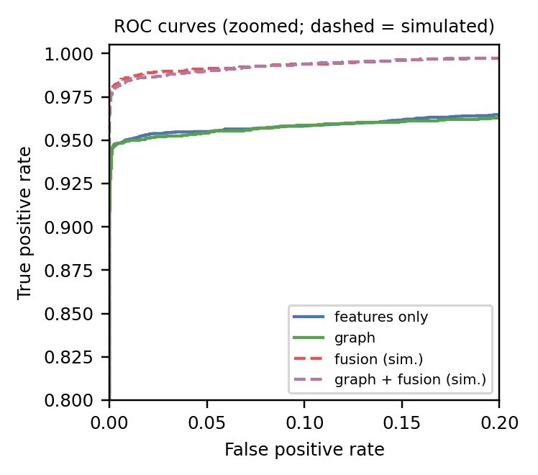
Fig. 3. ROC curves (zoomed). Dashed = simulated fusion features.
C. Ablation of the fusion features
Table III reports the ablation over five random vehicle-level splits. Removing the claimed-versus-fused distance lowers F1 from 0.9850 to 0.9588 (-0.0261), which equals the model with no fusion features at all (0.9589). That single feature therefore carries the whole gain. Removing the residual score changes F1 by 0.0002, well inside the split-to-split standard deviation of about 0.001 to 0.002. Dropping both leaves only coverage counts and gives 0.9588, which confirms that coverage no longer leaks the label. The same pattern holds with graph embeddings (full 0.9841, without the distance 0.9579).
TABLE III. ABLATION, MEAN OF FIVE SPLITS (ALL ROWS BUT THE LAST ARE SIMULATED)
Variant | F1 (mean ± sd) | Δ F1 | Evidence
Full (all fusion features) | 0.9850 ± 0.0009 | — | Simulated
Drop claimed-vs-fused distance | 0.9588 ± 0.0028 | -0.0261 | Simulated
Drop residual score | 0.9852 ± 0.0015 | +0.0002 | Simulated
Drop both (coverage counts left) | 0.9588 ± 0.0033 | -0.0261 | Simulated
No fusion features | 0.9589 ± 0.0030 | -0.0261 | Measured
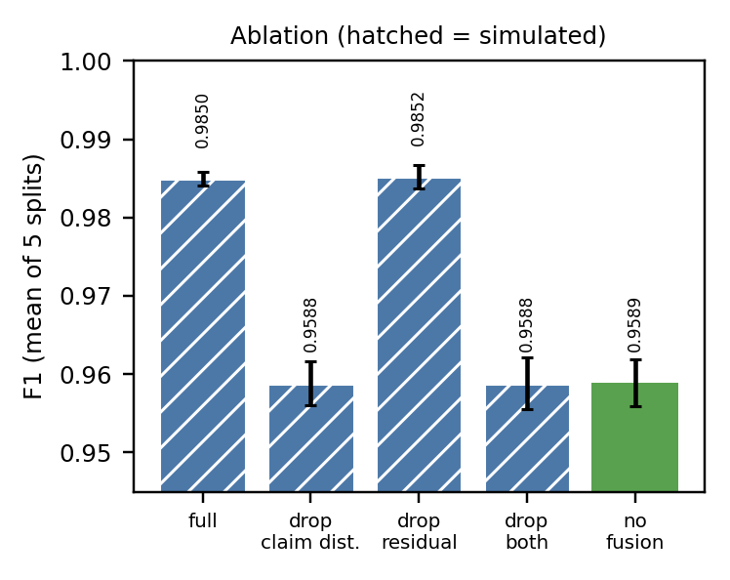
Fig. 4. Ablation of the simulated fusion features.
D. Spoof detection by the fusion features alone
Used on its own, the claimed-versus-fused distance separates spoofed from genuine windows with ROC-AUC 0.962 for offsets of 30 to 300 m and 0.874 for 10 to 50 m (Table IV). The residual score reaches 0.395 and 0.455, both below the 0.5 expected from a random guess.
TABLE IV. SPOOF DETECTION WITH A SINGLE FEATURE (SIMULATED)
Offset | Feature | ROC-AUC
30-300 m | Claimed-vs-fused distance | 0.962
30-300 m | Angular-consistency residual | 0.395
10-50 m | Claimed-vs-fused distance | 0.874
10-50 m | Angular-consistency residual | 0.455
E. Per-attack-class results
Fig. 5 shows F1 per attack class, each class scored against all genuine windows. Without fusion, 17 of the 19 classes reach F1 between 0.869 and 0.952. Class 2 is the exception: F1 is 0.000 and its ROC-AUC is near chance, so kinematic features cannot separate it from genuine traffic. Class 9 is also weak (0.739). With the simulated fusion features they rise to 0.792 and 0.872, but only because the simulation treats every class as position spoofing.
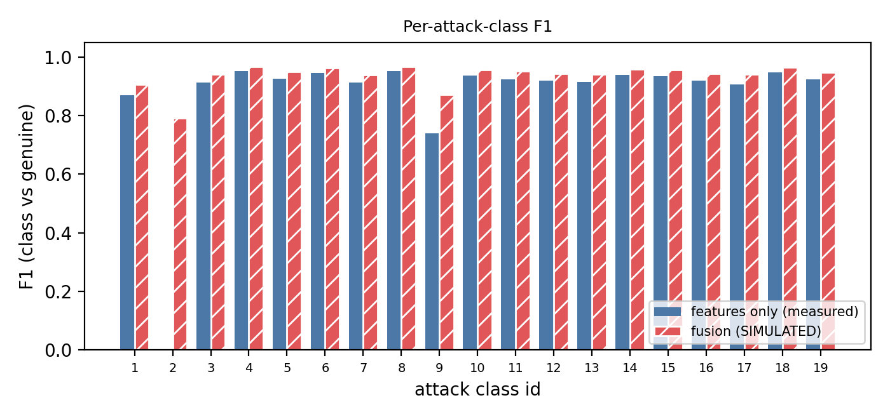
Fig. 5. F1 per attack class, class versus genuine (hatched = simulated fusion features).
F. Discussion
Strong kinematic baseline. Checks of claimed speed against actual movement, heading changes and message timing already separate most attackers (F1 0.969). This is in line with earlier work on VeReMi in which plausibility-style features feed classical learners [10]. The result is measured, not simulated.
Graph context adds little. Embeddings from the spatiotemporal graph leave F1 unchanged and only halve the false-positive rate. A plausible reason is that VeReMi attackers act independently, so neighbouring vehicles carry little evidence beyond what each vehicle’s own history shows.
Why the residual fails and the distance works. All UAVs measure the same physical transmitter, so their bearings agree with each other whatever position the message claims; the residual measures only bearing noise. A lie about position shows up instead as a gap between the claimed position and the position implied by the bearings, which is what the claimed-versus-fused distance captures. The residual would help only when bearings disagree, for example when several physical sources are involved, which the simulation does not model.
Relation to related work. Directional-antenna position checks have been proposed on the vehicle side [18]; here the direction measurement comes from elevated UAV observers and is fused cooperatively in the spirit of [20]. Whether this works on real traffic cannot be answered from the present data.
G. Threats to validity
- The fusion results are simulated. Every attack class is treated as position spoofing by 30 to 300 m; real VeReMi attacks include speed and denial-of-service types that do not falsify position, so the simulated gain is an upper bound.
- Coverage is decided from the claimed position, which is not how radio propagation behaves. UAV positioning error, antenna error beyond 2° Gaussian noise and GPS error beyond the dataset’s noise columns are not modelled.
- The task is attack versus genuine over 19 numeric classes; the classes are not mapped to attack names, and the study is not Sybil-only.
- The baseline uses each sender’s history because the table has no receiver-side data, so it is stronger than a strict single-observer detector and the margin for fusion is smaller.
- Only 20% of senders are used, the main tables use one fixed split (five splits only for the ablation), and no hyperparameters were tuned.
VI. CONCLUSION
We built and evaluated a pipeline that combines sender-history features, cooperative multi-UAV angle-of-arrival fusion and graph embeddings to detect misbehaving vehicles on the VeReMi Extension dataset. On real data, kinematic and trust features alone give an F1 score of 0.969, and graph embeddings add no accuracy. Under an explicit spoofing simulation, cooperative fusion raises F1 to 0.988, and the ablation shows that the distance between the claimed and the fused position carries the entire gain while the angular-consistency residual carries none.
These conclusions are limited by the simulation, which treats every attack class as position spoofing and idealises radio coverage and bearing error. The most valuable next step is to test the claimed-versus-fused distance on data that contains true transmitter positions, such as raw traces or a simulator that exports them. Further work includes mapping attack classes to names and restricting the simulated spoofing to position-falsifying ones, using the full data set, modelling realistic UAV and bearing errors, and extending the evaluation to colluding attackers.
REFERENCES
[1] J. R. Douceur, “The Sybil attack,” in Peer-to-Peer Systems (IPTPS 2002), ser. Lecture Notes in Computer Science, vol. 2429. Berlin, Germany: Springer, 2002, pp. 251–260.
[2] J.-P. Hubaux, S. Čapkun, and J. Luo, “The security and privacy of smart vehicles,” IEEE Security & Privacy Magazine, pp. 49–55, 2004.
[3] B. Xiao, B. Yu, and C. Gao, “Detection and localization of Sybil nodes in VANETs,” in Proc. Workshop on Dependability Issues in Wireless Ad Hoc Networks and Sensor Networks (DIWANS), Los Angeles, CA, USA, 2006, pp. 1–8.
[4] M. Raya and J.-P. Hubaux, “Securing vehicular ad hoc networks,” J. Comput. Secur., vol. 15, no. 1, pp. 39–68, 2007.
[5] S. Park, B. Aslam, D. Turgut, and C. C. Zou, “Defense against Sybil attack in vehicular ad hoc network based on roadside unit support,” in Proc. IEEE MILCOM, 2009, pp. 1–7.
[6] T. Zhou, R. R. Choudhury, P. Ning, and K. Chakrabarty, “P2DAP: Sybil attacks detection in vehicular ad hoc networks,” IEEE J. Sel. Areas Commun., vol. 29, no. 3, pp. 582–594, Mar. 2011.
[7] S. Ruj, M. A. Cavenaghi, Z. Huang, A. Nayak, and I. Stojmenovic, “Data-centric misbehavior detection in VANETs,” arXiv:1103.2404, 2011.
[8] B. Yu, C.-Z. Xu, and B. Xiao, “Detecting Sybil attacks in VANETs,” J. Parallel Distrib. Comput., vol. 73, no. 6, pp. 746–756, 2013.
[9] Y. Yao, B. Xiao, G. Wu, X. Liu, Z. Yu, K. Zhang, and X. Zhou, “Voiceprint: A novel Sybil attack detection method based on RSSI for VANETs,” in Proc. 47th IEEE/IFIP Int. Conf. Dependable Syst. Netw. (DSN), 2017.
[10] S. So, P. Sharma, and J. Petit, “Integrating plausibility checks and machine learning for misbehavior detection in VANET,” in Proc. 17th IEEE Int. Conf. Mach. Learn. Appl. (ICMLA), 2018, pp. 564–571.
[11] R. W. van der Heijden, T. Lukaseder, and F. Kargl, “VeReMi: A dataset for comparable evaluation of misbehavior detection in VANETs,” in Proc. SecureComm, 2018, arXiv:1804.06701.
[12] S. Hamdan, A. Hudaib, and A. Awajan, “Detecting Sybil attacks in vehicular ad hoc networks,” arXiv:1905.03507, 2019.
[13] M. Baza, M. Nabil, N. Bewermeier, K. Fidan, M. Mahmoud, and M. Abdallah, “Detecting Sybil attacks using proofs of work and location in VANETs,” arXiv:1904.05845, 2019.
[14] J. Kamel, M. Wolf, R. W. van der Heijden, A. Kaiser, P. Urien, and F. Kargl, “VeReMi Extension: A dataset for comparable evaluation of misbehavior detection in VANETs,” in Proc. IEEE Int. Conf. Commun. (ICC), 2020.
[15] J. Kamel, M. R. Ansari, J. Petit, A. Kaiser, I. Ben Jemaa, and P. Urien, “Simulation framework for misbehavior detection in vehicular networks,” IEEE Trans. Veh. Technol., vol. 69, no. 6, pp. 6631–6643, Jun. 2020, doi: 10.1109/TVT.2020.2984878.
[16] O. Slama, B. Alaya, and S. Zidi, “Towards misbehavior intelligent detection using guided machine learning in vehicular ad-hoc networks (VANET),” Inteligencia Artificial, vol. 25, no. 70, pp. 138–154, 2022, doi: 10.4114/intartif.vol25iss70pp138-154.
[17] S. Kakulla and S. Malladi, “Sybil attack detection in VANET using machine learning approach,” Ingénierie des Systèmes d’Information, vol. 27, no. 4, pp. 605–611, 2022.
[18] M. Thomas, A. Borah, and A. Paranjothi, “Trust-aware Sybil attack detection for resilient vehicular communication,” Internet Technology Letters, 2024, arXiv:2411.07520.
[19] M. S. T. Khan, M. S. A. Utsho, and M. Jahan, “A robust framework for Sybil attack detection in vehicular ad hoc networks,” arXiv:2606.11667, 2026.
[20] B. Ananthasubramaniam and U. Madhow, “Cooperative localization using angle of arrival measurements: Sequential algorithms and non-line-of-sight suppression,” arXiv:1206.3988, 2012.
[21] T. Chen and C. Guestrin, “XGBoost: A scalable tree boosting system,” in Proc. 22nd ACM SIGKDD Int. Conf. Knowl. Discov. Data Min., 2016, pp. 785–794.
[22] A. Grover and J. Leskovec, “node2vec: Scalable feature learning for networks,” in Proc. 22nd ACM SIGKDD Int. Conf. Knowl. Discov. Data Min., 2016, pp. 855–864.
[23] L. Breiman, “Random forests,” Mach. Learn., vol. 45, no. 1, pp. 5–32, 2001.

