**Project My Basecamp:**

My basecamp project aims to replicate the basic functionality of the widely-used project management and team collaboration tool called Basecamp launched in 2004. Basecamp offers a centralized platform for teams to organize their work, communicate effectively, and track progress on projects.

**Project Plan:**

* Requirements
* System Design
* Database Design
* Project Plan
* Testing
* Deployment

**Requirements:**

**Functional Requirements:**

* User should be able to create, edit and delete projects, add team members
* User should be able to create a new user, add team member, delete a user
* User should be able to log in and log out
* User authentication and authorization. Ability to add and remove the admin permission from a user.
* Task management: creating, assigning, and tracking tasks within projects.
* File sharing: upload, download, and manage files associated with projects.

**Non-Functional Requirements:**

* User-friendly interface for ease of navigation and task management
* Fast response times under the load of multiple users
* Ability to scale up for more projects and users as needed.
* Secure handling of data with proper authentication and authorization
* High availability and minimal downtime

**System Constraints:**

* Limited development resources and time constraints
* Single-page application architecture due to lightweight nature

**Assumptions and Dependencies:**

* Assumes stable internet connectivity for real-time features
* Dependent on third-party libraries for certain functionalities.

**Hardware interface:**

* No specific hardware interface requirements

**Memory Constraints:**

* Optimize memory usage for efficient performance on devices with limited resources.

**Interfaces:**

* Web-based interface with responsive design for desktop

**Diagram:**

* A high-level component diagram to visualize the system architecture and major components.

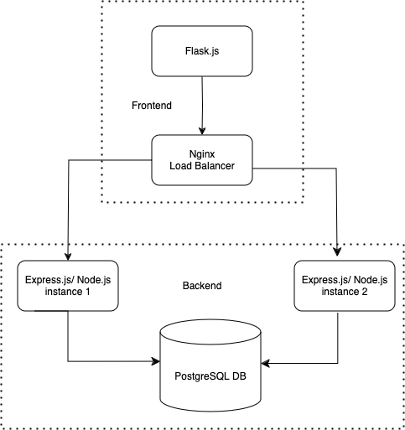

**System Design:**

**Architecture and Design:**

* Client-Server model application architecture using React for frontend and Node.js for backend.

**Data Flow:**

* Frontend interacts with the backend REST API to fetch and update data.

**Components/ Modules/ Interfaces:**

* Frontend: React components for UI elements handling user registration, login, profile management etc
* Backend: Express.js for REST API endpoints.

**Algorithms and Data Structures:**

* Sorting and Filtering: Algorithms for task scheduling, prioritization and searching
* Data Structures: Tables for users, projects, tasks, files etc. Use of lists for task management and trees for project breakdown.

**APIs:**

* RESTful API for client-server communication

**Languages/ Frameworks/ Tools:**

* JavaScripts: Main programming language
* React.js: Frontend framework
* Redux: state management
* Nginx: Load Balancer
* Node.js: Backend runtime environment
* Express.js: Backend framework

**Database:**

* PostgreSQL for relational database management. Chosen for its robustness and support for complex queries.

**Database Design:**

* **Structure:** Tables for Users, Projects, Tasks. Messages, Files with appropriate relationships and indexes.
* **Entity-Relationship Diagram:** Visual representation of entities and their relationships
* **Schema Details:** Detail attributes for each table including data types.

**Project Plan:**

**Project Management Tool:** Trello

**Project Timeline:** 3 months

**Meeting Plan:** Weekly progress updates and issue resolution

**Milestones:**

* Milestone 1: Backend Development
* Milestone 2: Frontend Development
* Milestone 3: Testing and bug Fixing
* Milestone 4: Deployment and launch

**Task List:**

* Backend Development Tasks: API endpoints, database schema setup
* Frontend Development Tasks: UI design, client-server communication
* Testing tasks: Unit testing, Integration testing, End-to-end testing

**Project Risks:** Potential performance issues due to its complexity

**Test Plan:**

**Testing Strategy:**

* Unit testing: For individual components
* Integration testing: To ensure components work together as expected
* System Testing: To ensure entire application works as expected

**Test Scenarios:**

* User authentication and authorization
* Project creation and management
* Task creation and assignment
* File sharing and collaboration

**Test Cases:**

* Detailed steps to validate each scenario

**Test Data:**

* Sample data for testing different scenarios

**Expected Result:**

* Defined outcomes for each test case

**Deployment:**

**Deployment Plan:**

* Docker for containerization
* AWS for hosting

**Deployment Procedures:**

* Build Docker images
* Deploy container to AWS
* Build CI/CD pipeline

**System Requirements:**

* Linux-based server with sufficient CPU, memory, and storage resources