

Class performance Report_2
Only for course Teacher
 |  | Needs Improvement | Fair | Good | Excellent | Total Mark
Allocate mark & Percentage |  | 25% | 50% | 75% | 100% | 15
Level of Content | 3
Analysis | 5
Development | 4
Accuracy | 3
Total obtained mark
Comments
Semester: Summer 2026
Student ID: 242-35-659
242-35-338
242-35-530
242-35-846
Student Name: Md Tasfiq Ahammed Ratul
Omar Faruk Khan
Foysal Ahammed
AKM Murtoza Basir Sojeeb
Group: 8 Batch: 43 Section: B2
Course Code: SE231
Course Name: System Analysis & Design Capstone
Course Teacher Name: Dr Kamrul Islam Shahin
Designation: Associate Professor
Submission Date: 15/07/2026
Use Case Diagram:
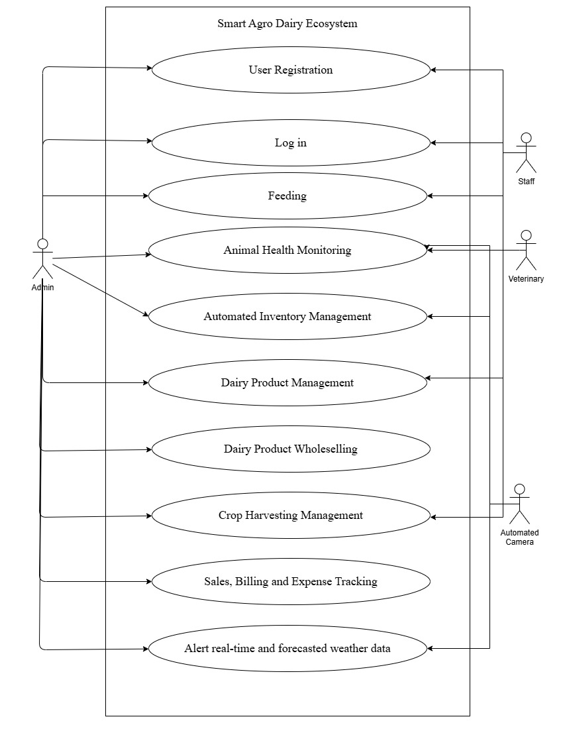
Activity Diagrams:
Use Case 1:

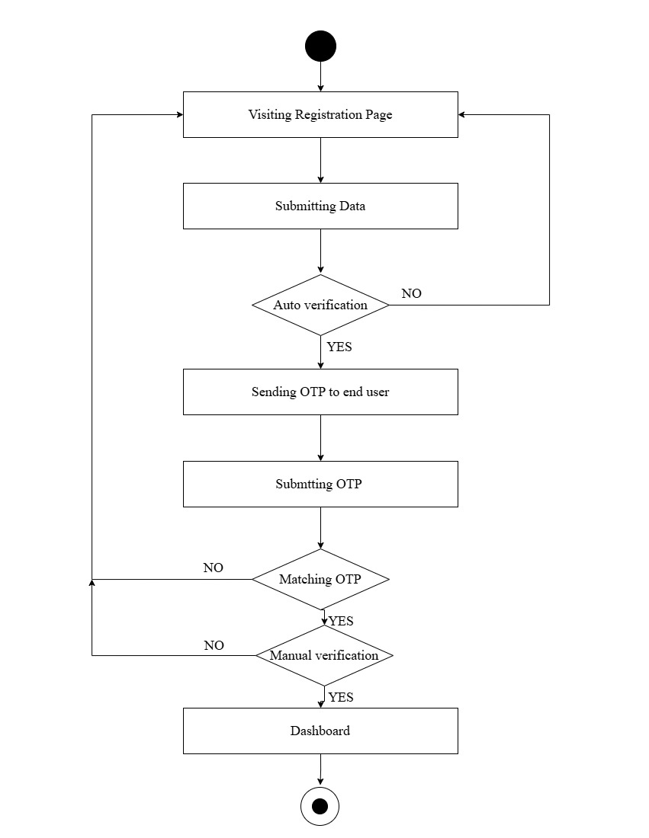
Use Case 2:
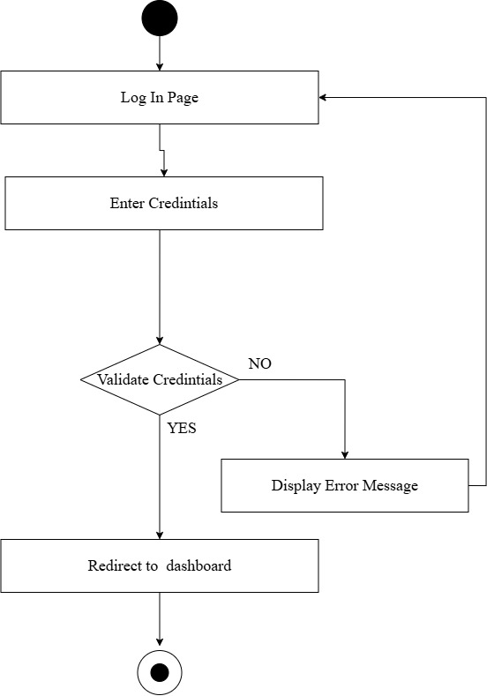
Use Case 3:

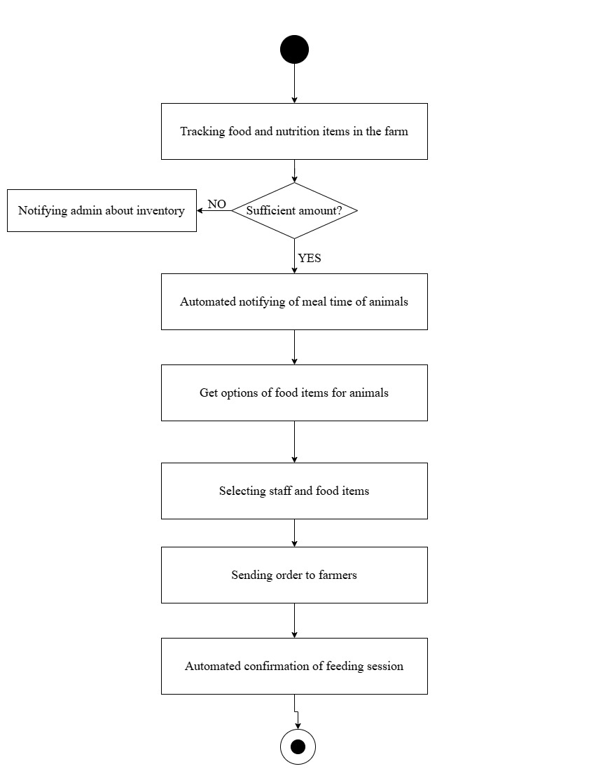
Use Case 4:
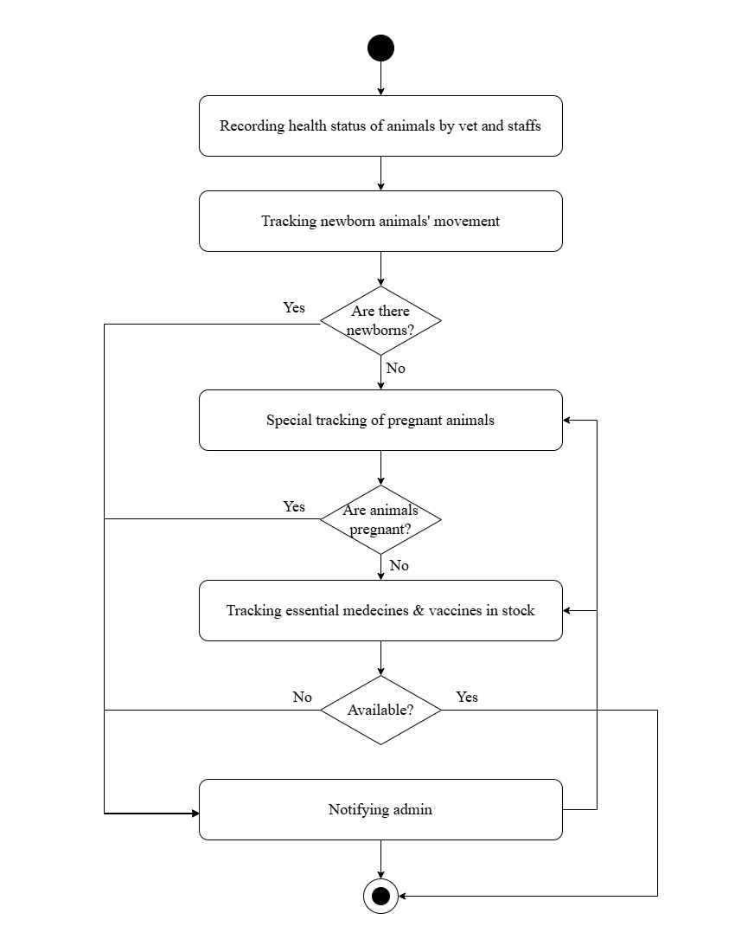
Use Case 5:
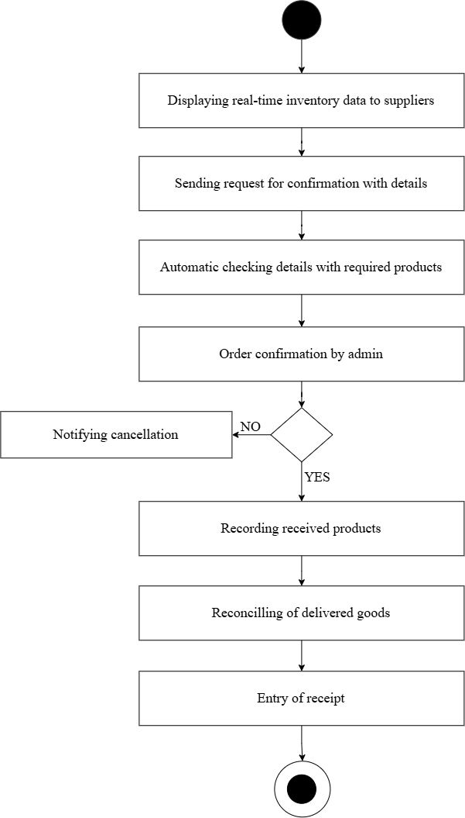
Use Case 6:
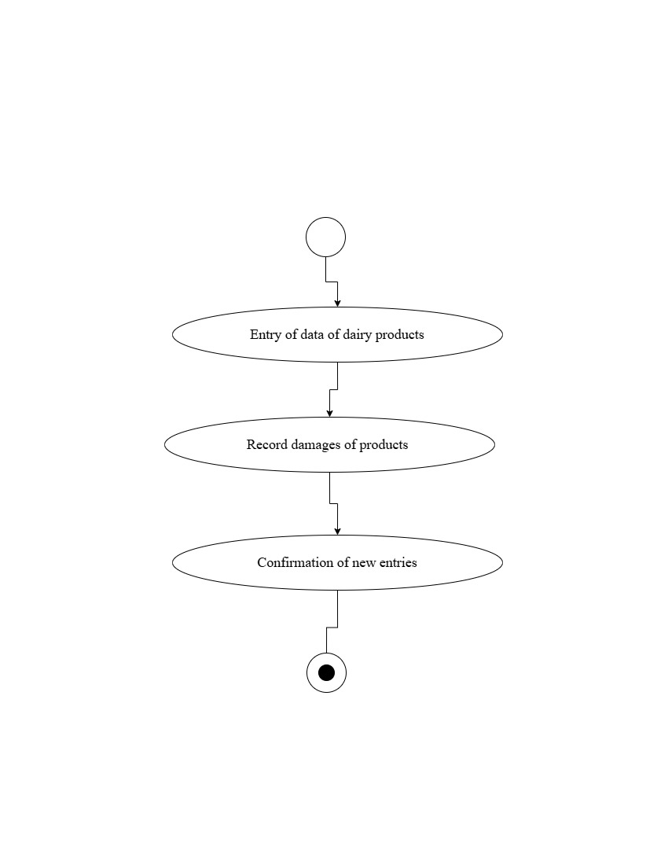
Use Case 7:
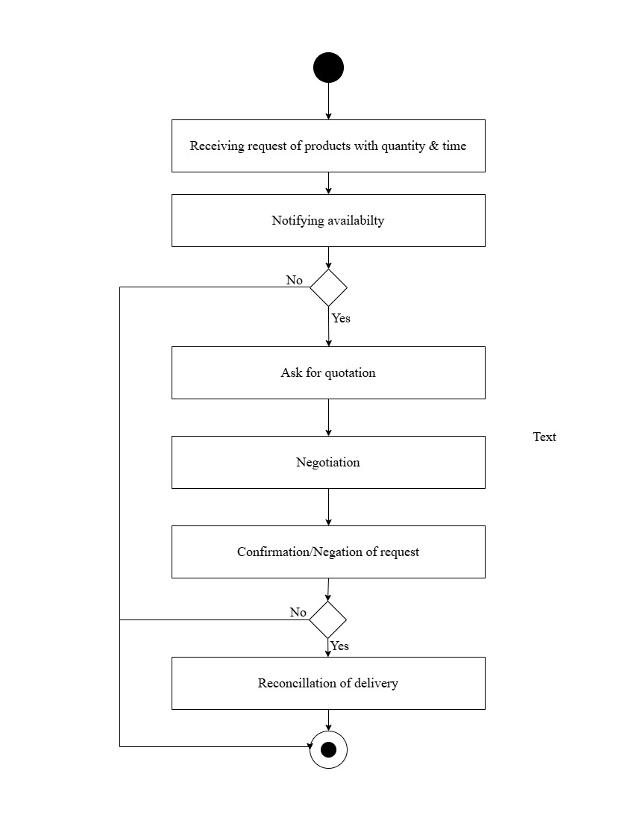
Use Case 8:
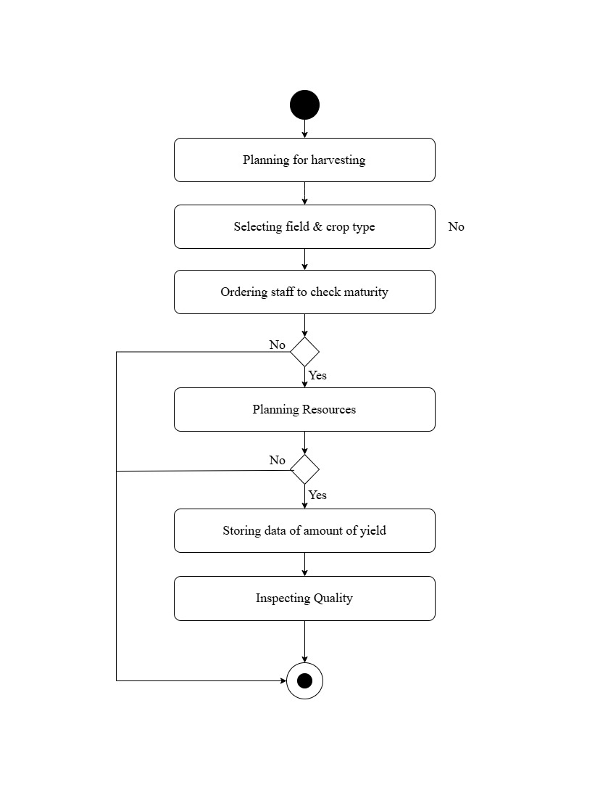
Use Case 9:
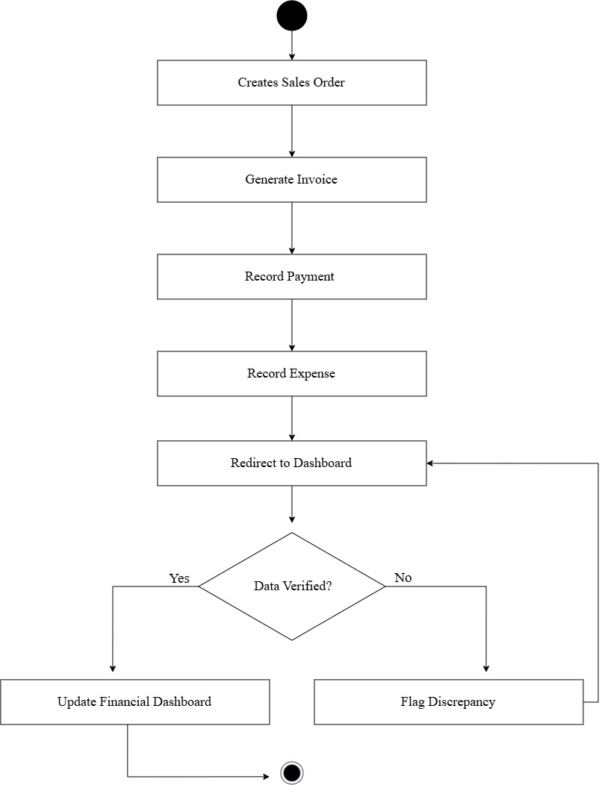
Use Case 10:

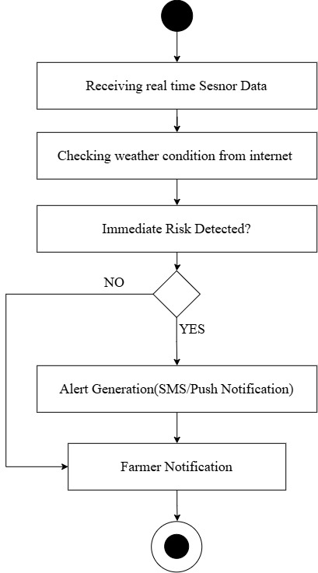

Use Case Description:
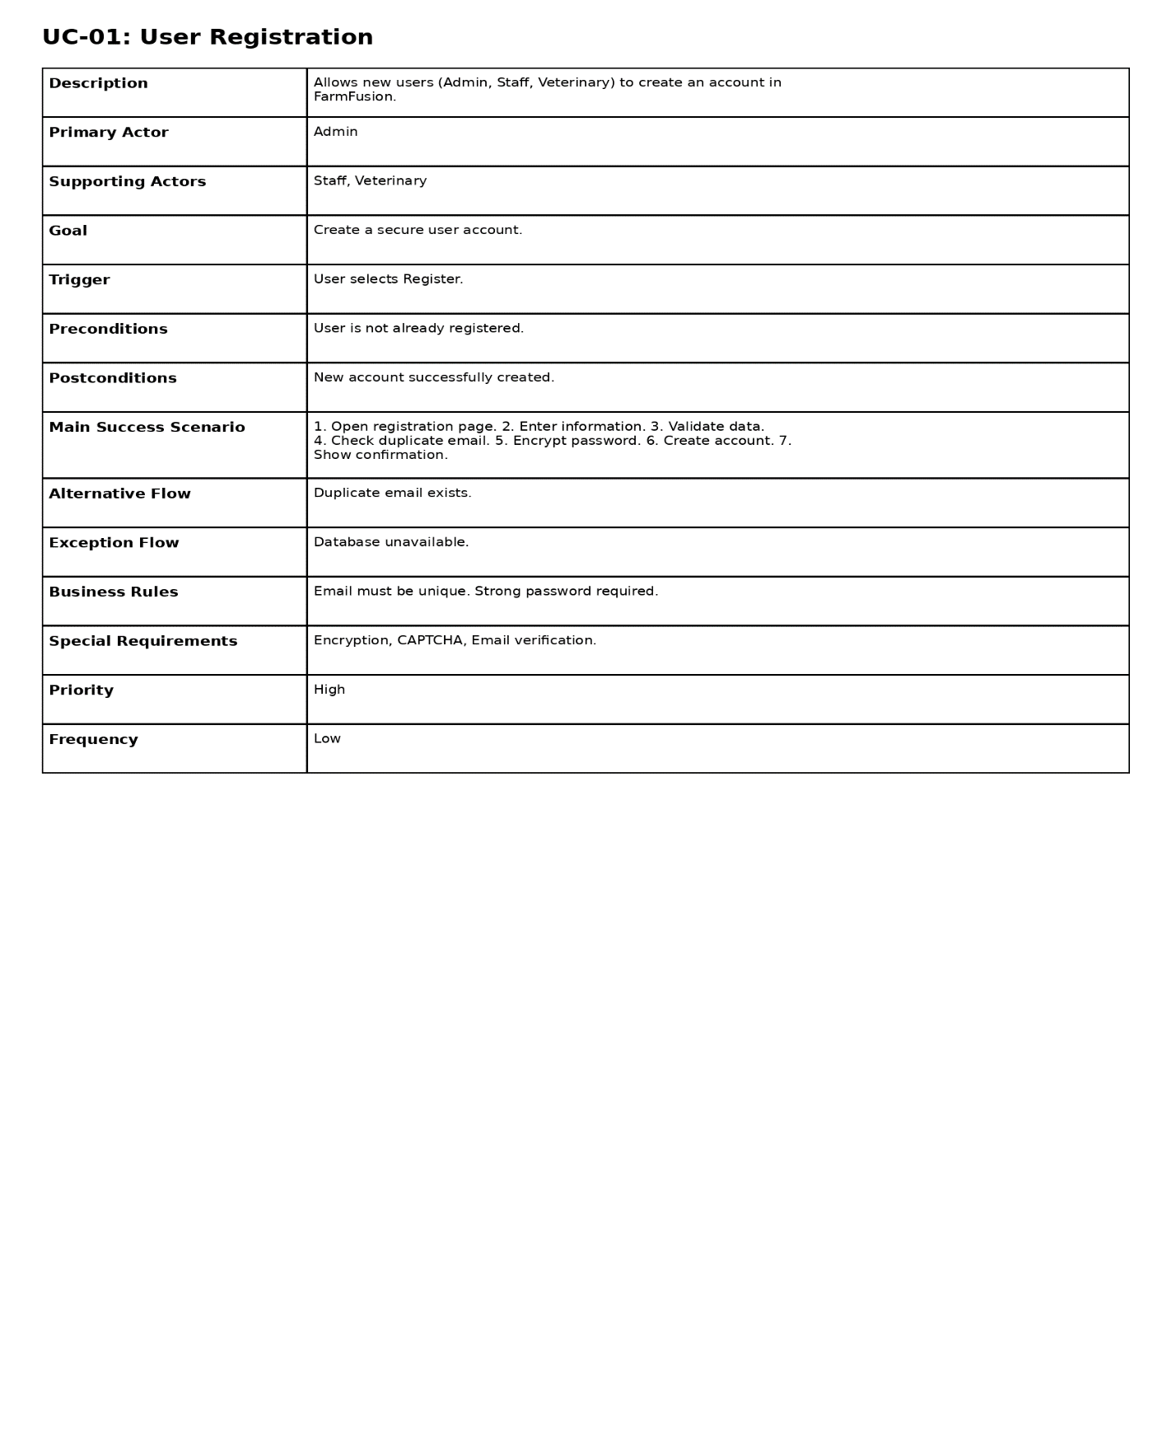
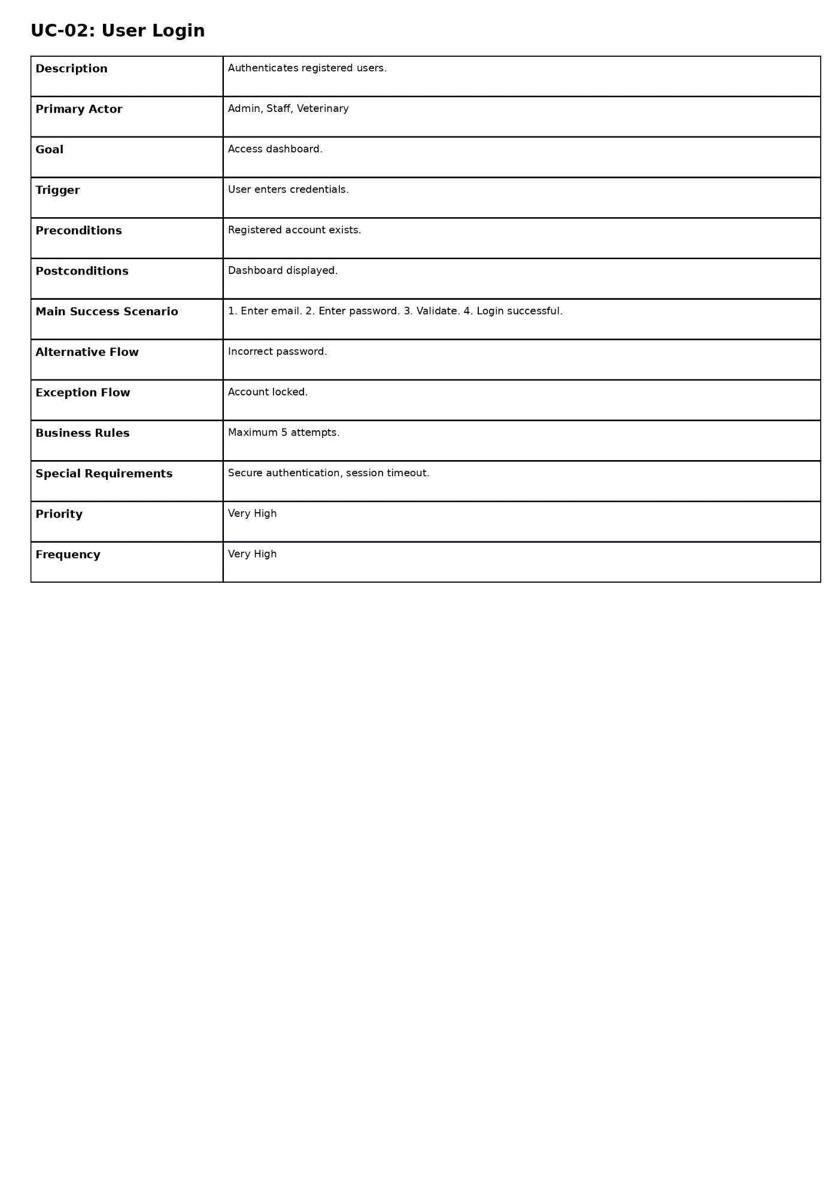
UC-03 : Feeding Session