**ABSTRACT**

The objective of this study was to evaluate the effect of milling time, milling speed and particle size of initial powders on the coating thickness of Fe-Al intermetallic coating by using neural network (NN). Coating morphology and cross-section microstructures were evaluated using a scanning electron microscope (SEM). It was found that an increase in the milling time provided an increase in the coating-layer thickness due to the cold welding process between particles and the steel substrate. The microstructure of the coating surface was refined by ball impacts in the milling process. As a result of this study, the ANN was found to be successful for predicting the coating thickness of Fe-Al intermetallic coatings. The correlation between the predicted values and the experimental data of the feed-forward back-propagation NN was quite adequate. The mean absolute percentage error (MSE) for the predicted values didn’t exceed 3.995 %. The NN model can be used for predicting the coating thickness of Fe-Al intermetallic coating produced for different milling time, milling speed and particle size.

**Keywords**: Artificial neural network; coating; coating thickness; Fe-Al intermetallic; mechanical milling

This problem is solved by using Python language.

I make class and object in python because of repeted value and make the coding short and precise.

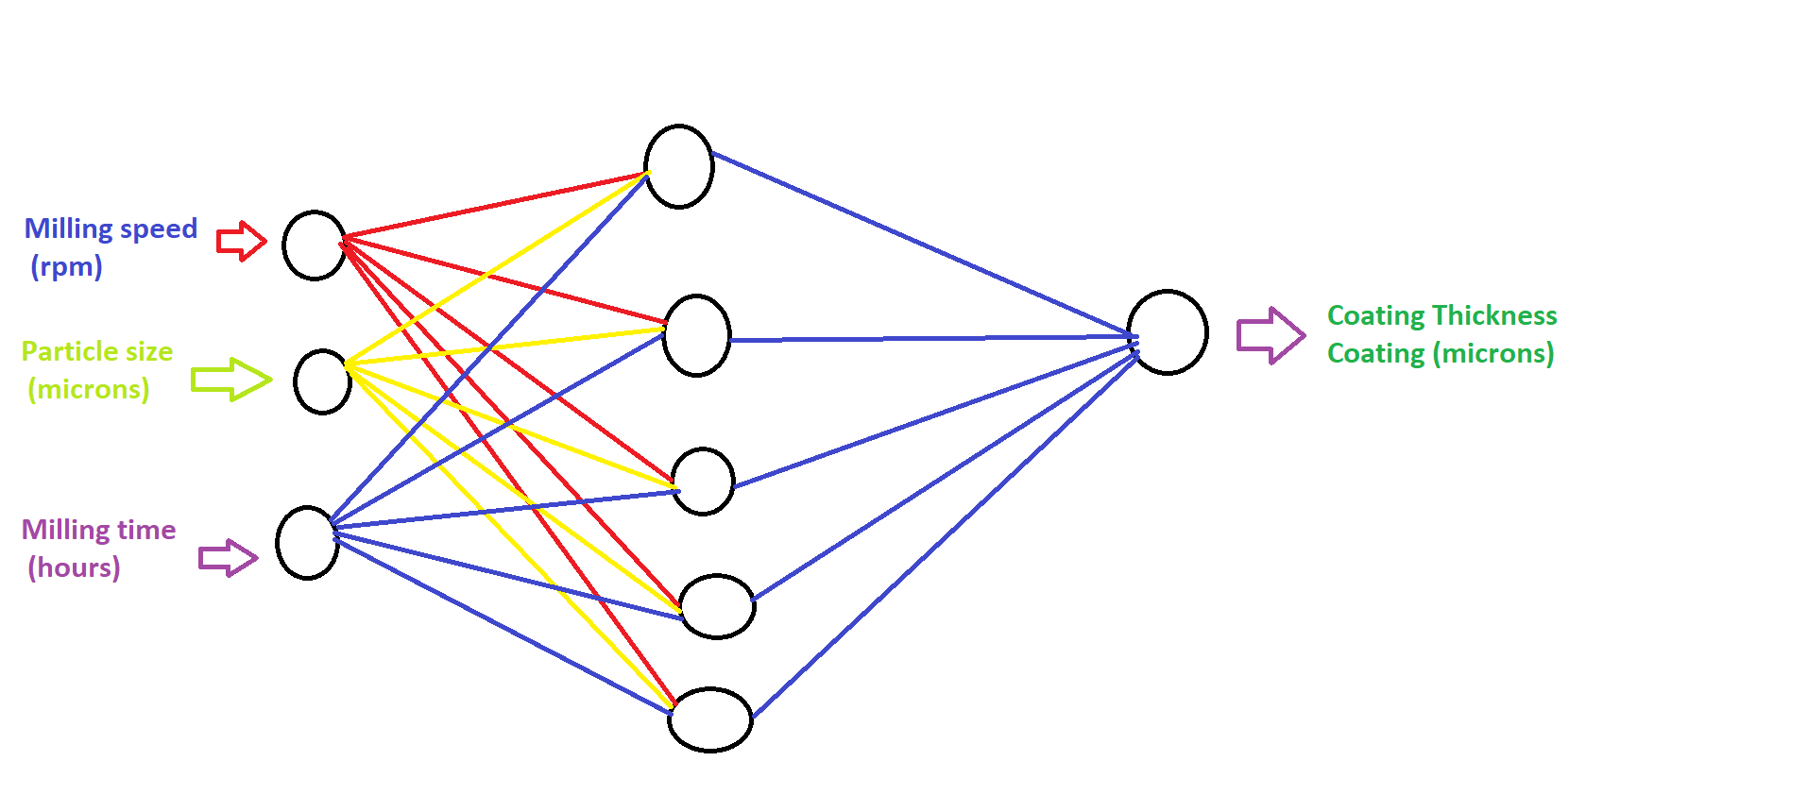

**Diagram: Neural Network**

**Input parameter:-**

Input Parameter is Milling speed (rpm), Particle size(microns) ,Milling time (h)

Output parameter is taken as coating thickness in microns

Learning rate is taken as 0.5 and number of neurons in hidden layer is taken desired value by checking the minimum error**.**

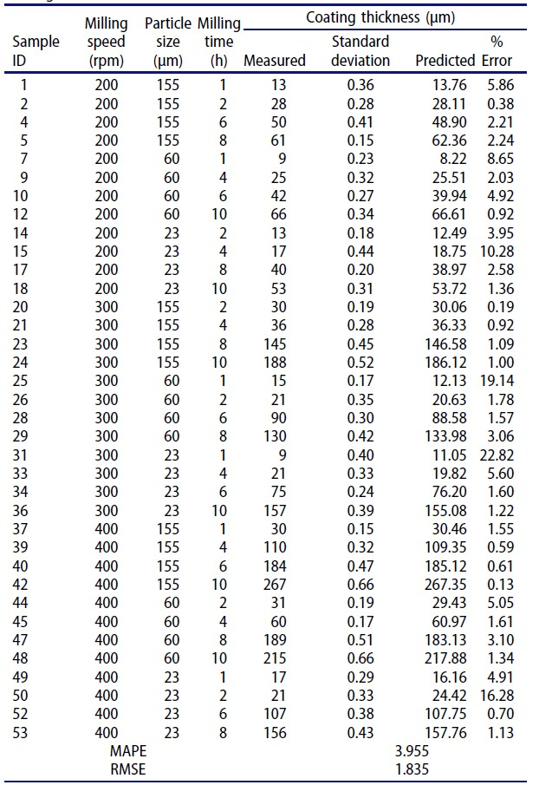

Results can be see by run the programming using python language.

**Results:-**

Mean square Error is 0.03955

**Conclusion:-**

The following conclusions can be drawn from the experimental results:

1. The Fe-Al coatings were fabricated on the low-carbon steel by the mechanical alloying method. It was found that an increase in the applied milling time, milling speed and size of milled powders affect the coating thickness.

2. The deposition of a uniform coating by mechanical milling is possible, but it requires optimization of milling para-meters and properties of as-received powders so that the uniform distribution of ball–substrate–ball collisions over the processed surface is efficient.

3. The coating thickness on the steel substrate increased with increasing milling time. The coating thickness increased to its maximum value after 10 h of milling.

4. The increase in milling speed also increased the coating thickness on the steel substrate. For high milling speed conditions, the coating thickness because of the higher impact energy due to more ball–steel substrate–ball collisions.

5. The NN model generated satisfactory results with high correlation coefficients. The MSE for the predicted values did not exceed 3.995%. Therefore, using the NN model, results can be estimated satisfactorily, which thereby reduces the testing time and cost.