**Identifying Underserved Food Types In Memphis, TN**

**Prashant Kumar**

**April 8, 2020**

1. **INTRODUCTION**

**1.1.  Background**

Memphis, Tennessee, USA is a small city that resides in Shelby County.  According to the World Population Review, the city itself has a population of approximately 650,000.  The greater Memphis metropolitan area, though, has a population of almost 1.2 million (macrotrends.net).  Consequently, any analysis of Memphis should study the greater Memphis metropolitan area. For the purpose of this study, the greater metropolitan area was defined as the United States Zip Codes in Shelby County that has a population of greater than 10,000 people.

**1.2 Problem**

As a thriving metropolis, the greater Memphis area has a plethora of great restaurants.  That said, there are areas that are underserved. Entrepreneurs look for ways to fill a gap and add value to society.  A great starting point is to find the areas where there is a scarcity of supply. This analysis looks at a good sampling of the restaurants in the Memphis area and identifies the least served food categories.  The results from this study to a prospective entrepreneur that is starting to develop his/her business plan.

1. **DATA ACQUISITION AND METHODOLOGY**

**2.1 Data Sources**

This study used the U.S. Zip Codes from [www.zip-codes.com](http://www.zip-codes.com).  This site provided all the zip codes and their respective populations in Shelby County, TN.  The study also used data from [www.public.opendatasource.com](http://www.public.opendatasource.com). This site provided all the latitude and longitudes of each zip code studied.  Lastly, the venue data was from Foursquare.

**2.2 Data Scraping and Cleaning**

The zip code data from [www.zip-codes.com](http://www.zip-codes.com) was downloaded into a pandas dataframe.  All of the columns were dropped except for the zip codes and the populations.  The populations were converted into a series of integers and then the dataframe was resized so that it only had the zip codes in shelby county with populations in excess of 10,000.  Lastly, the zip codes were reformatted to just a 5 digit format.

The zip code data from [www.public.opendatasource.com](http://www.public.opendatasource.com) was downloaded into a pandas dataframe, as well.  The columns were renamed, datatypes changed, and then the dataframes were merged through an inner join so that only the zip codes that have populations above 10,000 were represented.  The resulting data frame had 30 zip codes and looked like:

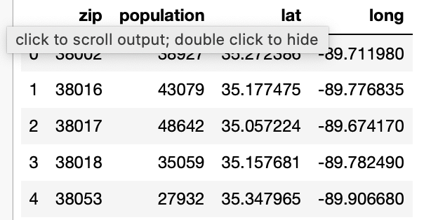

Table 1. Zip Codes and Coordinates of Shelby County With Populations Exceeding 10,000

The latitude and longitude of each of the 30 zip codes were submitted to Foursquare to provide the 100 most popular “food” venues within a 10km radius.  Each zip code’s venues were then cleaned and aggregated to create another dataframe that had approximately 3,000 rows and looked like this:

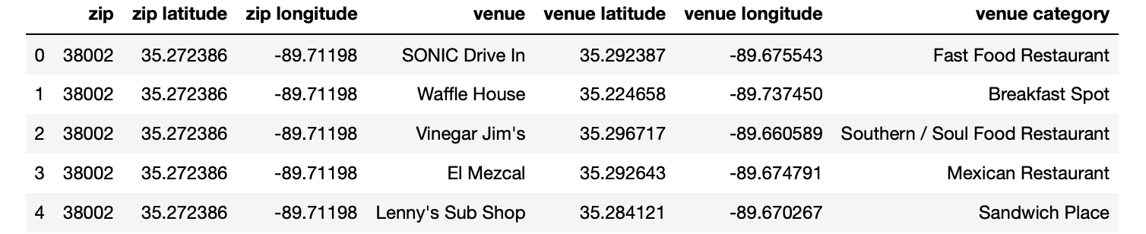

Table 2. Food Venues in Greater Memphis Area

1. **RESULTS**

Table 2 showed that there were 55 unique kinds of food venues (“venue category”) in the Memphis area.  This dataframe was broken down through one-hot encoding to identify the numbers of each category in each zip code.  Table 3 shows a representation of some of the 55 categories in each zip code:

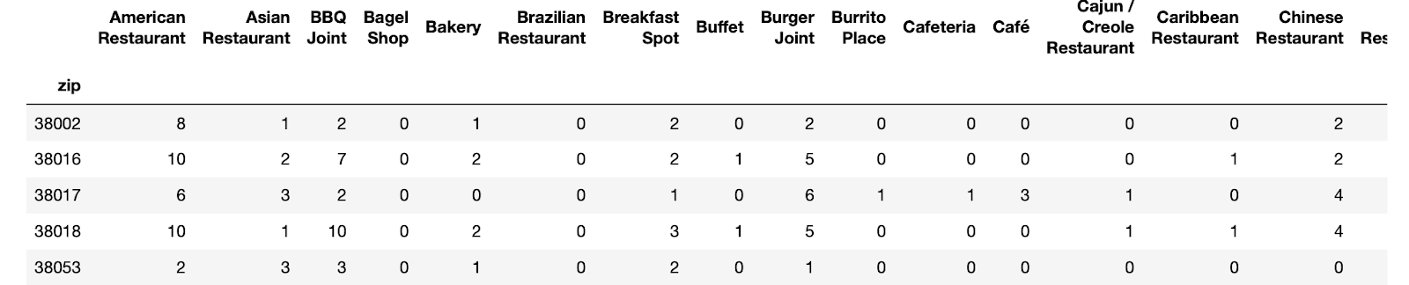

Table 3. Types of Food Vendors Offered By Memphis Zip Code

All of the zip codes were totalled together and sorted to find the overall offerings in Memphis.  From this data, the below chart shows which food categories have less then 10 venues in the entire Memphis metropolitan area.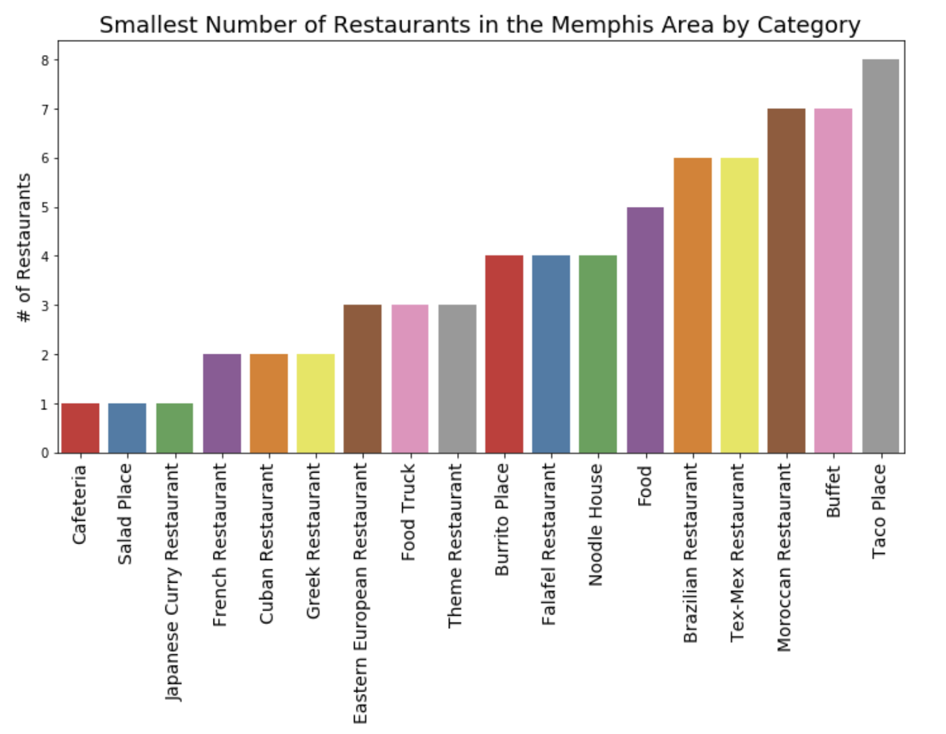

Chart 1. Smallest Number of Restaurants in the Memphis Area by Category

Table 2 was then filtered to get the names and coordinates of each of the venues in the above categories.  Using Folium, a map was generated with the location of each of the venues and color coded so that each category could be identified.  Consequently, a prospective entrepreneur can look at which category they want to explore and then see visually where the few restaurants are in that category on a map.  The map is interactive so that the person can click on the marker and the name of the restaurant will be visible. Below is a static look at the map:

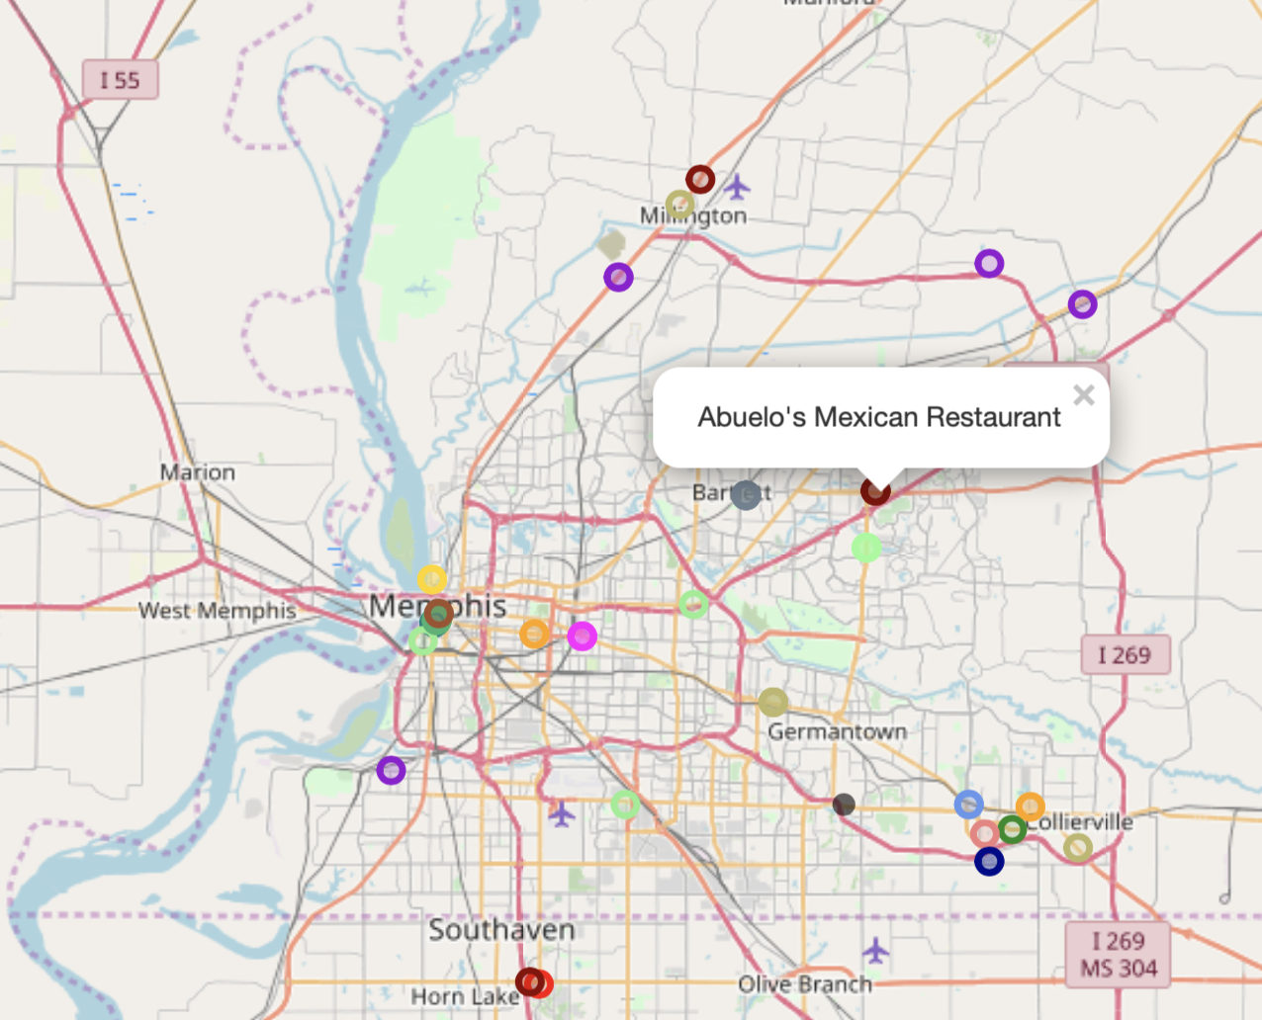

Chart 2. Map of Restaurants in Memphis That Have Fewer Than 10 Restaurants In Its Respective Category

1. **DISCUSSION**

Memphis has 55 different categories of food.  18 of them have less than 10 venues each. A prospective entrepreneur should use this list as a launching point to begin to develop a business plan. While this study looks at the scarcity of supply in the Memphis area, it does not look at the demand.  While there might only be 2 French restaurants in the Memphis area, this study did not evaluate whether there was enough demand to warrant investing in a 3rd restaurant. Moreover, there is the possibility that some French restaurants were missed during the data pull from Foursquare.

1. **CONCLUSION**

This study looked at the food categories that are served in the greater Memphis metropolitan area.  Specifically, it focused on identifying the areas that are least served so that a prospective entrepreneur can determine where there is a market for his or her investment.