EMPLOYEE APP CATALOG

OBJECTIVE:
The goal of this research is to understand existing app catalog/discovery solutions, analyze their strengths and weaknesses, and extract insights that will inform the design of an internal Employee App Catalog. This will help employees easily discover and access authorized applications while minimizing shadow IT and redundant access requests.

TOOLS ANALYSED

- Microsoft Intune Company Portal
- ServiceNow Service portal
- Okta End-User Dashboard
- IBM MaaS360

TOOLS ANALYSIS FRAMEWORK

Each tool was analyzed across four dimensions:
- Discovery Experience: How users search, browse, and discover apps.
- Information Architecture: Details displayed for each app, e.g., description, ratings, categories.
- User Interface Patterns: Navigation, search, filtering, and categorization.
- User Engagement Features: Reviews, ratings, recommendations, and usage stats

TOOL SPECIFIC ANALYSIS

- Microsoft Intune Company Portal
Microsoft Intune Company Portal is used for managing and securing applications on mobile in organization. It helps IT admin control how apps are deployed, updated, used by ensuring security and compliance without restricting employee productivity.
- Discovery Experience: Apps grouped by required, available, recommended; search & filters.
- Information Architecture: App name, publisher, description, size, compatibility.
- UI Patterns: Tile & list views, platform-specific icons.
- User Engagement Features: Admin usage stats; limited end-user recommendations.
- Insights: Categories are intuitive; personalized recommendations needed.

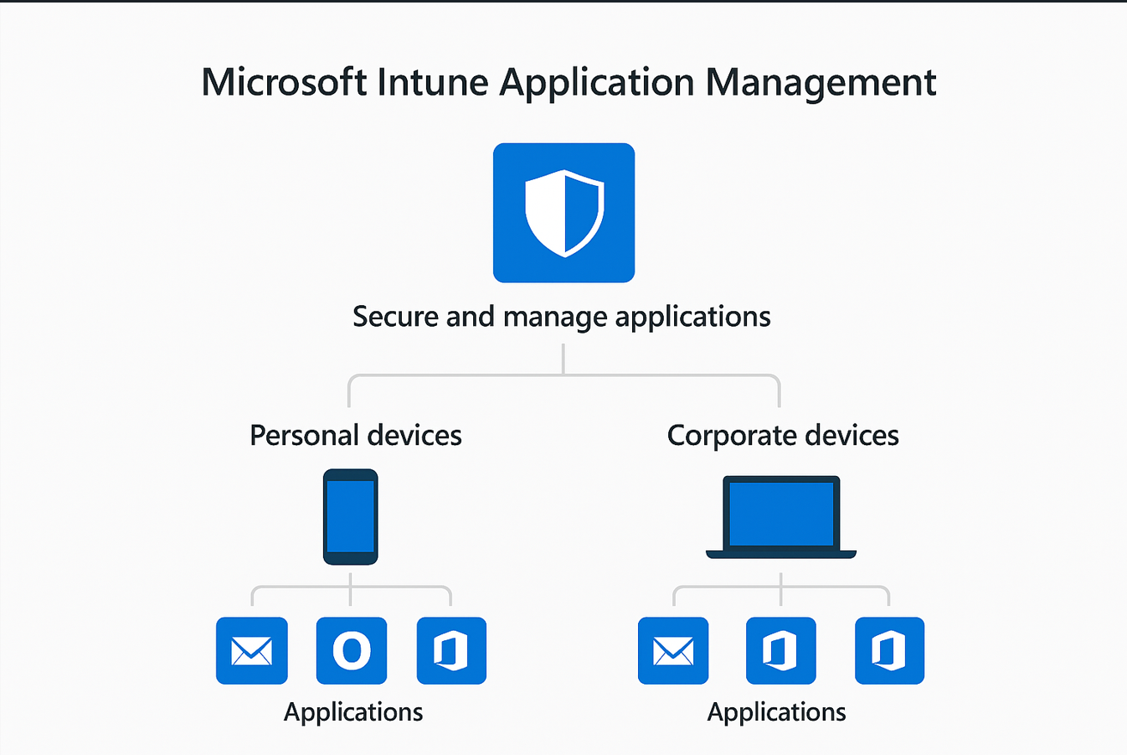

- ServiceNow Service portal

ServiceNow provides a product formerly known as Application Portfolio Management, which with recent releases has evolved into Enterprise Architecture.Gives a centralized Inventory or landscape of all business applications used across organization.

- Discovery Experience:Search bar with suggestions, categorized apps, "Most popular" section.
- Information Architecture: App name, description, category, owner/contact.
- UI Patterns: : Sidebar navigation, breadcrumbs.
- User Engagement Features:: Feedback forms, limited ratings.
- Insights: Categories are intuitive; personalized recommendations needed.

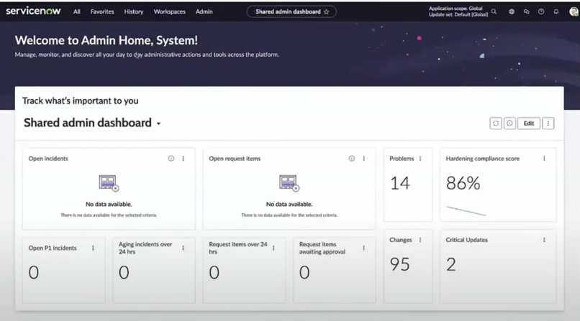

- Okta End-User Dashboard

Users can see all the launched enterprise applications assigned to them by organization in a single dashboard. Users can also request new enterprise apps or add certain apps themselves.
- Discovery Experience: Centralized SSO, alphabetical listing, search.
- Information Architecture: App name, icon, description, login link.
- UI Patterns: Grid layout, mobile-friendly.
- User Engagement Features: Frequent app access; limited reviews.
- Insights: Minimalistic design works; richer metadata and recommendations needed.

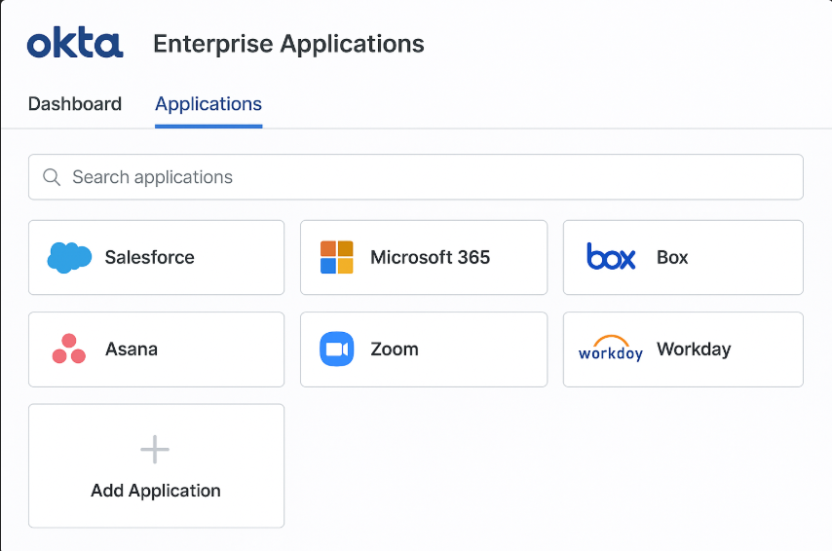

- IBM MaaS360

In this Enterprise Application the public and enterprise apps are listed.Admin distributes apps over the users and also tracks installation updates. It is more focused on device and application security, access management, mobile and end-user devices especially for mobile.
- Discovery Experience: Device-based app listing; required, recommended, optional.
- Information Architecture: App name, description, platform, compliance info.
- UI Patterns: Tile view, sorting options.
- User Engagement Features: Admin usage stats; limited end-user engagement.
- Insights: Strong security visibility; discovery features need improvement.

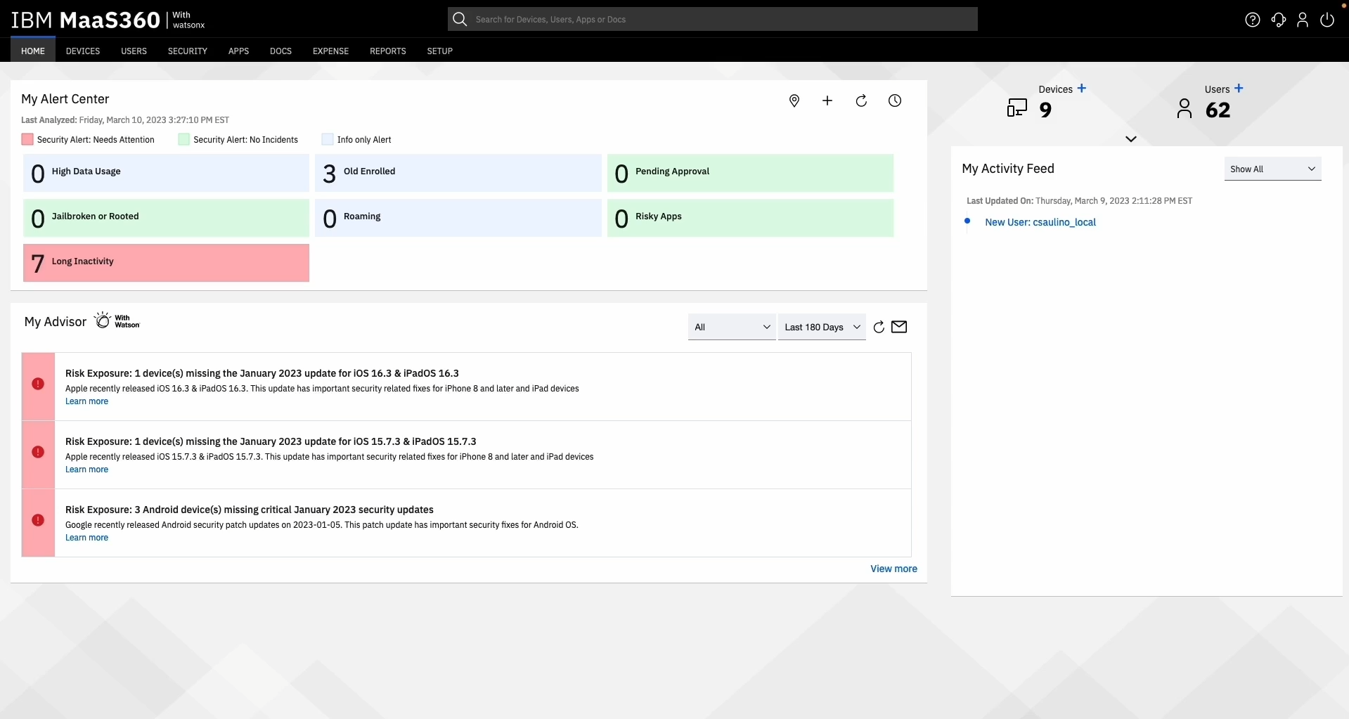

Feature | Intune | Okta | ServiceNow | MaaS360
Core Role | Device and app management | Identity and SSO | App portfolio Management | Mobile Application
Employee UX | Company Portal + self-service | One dashboard, one login | Simplified app landscape | BYOD privacy, secure access
SSO | Enabled | Enabled | Enabled | Enabled
Analytics & Tracking | Tracked  (Device & app usage) | Tracked | Tracked(Strong) | Tracked
MFA | Enabled | Enabled | Enabled | Enabled
Self-Service Access | Limited | Enabled | Enabled | Enabled

SSO : Single Sign in Option.
BYOD : Bring Your Own Device
2. Feature Specification & Design

The App store for Work - Secure,Intelligent and employee-first

Core Features to be implemented:

  - Unified dashboard
  - Single Sign-On
  - App Discovery
  - App Information
  - Access status
  - App Life–cycle management
  - In App Learning Resources
  - Role-Based App
  - Usage Monitoring and alerts10
  - Request and Approval Workflow

Core App catalog features:

- App discovery:

- Smart Search Bar : Implementing smart search bar with predictive suggestion by app name, function or keywords.
- Browsing by Category: Browsing by categories like functions, departments, popular or recently added.
- AI-powered Recommendations: Suggesting the apps for the employees based on the role and app mostly similar role employee.

- App Information:

- Detailings: Detailing each app with its logo and names so that employees can find required apps easily.
- Purpose and Use-cases: We should have to provide the key features , where to implement and certain use cases by blogs options below app or through any pop up window.
- Integration Information: Providing complete information about implementation guide to ensure employees may not face any difficulties.
- Access Requirements : Listing the roles for each application so that employees may not have difficulties identifying the apps which are available to them and they can get access by requesting.

- Categorization:
- Grouping the users by the based on their role and the department.
- Implement consistent policies for access and user roles.
- Creating custom Tags for some sets of apps. So that employees can find group of apps which are helpful for their work production
- Suggesting the app or recommending based on the popularity and functionality

- Access Status:
- Badges: Using Badges employees can see what is available to them and what requires approval
- Green badges indicate apps directly accessible or provisioned to the employee.
- Gray badges highlight apps with pending requests.
- Red badges for restricted apps or need to get managers approval for that app

- Personal Dashboard:
- Quick Launch App Tiles: Employees can favourite or pin apps they use most frequently.
- Pending Access & Approvals: Clear status indicators for pending requests with estimated timelines.Ability to track the entire approval workflow.
- Suggested Apps & Bundles : Role based recommendations and AI-driven suggestions.
- Single Sign-On (SSO) & Security: Seamless one-click access to all apps without multiple logins.MFA reminders or security alerts if any app requires re-authentication.

