**Bad Visualizations**

1. **Misleading scale**

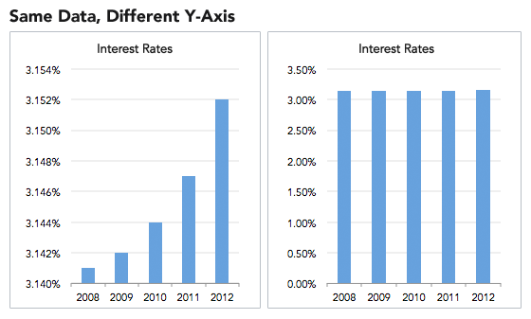

**Problem**:

1. Although the graphic looks simple and clear at first glance, the conventional way to present a bar graph is to start the y-axis at 0 and not following the convention could lead to misinformation.
2. Small differences could look hyperbolic and mislead audience perception.

**Solution**:

1. The same graph when rightly presented with a y-axis starting from 0 will reflect the data as it is and the differences don't look hyperbolic.
2. An alternate example of a bar graph with right scales is shown below.

1. **Burying key information**

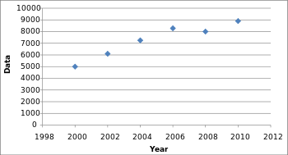

**Problem**:

1. This is an example of burying key information intentionally or unintentionally thus creating a misleading data visualization.
2. By omitting some data points, the scatter plot looks much smoother and more stable, for example, the performance report of a company could seem like a consistent and steady increase by only plotting every second year.

**Solution**:

1. When all the real data points from each year are included, the graph is more volatile, filled with dips and spikes as shown below.
2. Businesses can take advantage of such data visualization techniques to mask the real volatility to their advantage.

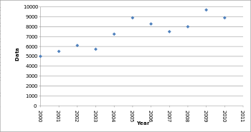

1. **Incorrect data**

**Problem:**

1. In an attempt to create a relevant graphic to the content, the actual representation of the data was compromised.
2. Based on the hexagonal graphic, the Fructose section with 38.5% looks more than twice that of Glucose which is 31% which seems to be an incorrect pictorial representation. Similarly the sections of 17.1% and 7.2% look the same as 31% in size.
3. Thus the visualization is beautiful yet greatly misleading with incorrect data.

**Solution:**

1. The same data can be represented using a simple pie chart using matplotlib or any other professional tool to get the exact representation of actual data.

1. However, the pie chart has its own disadvantages, especially when we want to present more than 3 major categories, the minor categories become ugly.
2. A better alternative would be the classical bar chart in horizontal orientation.

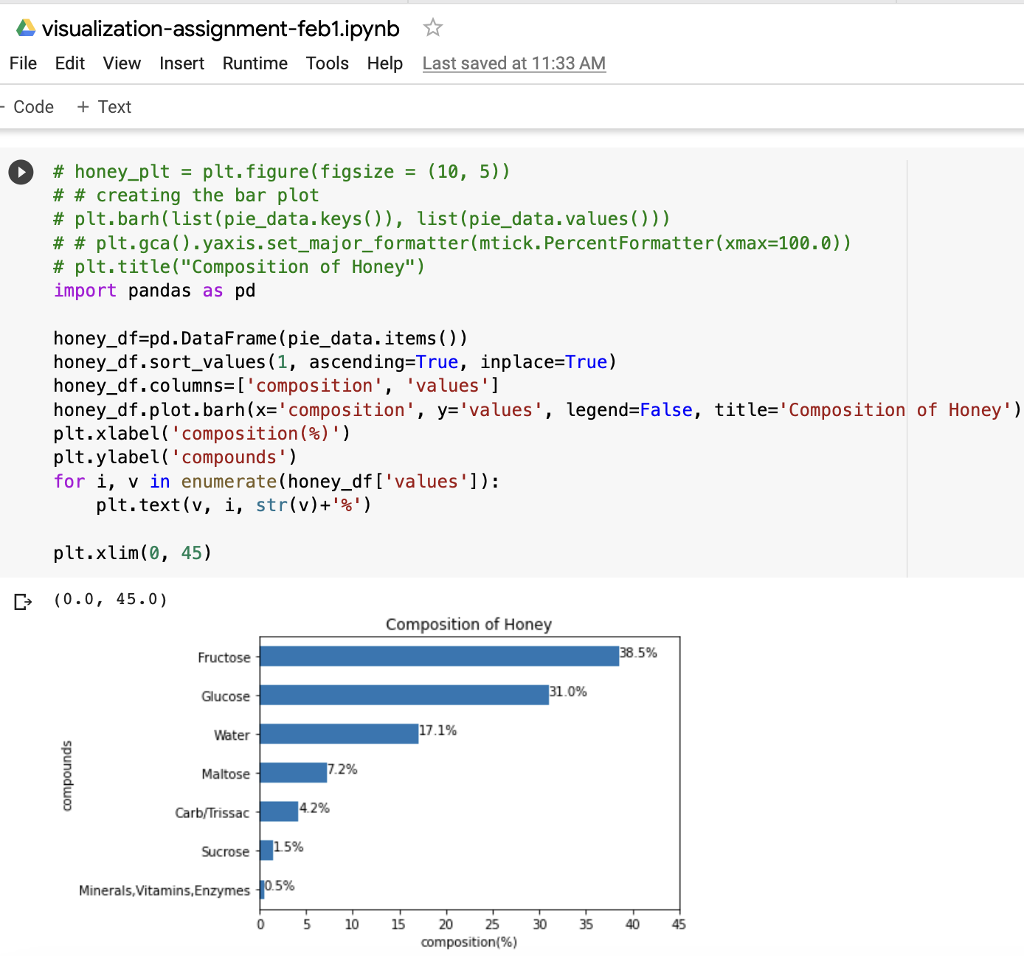

1. **Poor choice of chart type**

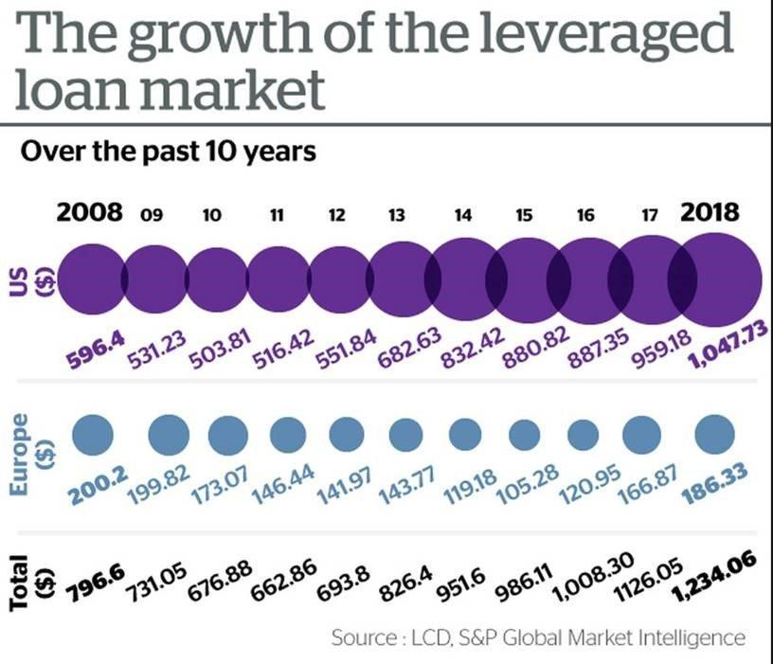

**Problem-**

1. The graphic used to present the data is very hard to interpret the information.
2. In general it’s difficult to compare the area of circles and hence it is hard to understand the exact difference between US and Europe data points.

**Solution-** The time series data can be plotted using various chart types like line graph and bar graph and since there are two different variables in the same time series, we can use stacked bar chart which will help us to compare the data easily.

1. **Unclear and too many information**

**Problem-**

1. The graph looks interesting but it is very hard to interpret the information. Everything is all over the place and the graph looks like a tornado.
2. There are more variables added to a single graph with all types of data representation like circles, lines, text and numbers.
3. Hence too much information is overloaded with poor choice of chart type.

**Solution-**

1. The graph contains time series data and average number of death counts in y-axis and shows increase and decrease of death counts in x-axis.
2. A waterfall model graph plot indicating the increase and decrease of death count along with a line graph indicating the average count against the monthly time series in x-axis could be one way to represent the data.
3. We can use more than one graph to plot the data, for example, a multi axis bar chart and a line chart to represent the data.
4. It could be much simpler and clearer to not have too much information loaded in a single graph.