**Dataset**: The visualization is built using the dataset from Kaggle that has information about the employees layoff in Tech companies across the globe from May 2022 until May 2023.

**Objective**:

The main objective of the project is to understand the distribution of layoffs across different countries and industries in addition to the timeline of layoffs globally to see patterns and trends. This could potentially be helpful for anyone who is interested in analyzing the trends in the job market.

The dataset contains many features like Country, company, layoff count, date of layoffs, in which stage the company is currently in with respect to the market establishment, but we are mainly interested in visualizing the layoff percentages across the globe and the timeline of the layoffs that happened.

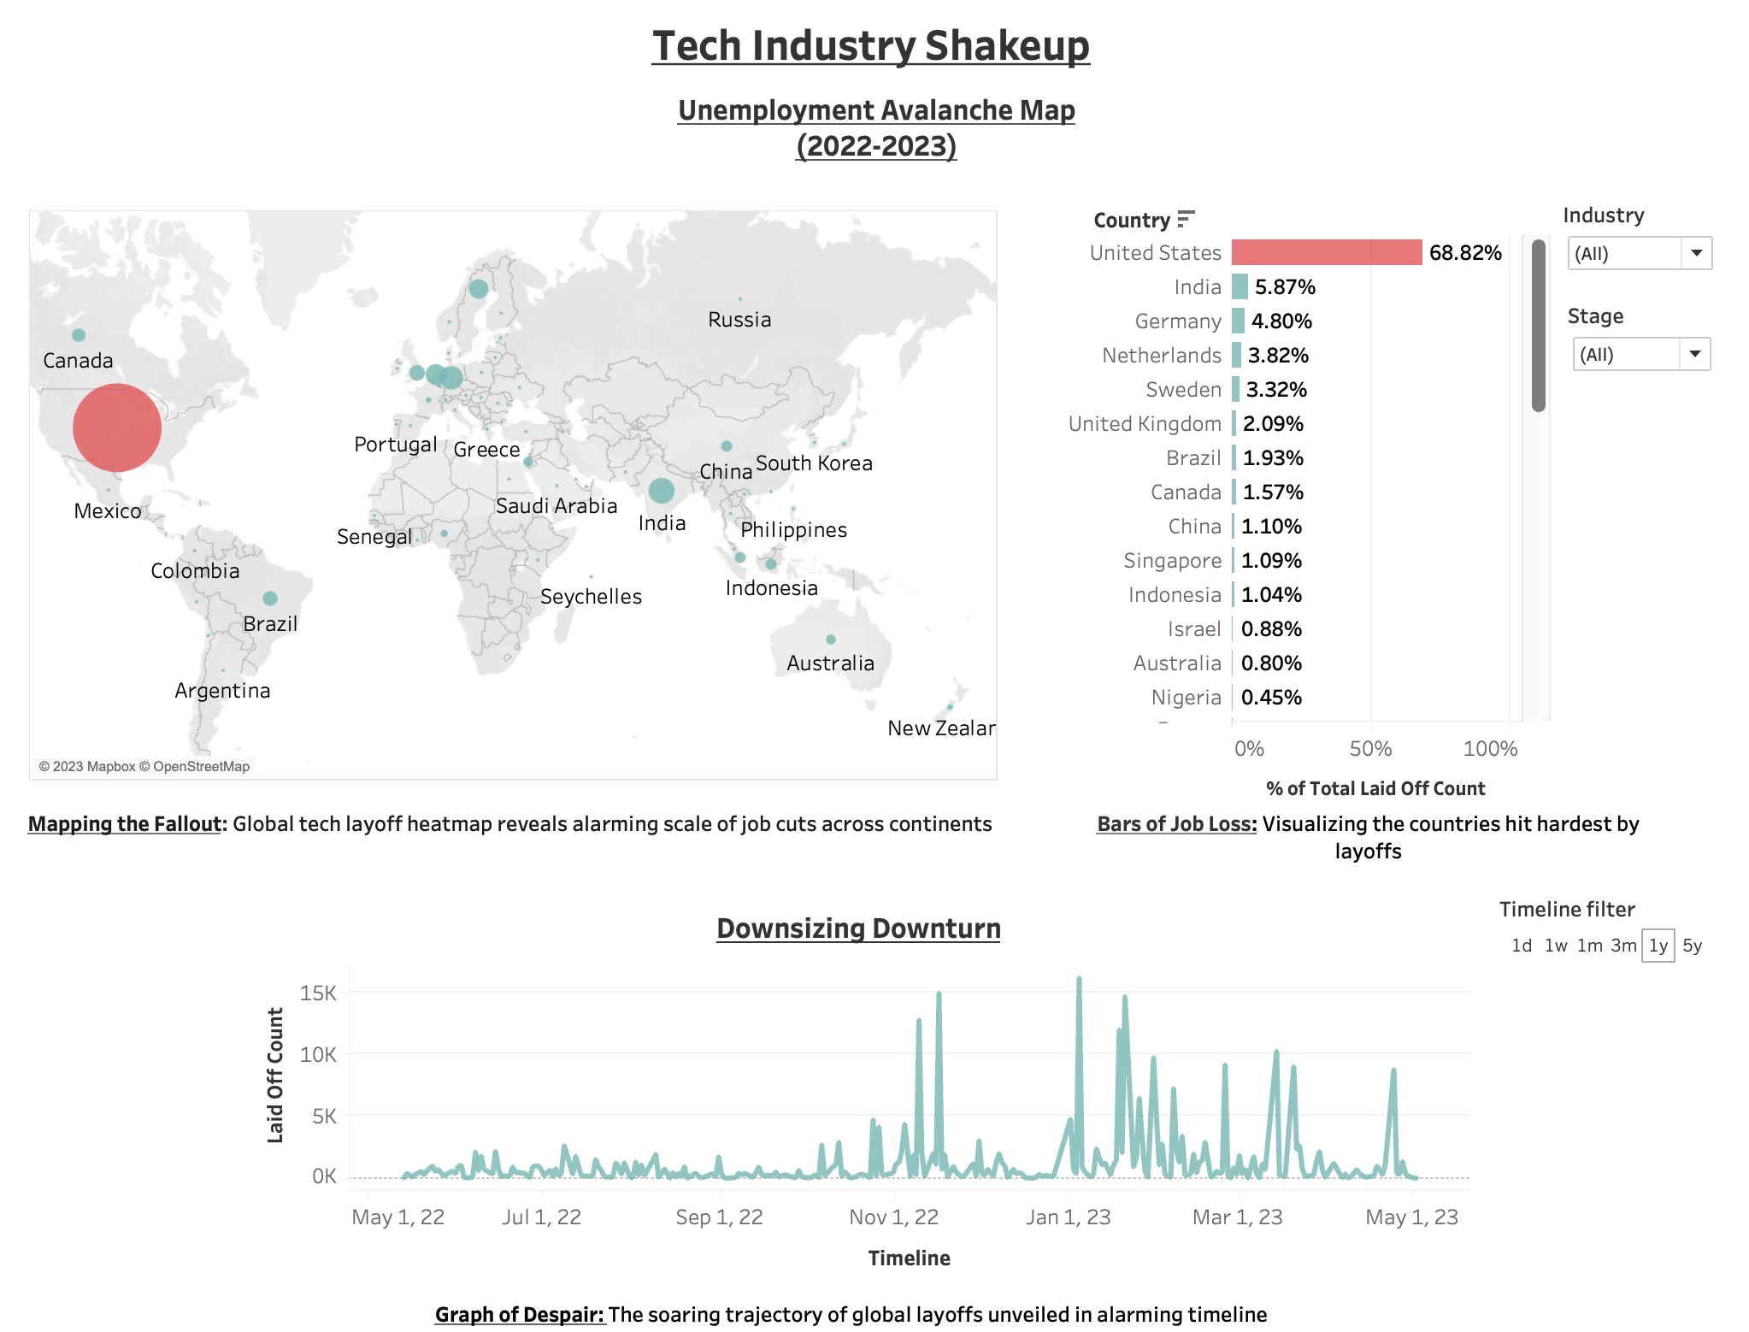

**Steps to develop the visualization:**

1. Data Gathering and preprocessing.

The data collected from Kaggle was chosen because of the richness in the data features and then preprocessed to clean bad data points and retain only necessary information.

1. Identified the tools.

Considering the efficiency of using Tableau, 3 chart types were chosen to represent the data points collected,

a world map that plots layoffs in various countries across globe,

a bar graph that lists the layoff count for different countries and

a line graph to show the layoff counts across the timeline.

1. Applied design and implementation:

All the charts are designed and employed as per all the design principles that I learned through the course.

The visualization is later published to the public Tableau server to be available publicly.

**Key principles followed:**

1. **Data accuracy and reliability**:

I made sure that the dataset used is through a reliable data source and the data is accurate.

1. **Clarity and Simplicity:**

As I am a fan of simplicity and clarity, I stuck with a simple layout with necessary information to carefully present the data with clarity.

**Gestalt principles:**

1. **Proximity**:

As per the principle, the related graphs of geo map and bar graph are put close together and the line graph that runs through the timeline is independently placed at the bottom that runs through the page width.

1. **Continuity**:

The bar graph is ordered in the decreasing order of the layoffs in each country so that its easily readable for a user with an emphasis on the continuity.

1. **Visual encoding:**

To highlight the country with the highest value in the layoff count, I deployed the visual encoding technique by using color encoding.

1. **Ranked based on size:**

The size of the circle/bubble on the geo map represents the percentage of the layoffs of that country with respect to the total number.

1. **Interactive**:

The dashboard is designed in such a way that it is interactive in multiple ways.

1. There is a filter for Industry on the right of the dashboard that filters all the layoff counts specific to that industry in all the charts in the dashboard.
2. A filter for stage which filters for different stages of establishment of companies in the market (eg. Acquired, IPO listed or in Series A funding etc)
3. There is also a filter to select the timeline window for which the data must be visualized across the dashboard,
4. A user can select any country either on the geo map or the horizontal bar graph to filter out the layoff counts and timeline only for that country.
5. Hovering over any part of the graph would give a tooltip for additional information.

**The public Tableau url is** - <https://public.tableau.com/app/profile/prasad.jayakumar/viz/Tech-Layoffs2022-2023/TechLayoffDashboard>