**DATA-230 Sec 21 - Data Visualization - Assignment-9**

1. **A geospatial chart**

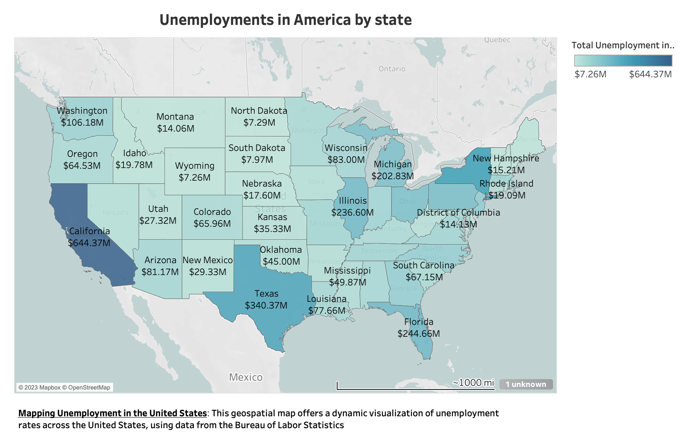

1. **A time series chart**

