1. Using the tool of your choice, produce an excellent table showing the data. The table should employ at least one Gestalt principle to clearly present the data relationships.

Dataset used - Kaggle - Pizza restaurant sales

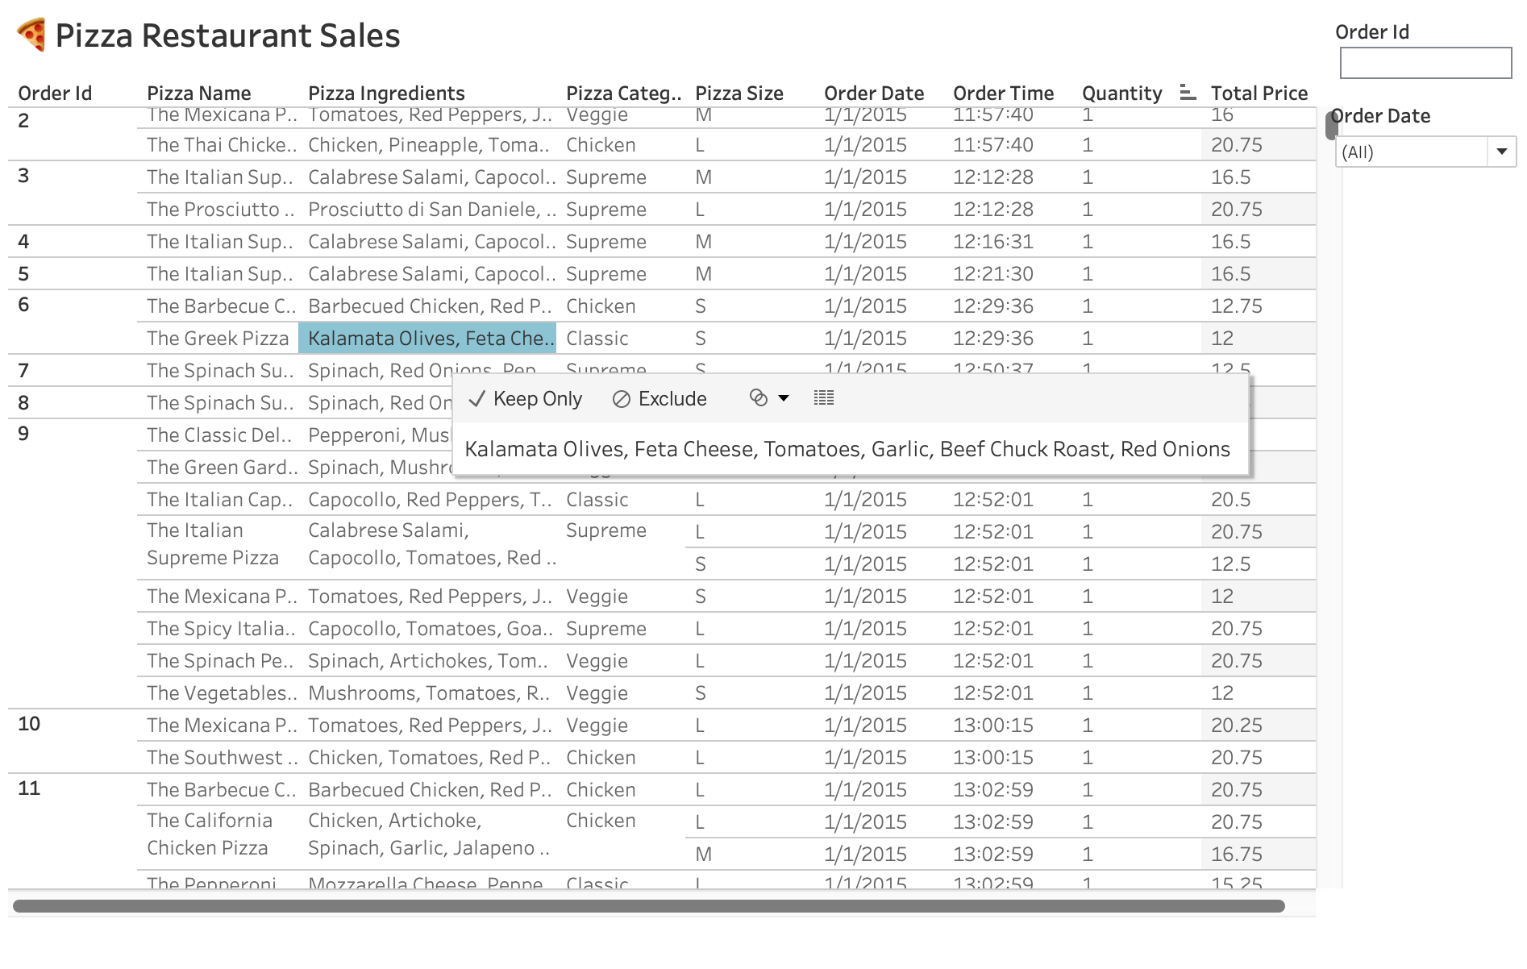

1. Include a separate comment describing your Gestalt principle use

**Gestalt principles:**

The table employs the Gestalt principle of proximity to clearly present the data relationships. The data is grouped together based on the order id that depicts proximity principle. In addition, the name and ingredients data for each pizza is displayed in close proximity as well as quantity with total price column making it easier for the reader to understand the relationships between the data.

The quantity

1. Using the tool of your choice, create a chart that clearly shows at least three dimensions of data.

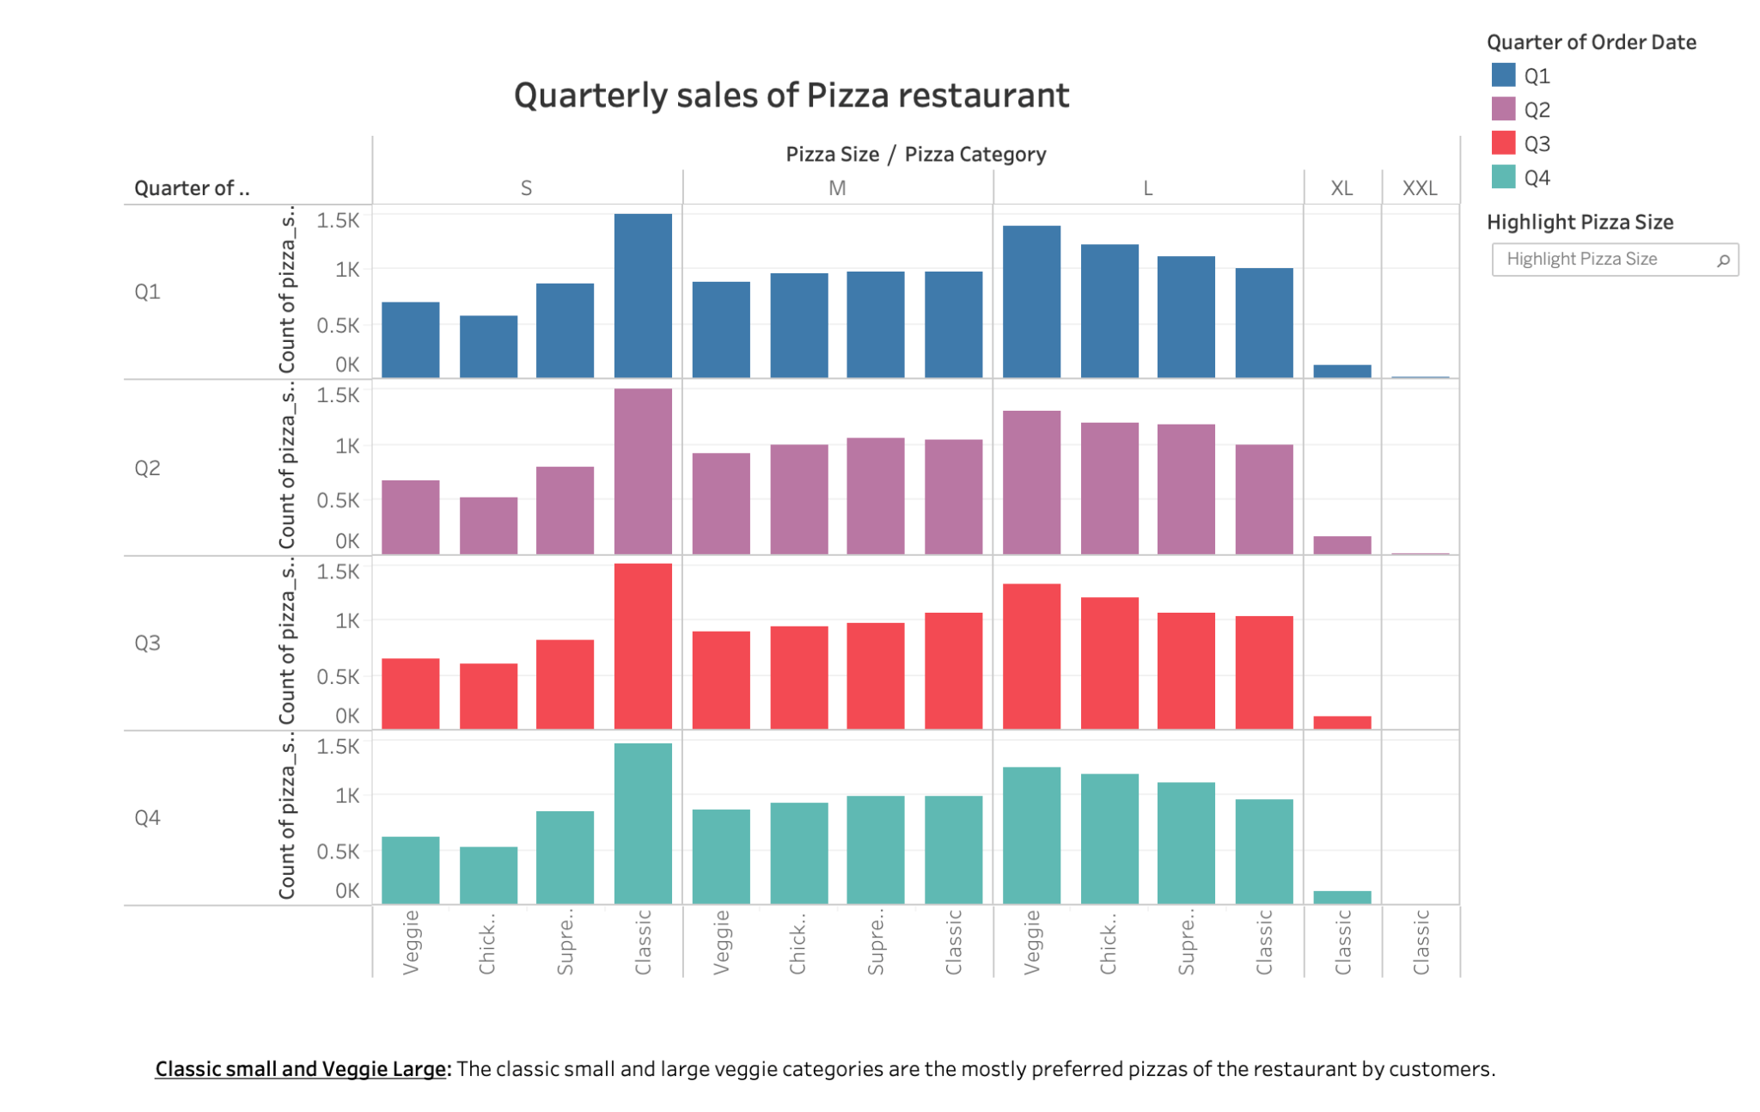

The above chart includes 4 dimensions of the data. The X-axis represents the pizza category (veggie, chicken, supreme and classic) which is further grouped according to the sizes (Small, Medium, Large, X-large and XX-Large).

The Y-axis represents the number of pizzas sold in each category and it is further grouped into four quarters per year.