**DATA-230 Sec 21 - Data Visualization - Assignment-6**

1. **Principle of Proximity**

This law states that objects placed close to one another are perceived as a group.We easily tend to make comparisons and look for similarities in such groups.

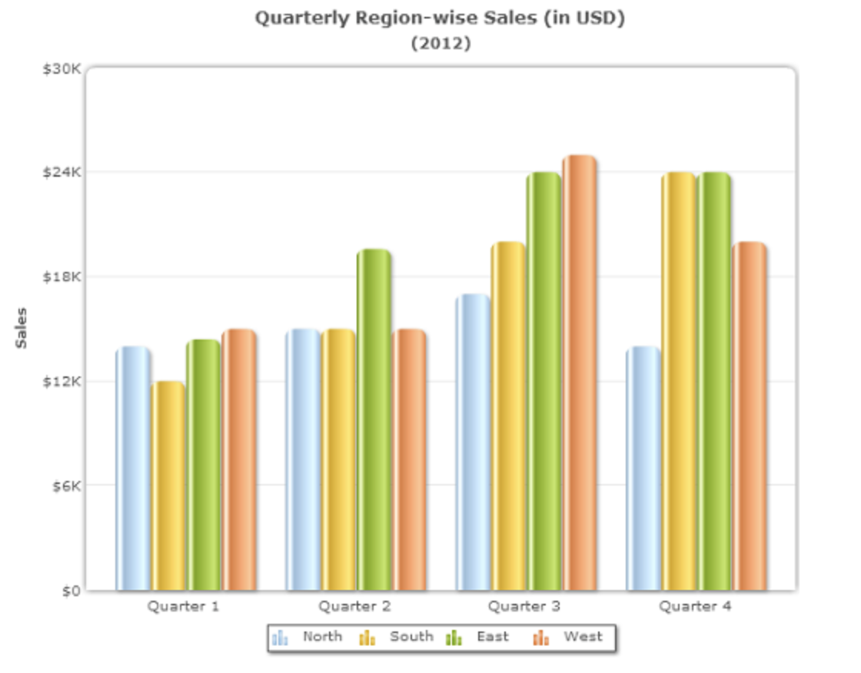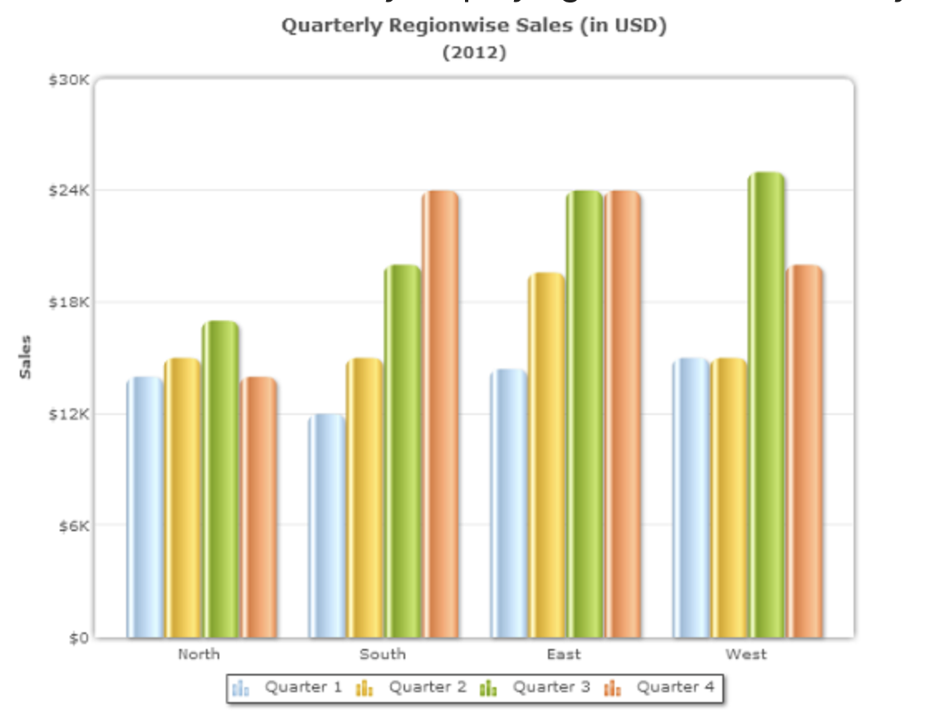

In the first chart, the sales of “North”, “South”, “East”, and “West” regions form 4 distinct groups: “Quarter 1”, “Quarter 2”, “Quarter 3”, and “Quarter 4”. It is quite easy to compare the sales of each region within a quarter.

But if the priority is to compare the sales region wise, then we can change the grouping as in the second chart which groups the data region wise.

Thus, based on the priority the grouping can help us to increase the readability.

1. **Principle of Similarity**

The principle states that similar elements are visually grouped, regardless of their proximity to each other.

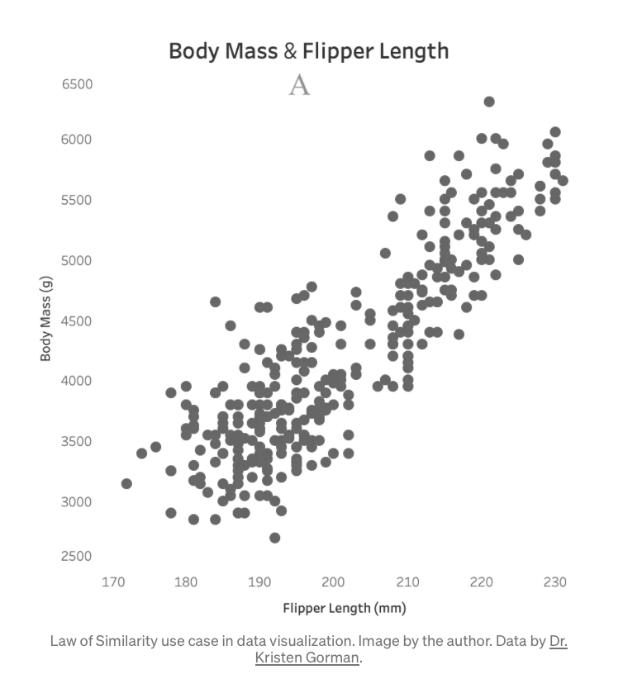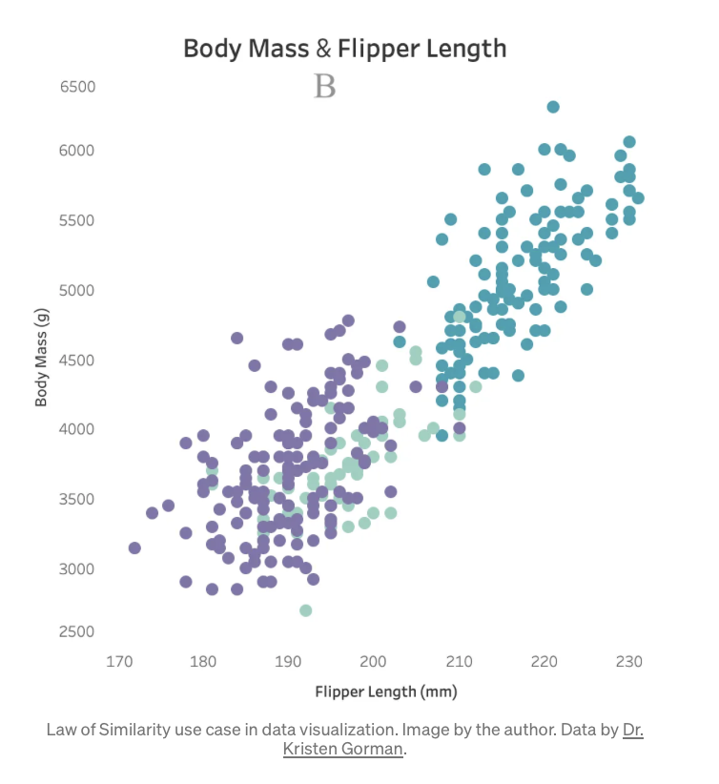

As shown in the charts, the data can be more readable with the introduction of color, and the different groups can be easily recognized without much cognitive load.

Practitioners can use similar characteristics and attributes (color, size, shape, etc.) to establish relationships between objects and to reinforce groupings.

1. **Principle of Enclosure**

The principle states that we perceive objects as belonging to a group when they are enclosed in a way that creates a boundary or border around them.

In the chart below, the 3 bars with the orangish shade appear to be part of a group. This is because when we enclose objects with a border or a boundary our mind perceives them as a group. We can use this technique to get the audience to focus on a group of objects in the chart.

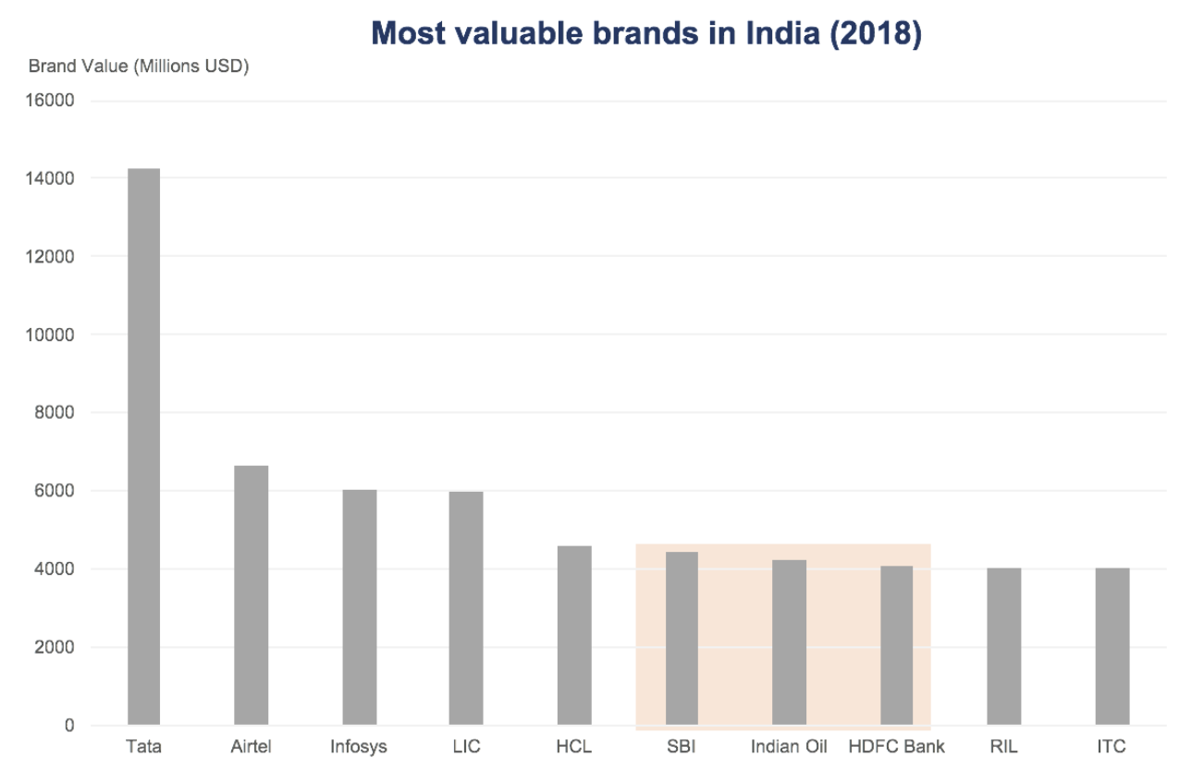

1. **Principle of Continuity**

The law of continuity states that our eyes instinctively group things that are aligned with each other.

In the chart below, there are abrupt directional changes.

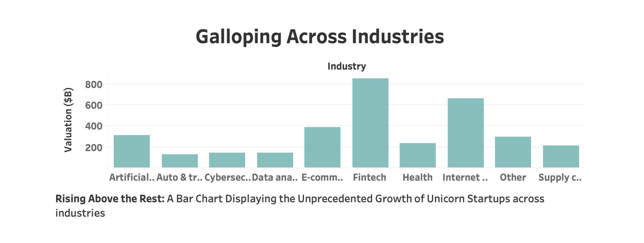

But in the second chart below, the eyes follow a continuous path; it makes the whole chart more readable because of the continuous downward direction.

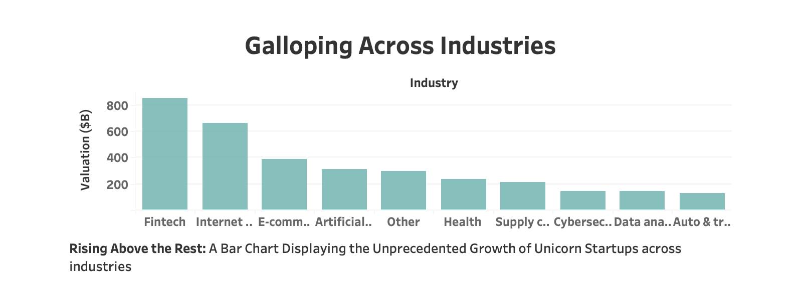

1. **Principle of Closure**

The principle states that our minds tend to see complete figures or forms even if a picture is incomplete. One cool example is shown below. We tend to imagine the structure of the bulb even if it’s not actually a bulb.



As shown in the below chart, looking at the missing population data for the year 1970, our minds automatically imagine a line connecting the 2 broken lines. Hence, we must be careful when showing graphs with breaks because our minds tend to form complete shapes even if the shape is incomplete and data could vary in between.

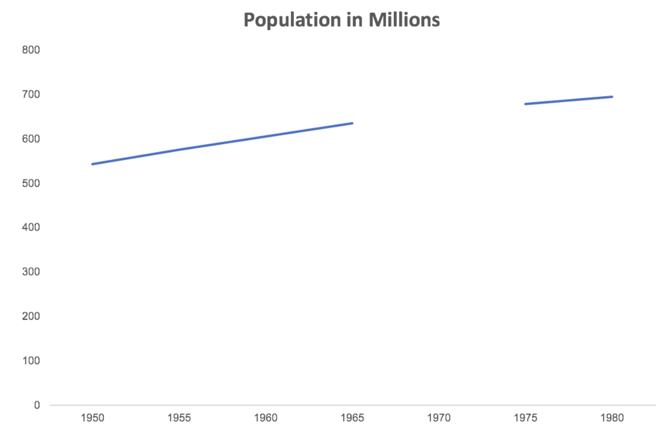

1. **Figure and Ground**

The Figure and Ground Principle describes the capacity to perceive the relationship between form and surrounding space to create meaning.The ‘figure’ is the focus element, while the ‘ground’ is the figure’s background.

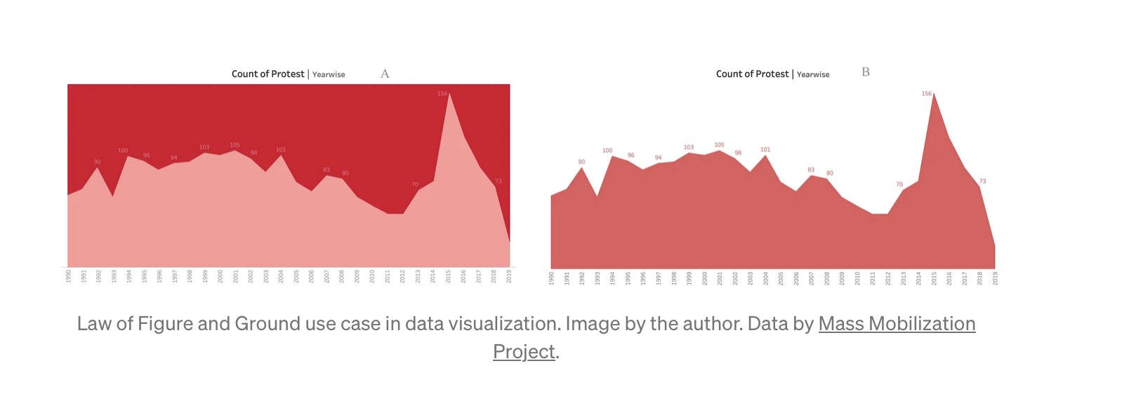

The low contrast between the figure (area graph) and background (sheet color) in the left chart demands cognitive load. While the second chart with increased/decreased contrast between the figure and ground increases the readability.

1. **Principle of Symmetry**

The principle states that objects that are balanced and symmetrical are seen as complete or whole.

The below chart shows the population pyramid of male population data to the left (negative x values) and female population data to the right. This creates a pyramid-like shape, stronger than two separate charts.

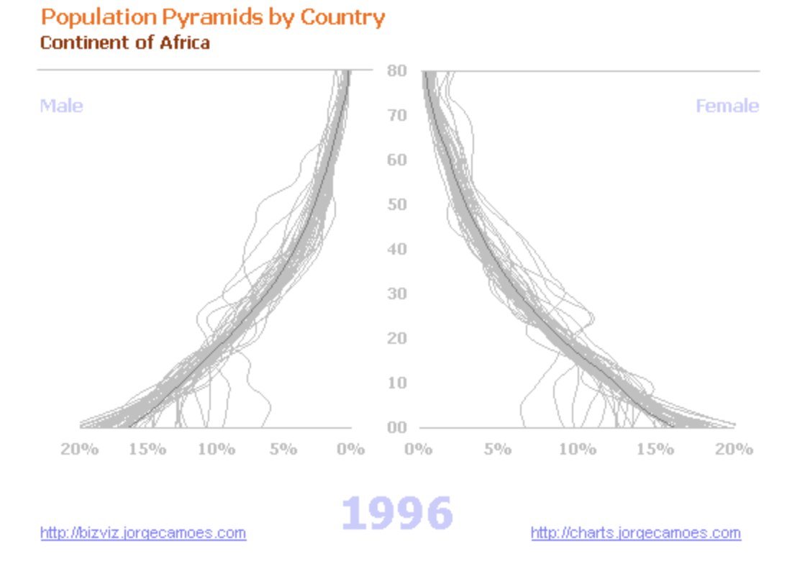

1. **Principle of Focal Point**

The Focal Point principle states that whatever stands out visually will be given priority attention by the audience.

The difference between the two charts below is that the attention is likely drawn to the United States because the author imposes a focal point using color to successfully deliver a story.

