1. **Visualization using Tableau with Unicorn startups dataset from Kaggle**

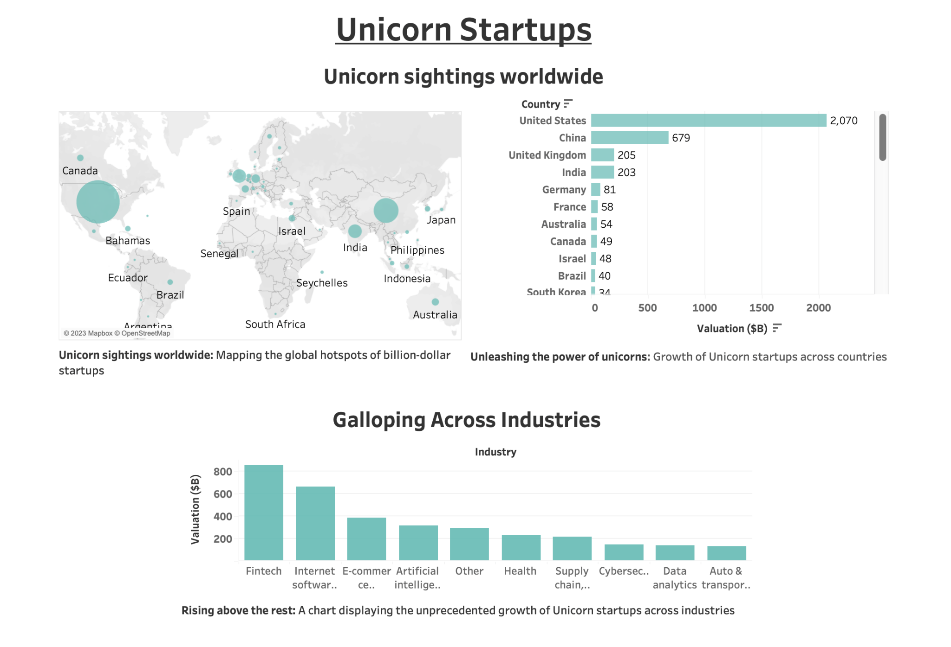

1. **With Visual Encoding**

