**📘 Jenkins Freestyle Job: Build Automation for Java HelloWorld App**

This document outlines the configuration and execution of a Jenkins Freestyle job used to build a simple Java-based HelloWorld application managed using Maven. The job fetches the project from a GitHub repository, compiles it using Maven, and outputs build results via Jenkins console logs.

The screenshots and steps provided demonstrate a successful build process, confirming that the Jenkins job is set up correctly and integrated with the version control system.

1.Job configuration screen

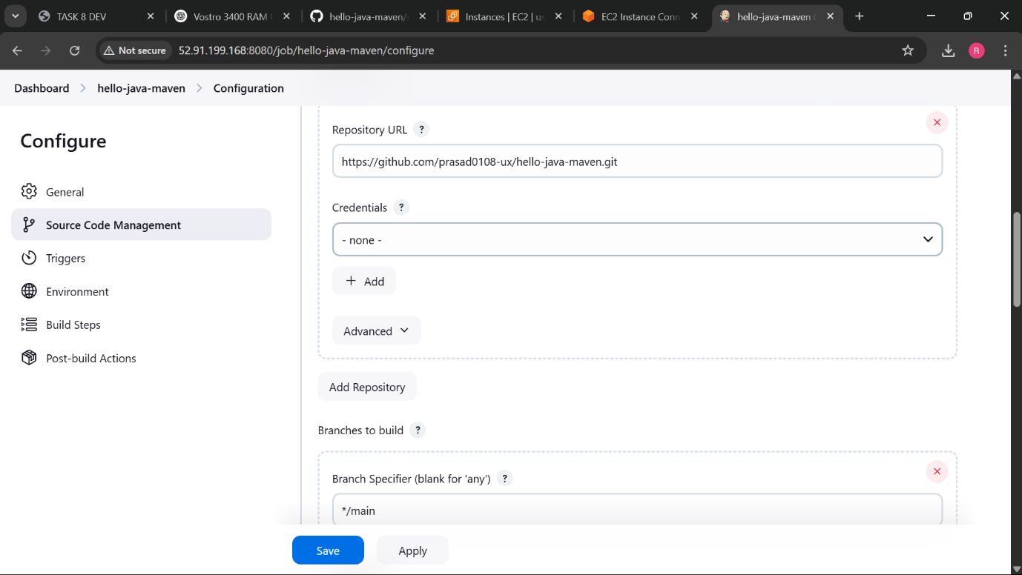

2.Jenkins dashboard with the job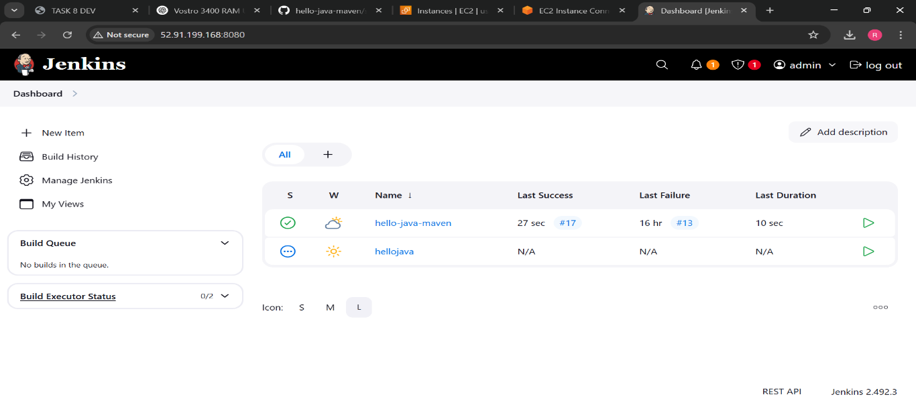

3.Console output with build status

