**Task 7: Monitoring System Resources Using Netdata**

In this task, I explored system and application performance monitoring using Netdata. The objective was to deploy a simple application inside a virtual machine (VM), run Netdata via Docker, and visualize key system metrics such as CPU, memory, disk usage, and Docker container activity. This document includes screenshots and key observations from the Netdata dashboard, showcasing lightweight server monitoring in real time.

1.Accessing the dashboard

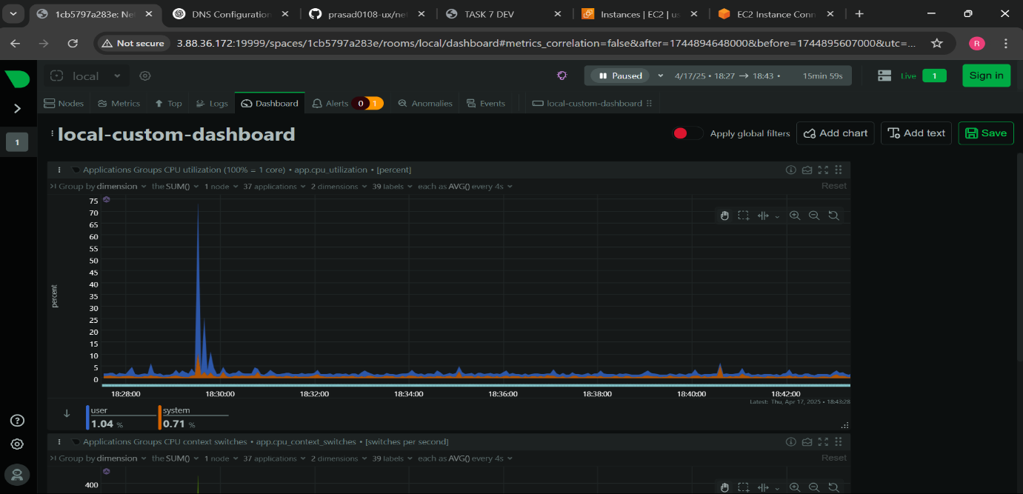

2.Accessing the metrics

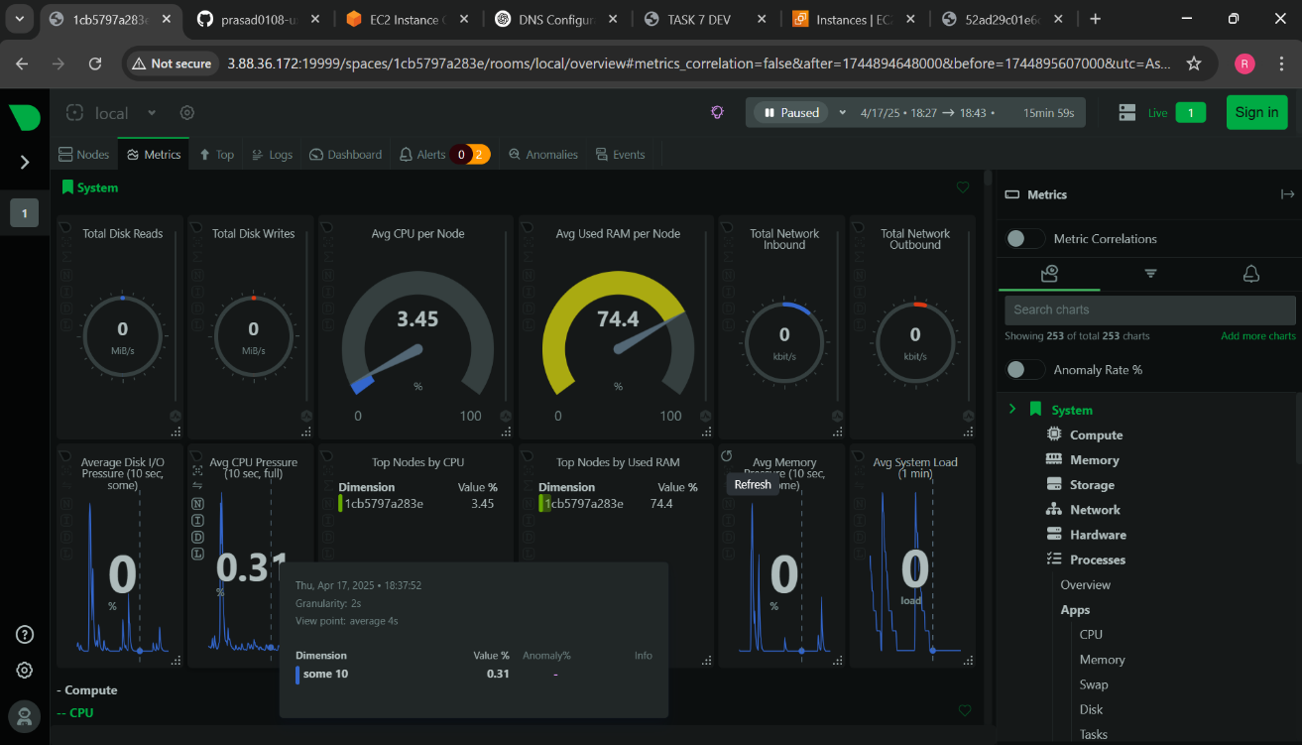

3.Accessing cpu metrics

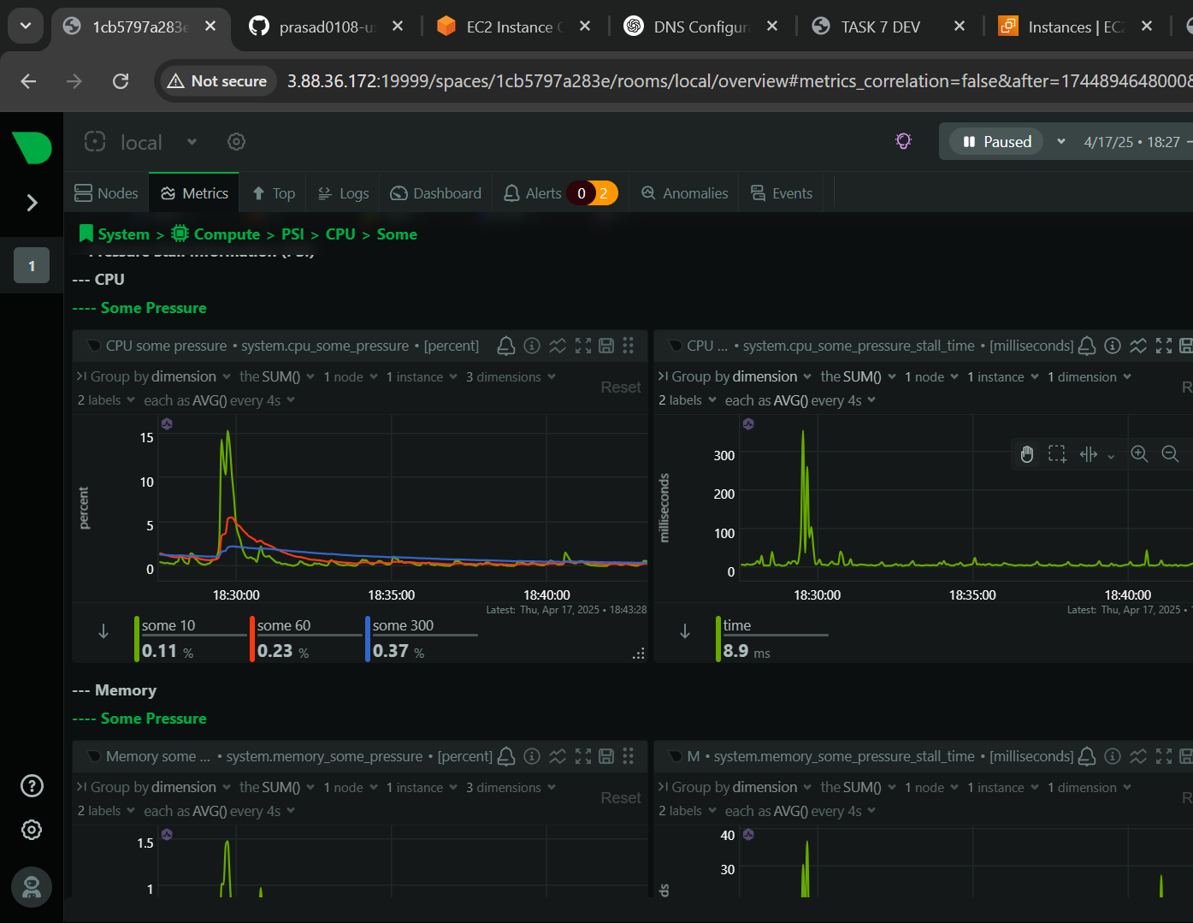

4.Accessing memory metrics

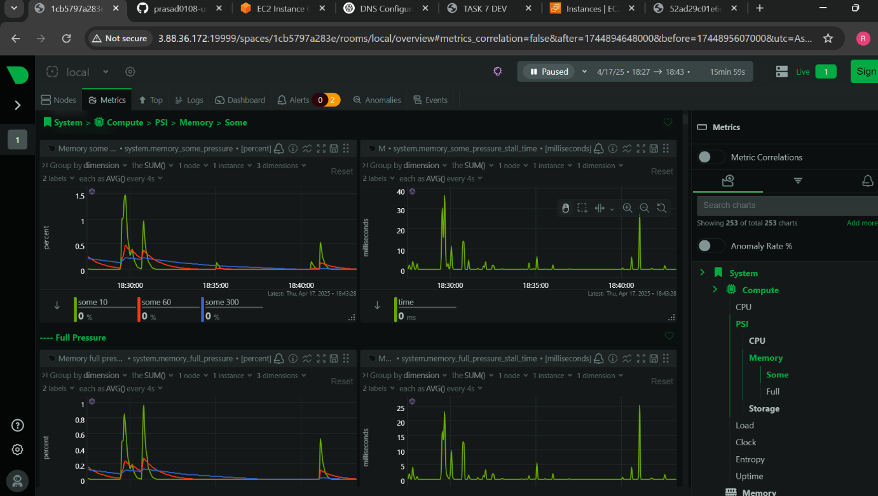

5.Accessing docker container metrics

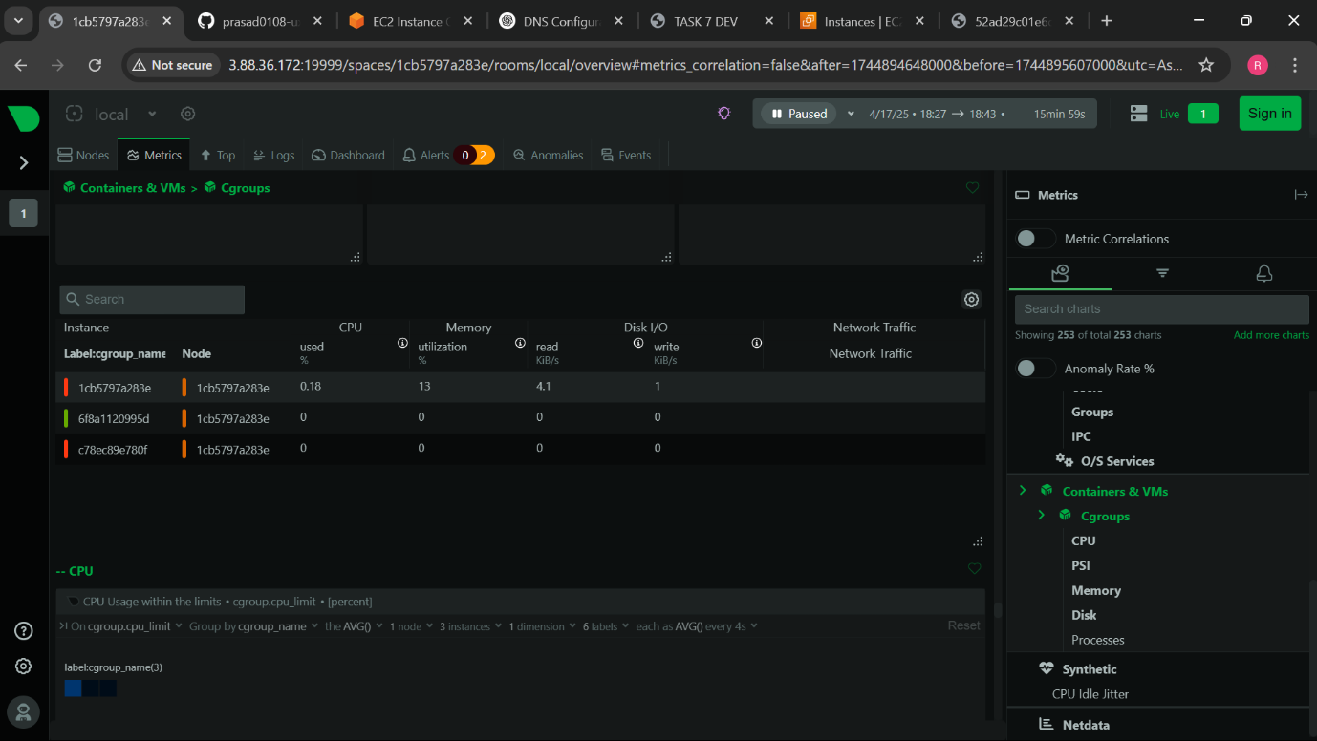

6.Accessing alert & warning

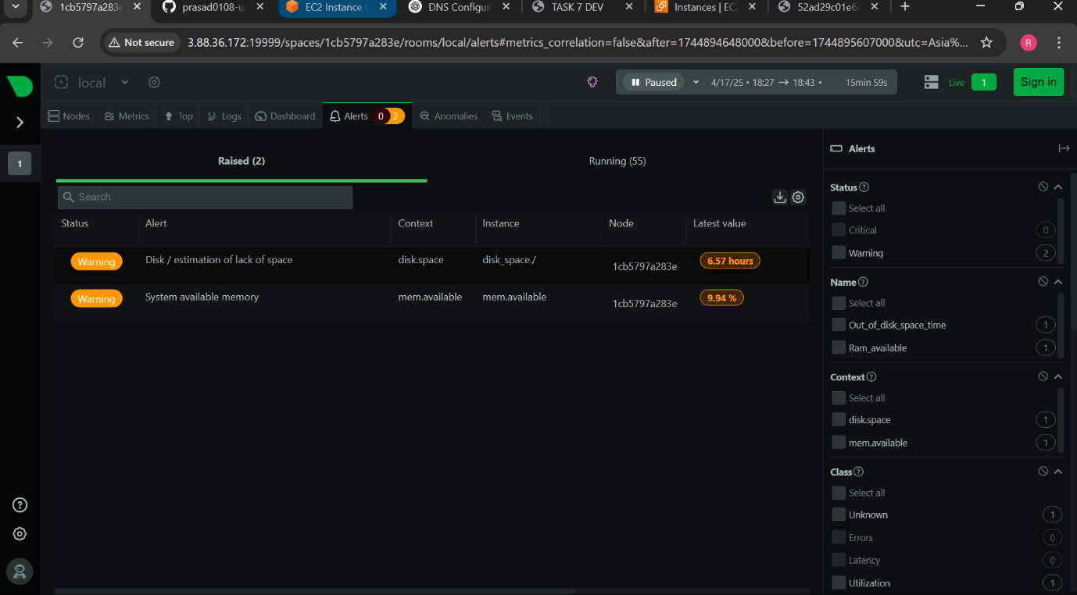

7.Accessing Chart panels

