This document provides a step-by-step overview of the process used to create and manage a version-controlled DevOps project. The screenshots below illustrate the workflow, starting from initializing the project in a local dev branch, pushing it to GitHub, creating a feature branch, and merging changes through pull requests.

1.Created the files

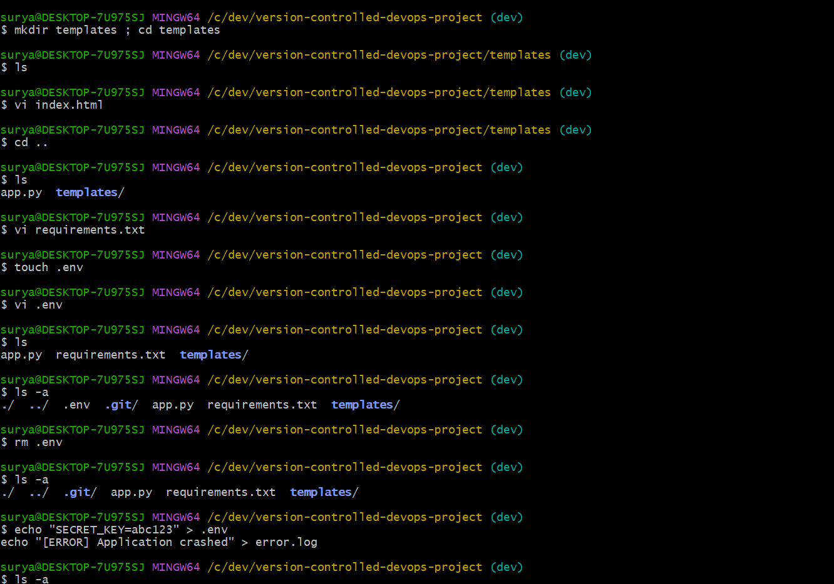

2. Pushed the code to the dev branch

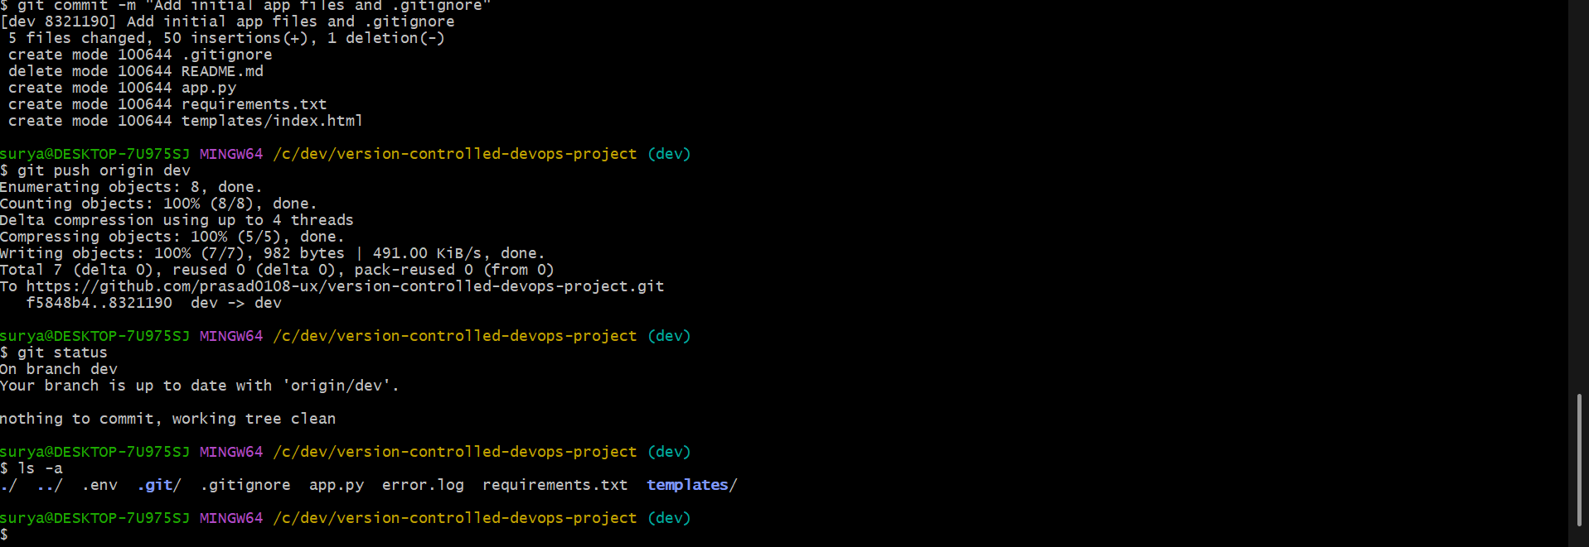

3. Created feature branch and created code and updated files for the new feature

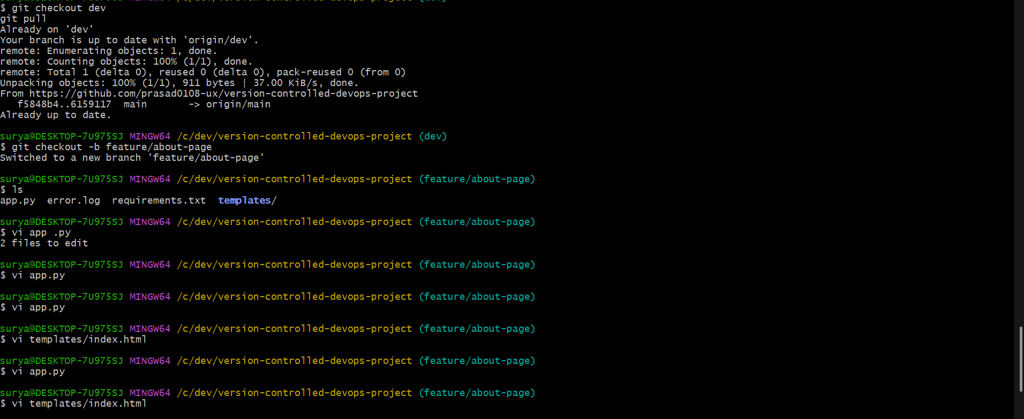

4. Pushed the feature to the remote repository

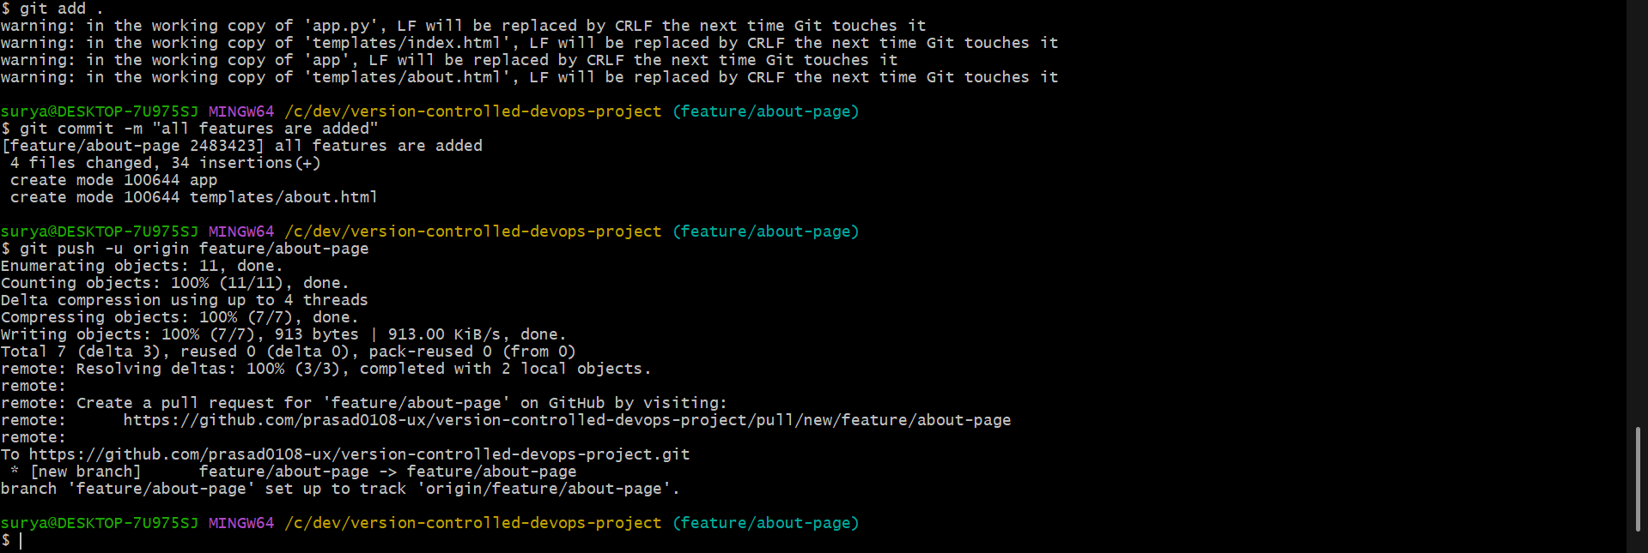

5. Created a pull request to merge the branch

