Q1) Write an SQL query to create a view named Book_List that displays the following columns
from Books table:
Book_No, Book_Name, Author_Name, Cost, Category.
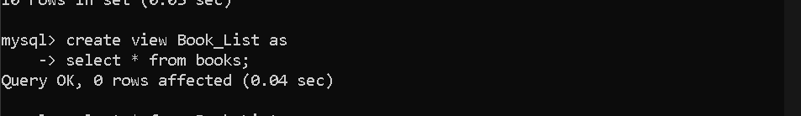
Q2) Write an SQL query to display all records from the view Book_List.
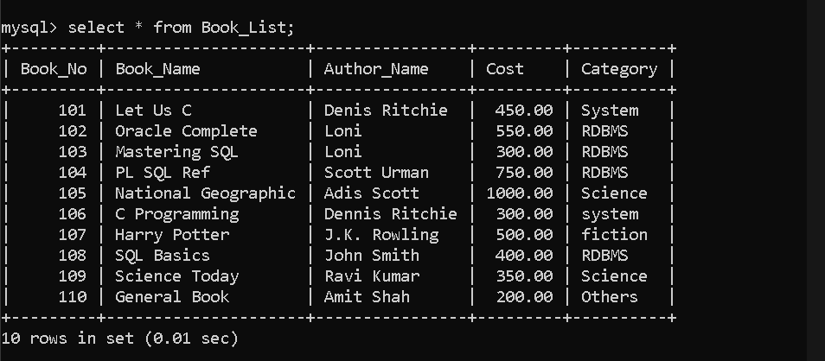
Q3) Write an SQL query to create a view named Issued_Books that displays details of all books
that are currently issued
(books whose Return_Date is NULL).
Output columns should include:
Lib_Issue_Id, Book_No, Member_Id, Issue_Date.
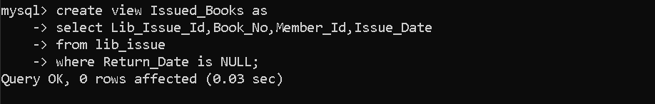
Q4) Write an SQL query to display all records from the view Issued_Books.
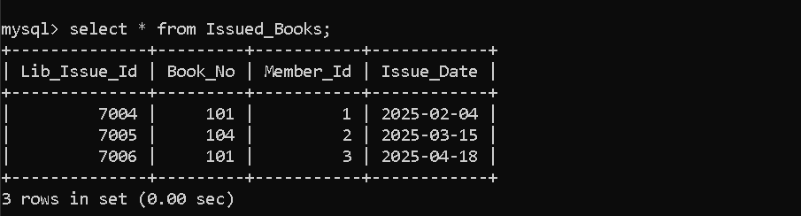

Q5) Write an SQL query to create a view named Member_Penalty that displays Member_Id,
Member_Name, Penalty_Amount
for members whose Penalty_Amount is greater than 0.
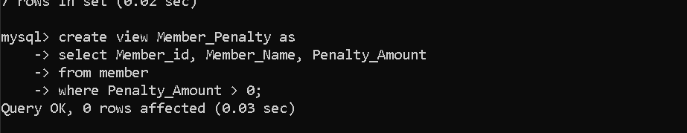
Q6) Write an SQL query to display all records from the view Member_Penalty.
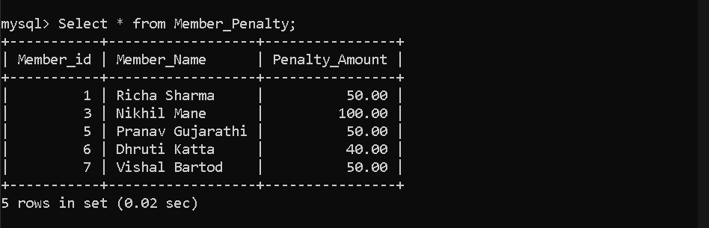
Q7) Write an SQL query to update the Penalty_Amount of a member using the Member_Penalty
view.
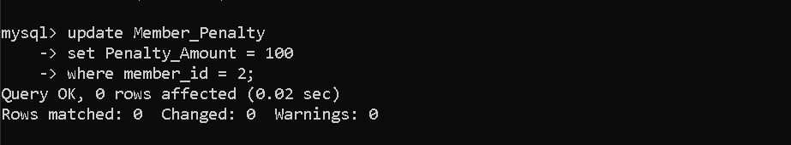
Q8) Write an SQL query to create a view named Book_Issue_Details that displays:
Book_Name, Member_Name, Issue_Date, Return_Date
by joining Books, Member, and Issue tables.
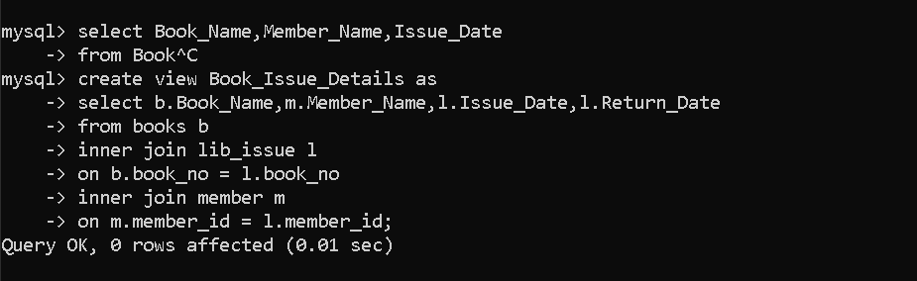

Q9) Write an SQL query to display Book_Name, Member_Name, Issue_Date from the view
Book_Issue_Details.
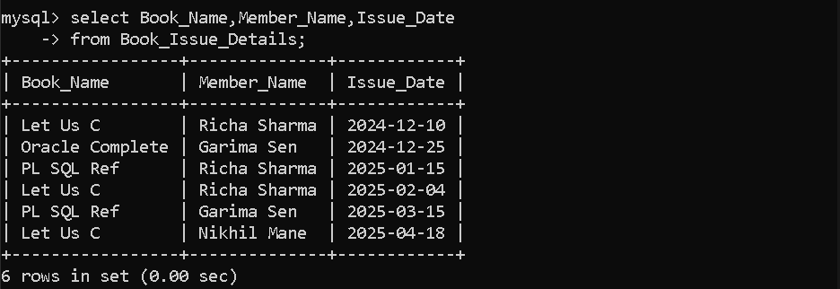
Q10) Write an SQL query to drop the view Issued_Books.
Q11) Write an SQL query to drop the view Member_Penalty.
Q12) Write an SQL query to drop the view Book_Issue_Details.

