** STRING Functions **
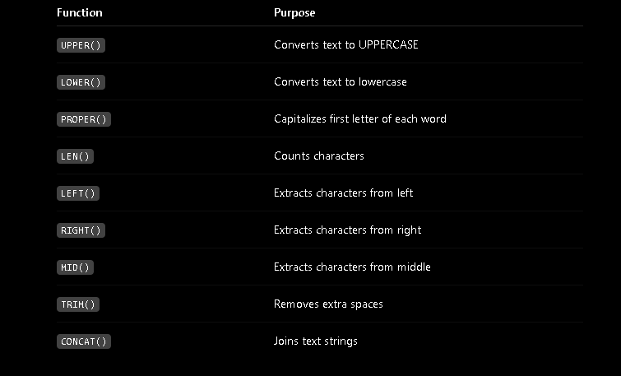

- UPPER(text) converts all letters in a text string to uppercase
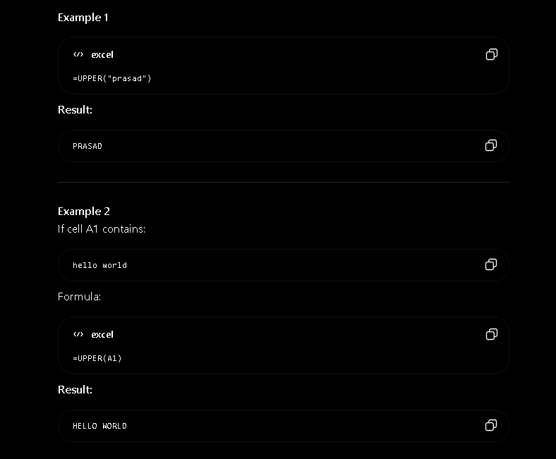

- LOWER(text) converts all letters in a text string to lowercase
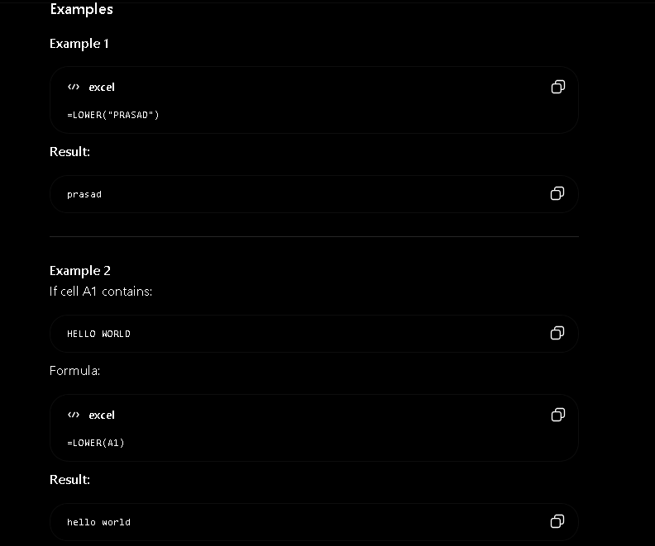
- LEFT(text, num_charc) it extracts a specified number of characters from the left side of text string.
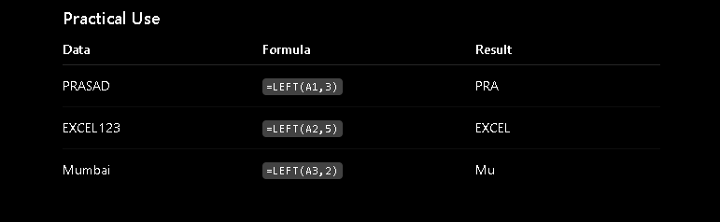
- RIGHT(number, num_charc) it extracts a specified number of characters from the right side of text string.
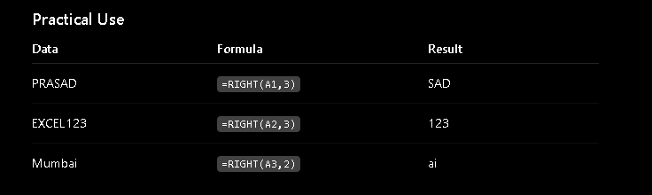
- MID(text, start_num, num_charc) it extracts a specified number of characters from the middle of text string.
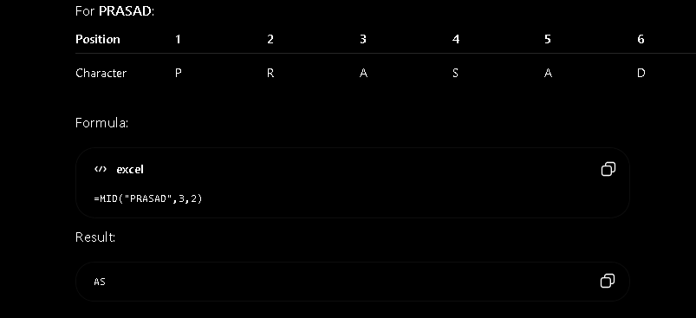
- LEN(text) it returns total number of characters in text string, including spaces.

- CONCAT(text1, text2, …) it is used to join (combine) two or more text strings into one string.
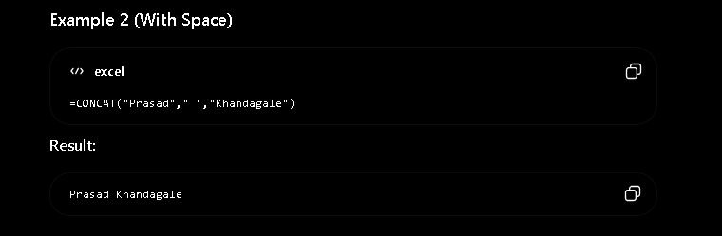
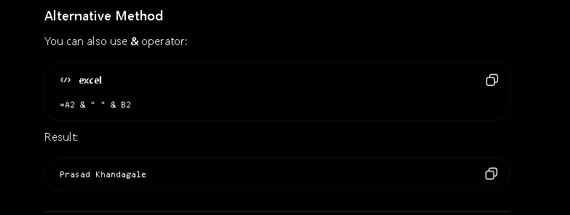
- EXACT(text1, text2) it compares two text strings and returns in True or False (EXACT is case sensitive)
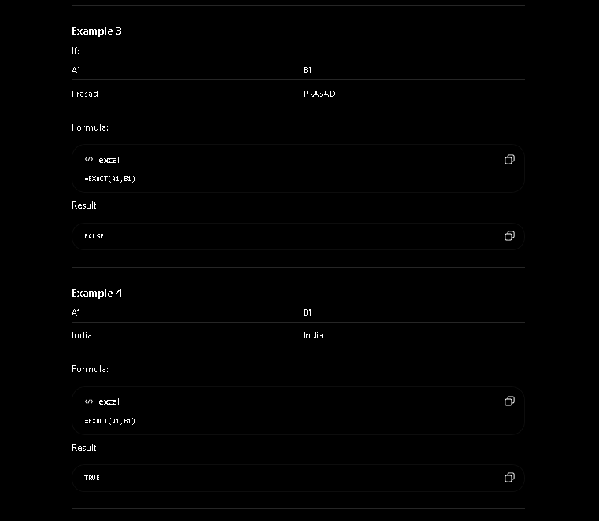
- TRIM(text) it removes extra spaces from a text string, leaving only a single space between words.
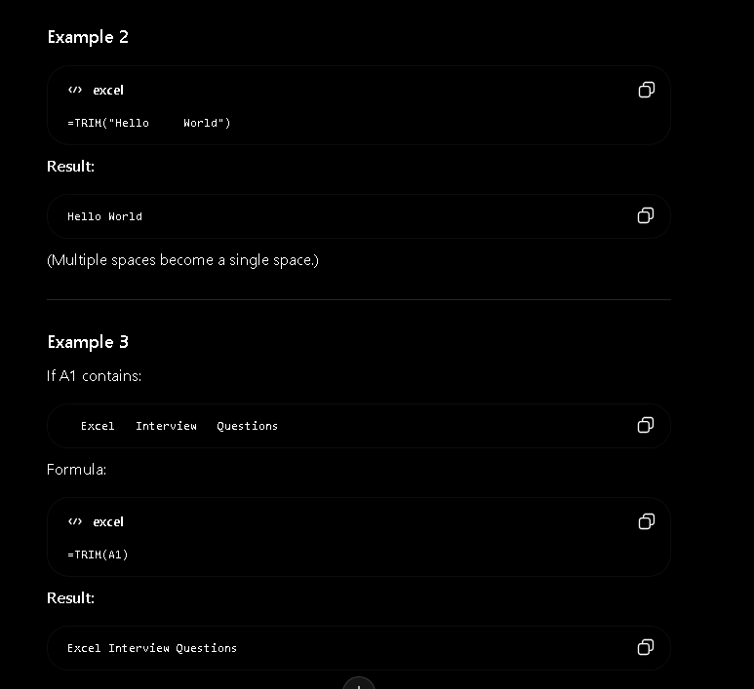
- DATE(year, month, day) it creates a valid date using Year, Month, and Day values
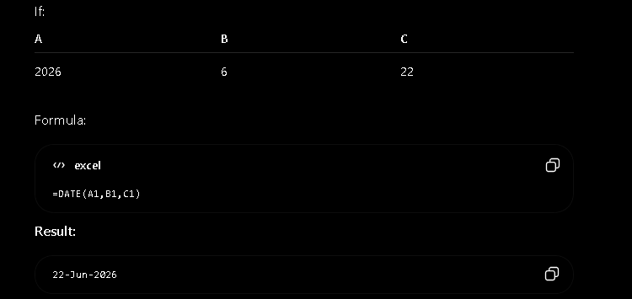
- TODAY() it returns the current date from your system and updates automatically whenever workbook is recalculated.
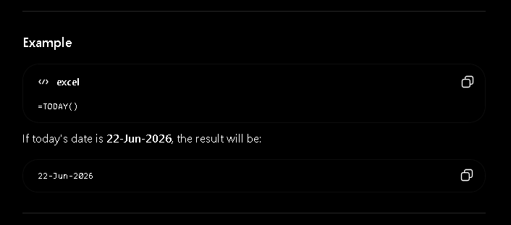
- NOW() it returns current date and current time from system
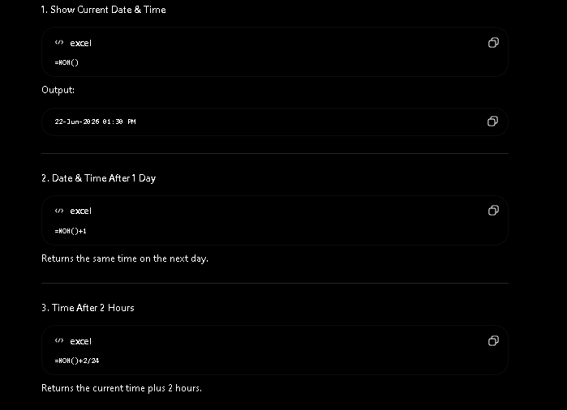
- TIME(hour, minute, second) it created a valid Excel time using Hour, Minute, Second values.
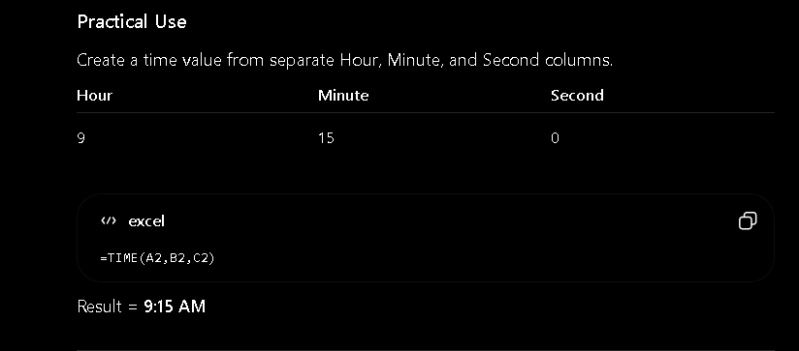
- YEAR(serial_number) it extracts the year from date.
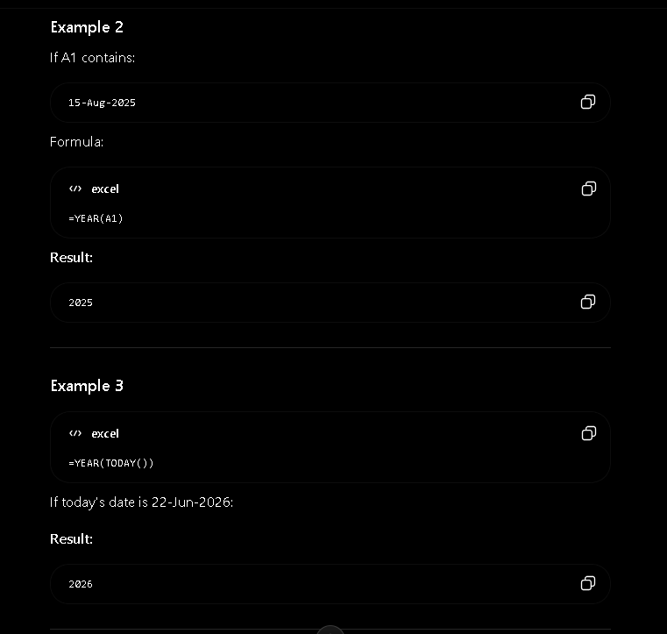

- MONTH(serial_number) it extracts month number from a date.
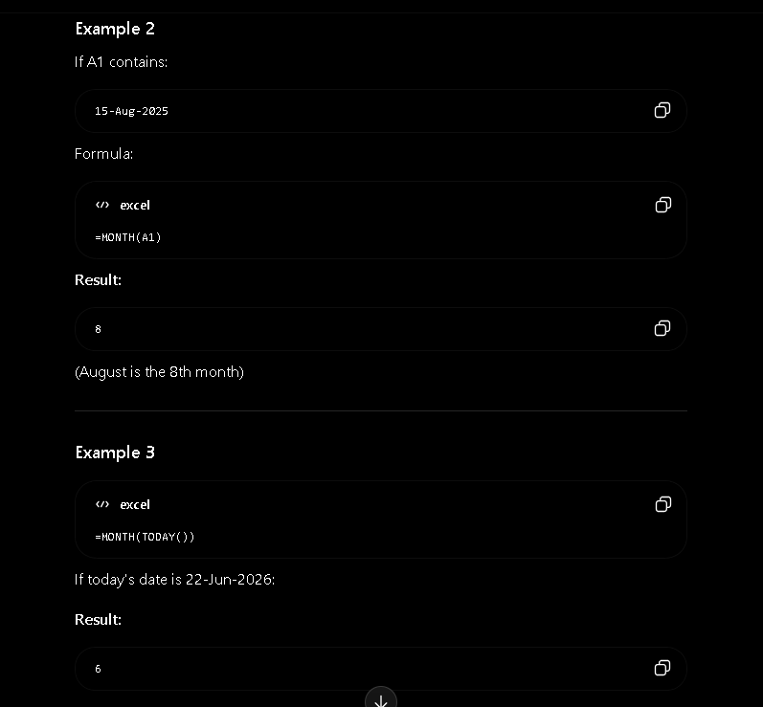
- DAY(serial_number) it extracts day of month from date.
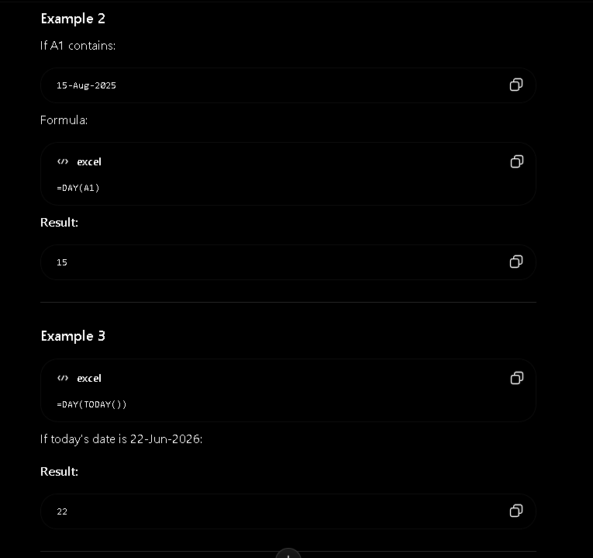
- DATEDIF(start_date, end_date, unit) it calculates the difference between two dates in years, months or days.
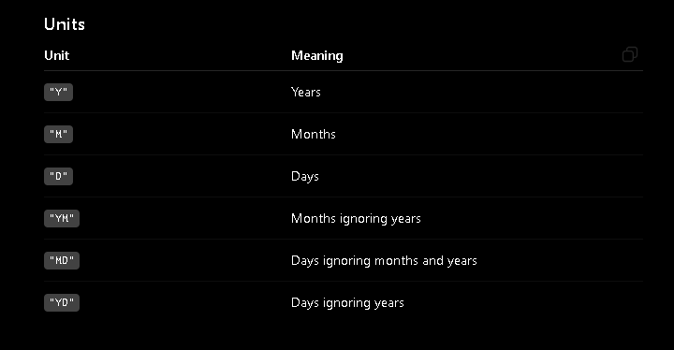
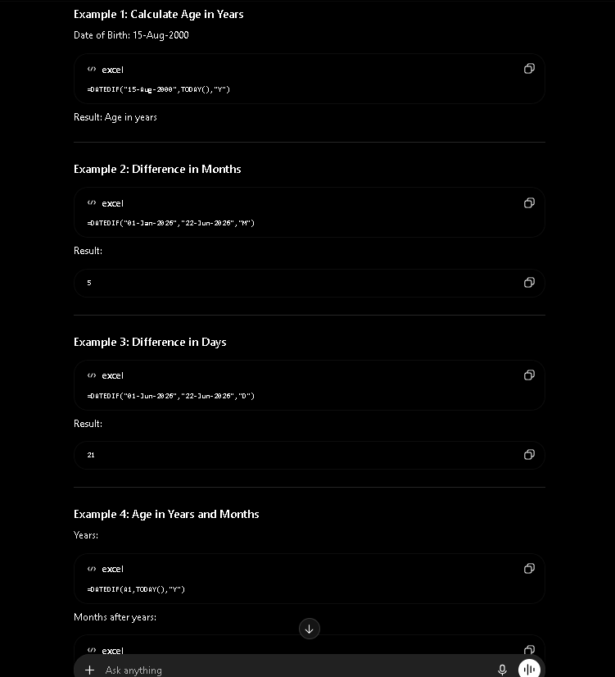
- AVERAGE(number1, number2,….) it calculates the arithmetic mean(average) of a group of numbers.
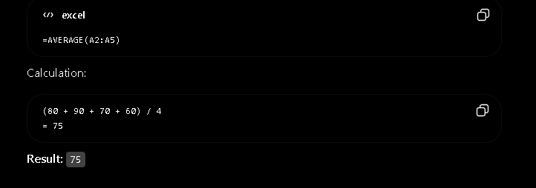
- MIN(number1, number2,…..) it returns smallest value
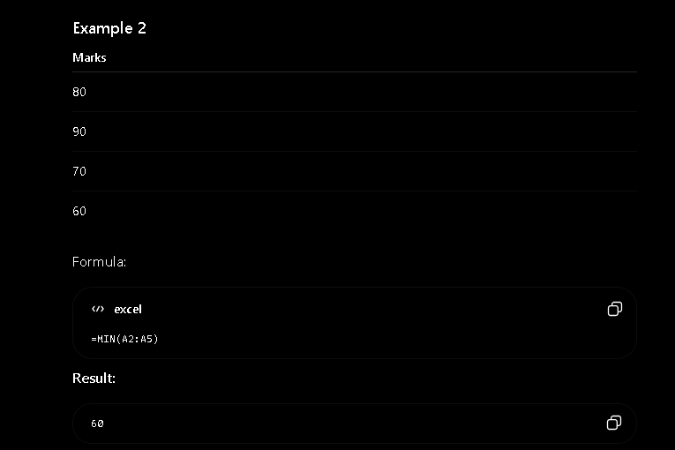
- MAX(number1, number2,..) it returns largest value.
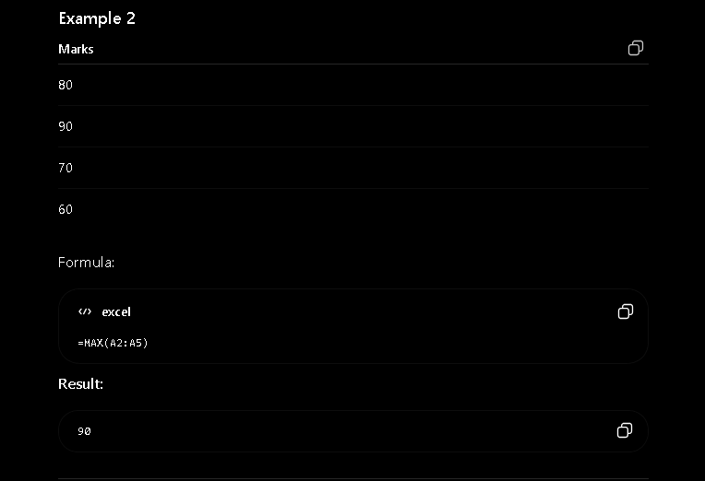
- MODE.SNGL(number1, number2,…) it returns most frequently occuring number.
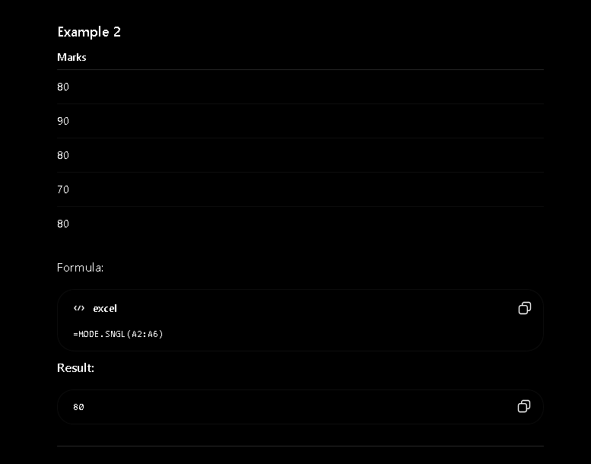
- MODE.MULT(number1, number2,…) - it returns multiple modes(more than one most frequently occuring value) in dataset.
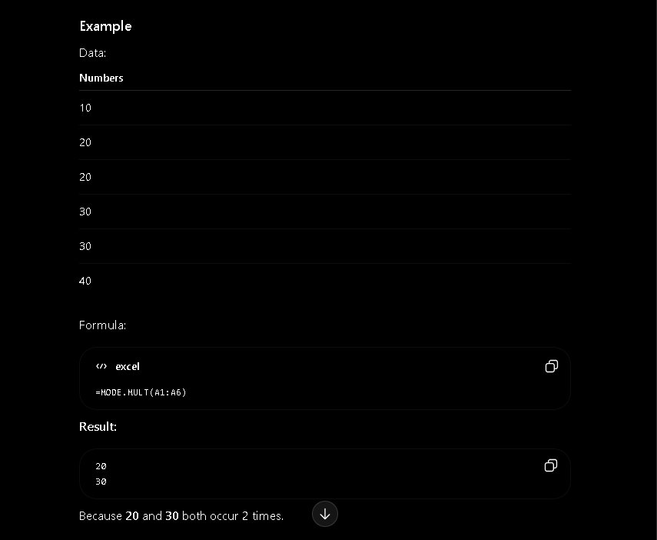
- COUNT(value1, value2,..) it counts the number of cells that contain numbers.
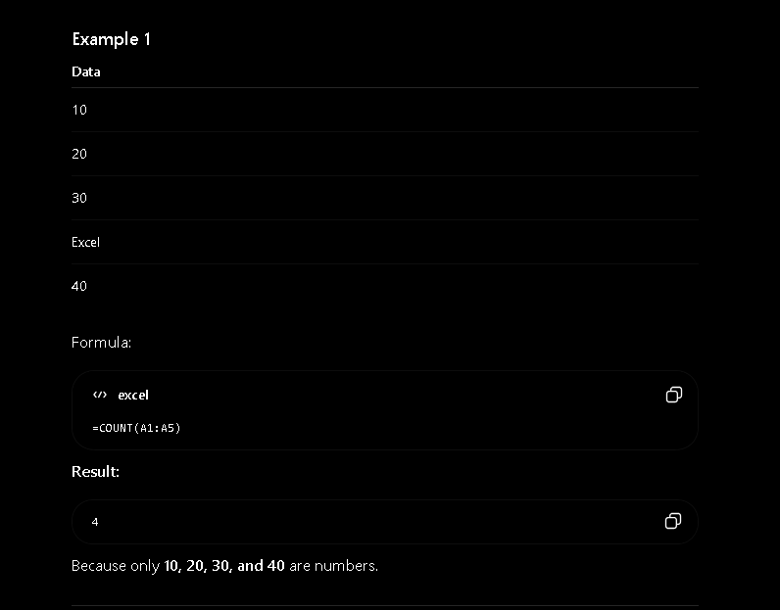
- COUNTA(value, value2,..) it counts all non-empty cells in range, including numbers, text, dates, true_false values.
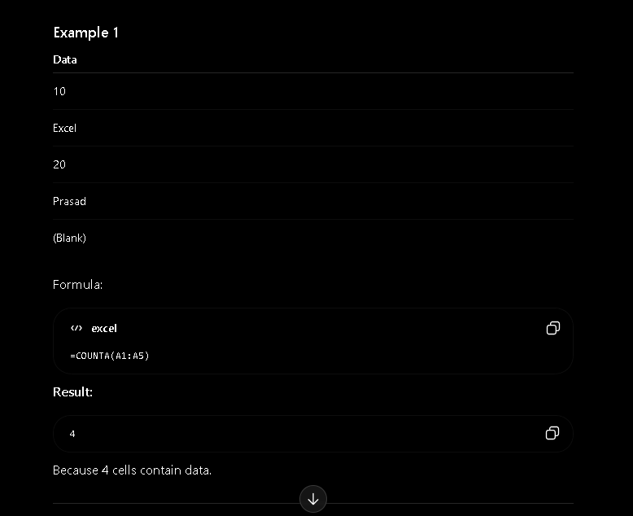
- COUNTBLANK(range) it counts the number of empty cells in range.
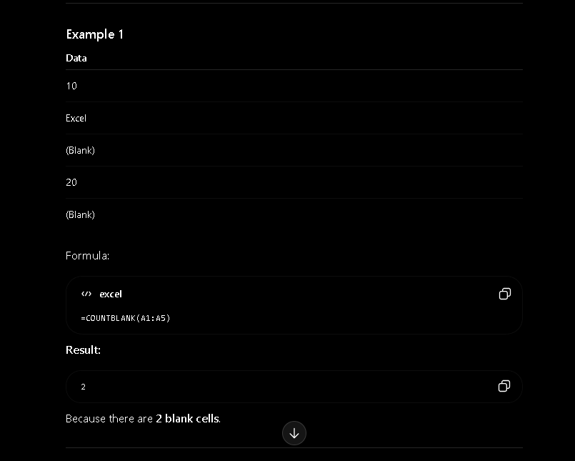
- COUNTIF(range, criteria) it counts the number of cells that meet a specific condition.
