- Display employee name along with department name.

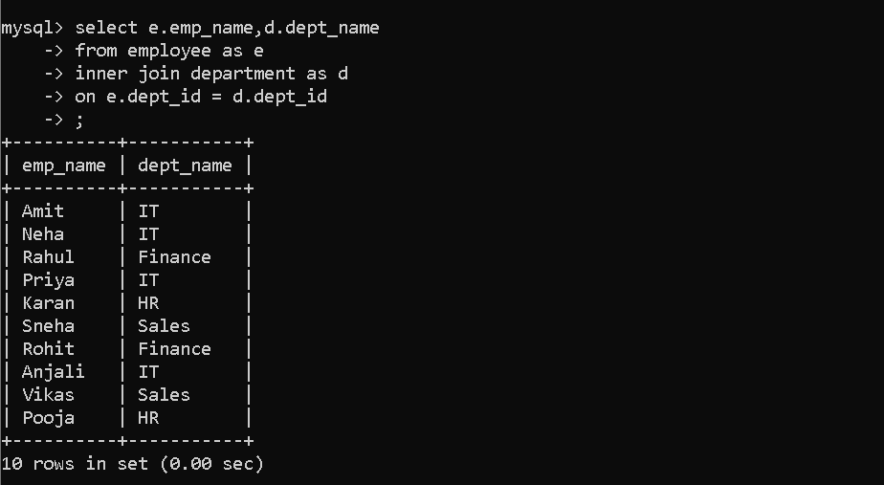
- Find employees earning more than ₹60,000.
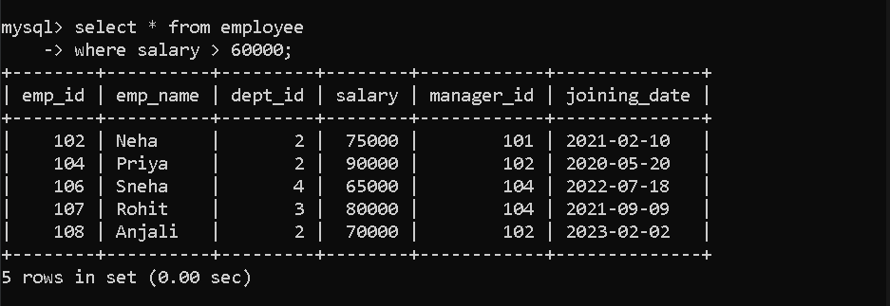
- Display employees working in IT department.
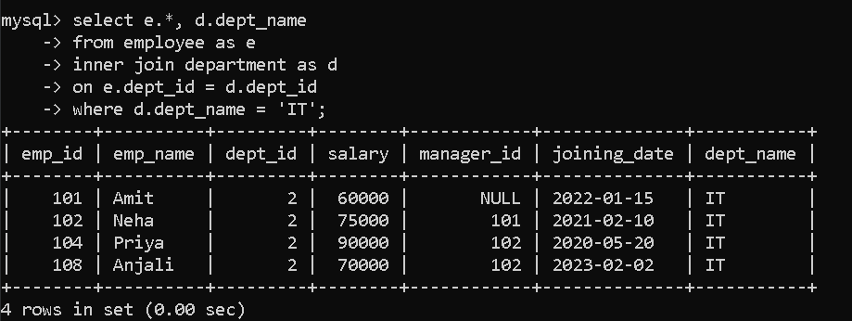

- Count employees in each department.
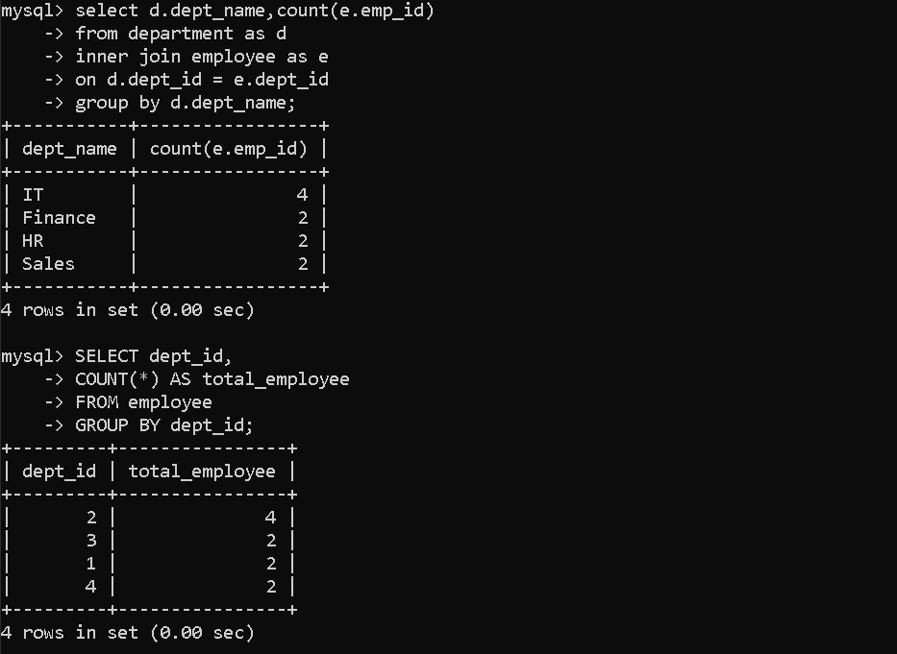
- Find average salary of every department.
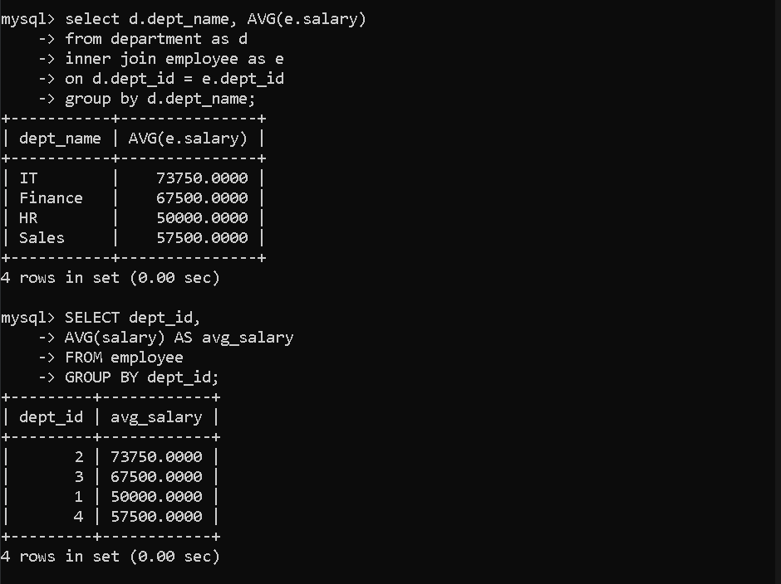

- Find highest salary in each department.
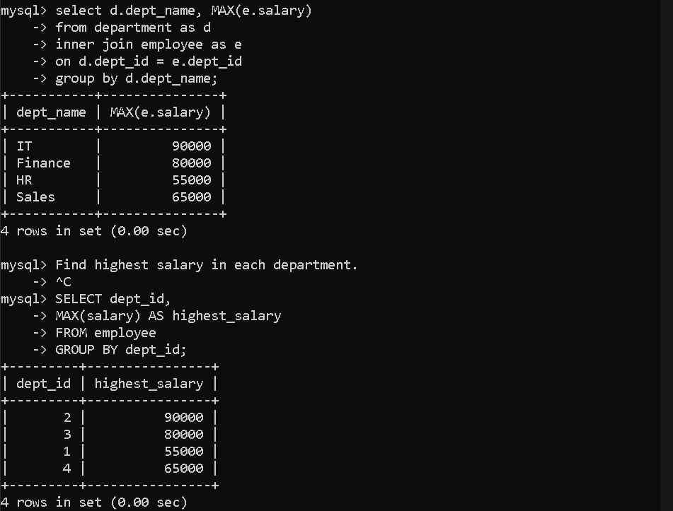

- Find departments having more than 2 employees.
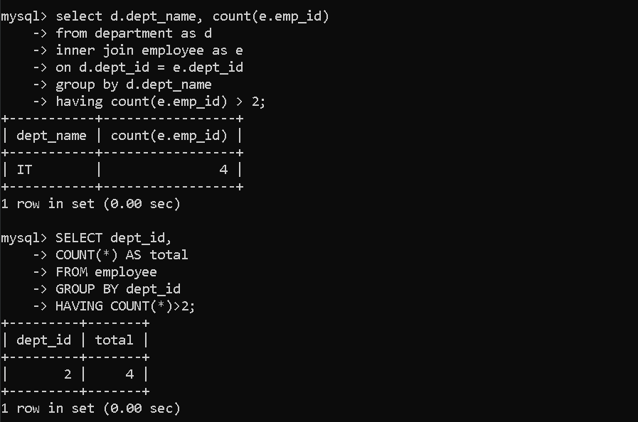
- Display employees joined after 2022.
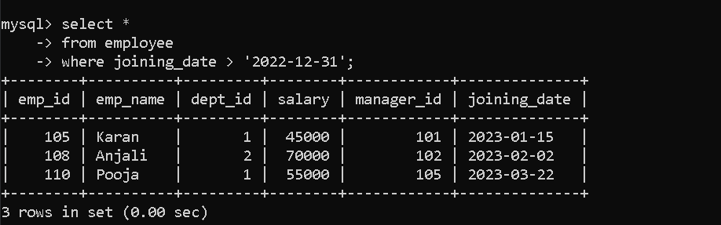

9. Find employee with highest salary.
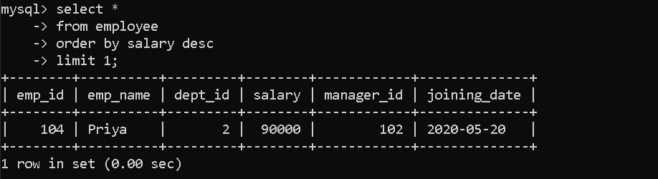

10. Find second highest salary.
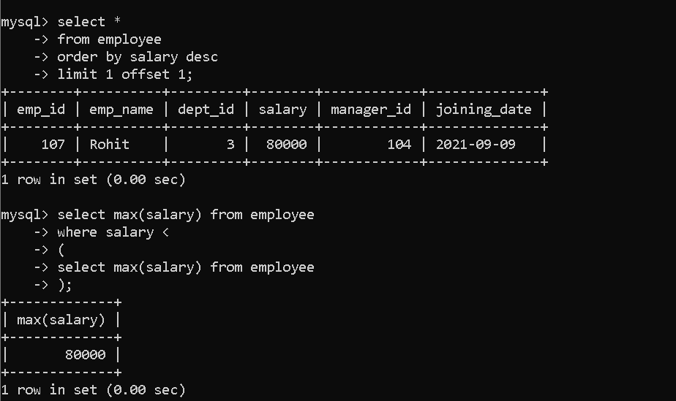
11. Find third highest salary.
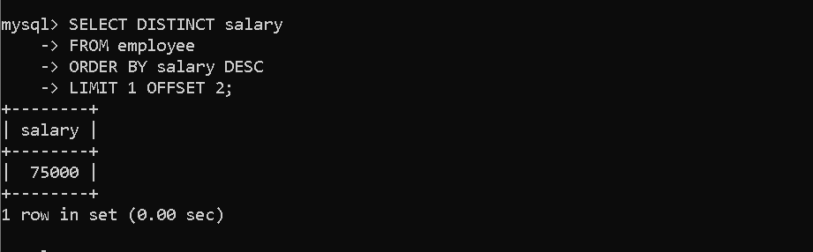

12. Display employees whose salary is greater than average salary.
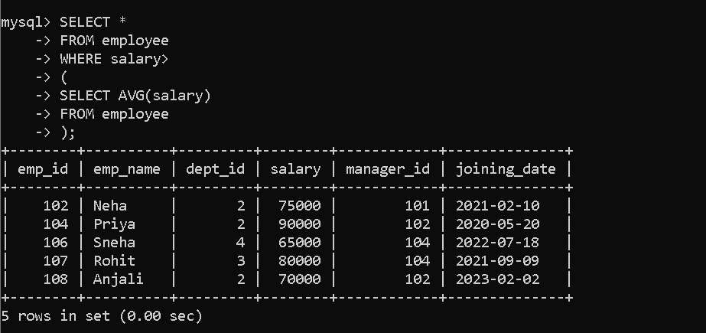
13. Find employees whose salary is between 50000 and 70000.
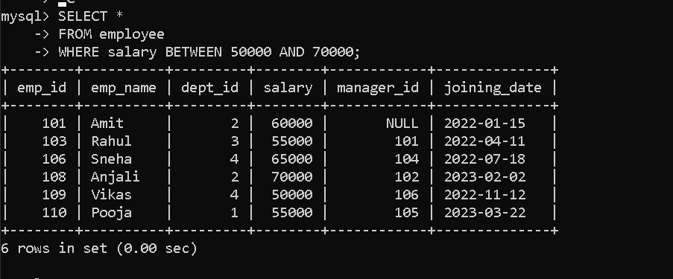
14. Display employee names starting with 'A'.
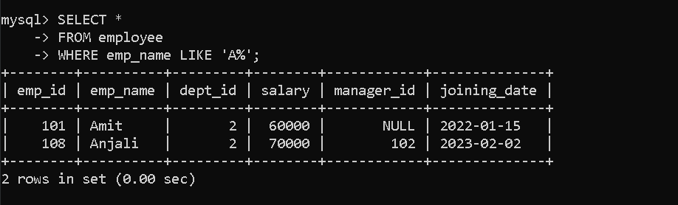
15. Find total salary paid by company.
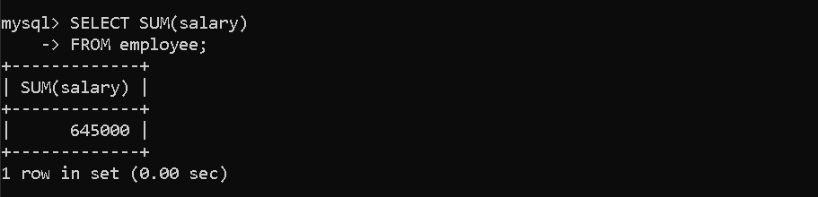

HARD LEVEL
16. Find employee along with manager name.
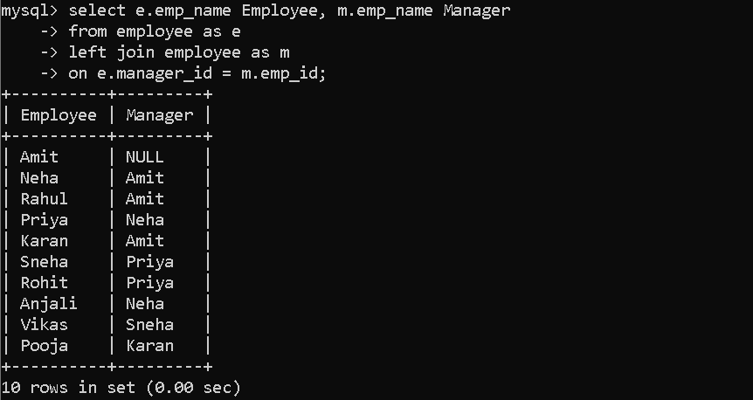
17. Find employees earning more than their manager.
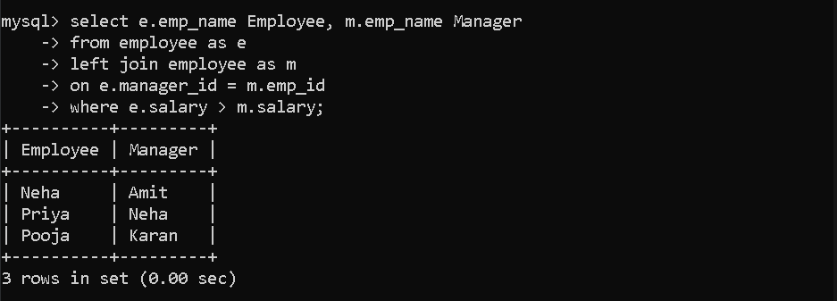
18. Find highest paid employee in every department.
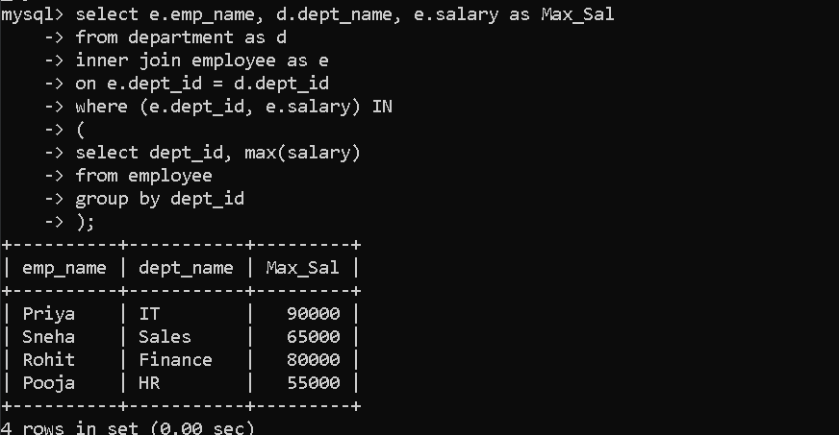

19. Find department having highest average salary.
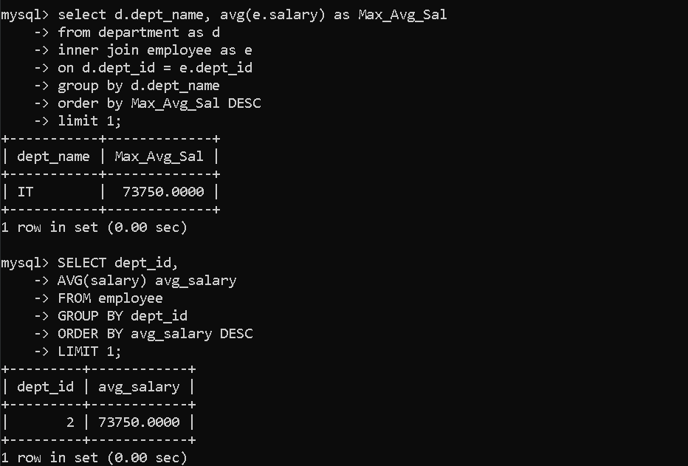
20. Rank employees according to salary.
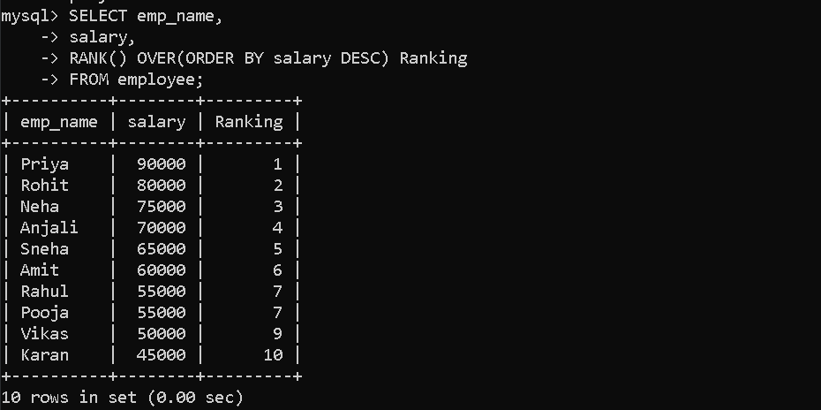

21. Dense Rank.
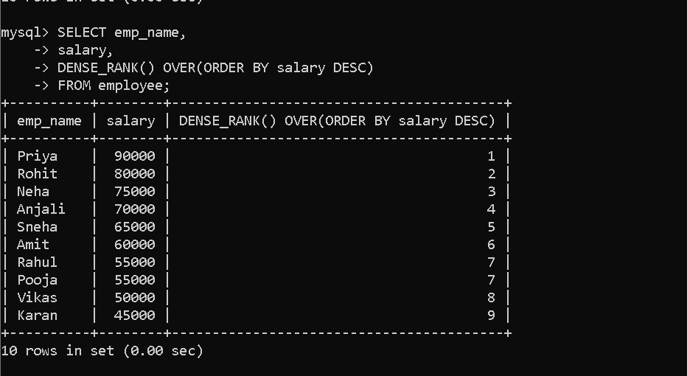

22. Row Number.
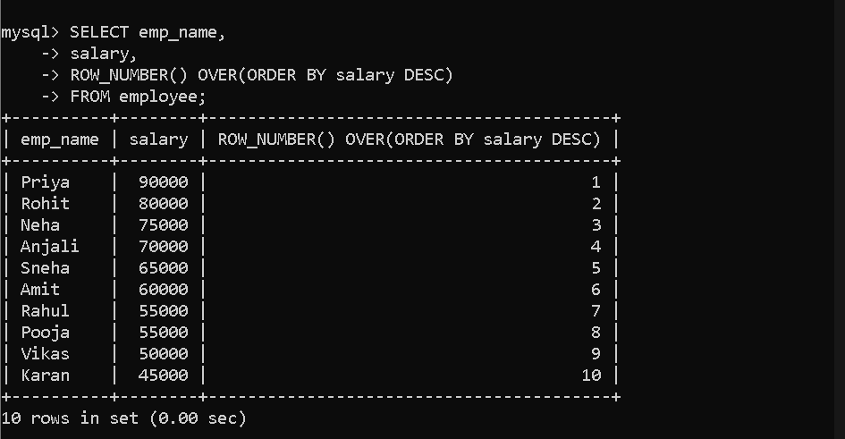
23. Find Top 3 highest salaries.
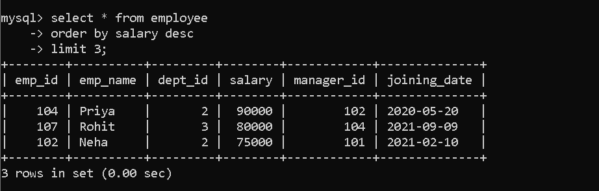
24. Find Nth highest salary (3rd). 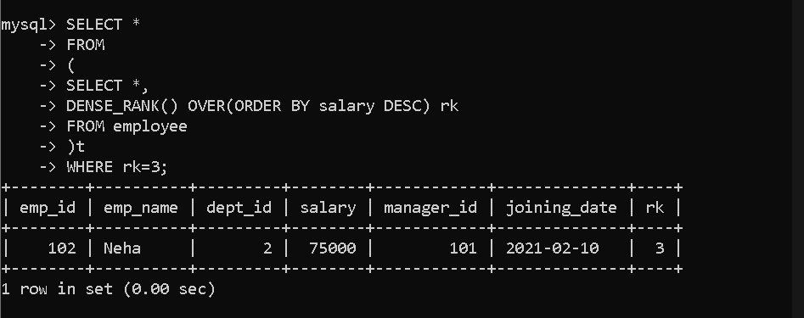
25. Display employees whose salary is equal to maximum salary of their department.
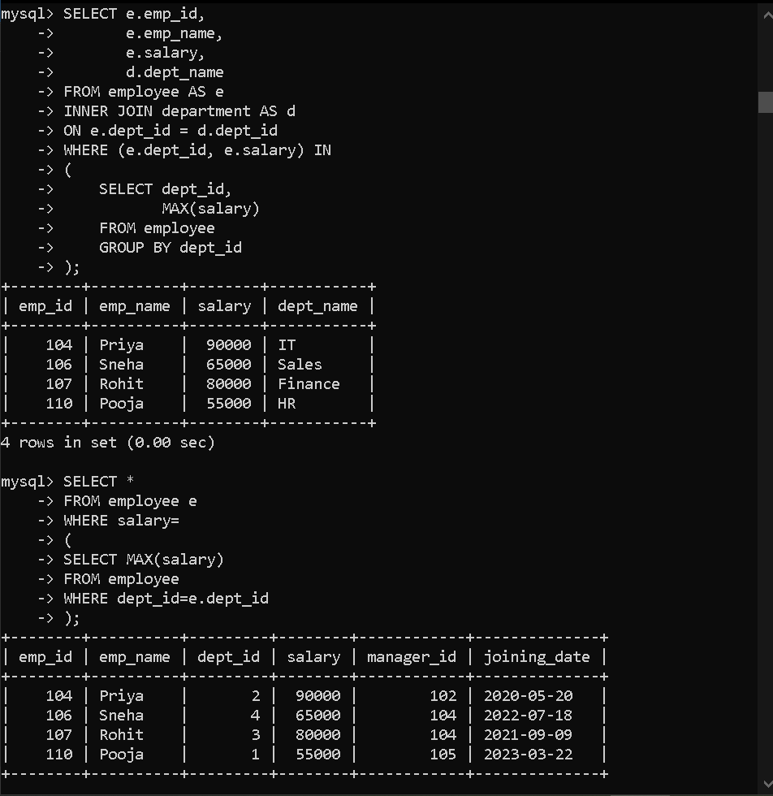

26. Find employees who have same salary.
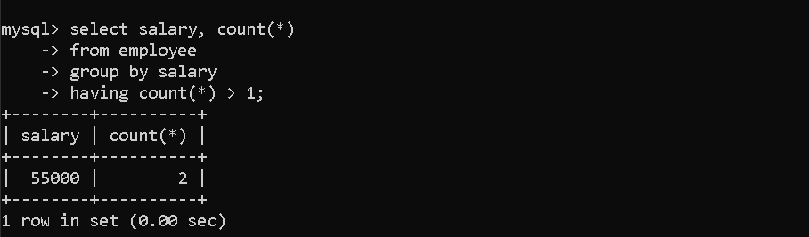
27. Find employees whose manager works in IT department.
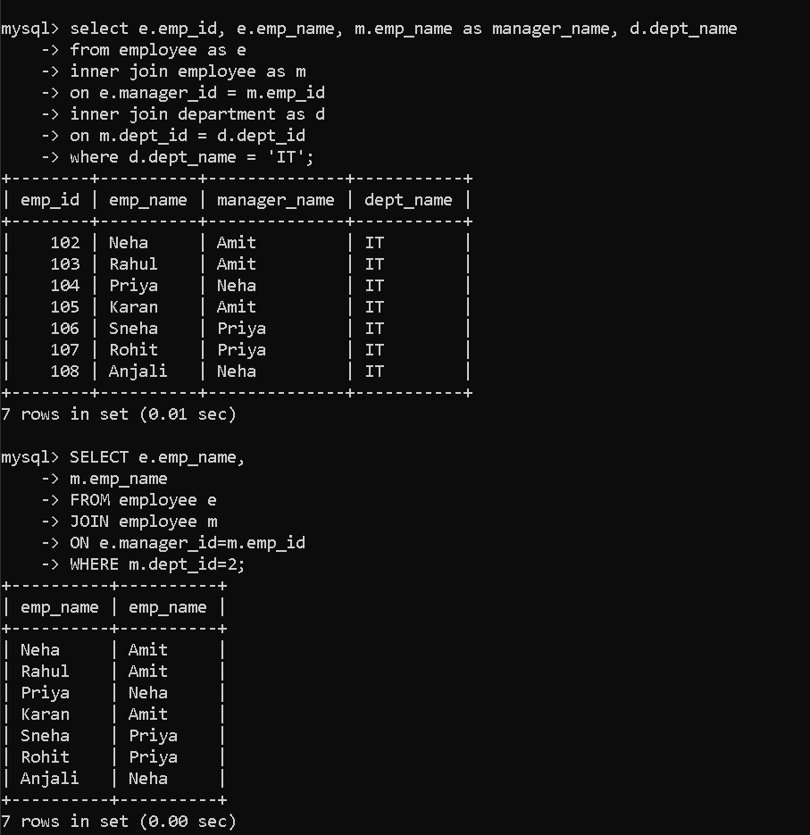

28. Find department-wise total salary.
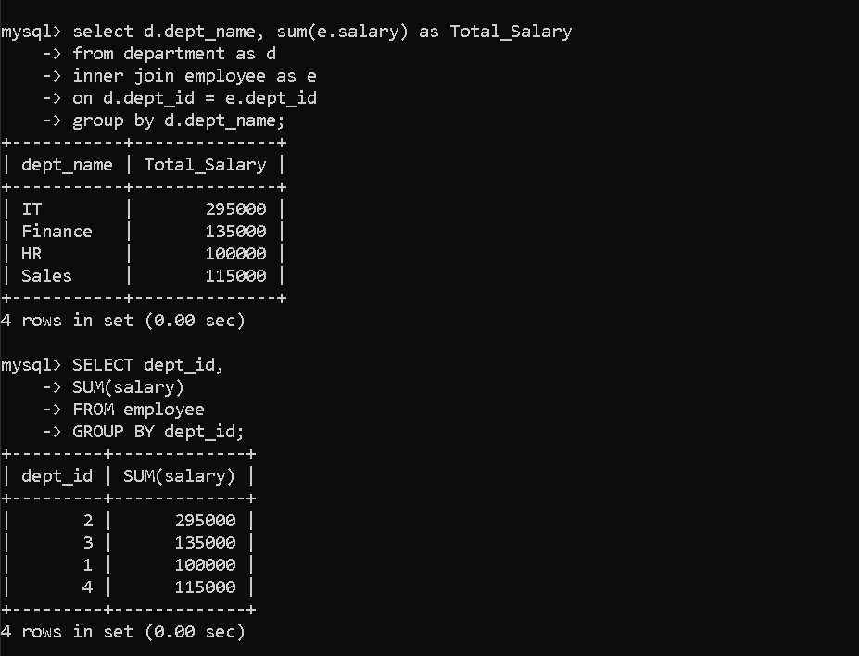

29. Find employee hired first.

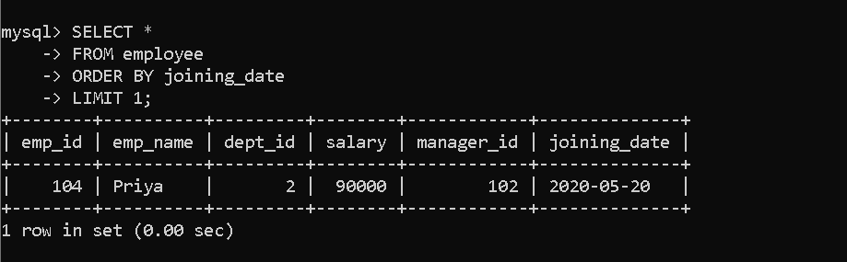
30. Find latest joined employee.
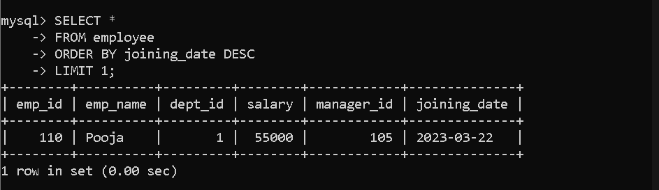
- List each employee with their department name
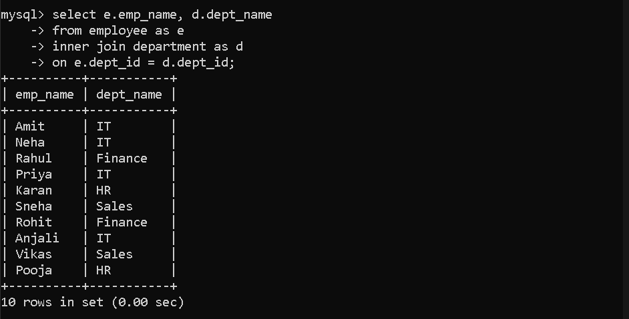
2. Find employees who earn more than their manager
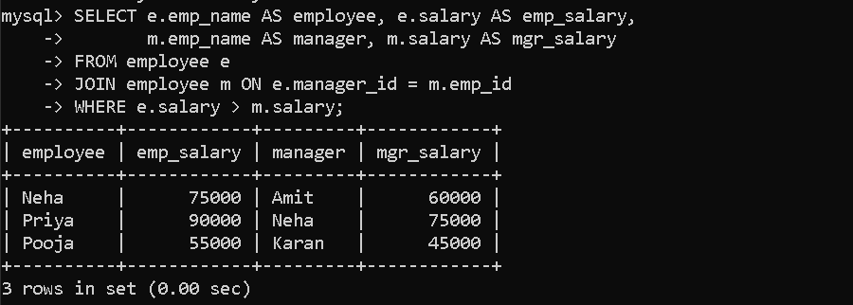
4. Find the highest-paid employee in each department
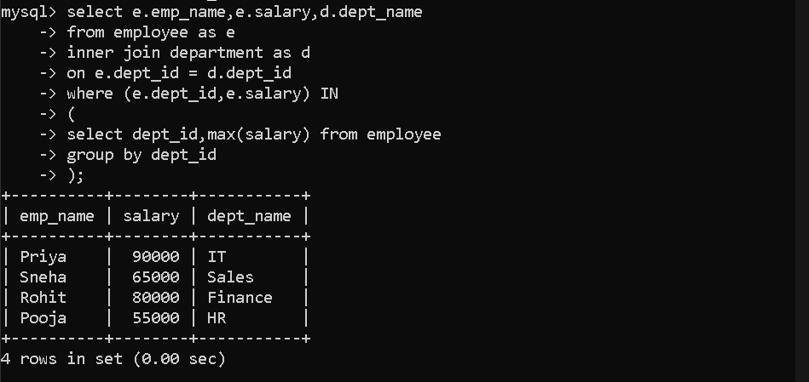
5. Department-wise average salary
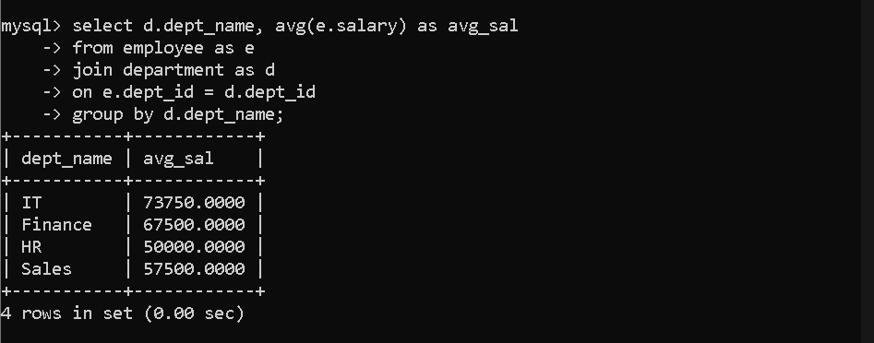
6. Employees who joined in 2022
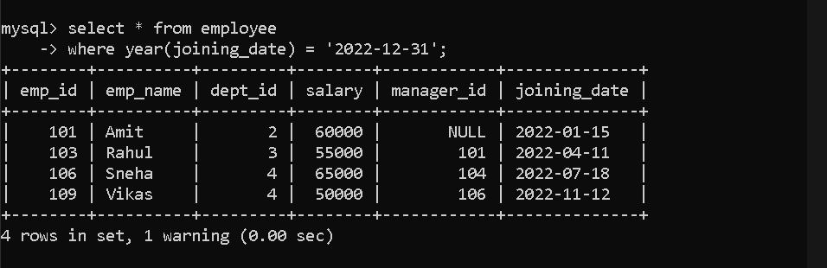
7. Second highest salary (without LIMIT)
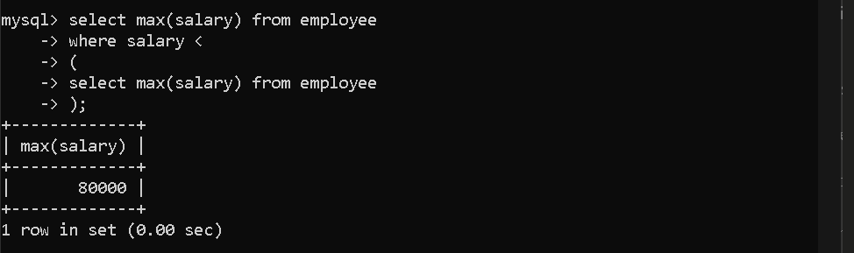
8. Employee(s) with no manager (top of hierarchy)
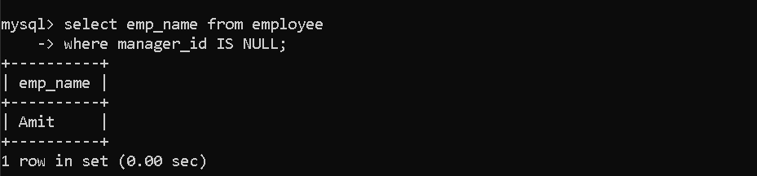
9. Rank employees by salary within their department
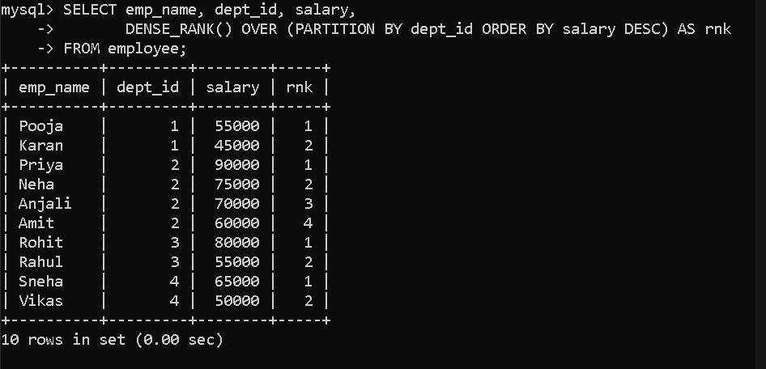
10.Count of employees per department (including departments with zero employees)
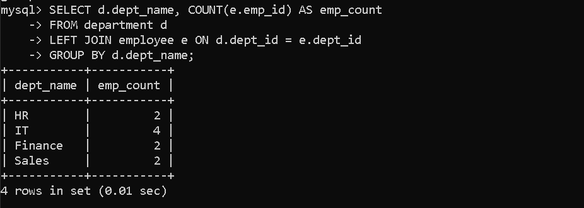
11. Who are the managers (i.e., appear in manager_id column)?
