Q1) Display Databases.
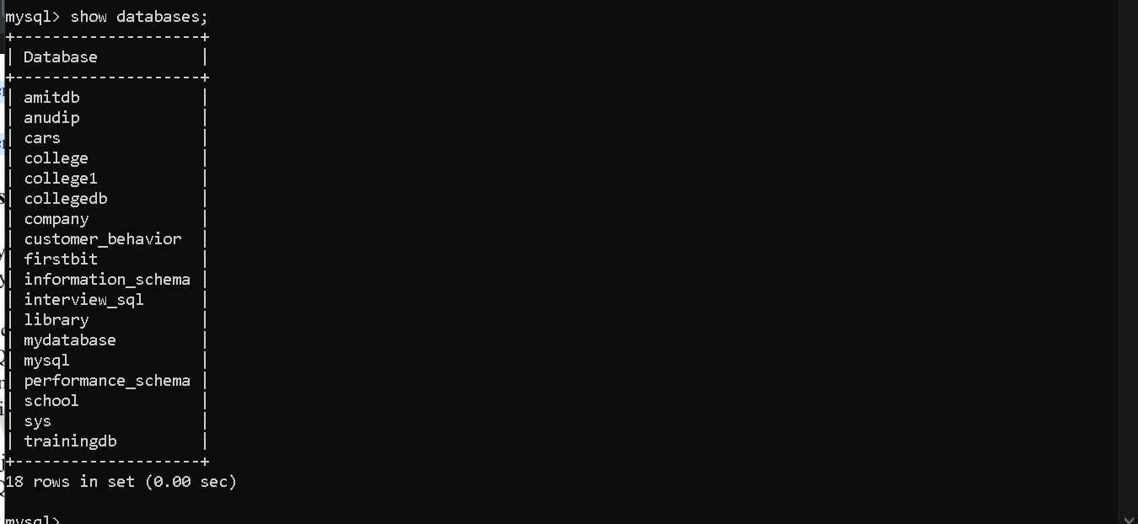
Q2) Create countries Table
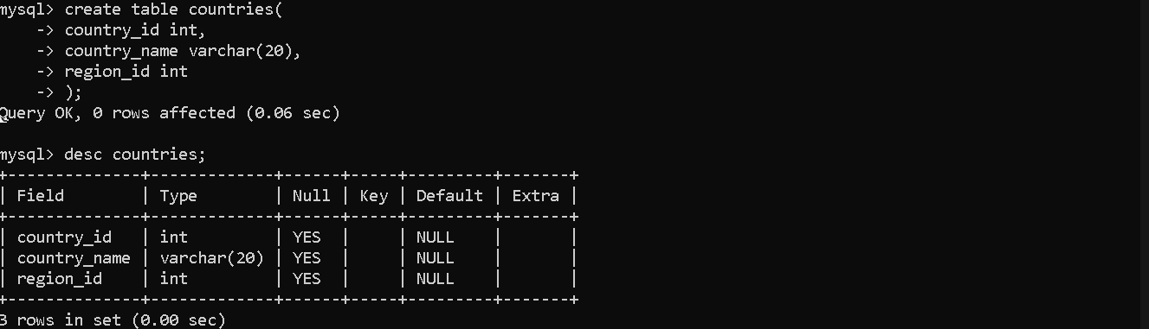
Q3) Create jobs Table with Constraints
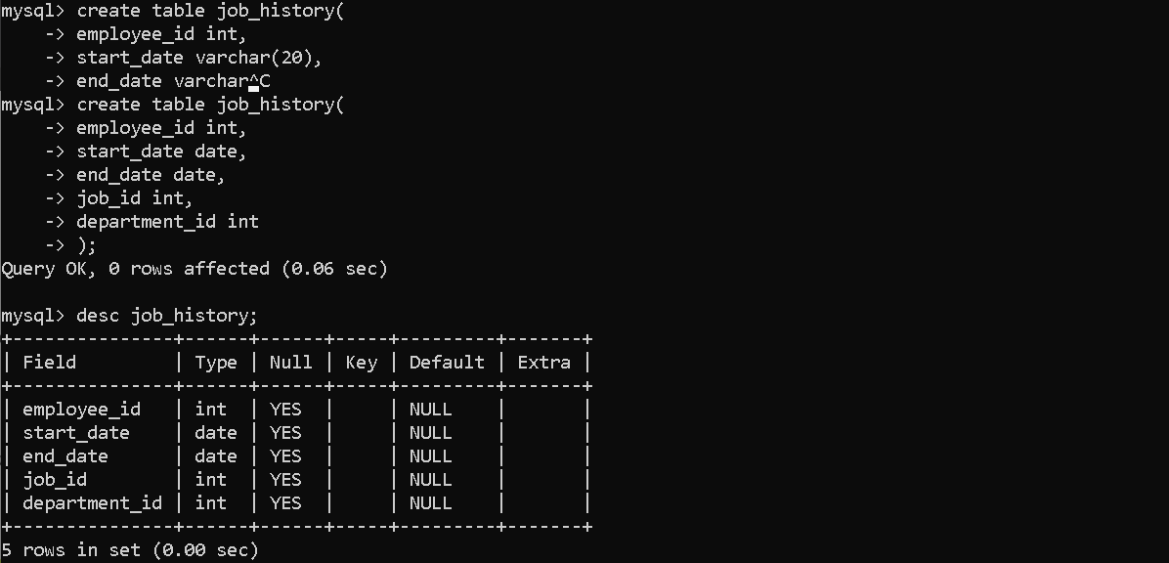

Q4) Create job_history Table
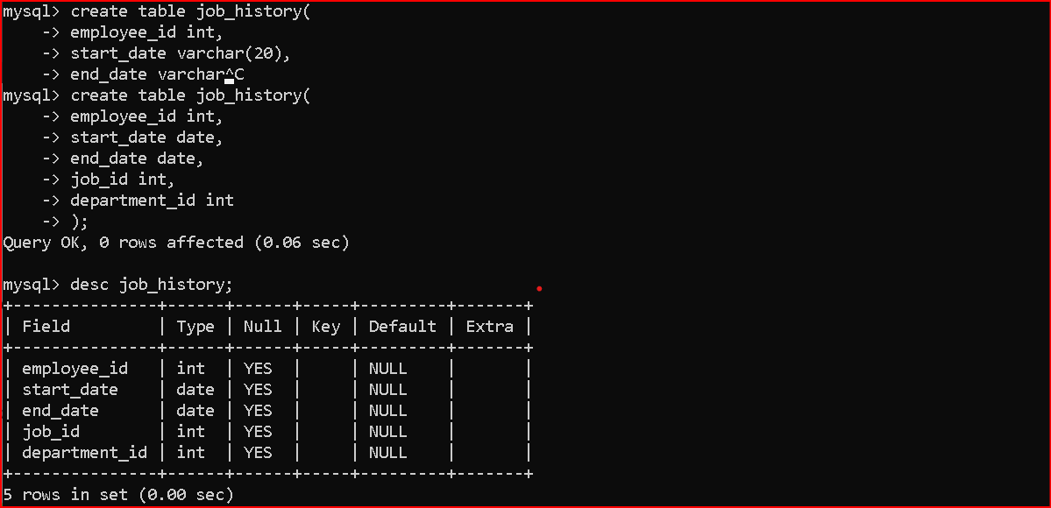
Q5) Add UNIQUE Constraint
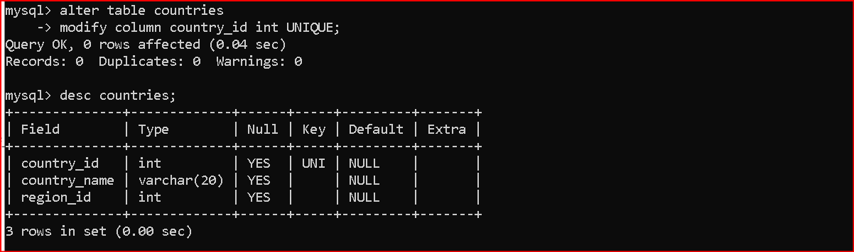
Q6) Create jobs_default Table with DEFAULT Values
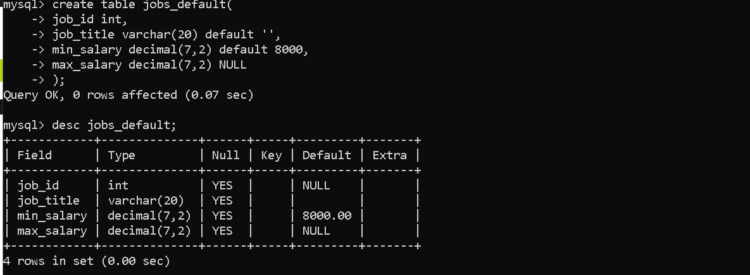

Q7) Create departments Table (Composite Primary Key)
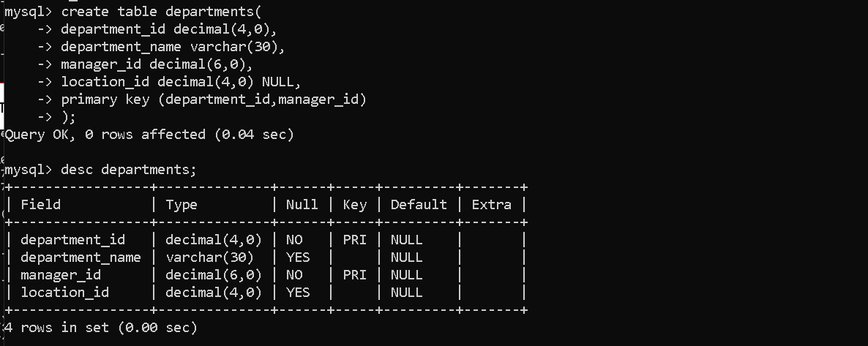
Q8) Create employees Table with Normal Foreign Key
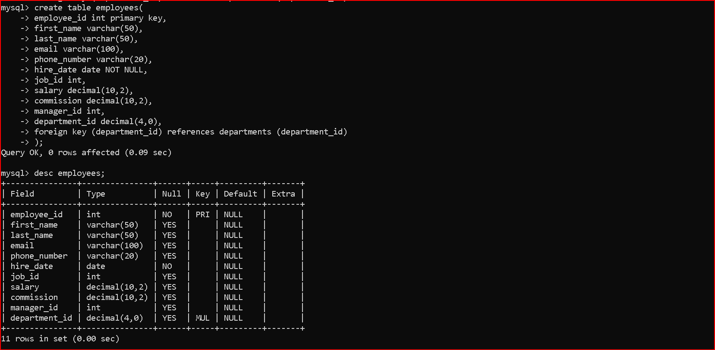
Q9) Composite Foreign Key Implementation

