- AVERAGEA(value1, value2,…) it calculates the average of values, but unlike AVERAGE(), it also considers text and logical values.
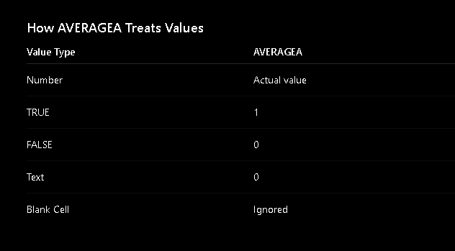
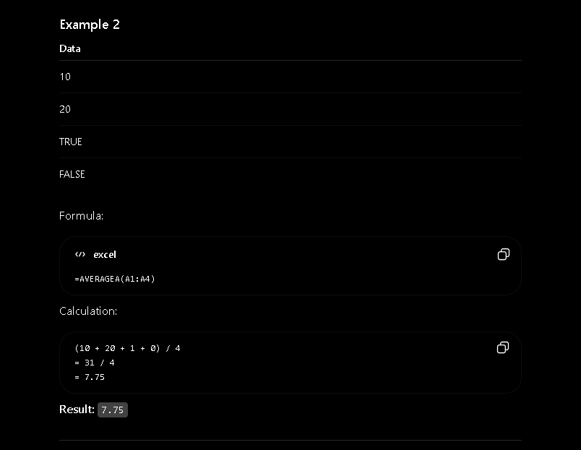

- AVERAGEIF(range, criteria, average_range) it calculates the average of cells that meet a specific condition.
    - range cells to check the conditions
    - criteria condition to match
    - average_range cells whose average will be calculated (optional)

