Q1) Create the tables Member, Books, and Issue WITHOUT constraints.
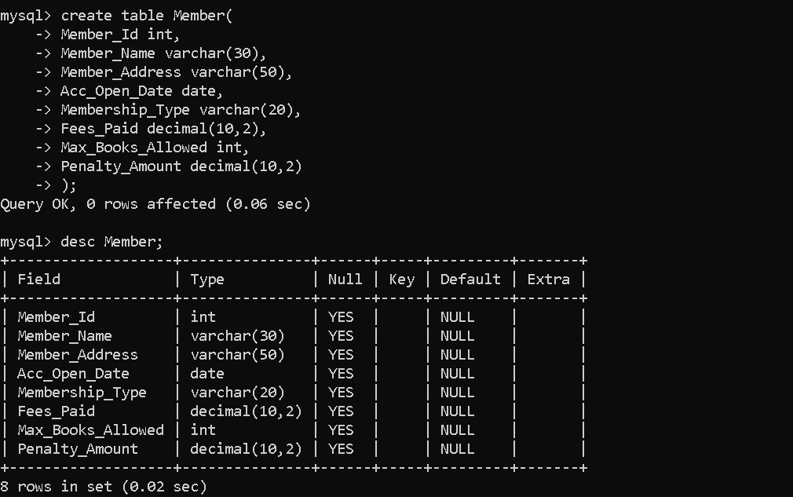
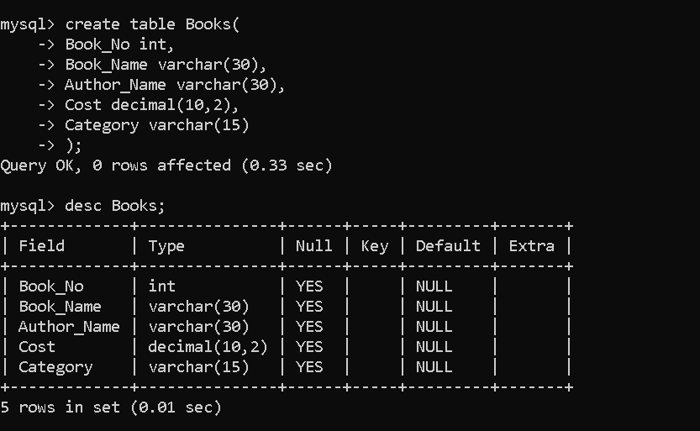
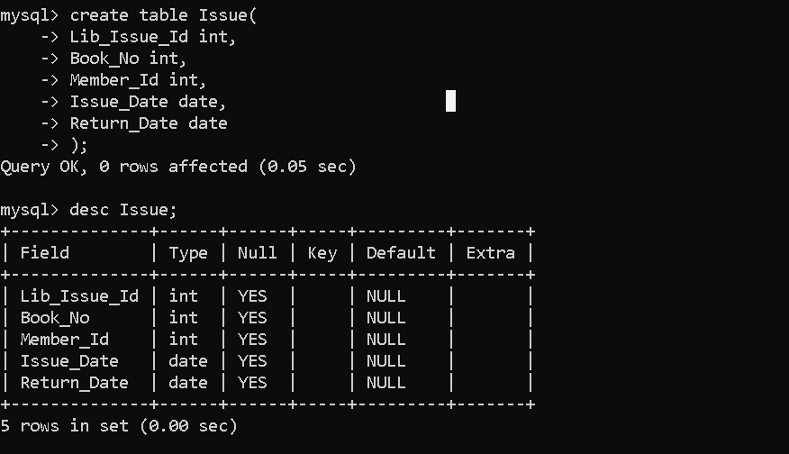
Q3) Drop the Member table.

Q4) Create the Member table again with these constraints:
- Member_Id must be PRIMARY KEY
- Membership_Type must allow only:
('Lifetime','Annual','Half Yearly','Quarterly')
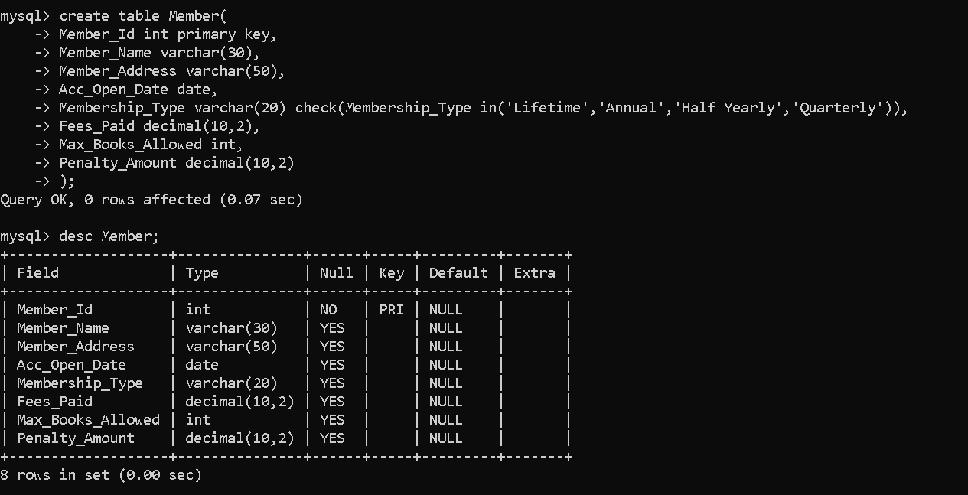

Q5) Alter Member table to increase Member_Name size from 30 to 40.

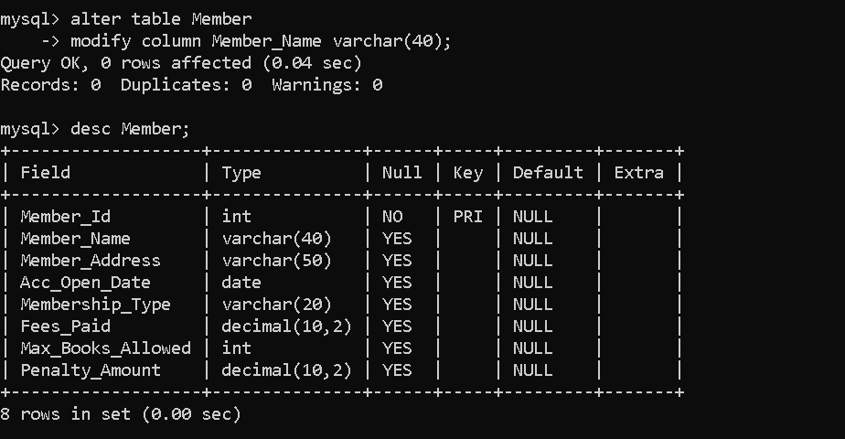
Q6) Add a column Reference (VARCHAR (30)) to Issue table.
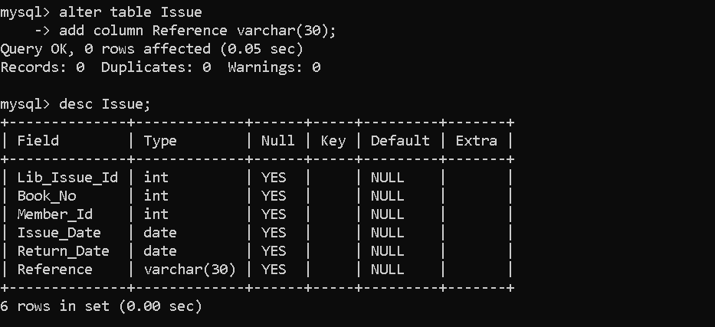
Q7) Drop the column Reference from Issue table.
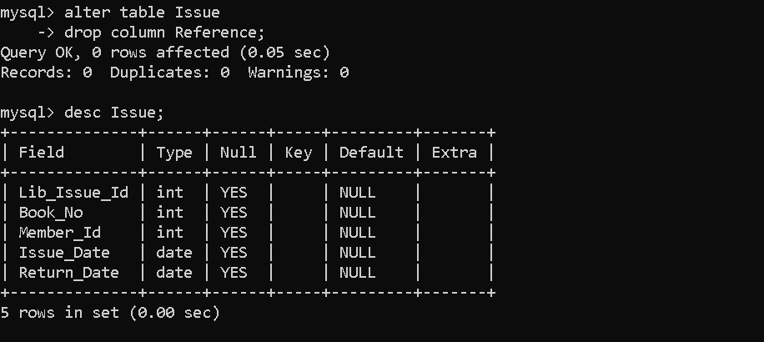

Q8) Rename the table Issue to Lib_Issue.

Q9) Insert the following records into Member table:
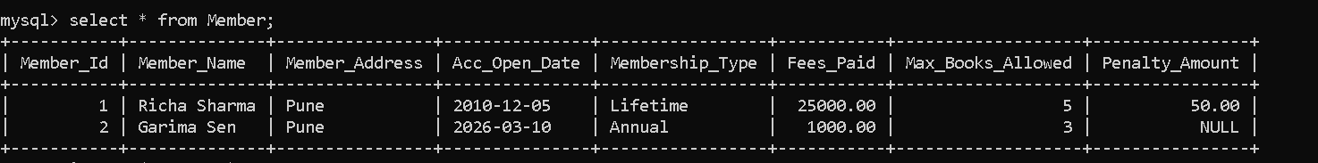
Q10) Insert at least 5 more records with suitable data into Member table.
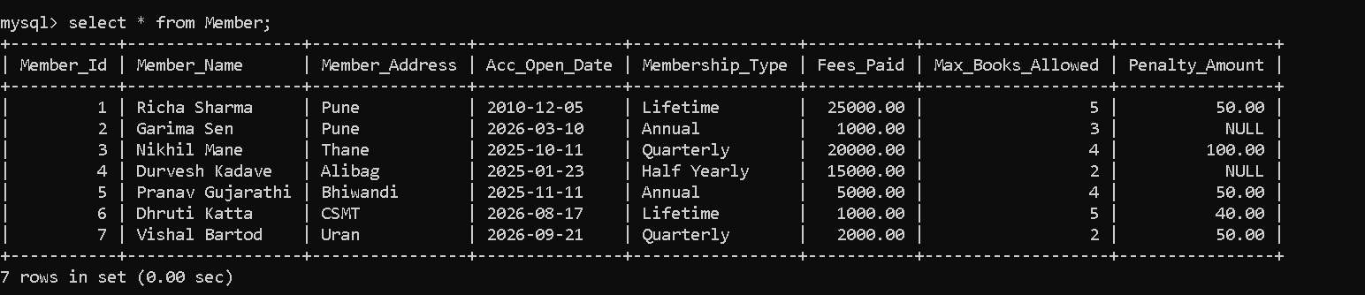
Q11) Try to decrease Member_Name size from 40 to 20.
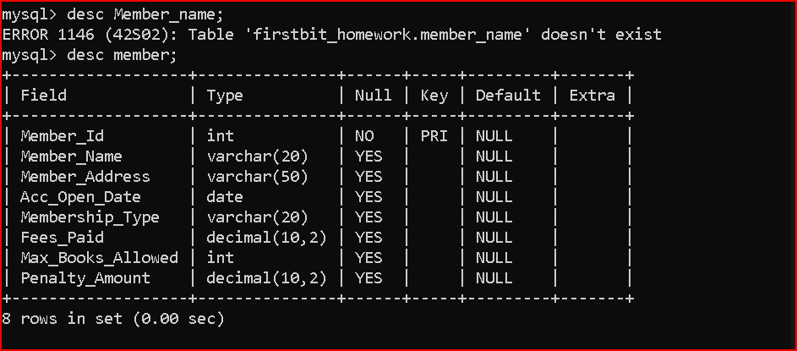
Q12) Add a CHECK constraint:
Max_Books_Allowed must be less than 100.

Q13) Create a backup table named MemberBackup using the Member table.
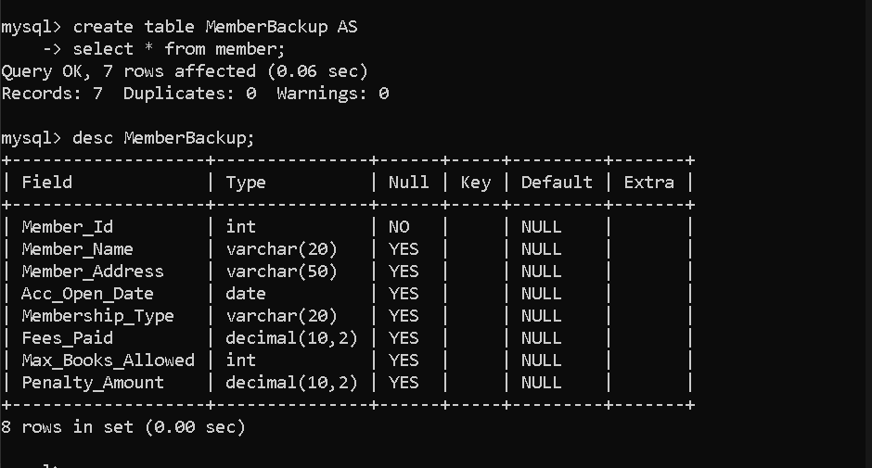
Q14) Add named constraints:
- Max_Books_Allowed < 100
- Penalty_Amount <= 1000

Q15) Drop the Books table.
Q16) Create Books table again with constraints:
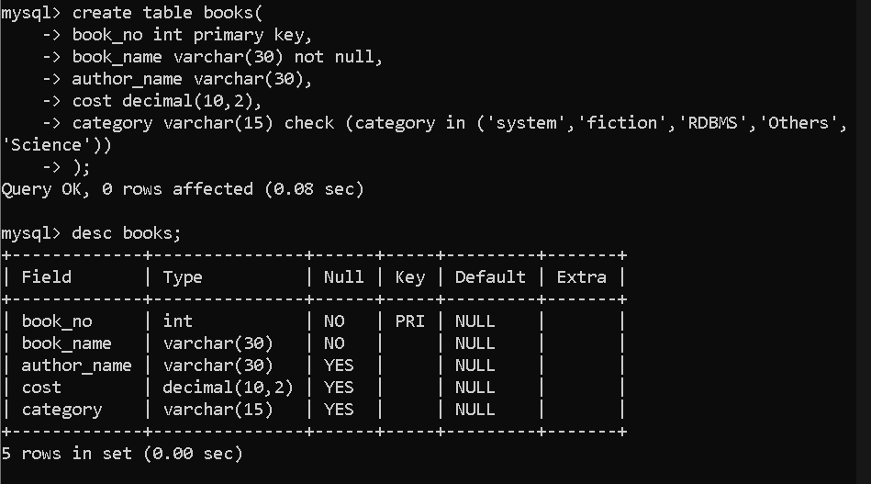
Q17) Insert the following data into Books table:
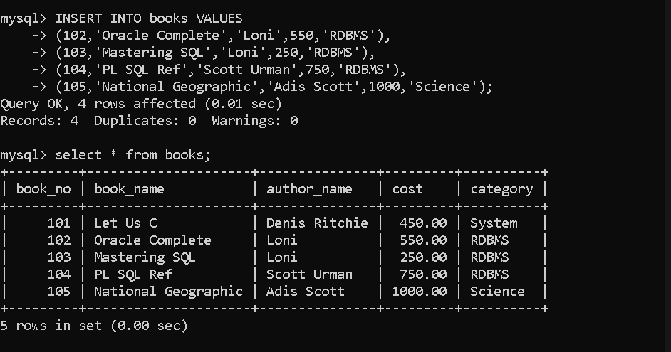
Q18) Insert at least 5 more records into Books table.
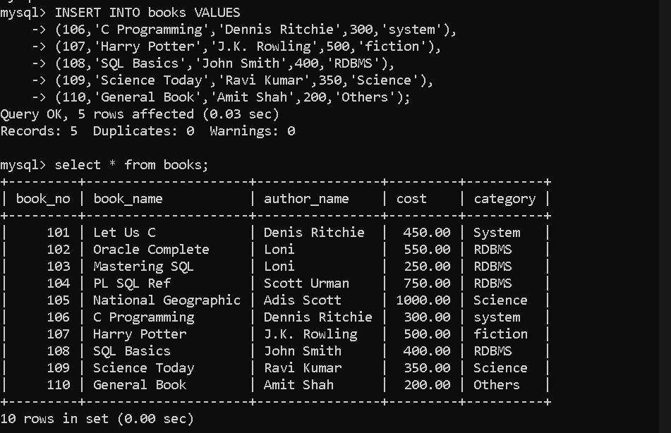
Q19) View all data from Member and Books tables using SELECT.
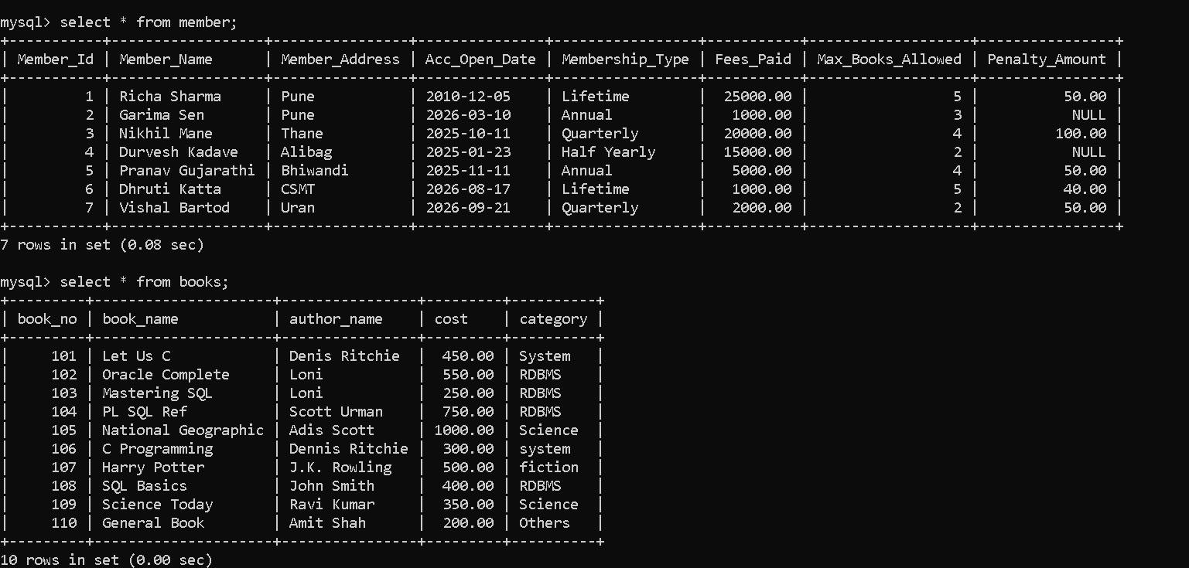
Q20) Drop Lib_Issue table.
Q21) Create Issue table again with constraints:
- Lib_Issue_Id PRIMARY KEY
- Book_No FOREIGN KEY REFERENCES Books(Book_No)
- Member_Id FOREIGN KEY REFERENCES Member(Member_Id)
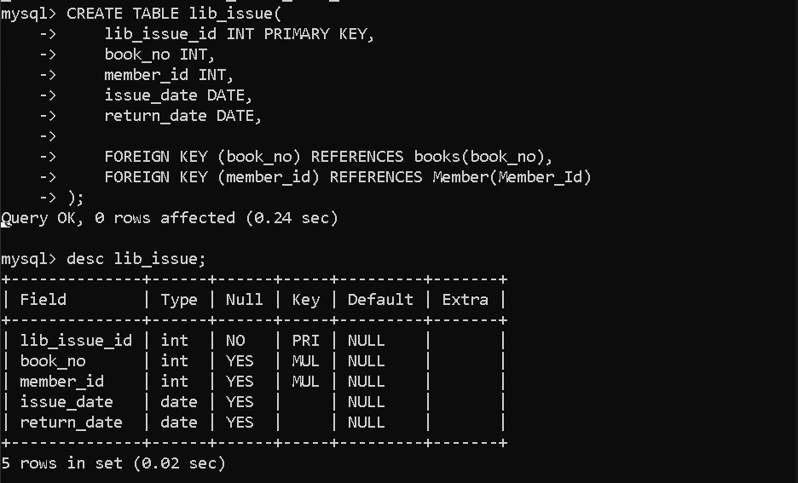
Q22) Insert the following records into Issue table:
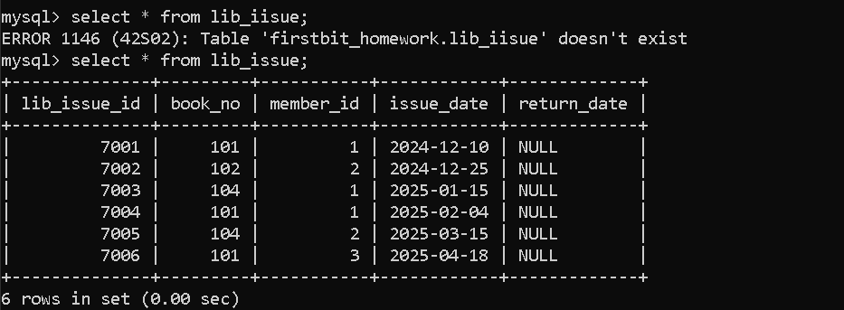
Q23) Try inserting an Issue record with Member_Id not existing in Member table.
Observe and write the error.
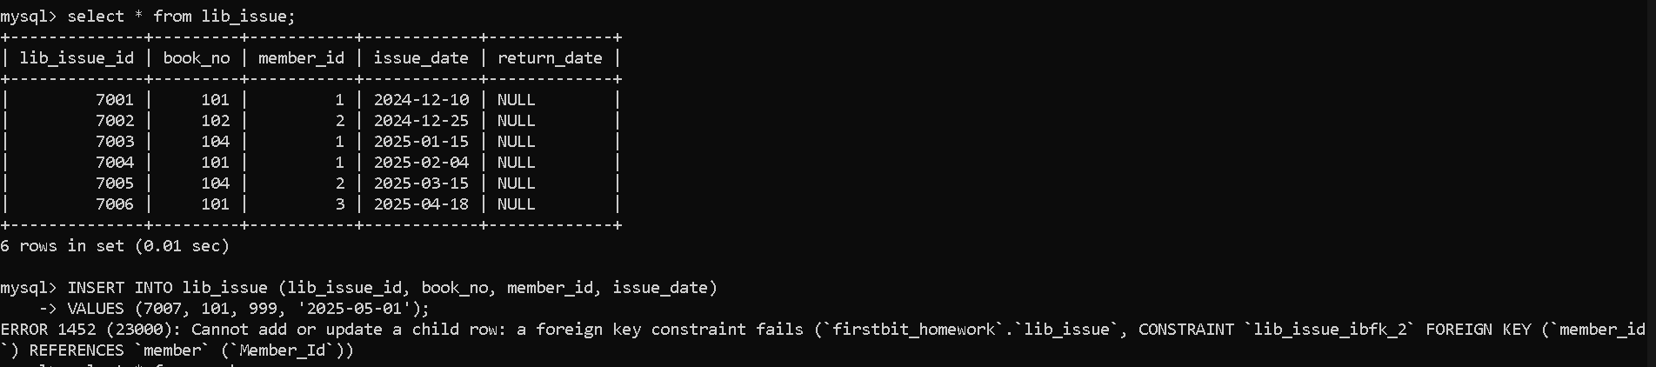
Q24) Try deleting Member_Id = 1 from Member table.
Observe and write the foreign key error.
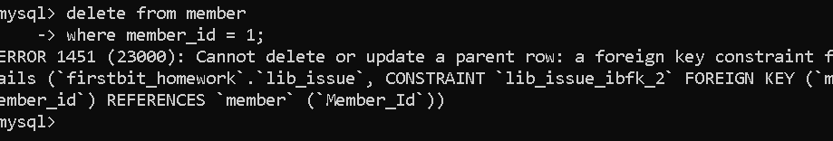
This happens because Member_Id = 1 is used in the lib_issue table.
So MySQL does not allow deleting it, as it would break the relationship
Q25) Update Return_Date for Issue_Id 7004 and 7005 to 15 days after Issue_Date.
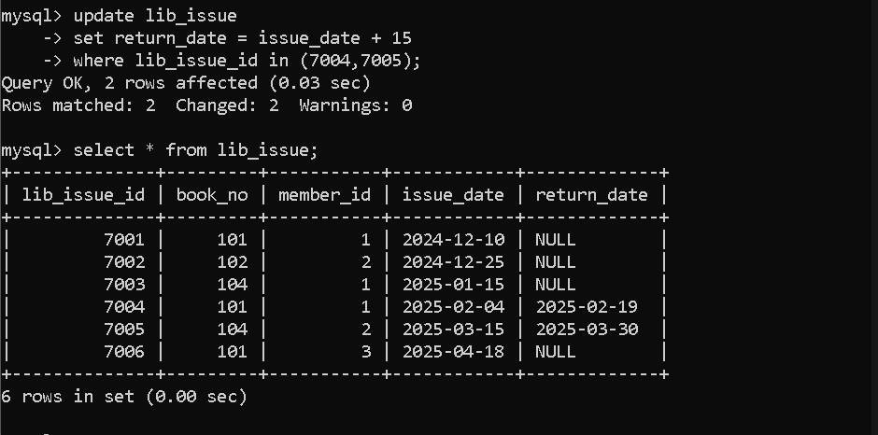
Q26) Delete all Issue records where Member_Id = 1 and Issue_Date is before '2006-12-10'.
Q27) Delete all Books where Category is not Database or RDBMS.
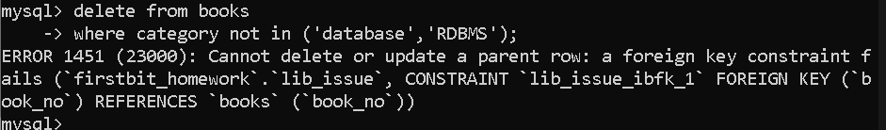
Q28) Drop all three tables: Issue, Member, Books.


